20 EKGs you should know

Chest Pain

1. 45-year-old man with one hour chest pain radiating to back.
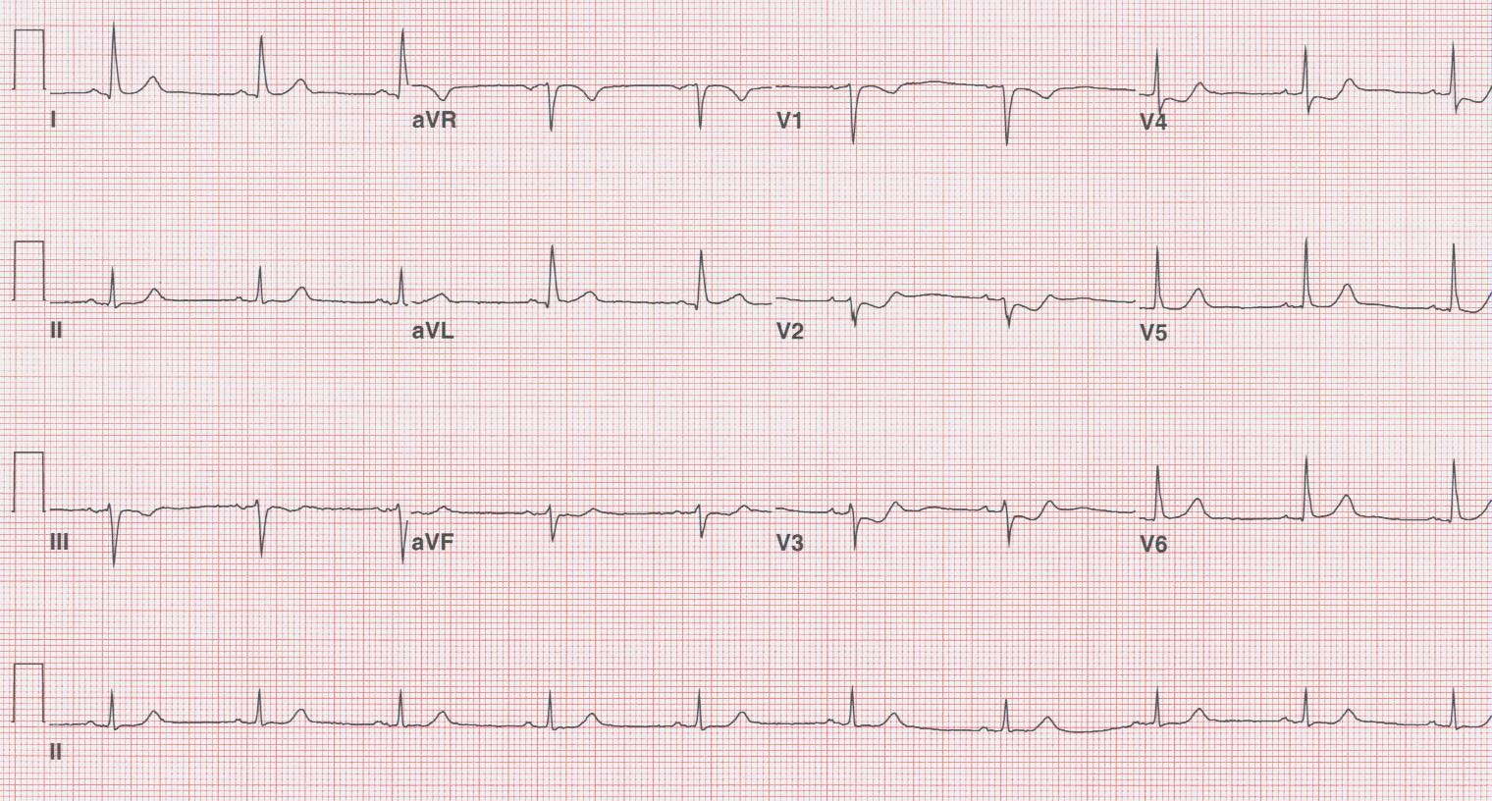

2. 78-year-old man, a dairy farmer, with one hour chest pain associated with sweating.
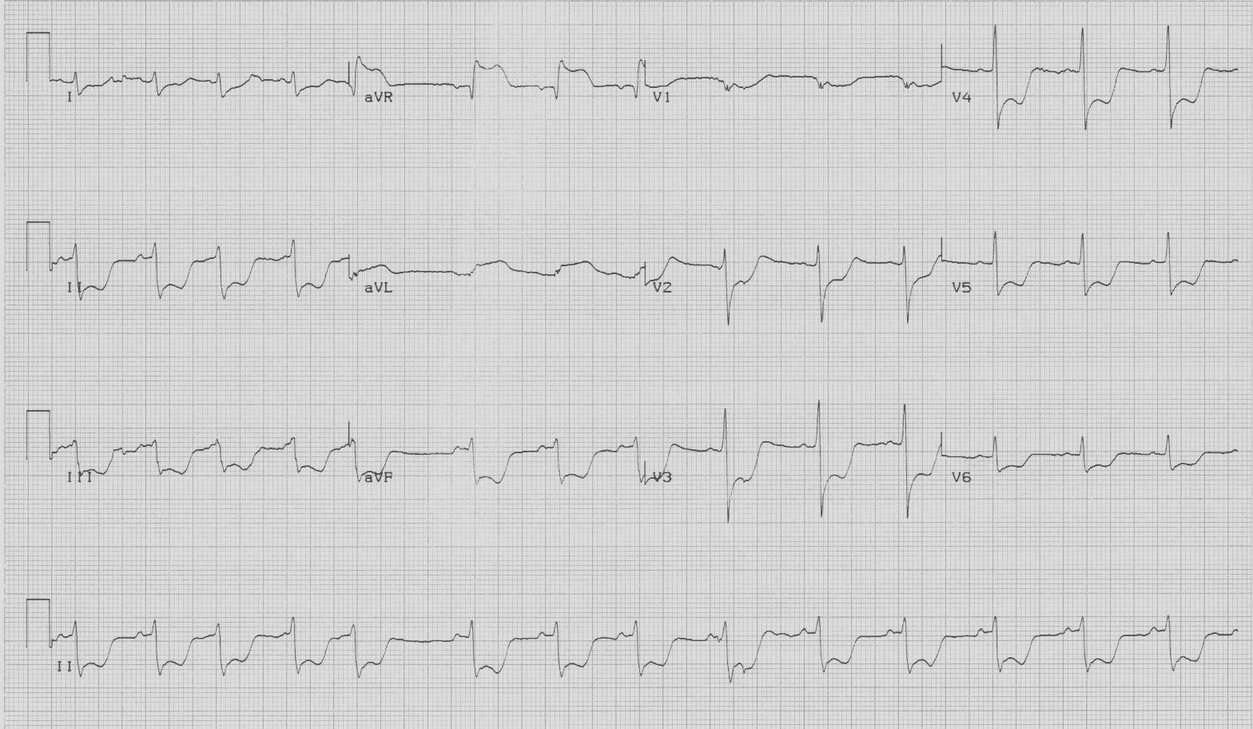

3. 36-year-old woman, 3 weeks post-partum, with 30 minutes chest pain which is now resolved.
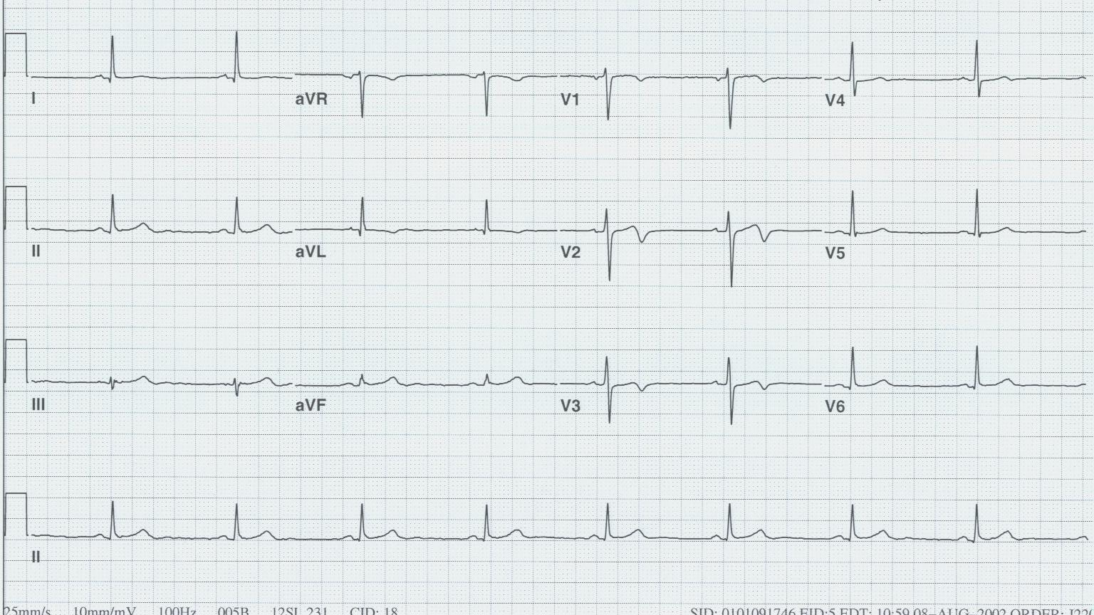

4. 53-year-old man with acute MI who received thrombolytic therapy in ED one hour ago.
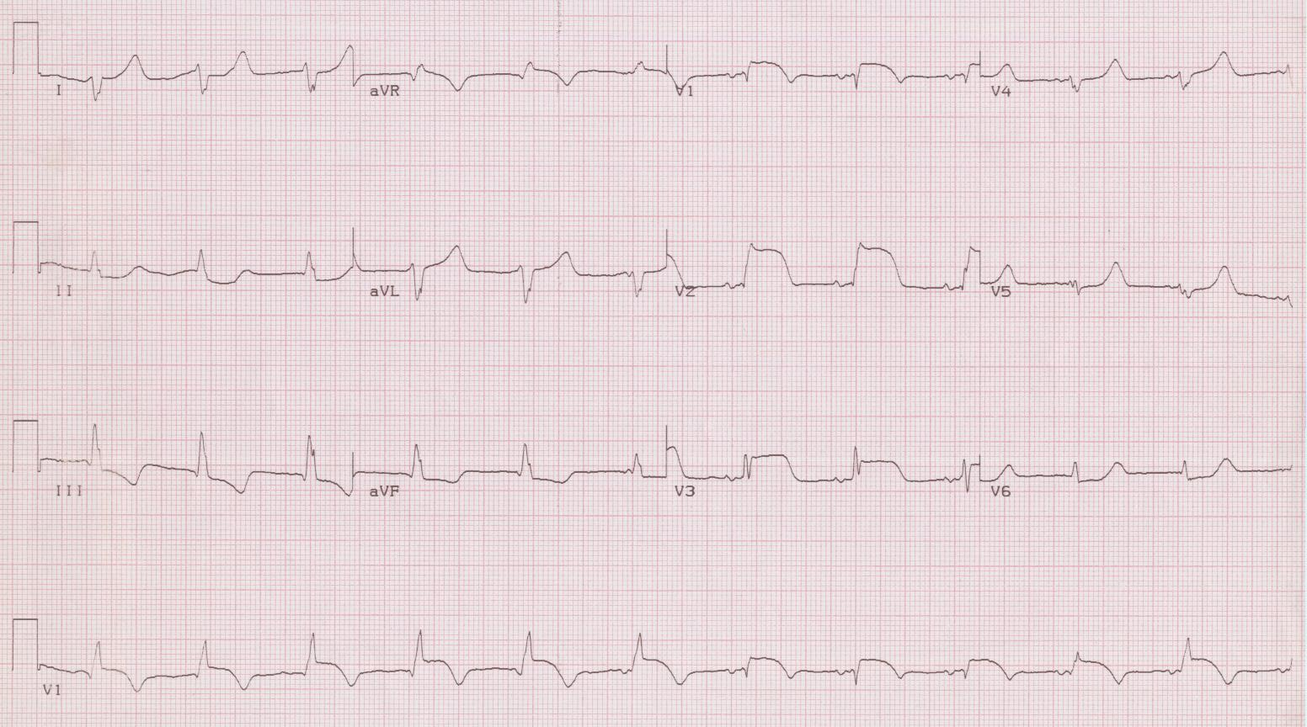

5. 35-year-old man with chest pressure all day, worse with inspiration and position.
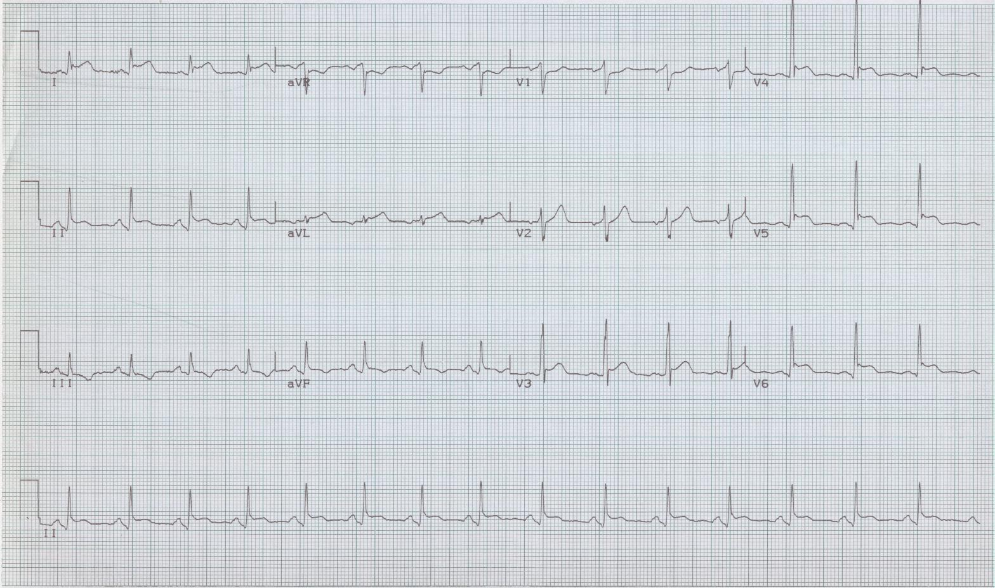

Syncope

6. 40-year-old man being evaluated for episode of syncope earlier that day.
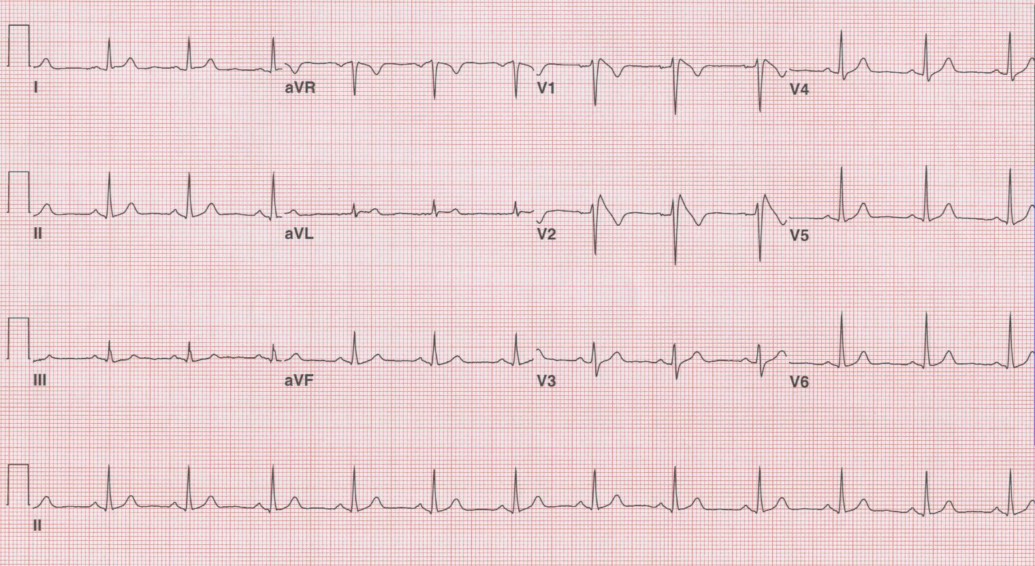

7. 48-year-old woman with shortness of breath after experiencing syncope.
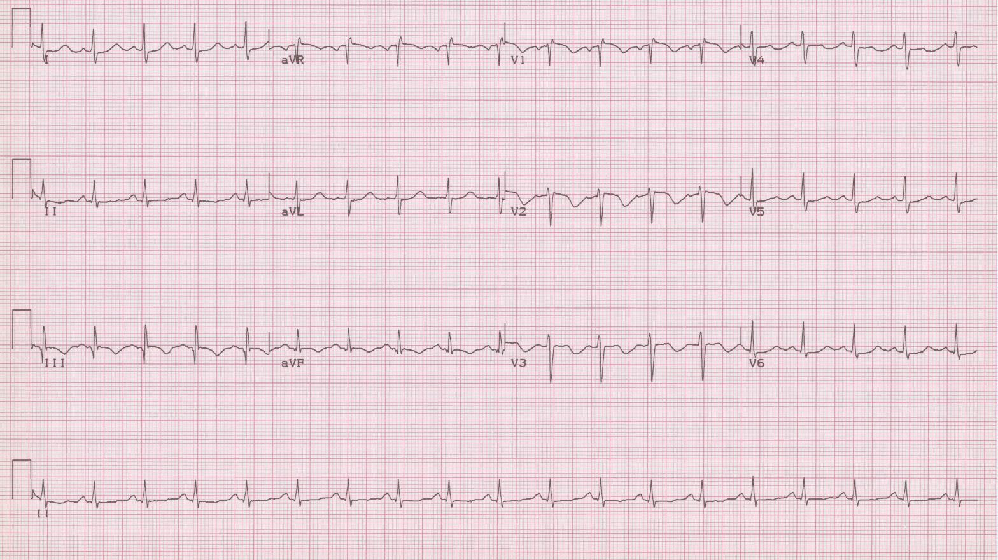

8. 45-year-old man with “worst headache of his life” associated with vomiting.
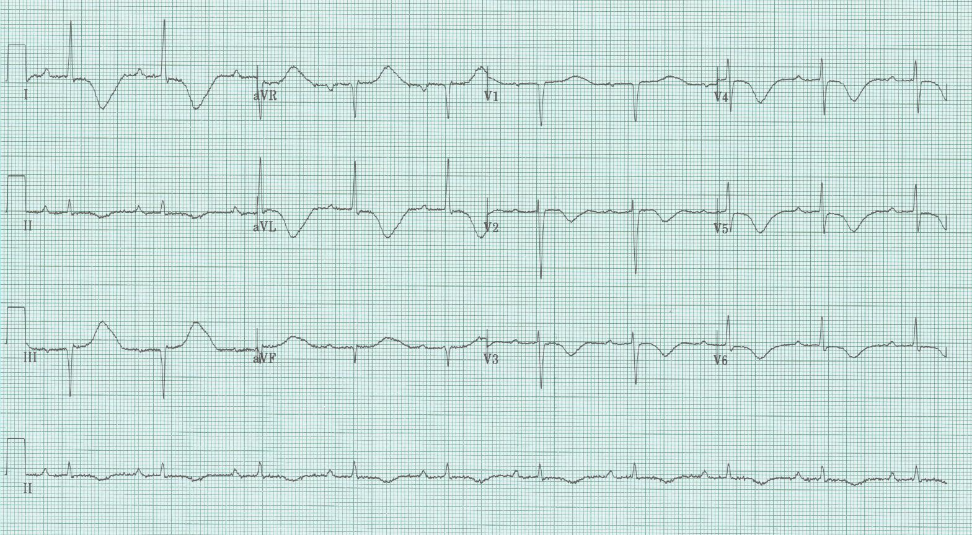

9. 65-year-old woman collapses 3 days after experiencing severe thoracic back pain.
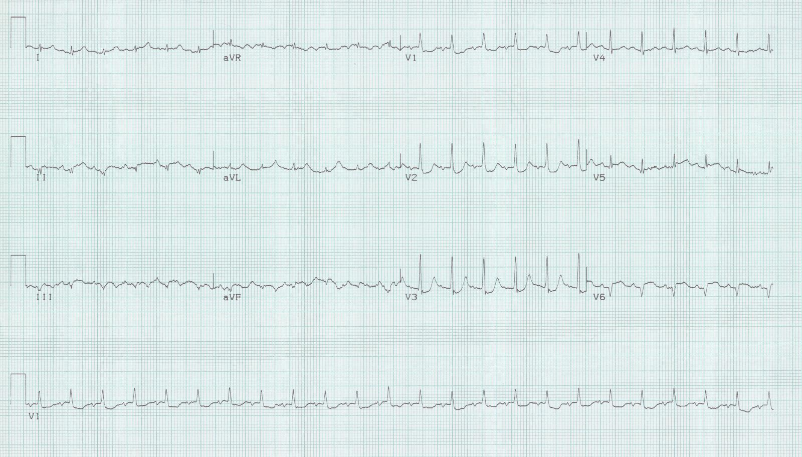

10. 75-year-old woman with syncope in church – asymptomatic when lying flat on stretcher.
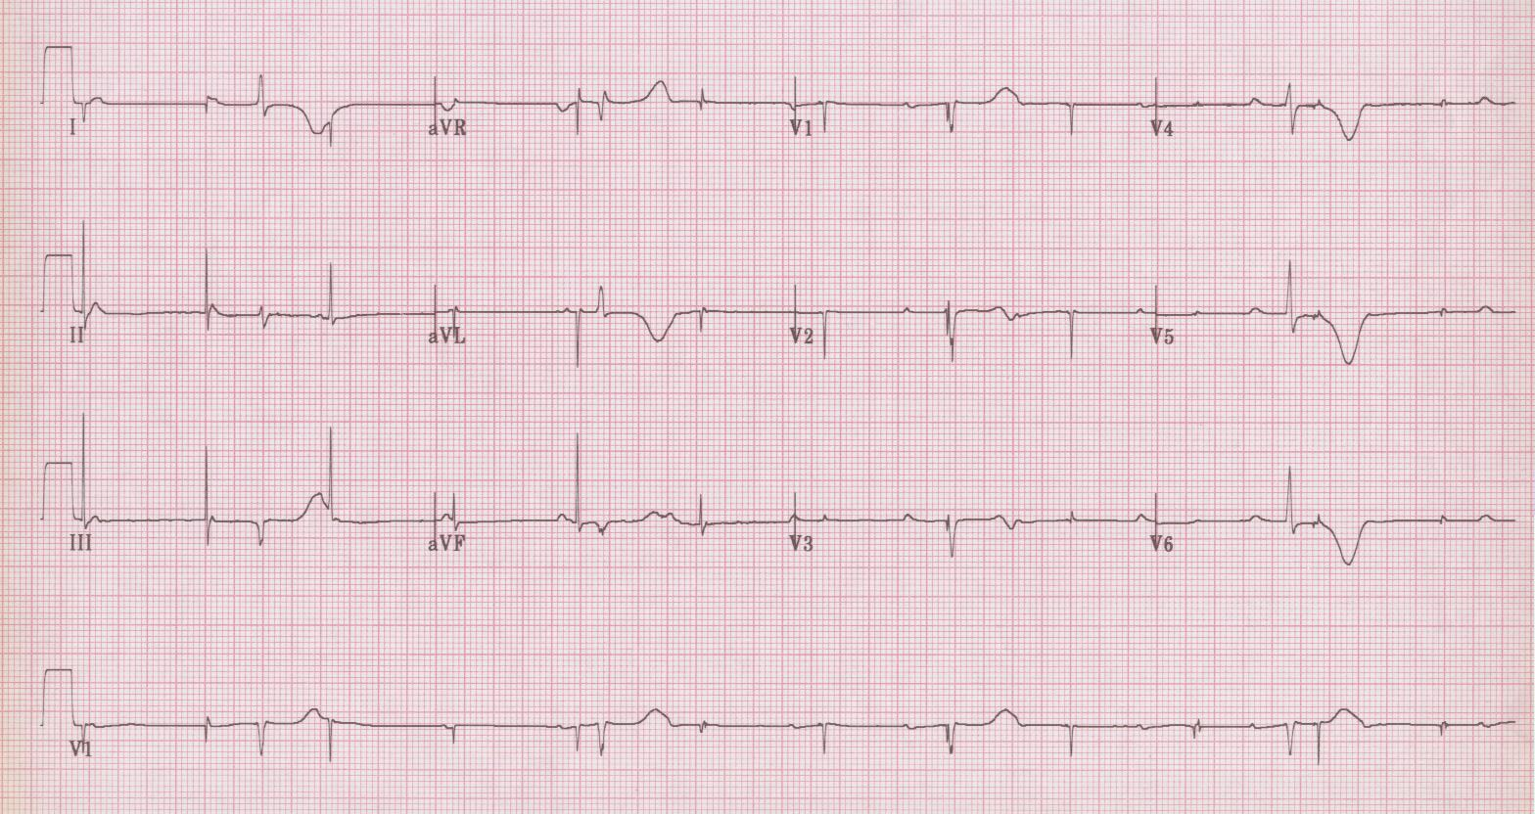

Palpitations

11. 60-year-old man with weakness and “heart racing.” No prior history; no medications.
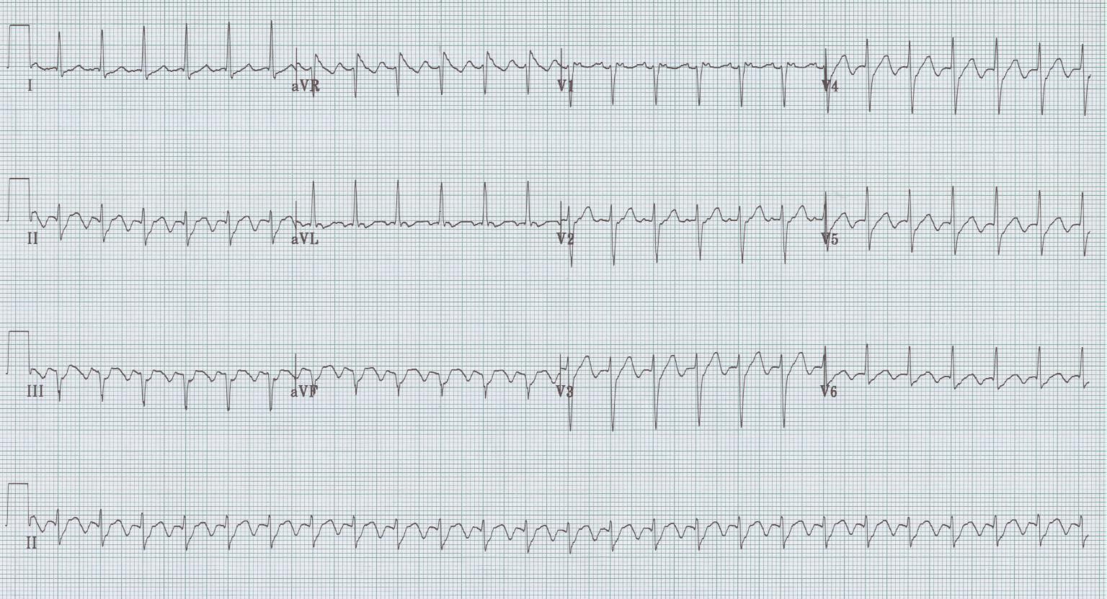

12. 36-year-old man with palpitations and near-syncope. History of “rapid heart beating.”
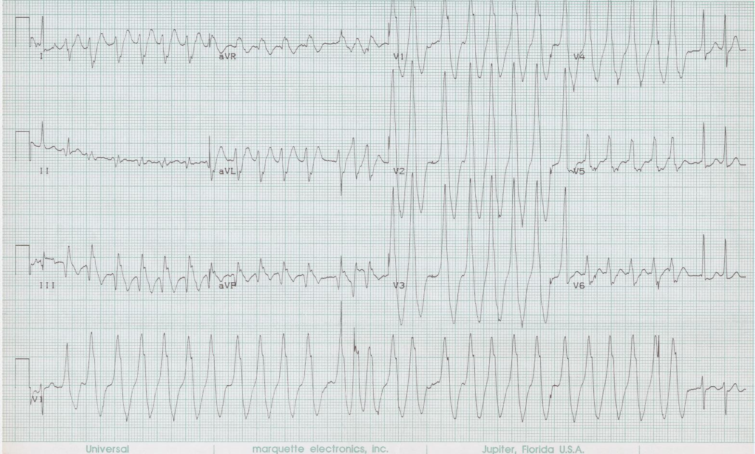

13. 28-year-old woman with frequent episodes of “SVT” requiring treatment in ED.
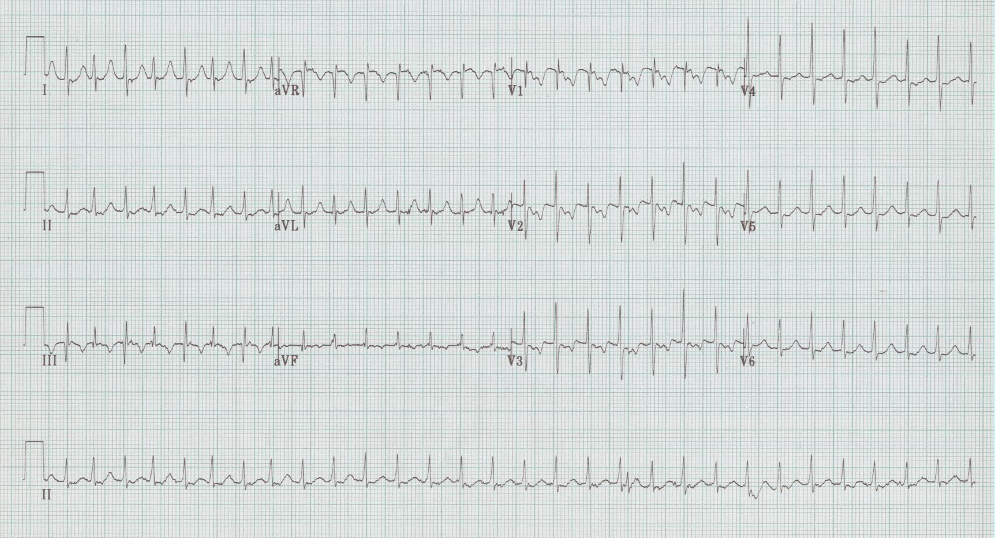

14. 50-year-old woman with “heart jumping” but no syncope.
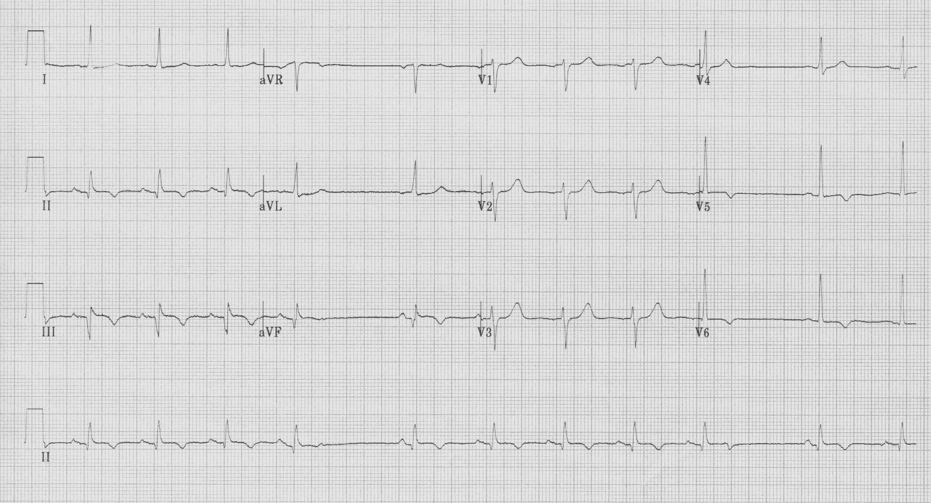

15. 68-year-old woman with chronic atrial fibrillation.
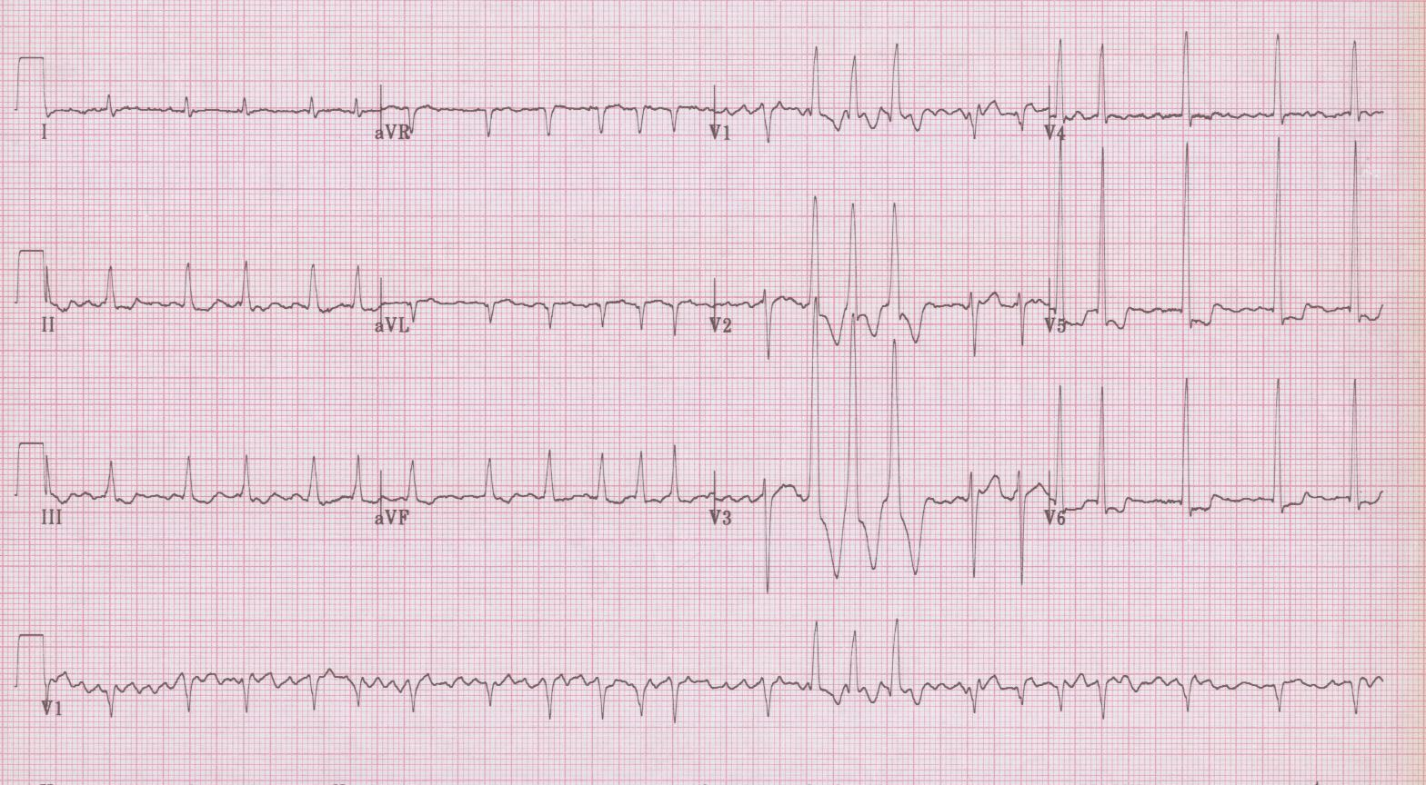

Miscellaneous

16. 45-year-old man with end-stage renal disease who missed last hemodialysis session.
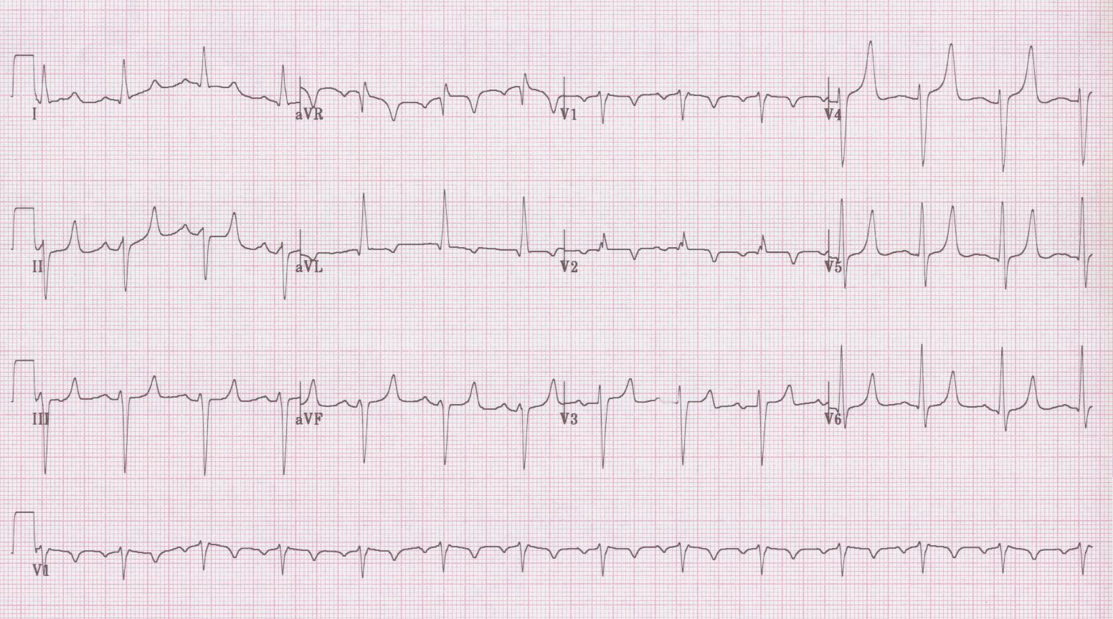

17. 70-year-old woman with complain of weakness; meds include hydrochlorothiazide.
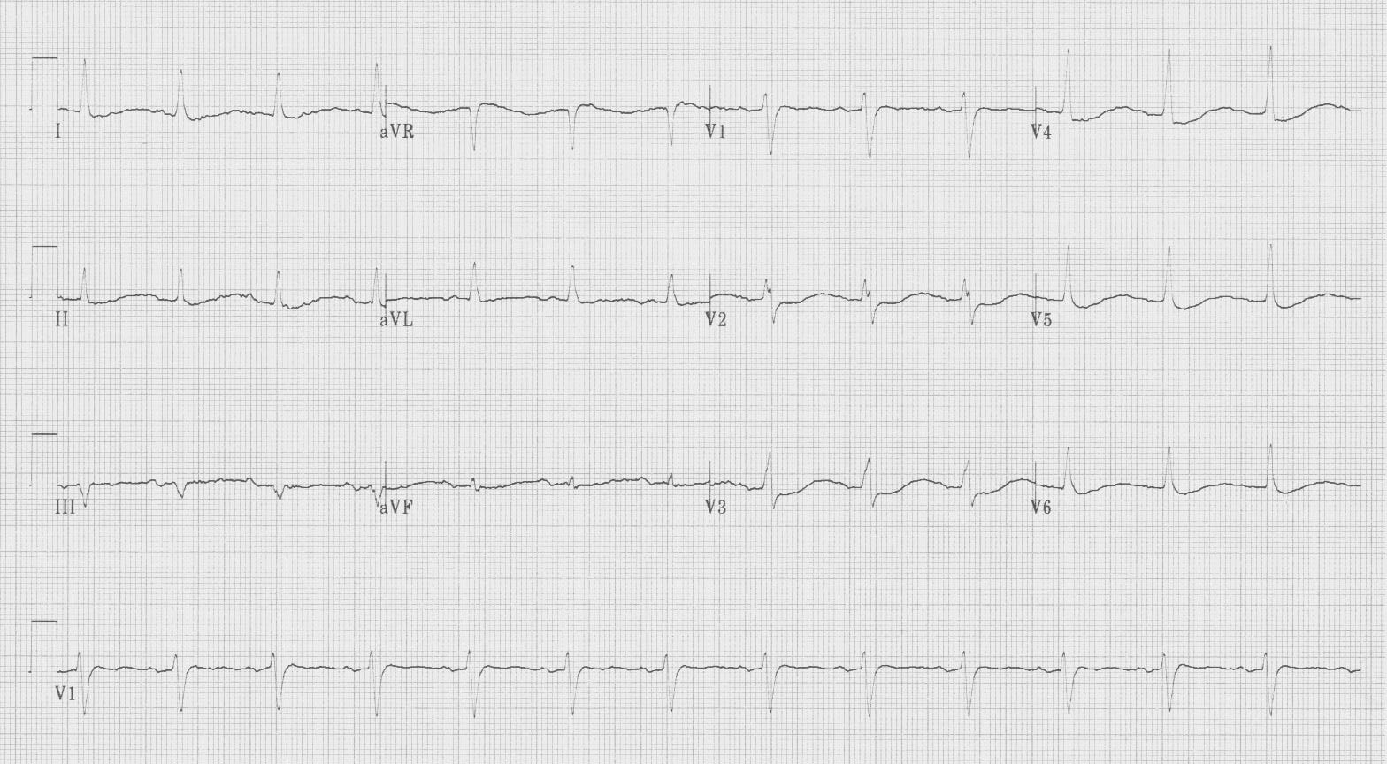

18. 70-year-old man with metastatic lung cancer, complains of lethargy.
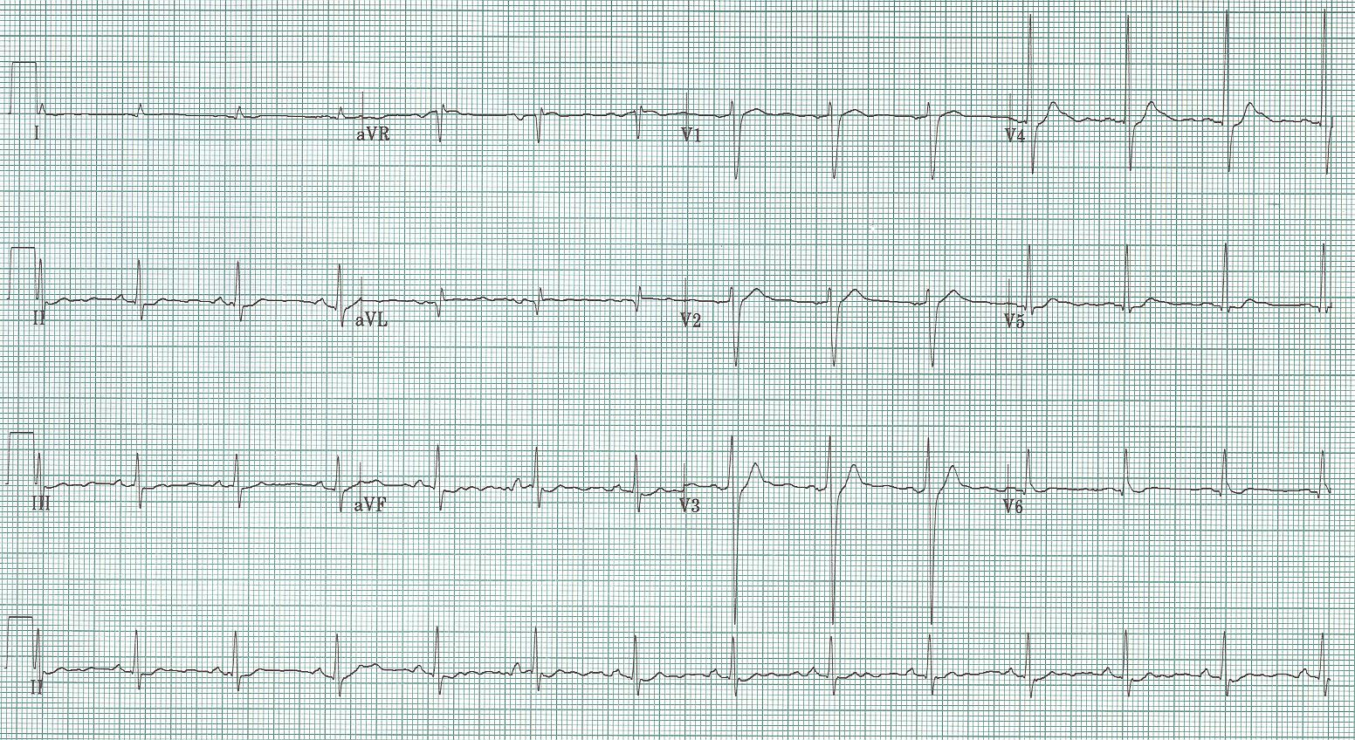

19. 30-year-old homeless man found outside on winter night; unresponsive.
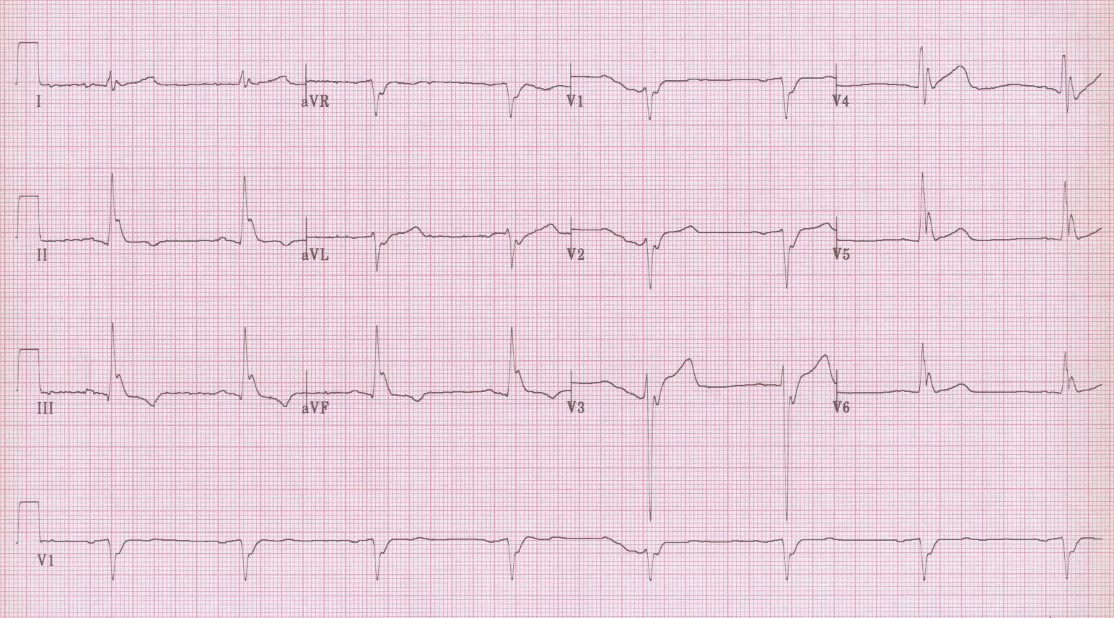

20. 22-year-old man found unresponsive by roommate.
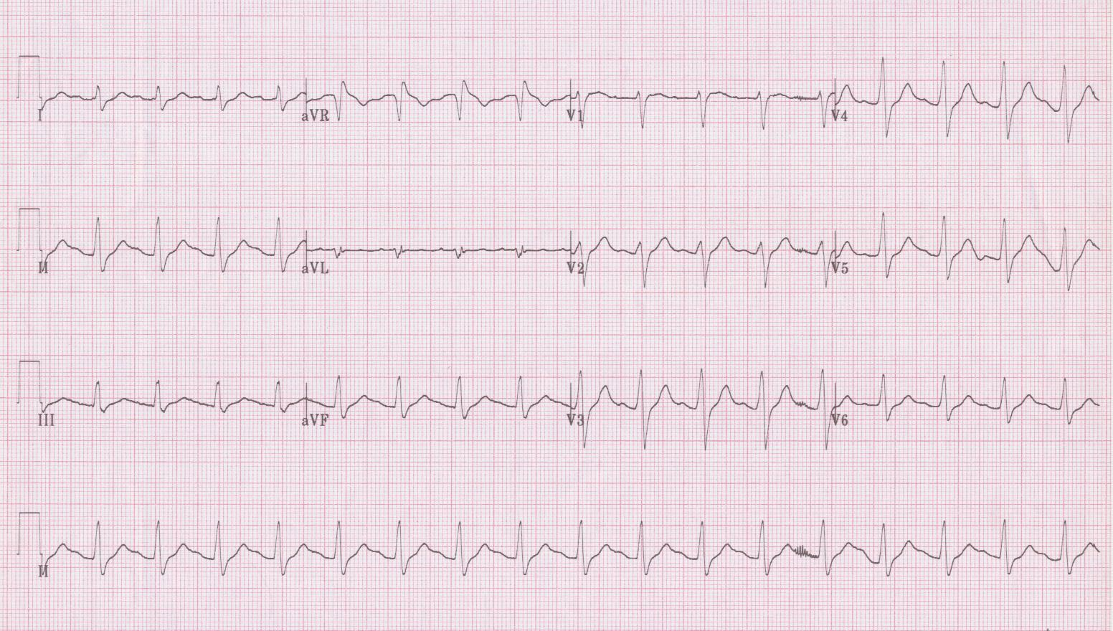

Discussion of 20 EKGs you should know…

1. While posterior MI is commonly associated with an inferior MI, posterior wall infarction can occur in isolation – a result of occlusion of the circumflex artery. The typical EKG changes of an acute isolated posterior MI are important to recognize as these patients will not meet criteria for acute intervention, but will benefit from thrombolysis or emergent angioplasty. Earliest EKG changes include ST-segment depression in leads V₂₋₄, followed by upright T waves and the development of tall R waves (especially in V₁₋₂).
- Brady WJ, Erling B, Pollack M, et al. Electrocardiographic manifestations: acute posterior wall myocardial infarction. J Emerg Med 20:391-401, 2001.

2. Wellens described the association of ST-segment depression in ≥8 leads and ST-segment elevation in lead aVR with acute occlusion of the left main coronary artery. Clinically these are patients whose outcome is not improved by medical management
- Lawner BJ, Nable JV, Mattu A. Novel patterns of ischemia and STEMI equivalents. Cardiol Clin 20:591-599, 2012.

3. Wellens also described characteristic EKG changes associated with critical stenosis of the proximal left anterior descending coronary artery – T wave changes in precordial leads (V₂₋₄). The changes are either deeply inverted T waves or biphasic T waves in these anterior leads, occurring in the pain-free interval after chest pain typical for ischemia. These patients often have an essentially normal EKG on presentation, with no ST-segment elevation or Q waves, and negative serum markers. The natural history of this finding, unfortunately, is an anterior MI usually within weeks of presentation, despite medical management.
- Rhinehardt J, Brady WJ, Perron AD, et al. Electrocardiographic manifestations of Wellens’ Syndrome. Am J Emerg Med 20:638-643, 2002.
- Tandy TK, Bottomy DP, Lewis JG. Wellens’ Syndrome. Ann Emerg Med 33:347-351, 1999.

4. Accelerated idioventricular rhythm (AIVR) is the most frequent reperfusion arrhythmia after infarction. It is a wide-complex rhythm, typically occurring at rates between 70-100/minute. It is nonparoxysmal, that is it frequently competes with sinus rhythm with fusion beats seen as the rhythm transitions.
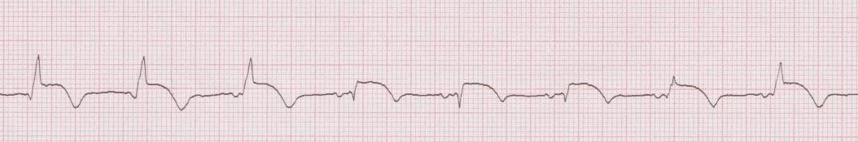
Rhythm strip from EKG #4 – the first 3 beats are AIVR, notice the emergence of a P wave just before the 3rd beat, beats 4-6 are sinus, and the 7th beat is a good example of a fusion beat as AIVR reappears (it is a combination of sinus and AIVR complexes).

5. Pericarditis is associated with repolarization changes in both the atria and ventricles as a result of epicardial inflammation. The first EKG changes of acute pericarditis include diffuse ST-segment elevation (with ST-segment depression often seen in aVR and V₁) and PR-segment depression (especially in II, with PR-segment elevation often noted in aVR).
- LeWinter MM. Percarditis – clinical review. NEJM 371:2410-16, 2014.

6. Brugada syndrome is the association of life-threatening ventricular arrhythmias with a characteristic EKG pattern. This genetic disorder is caused by cardiac Na-channel mutations and manifests in the 4th – 5th decades of life. The EKG includes a peculiar downsloping ST-segment elevation in V₁₋₂ (which has been described as RBBB-like, but it has only this J point elevation in the right precordial leads without findings of classic RBBB). If this finding is associated with a history of syncope or a family history of sudden death, these patients require electrophysiologic study and an AICD (antiarrhythmic medications have not proved beneficial).
- Antzelevitch C, Brugada P, Borggrefe M, et al. Brugada syndrome – report of the second consensus conference. Circ 111:659-670, 2005.
- Junttila MJ, Gonzalez M, Lizotte E, et al. Induced Brugada-type electrocardiogram, a sign for imminent malignant arrhythmias. Circ 117:1890-1893, 2008.

7. While many EKG changes are associated with acute pulmonary embolus, including S₁Q₃T₃ and a new RBBB, these findings are neither sensitive not specific. One useful sign of massive PE is negative T-waves in the anterior precordial leads, typically V₁₋₃.
- Ferrari E, et al. The ECG in pulmonary embolism: predictive value of negative T waves in precordial leads – 80 case reports. Chest 111:537, 1997.

8. EKG changes can be associated with acute CNS events, especially subarachnoid hemorrhage and intracerebral hemorrhage. The changes typically appear as diffuse T wave inversion, and may be impressively deep. The T wave inversion is often asymmetric with a characteristic outward bulge in the ascending portion. These changes may also be associated with prominent U waves and QT prolongation.
- Perron AD, Brady WJ. Electrocardiographic manifestations of CNS events. Am J Emerg Med 18:715- 720, 2000.
- Hanna EB, Glancy DL. ST-segment depression and T-wave inversion: classification, differential diagnosis, and caveats. Clev Clin J Med 78: 404-414, 2011.

9. A tall T wave (T wave > S wave) in lead V₁ can be caused by 4 things: 1) RBBB – associated with prolonged QRS and a wide terminal S wave in lateral leads (I, aVL, V₆), 2) right ventricular hypertrophy – associated with right axis deviation, 3) Wolff-Parkinson-White, type A – associated with short PR interval and delta wave, and 4) a prior posterior wall MI – typically associated with evidence of a prior inferior MI. In this EKG, the tall R wave in V₁ is associated with Q waves in the inferior leads, although the Q waves are small and difficult to appreciate. The complexes in the limb leads are all small, because this EKG represents a subacute inferior-posterior MI with myocardial rupture and subsequent tamponade.

10. Pacemaker failure secondary to battery depletion. There is failure of both sensing (pacemaker spikes occur near or on the T waves) and capture (pacer spikes which do not produce a QRS). The underlying rhythm is complete heart block with an atrial rate of 75/minute and a ventricular escape rate of 24/minute, likely the reason this woman got a pacemaker originally!
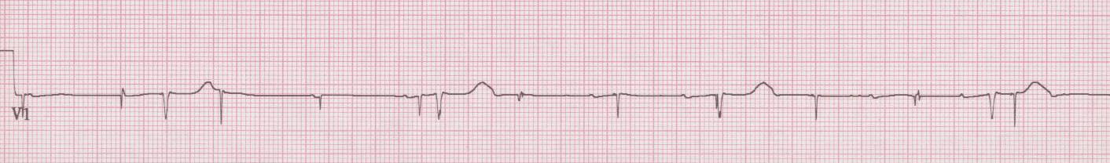
3 separate rhythms - ventricular escape at 24/minute, P waves at 75/min, and pacer spikes at 72/min.

11. Narrow-complex and regular tachycardia at 150/minute. A rate of 150/minute should be a reminder that atrial flutter (with flutter waves occurring at 300/minute) presents with a physiologic 2:1 AV block, producing a rate of 150. With this clue, it is possible to see the “saw-tooth” flutter waves underlying the QRS complexes, especially in the inferior leads (II, III, aVF).

12. Wide-complex tachycardia, that is irregularly irregular – atrial fibrillation with a pre-existing bundle-branch block, aberrant conduction, or proceeding down a bypass tract of WPW. The last option is suggested because of the extremely rapid conduction (note the ventricular response ≥ 300/minute). You must avoid AV node blocking agents typically used for atrial fib: Adenosine, β-blockers, Calcium-channel blockers, and Digoxin. These agents will increase conduction down the accessory pathway, and may precipitate ventricular fibrillation. Treat with procainamide or electricity; amiodarone remains controversial
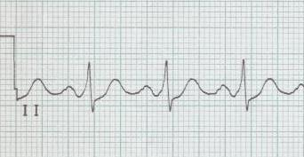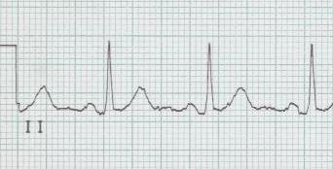
WPW rhythm strip after conversion after ablation – no more bypass!

- Fengler BT, Brady WJ, Plautz CU. Atrial fibrillation in the Wolff-Parkinson-White syndrome: ECG recognition and treatment in the ED. Am J Emerg Med 25:576-583, 2007.

13. Supraventricular tachycardia (SVT) at 180/minute. While it is often impossible to say whether the re-entry circuit of SVT is utilizing two paths within the AV node (AVNRT) or the AV node and a bypass tract of WPW (AVRT), this EKG has two findings that strongly suggest AVNT and underlying WPW. There is QRS alternans (seen best in lead III) and there is a retrograde P wave at a substantial distance from the QRS (seen in V₁₋₂).
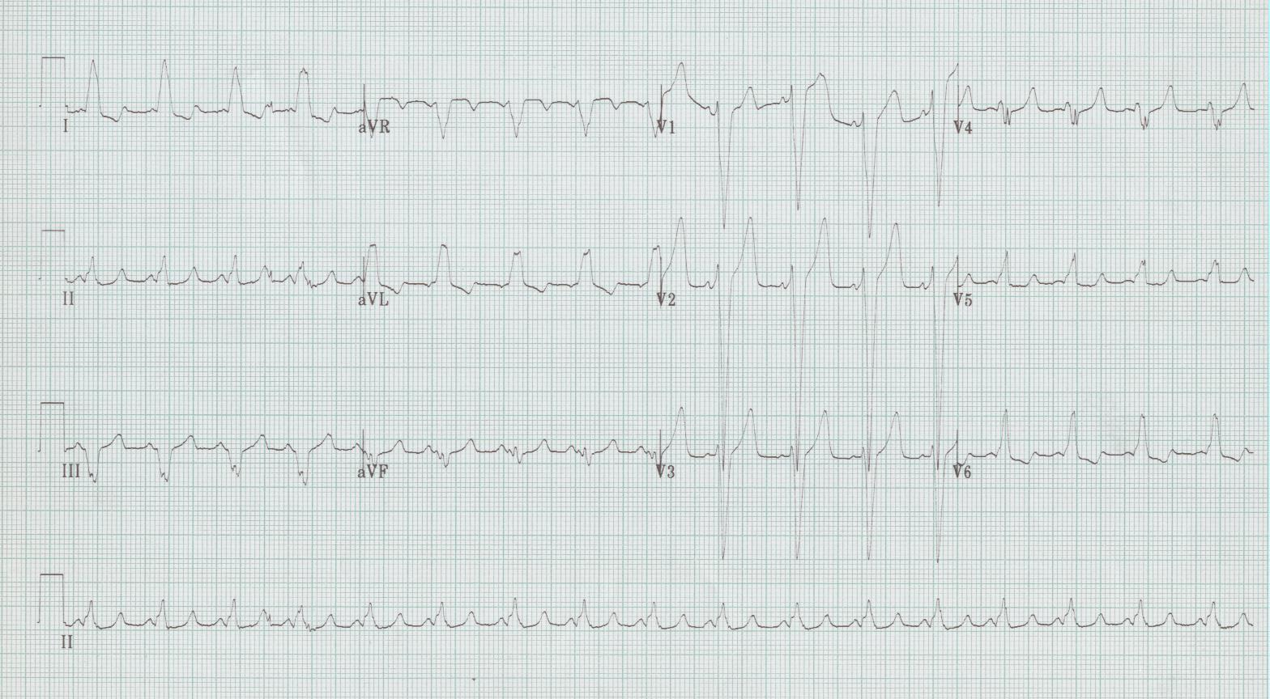

EKG of same patient after conversion to sinus rhythm. Now WPW becomes apparent (look especially in lead V₂).
- Fox DJ, Tischenko A, et al. Supraventricular tachycardia: diagnosis and management. Mayo Clin Proc
83:1400-1411, 2008.
14. The most common cause of a pause during sinus rhythm is a blocked PAC. Notice that the T wave of the complex preceding the pause is different from others – it is deformed by an early atrial depolarization, so early that the conduction system is still refractory and doesn’t conduct. Like all PACs, however, the sinus metronome has been reset, causing the pause before the next normal beat.
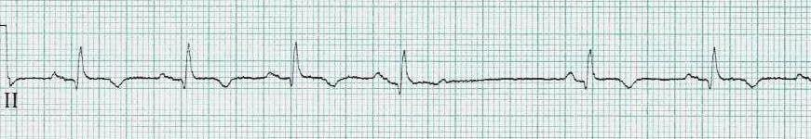

15. While the three wide-complex and rapid beats certainly look like ventricular beats, there may be another explanation. These are aberrantly conducted supraventricular beats and Ashman described the scenario that predicts this phenomenon many years ago. Repolarization of a given beat is proportional to the R-R interval that precedes it. Thus in an irregular rhythm like atrial fibrillation, if a relatively long R-R interval is followed by a short interval, the complex ending the short interval is more likely to find a portion of the conducting system refractory. The RBBB is the slowest to repolarize, so aberrancy is typically a RBBB pattern (tall R wave in lead V₁)
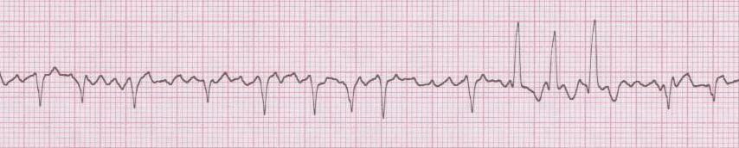
V₁ rhythm strip. Just remember… LONG - SHORT – WEIRD

16. EKG changes of hyperkalemia are important to recognize so treatment can be promptly begun. Changes are progressive in a predictable way, but there is unfortunately little correlation between changes and specific potassium levels. The first changes seen are peaked T waves (narrow-based and symmetrical), then prolongation of the QRS complex and diminution of the P wave. These changes progress until a “sine” wave heralds impending cardiac collapse. [This patient’s K⁺ was 7.4 mEq and was treated with calcium, sugar and insulin, and urgent dialysis.]
- Weisberg LS. Management of severe hyperkalemia. Crit Care Med 36:3246-3251, 2008.
- Freeman K, Feldman JA, Mitchell P, et al. Effects of presentation and electrocardiogram on time to treatment of hyperkalemia. Acad Emerg Med 15:239-249, 2008.

17. Severe hypokalemia produces characteristic EKG changes. As the potassium level decrease, U waves become apparent and the amplitude of the T waves diminish. At the extremes (often K < 2.0mEq), the ST-segment becomes depressed, the T wave absent and a generous U wave dominates the pattern. These changes have been called the “roller coaster” appearance of severe hypokalemia. While it may appear that there is significant prolongation of the QT interval, it is actually a long Q-U interval! [This elder woman on diuretic had a K⁺ of 1.7mEq.]

18. Hypercalcemia will produce a decrease in the QT interval, almost always < 400msec. Other visual clues to hypercalcemia include a noticeably prolonged T to next QRS interval and occasionally a change in T wave morphology with shortened Q-aT, or movement of the apex of the T wave toward the QRS. [This patient with lung cancer had a Ca⁺⁺ of 16mg/dL]
- Diercks DB, Shumaik GM, et al. Electrocardiographic manifestations: electrolyte abnormalities. J Emerg Med 27:153-160, 2004.
19. Hypothermia produces Osborne waves on the EKG. These waves will appear with core temperature < 32°. The magnitude of the Osborne wave correlates inversely with temperature.
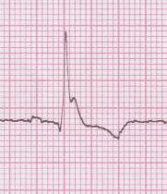 [Core temperature was 28°]

- Vassallo SU, et al. A prospective evaluation of the electrocardiographic manifestations of hypothermia. Acad Emerg Med 6:1121, 1999.

20. Tricyclic antidepressant toxicity produces predictable changes in the EKG, including: sinus tachycardia, prolongation of the QRS interval, prolongation of the QTc interval, and a rightward shift of the terminal 40msec of the QRS axis. The rightward shift of the terminal portion of the axis is demonstrated on the EKG by an increase in the amplitude of the R wave in lead aVR.

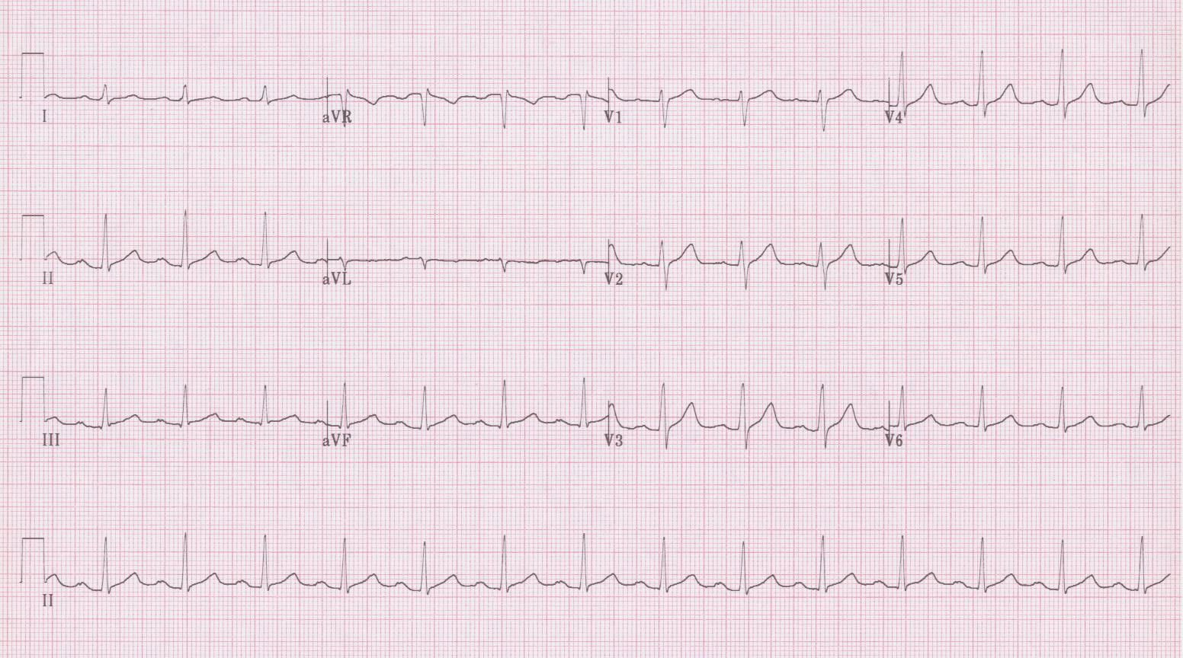
EKG of same patient 60 minutes later, after treatment with NaBicarb infusion. Though subtle, the QRS is more narrow and the R wave seen previously in aVR is gone.

- Harrigan RA, Brady WJ. ECG abnormalities in tricyclic antidepressant ingestion. Am J Emerg Med 17:387, 1999.
- Liebelt EL, Francis PD, Woolf AD. ECG lead aVR versus QRS interval in predicting seizures and arrhythmias in acute tricyclic antidepressant toxicity. Ann Emerg Med 26:195, 1995.

