Basic EKG Interpretation
…an introduction or a review

The graph paper
Time Voltage
1 small box = 0.04 sec 1 small box = 1 mm
1 large box = 0.20 sec 1 large box = 5 mm
1 large box = 200msec

Normal 12-lead EKG
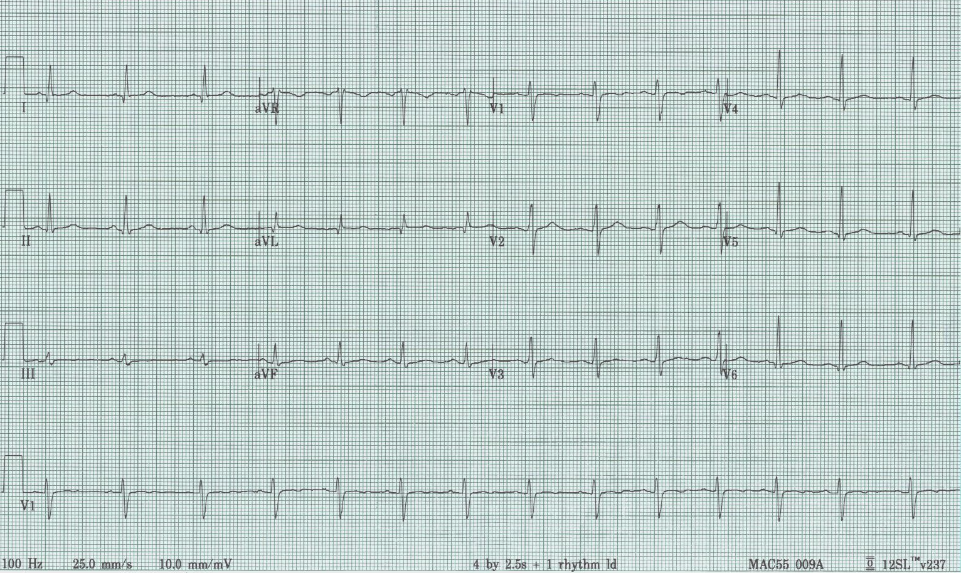
12-lead EKG = 6 limb leads + 6 chest leads, also a rhythm strip (either II or V1)

3 standard limb leads were the first

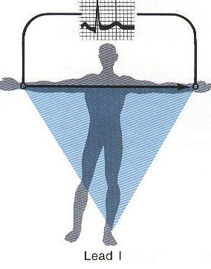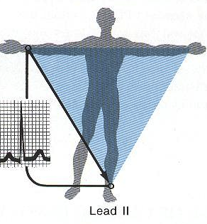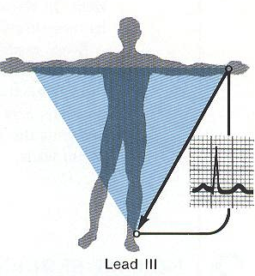

Then augmented leads
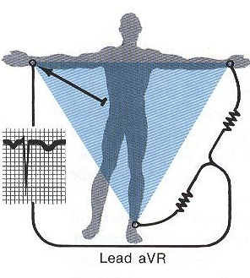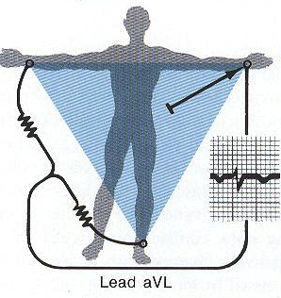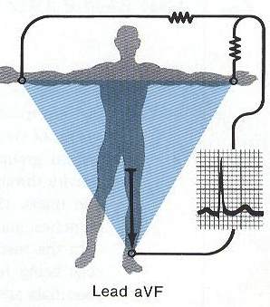

Finally chest leads
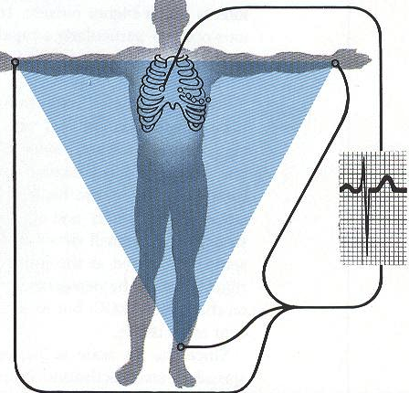

If current is moving toward a + electrode a positive wave is inscribed
If current is moving away from a + electrode a negative wave is inscribed
If current is perpendicular to + electrode an isoelectric line is inscribed

Rhythm

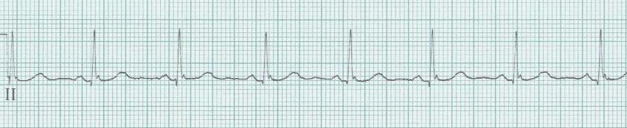
Sinus rhythm
- upright P wave before every QRS

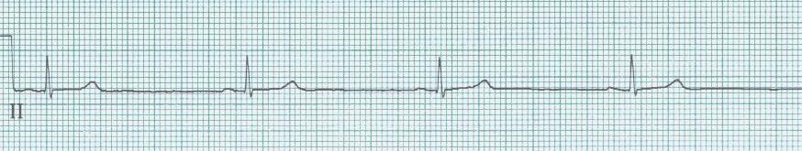
Sinus bradycardia

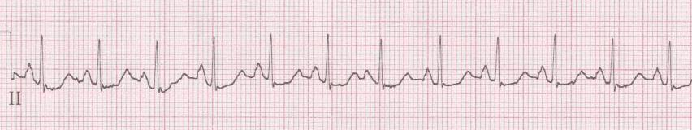
Sinus tachycardia

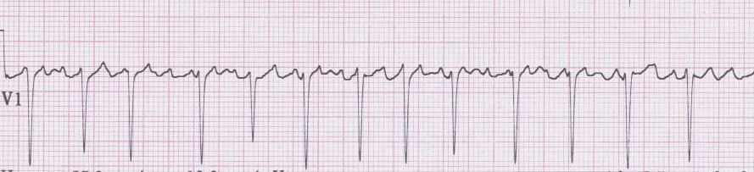
Atrial fibrillation with RVR (rapid ventricular response)
- irregularly irregular rhythm, fast if untreated

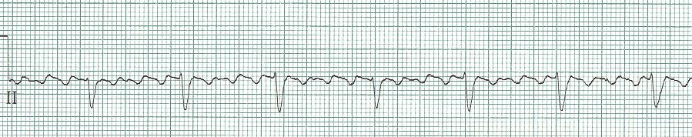
Atrial flutter with 4:1 conduction

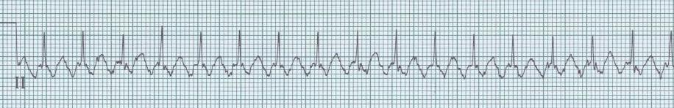
2:1 Atrial flutter (approx. rate of 150/min)

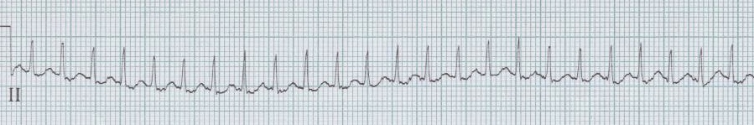
SVT at 180/minute

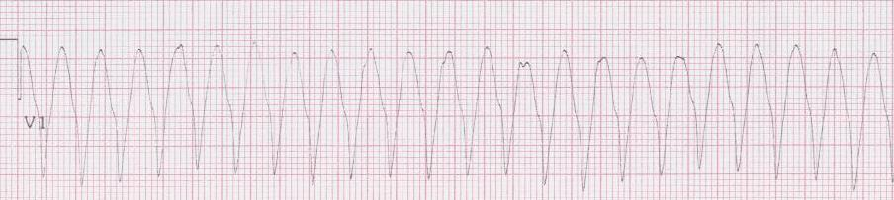
Ventricular tachycardia

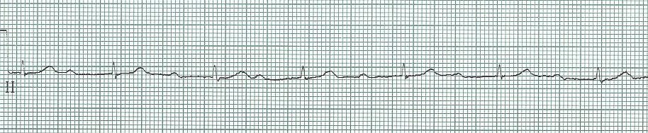
1° AV block

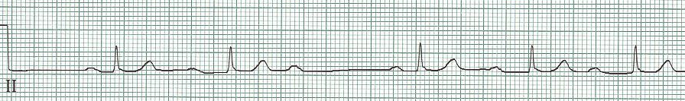
2° AV block, type I (Wenckebach)

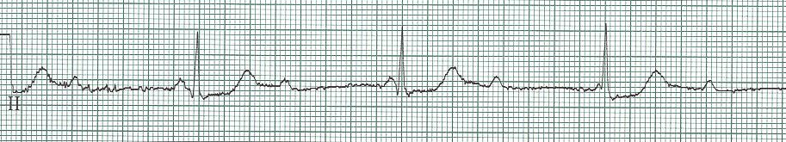
3° AV block (Complete heart block)
Rate
Rate rule – if R-R complexes are 1 large box apart, rate = 300/min. And 300 divided by the # of large boxes between complexes = the rate.

300 – 150 – 100 – 75 – 60 - 50

250 136 94 71
300 214 150 125 100 88 75 68 60 50 43
187 115 83 65
167 107 79 62

Axis
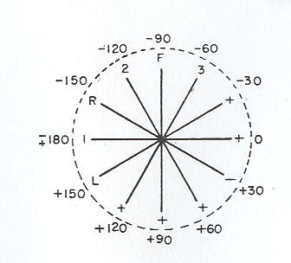

Intervals
PR – normal < 200msec (0.20sec) - see AV blocks under rhythms
1° - PR > 200msec
2° - there is a dropped beat (P with no following QRS)
type I – prolongation of each PR interval under beat is dropped
type II – one or more P waves with no following QRS
3° - P waves that do not conduct to ventricles, QRS at different rate

QRS – normal is 80-100msec (0.08-0.10 sec)
When prolonged in sinus rhythm (QRS >100 – 120msec)…
RBBB
LBBB
Severe LVH
Hyperkalemia
TCA toxicity
Wolff-Parkinson-White syndrome
Hypothermia

RBBB
- QRS ≥ 0.11s
- rSR´ in V₁ ( or, a tall R in V₁)
- wide terminal S wave in V₆ (and lateral leads)
LBBB
- QRS > 0.12s
- monophasic R wave in V₆
- absence of septal q waves

QT – varies, but proportional to the preceding R-R interval
- normal QTc should be ≤ 500msec or < ½ the preceding R-R

Chamber Enlargement
- Left ventricular hypertrophy
- deepest S in V₁₋₂ + tallest R in V₅₋₆ > 35mm, or
- R in aVL > 12mm (especially with left axis deviation)
- associated criteria
- strain pattern in lateral leads
- left axis deviation
- eventually, QRS widening and poor R wave progression

Right ventricular hypertrophy
- tall R wave in V₁
- right axis deviation

Right atrial enlargement
- tall, peaked P waves (> 2.5mm in II, III, or aVF)
- prominent positive initial deflection in V₁

Left atrial enlargement
- wide, notched P in I, II, or aVL (> 0.12s)
- large. negative terminal deflection in V₁

Ischemia and Infarct

Evolution of transmural MI

- hyperacute T waves
  - within minutes after onset of acute occlusion
  - transient
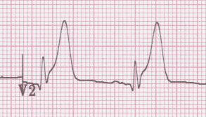

- giant R waves
  - “tombstones”
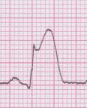

- ST segment elevation
  - begin to decrease within 6 hours after onset (faster after reperfusion)
  - most subside within few days – if persist after weeks consider aneurysm
  - may see reciprocal changes in opposite leads

- T wave inversion
  - begin to develop as ST segments return to baseline
  - remain for days to weeks
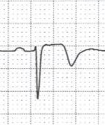

- abnormal Q waves
  - begin to develop in 6-12 hours, sooner with intervention
  - usually persist indefinitely

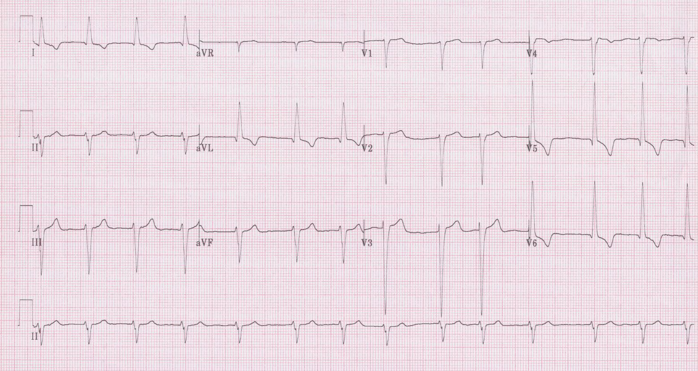
1

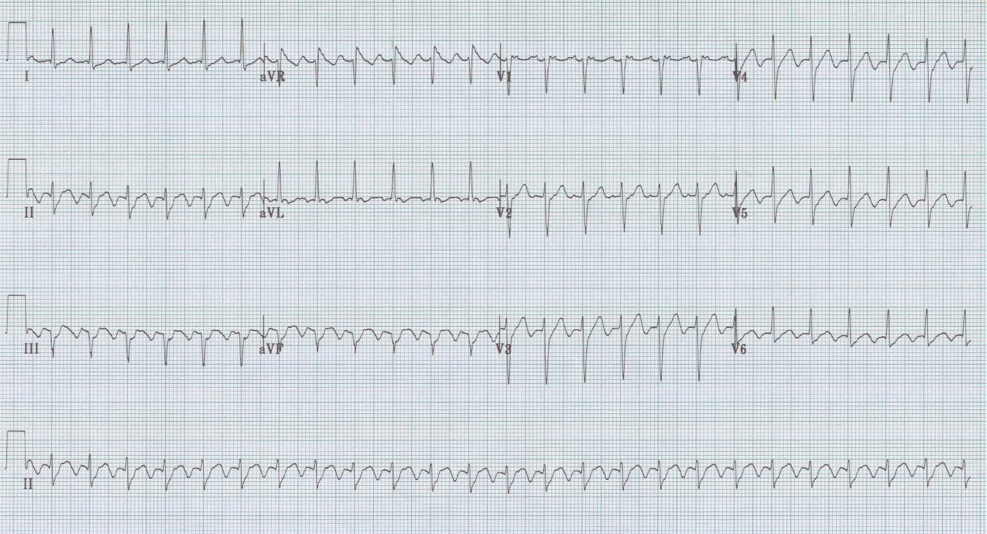
2

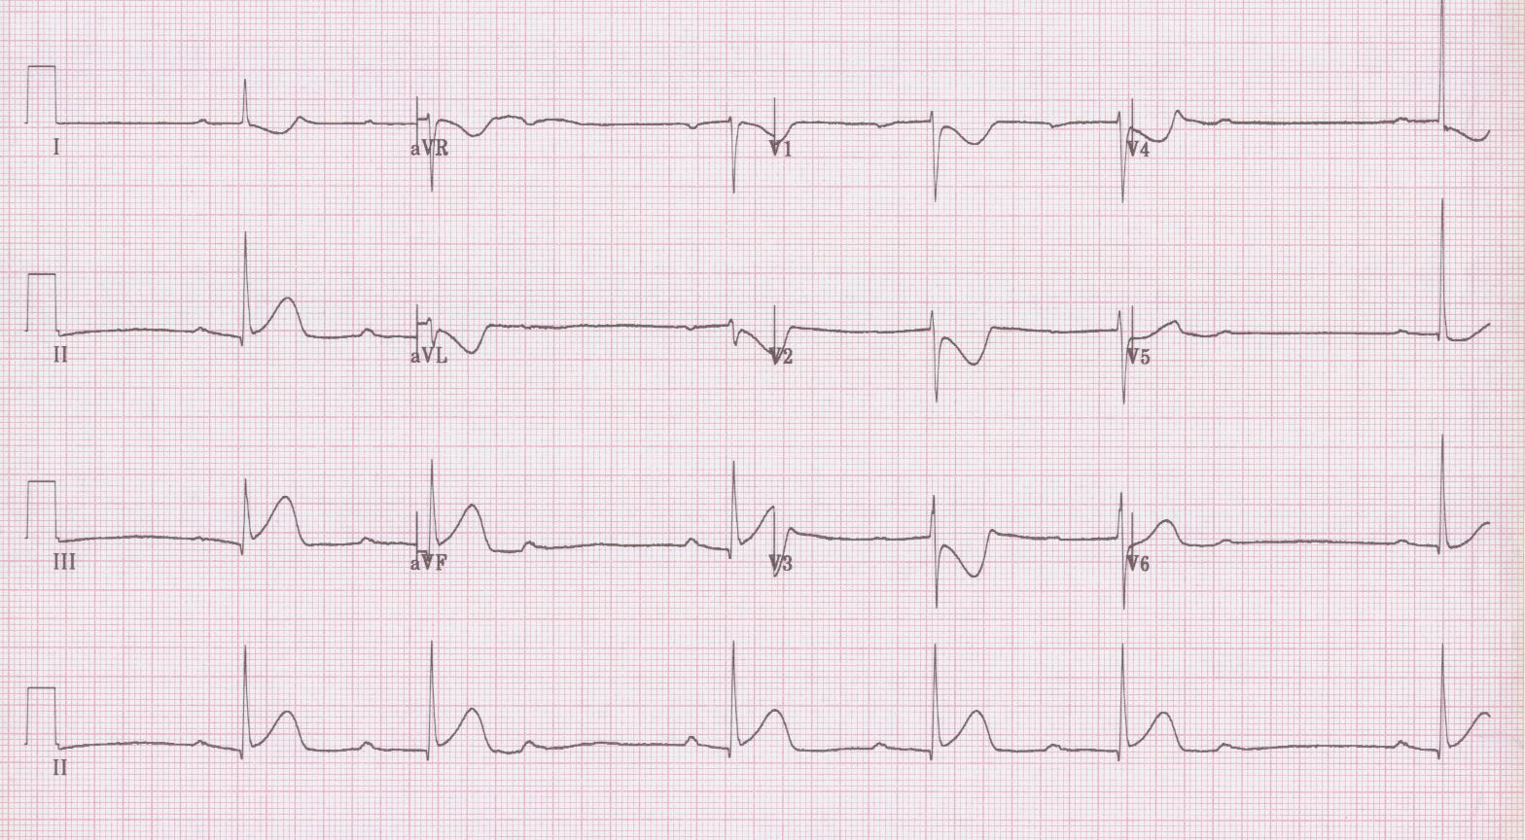
3

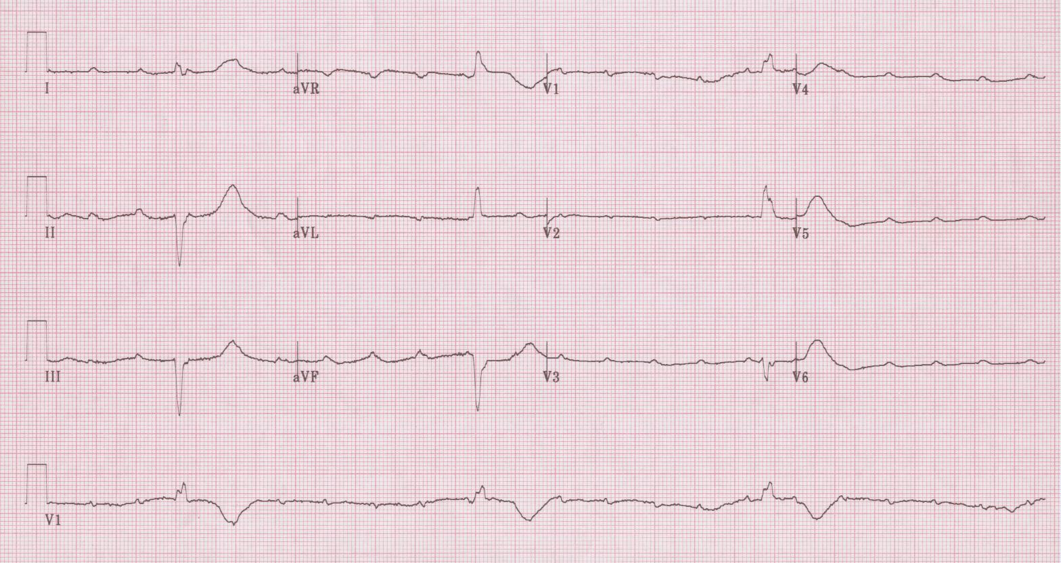
4

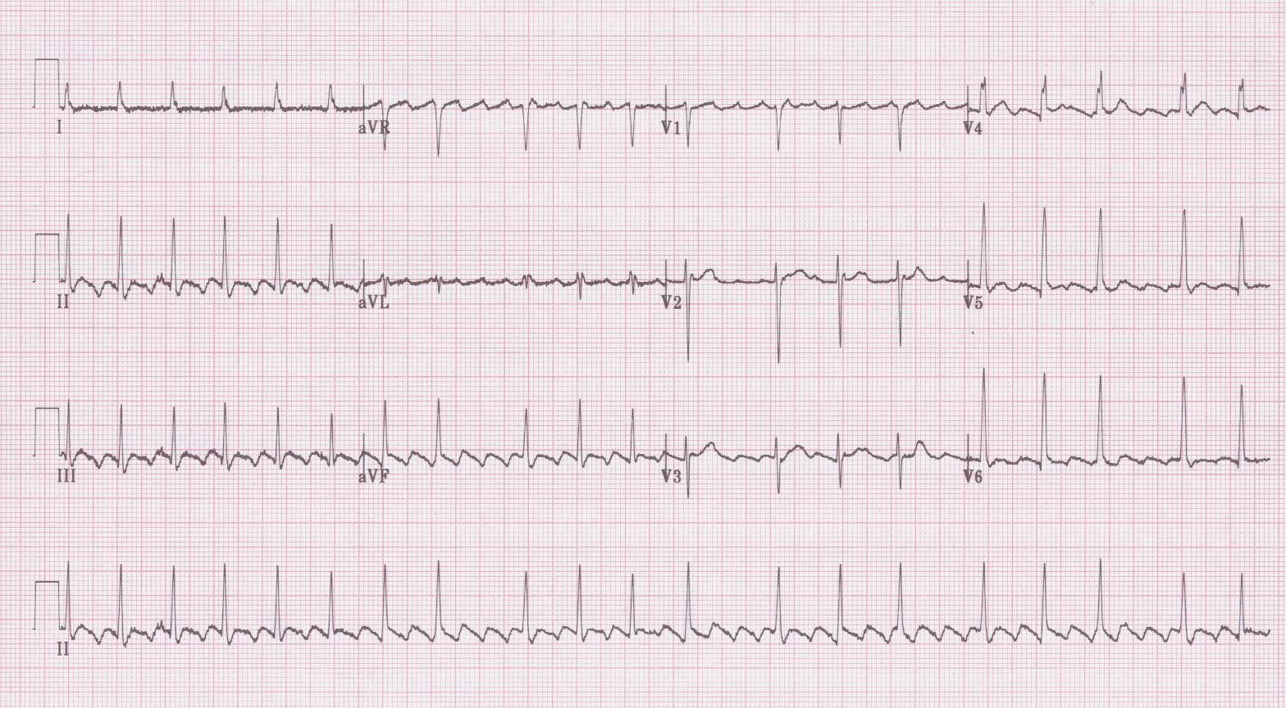
5

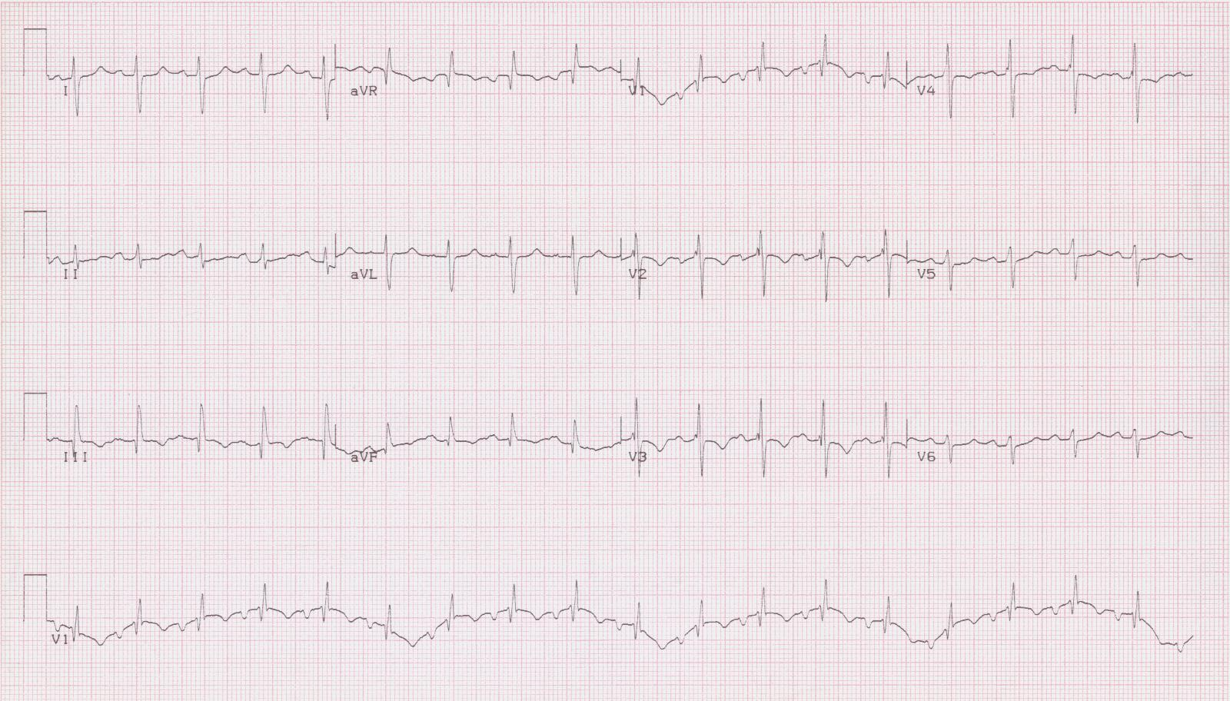
6

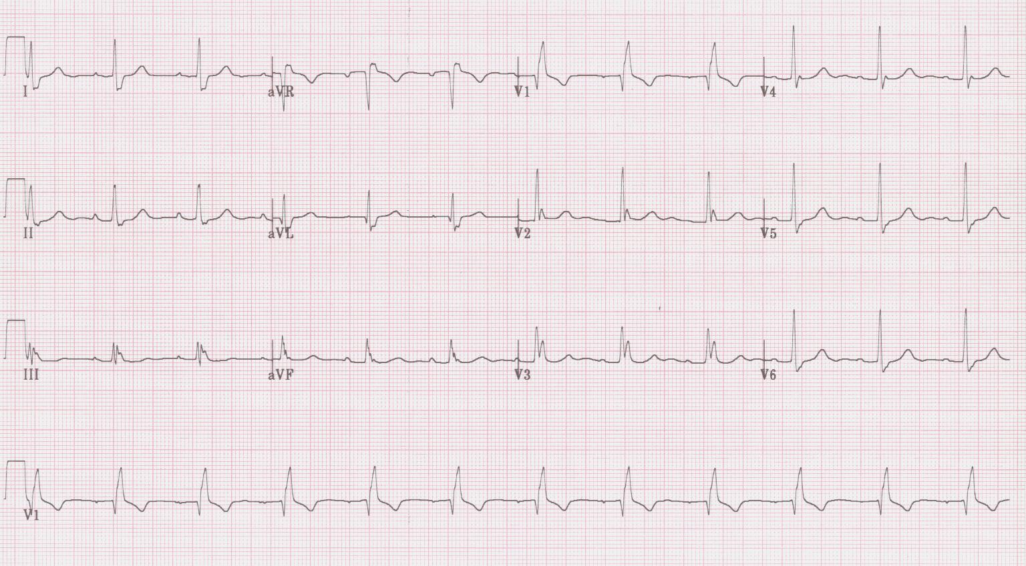
7

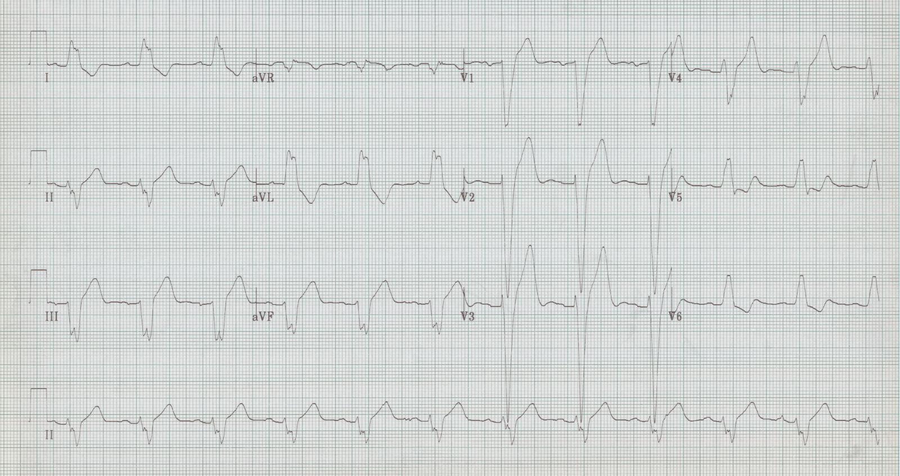
8

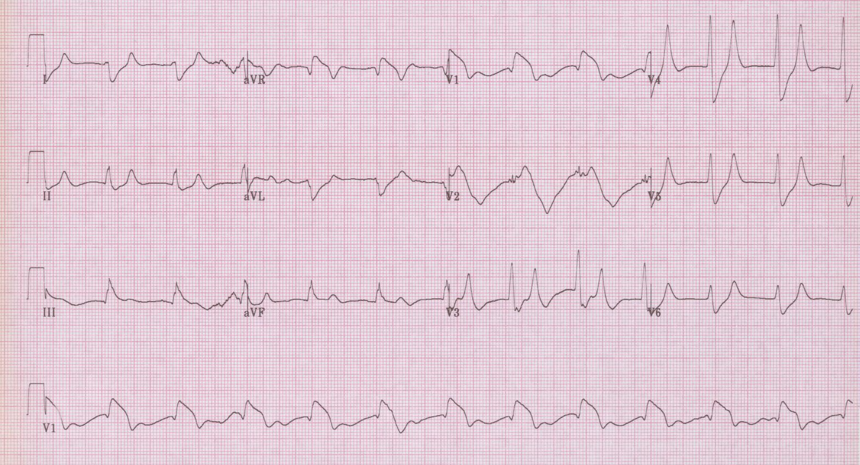
9

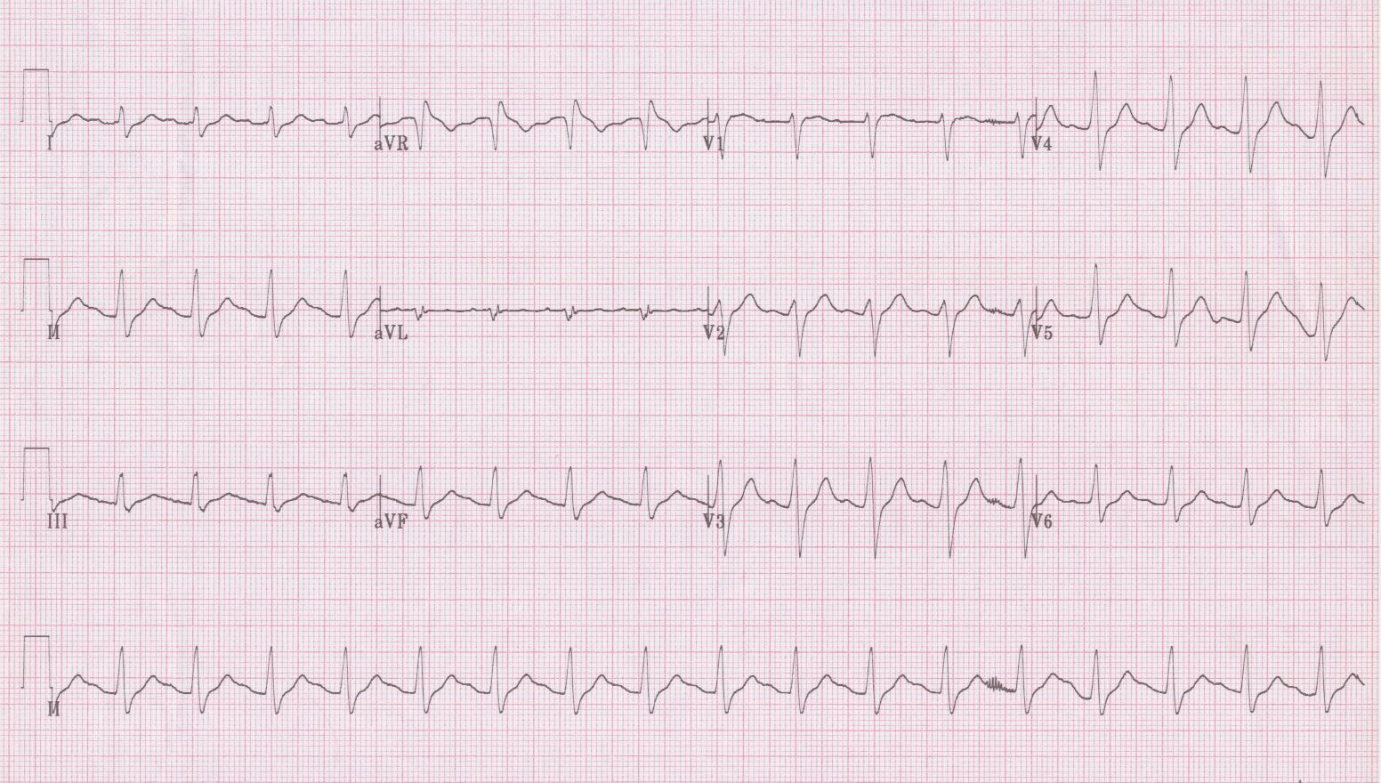
10

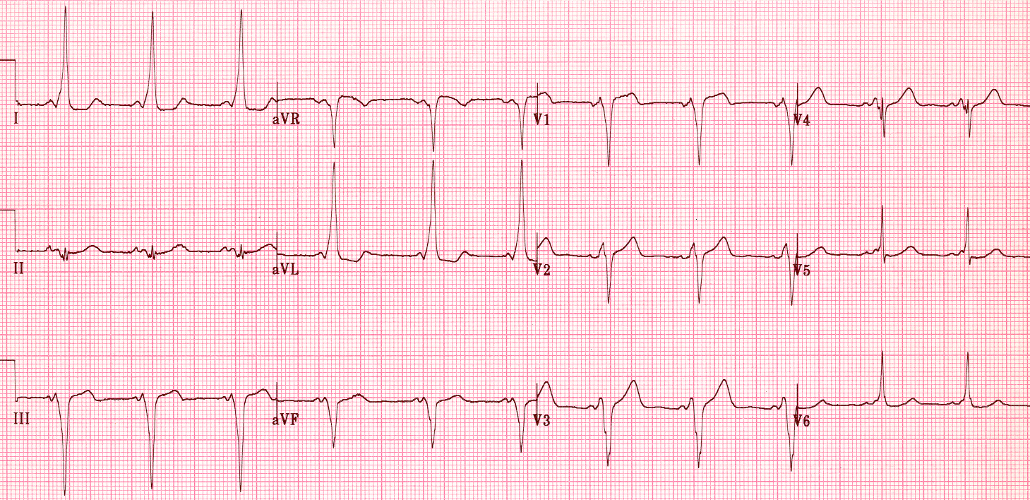
11

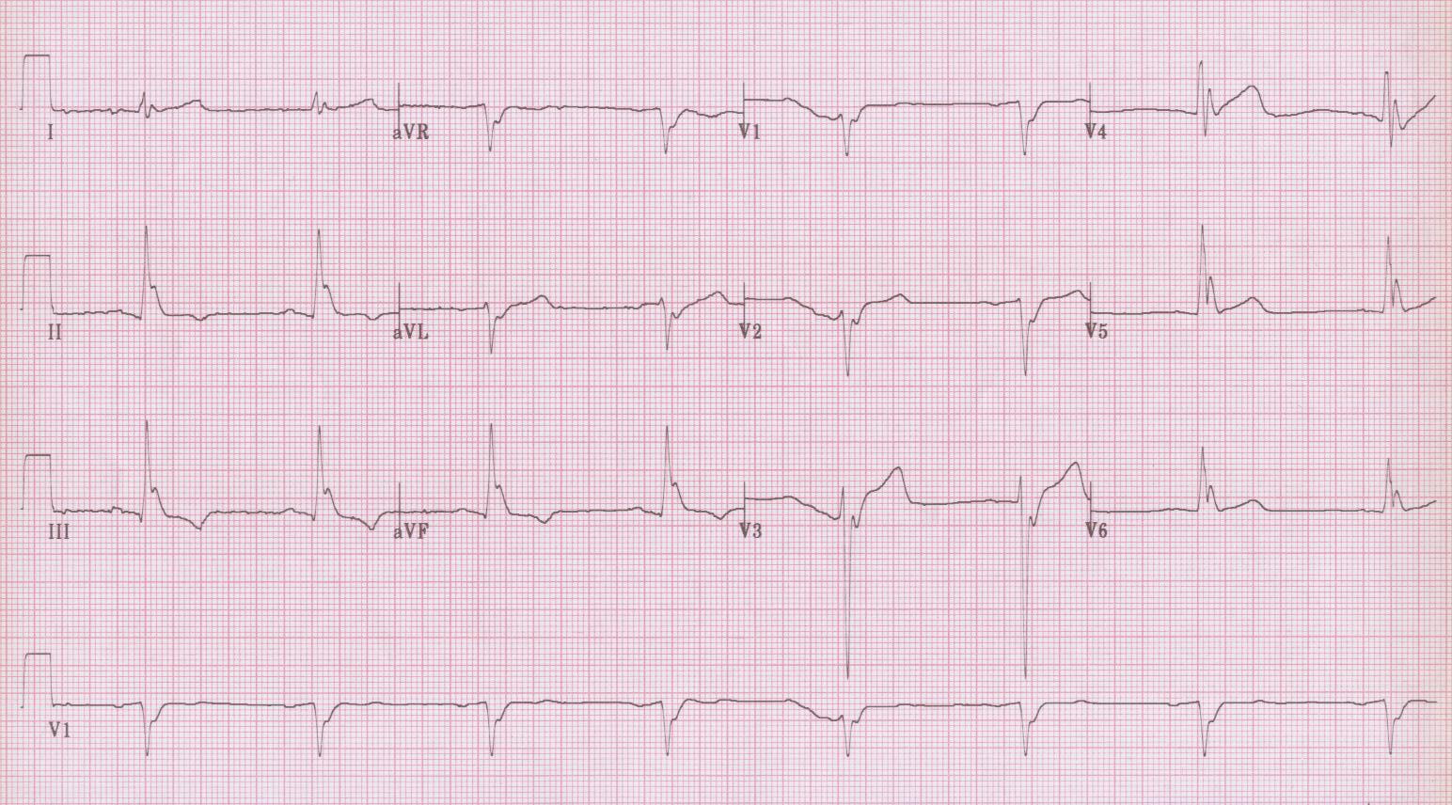
12

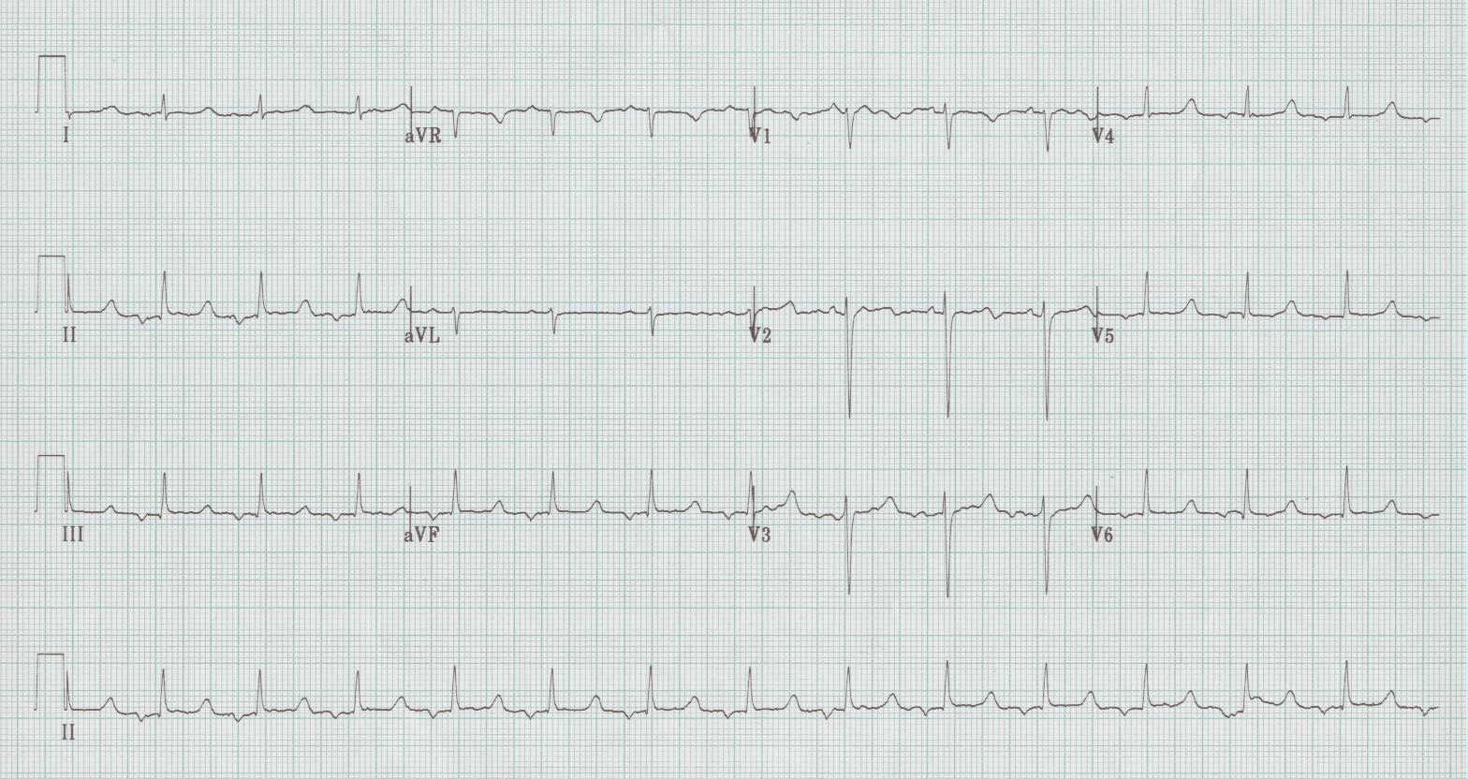
13

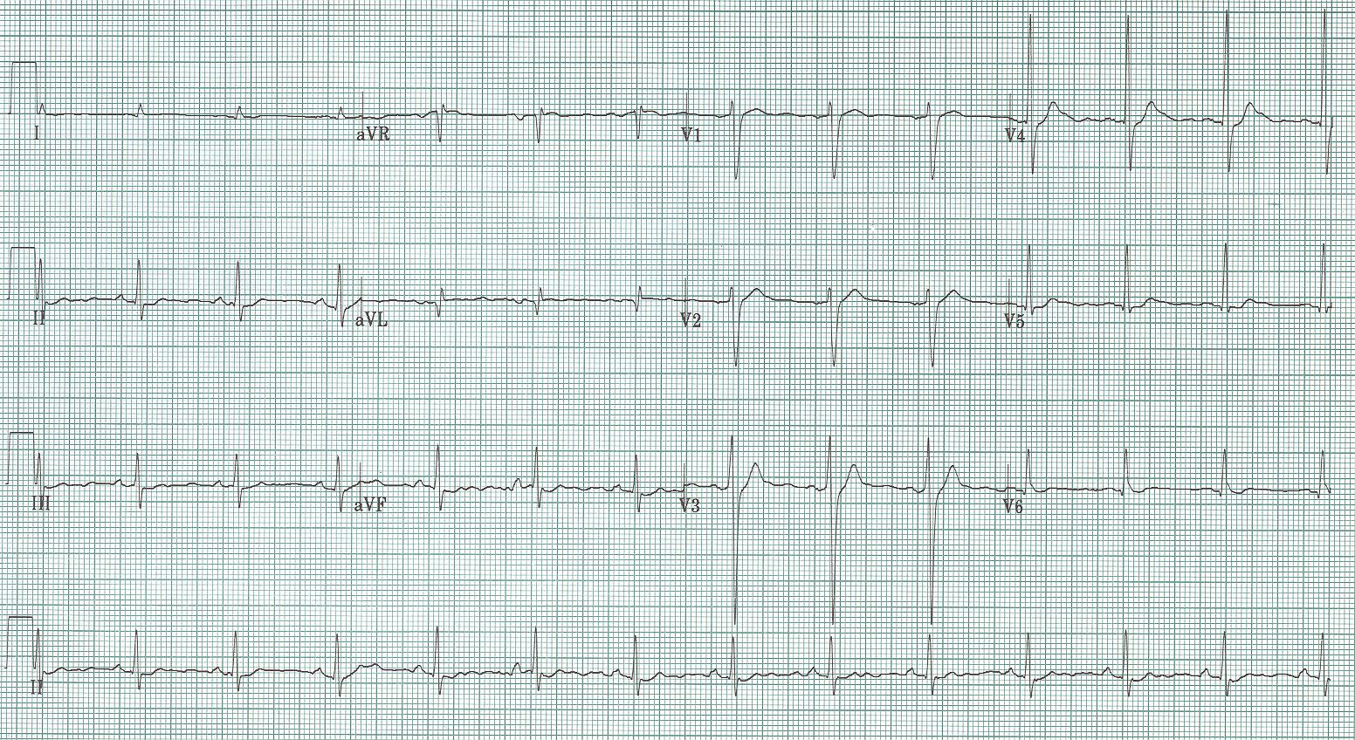
14

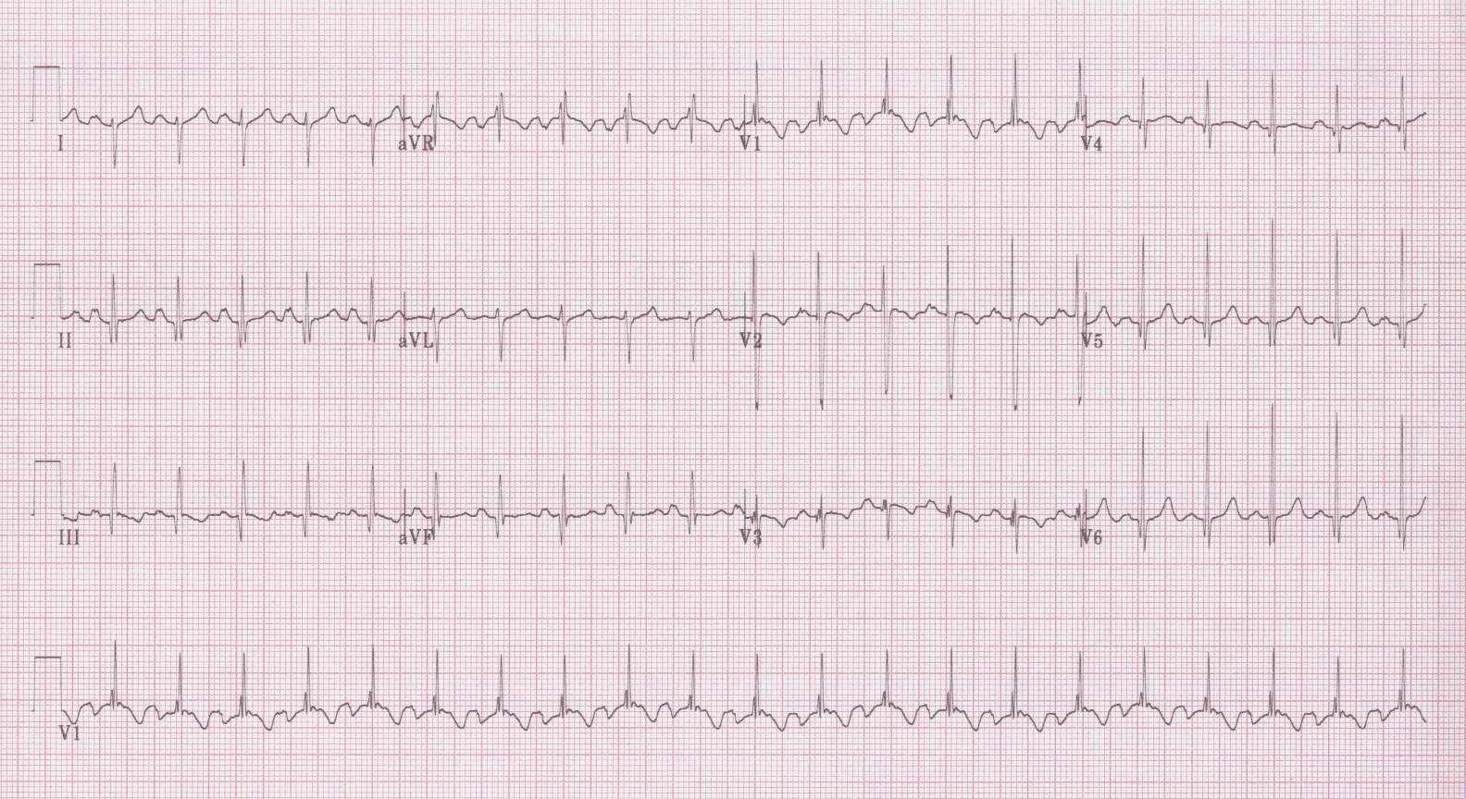
15

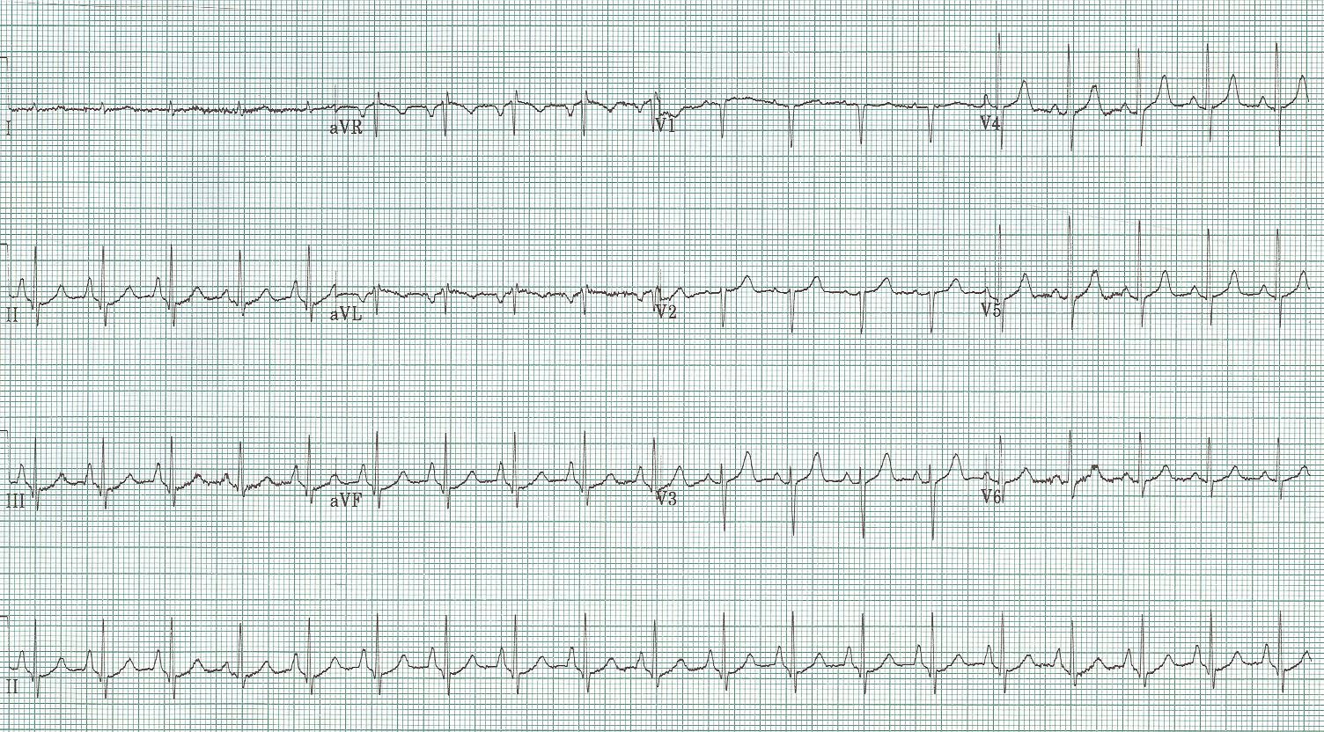
16

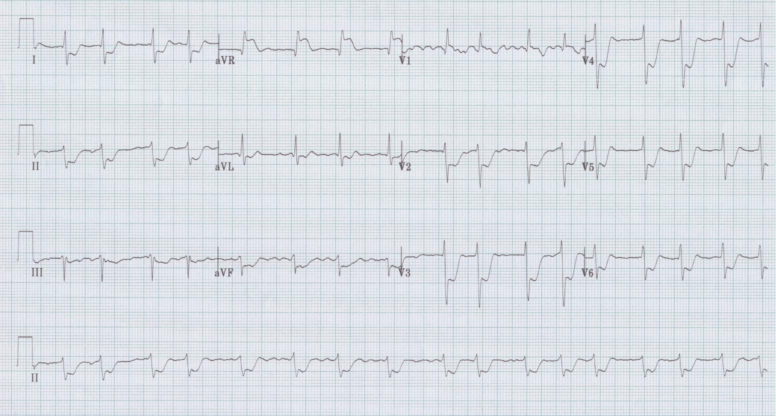
17

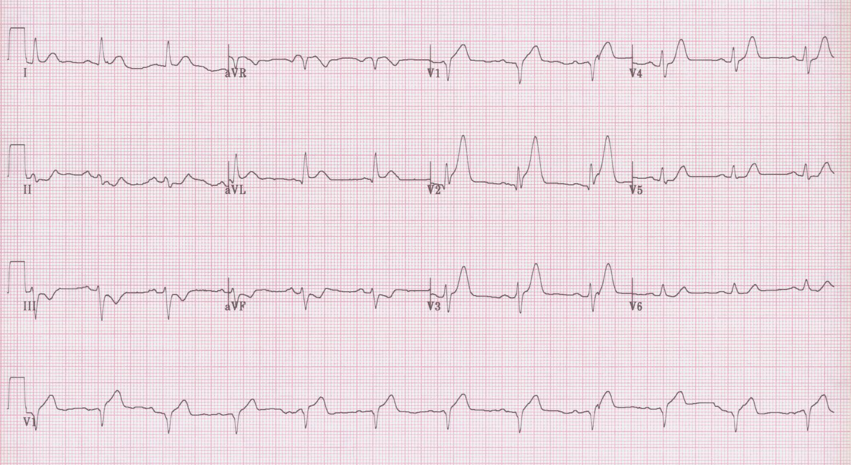
18

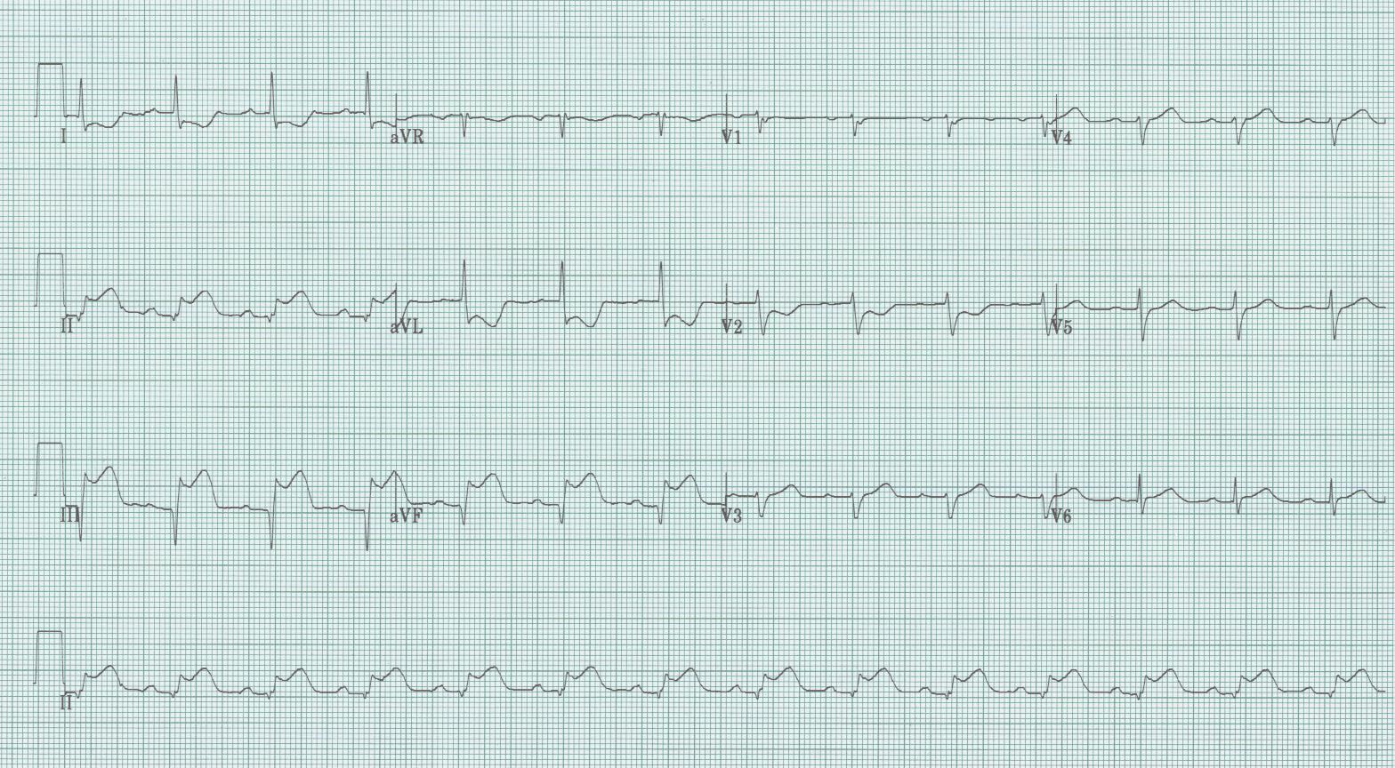
19

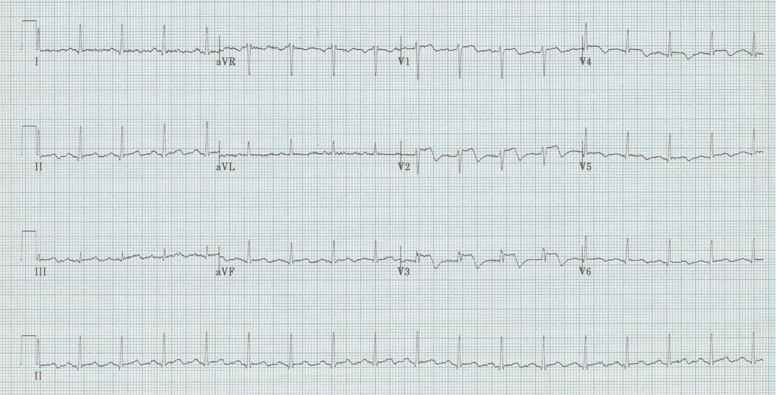
20

Interpretation and discussion points for EKGs

- Atrial fibrillation with ventricular response of 84/minute, left axis deviation (-60°), QRS slightly wide at 110msec, voltage for LVH with many associated findings – strain pattern of T wave inversion laterally, left axis, prolonged QRS, poor R wave progression
- Narrow-complex tachycardia at 150/minute 2:1 flutter
- 2° AV block, type I (Wenckebach), heart rate 36/min. hyperacute T waves inferiorly (II, III, aVF) and reciprocal changes V1-3 (?posterior infarct) – an acute inferior-posterior STEMI
- 3° AV block (complete heart block) with ventricular escape 18/minute. Note – P waves at 130/minute but not communicating to ventricles
- Atrial flutter with variable block, average rate 120/min, axis normal, QRS and QT normal.
- Sinus at 108/min, right axis deviation, tall R in V1 Right Ventricular Hypertrophy (RVH)…in a person with pulmonary hypertension.
- Sinus at 72/minute, normal axis, QRS wide at 0.12sec with tall R wave in V1 RBBB, also wide terminal S wave in I, aVL, and V6; no ischemia
- Sinus at 66/min, left axis deviation, QRS 0.16sec with tall monophasic R wave in I, aVL, and V6 LBBB with plenty of expected repolarization changes like ST elevation in V1-3 and ST depression, T wave inversion in I, aVL, and V5-6.
- Rate 72/minute, probably sinus but no obvious P waves; wide QRS with peaked T waves V3-5 severe hyperkalemia.
- Sinus tachycardia at 102/min, normal axis, QRS slightly wide at 0.11sec, QT wide, R wave in aVR ≥ 3mm TCA toxicity
- Sinus at 66/min, axis -30°, PR short (0.12sec), QRS wide, and delta wave between the P and QRS Wolff-Parkinson-White syndrome/
- Sinus bradycardia at 48/min, normal axis, QRS wide with added wave at end of QRS complexes – the Osborne wave of hypothermia.
- Rate 78/min, P waves are inverted in inferior leads (II, III, and aVF) suggesting a junctional or low atrial ectopic focus; normal PR and QRS intervals, prolonged QT interval – a patient with new renal failure and hypocalcemia.
- Sinus at 84/minute, normal axis, PR and QRS are normal, QR interval is very short hypercalcemia (in a patient with metastatic adenoCa and hypercalcemia).
- Sinus at 126/min, right axis deviation, intervals normal, tall R in V1 with right axis RVH; also note wide R in II and terminal P inversion in V1 (left atrial enlargement); RVH and LAE mitral stenosis
- Sinus at 114/min, axis 90°, tall peaked P waves in inferior leads (II, III, avF) consistent with “P pulmonale” or right atrial enlargement; also the essentially isoelectric complexes in I are consistent with COPD.
- Atrial fibrillation at 102/min, diffuse ST segment depression in multiple leads diffuse ischemia in a patient with left main stenosis.
- Sinus at 72/min, axis -30°, intervals normal, hyperacute T waves in V2-4 with reciprocal changes (ST depression and T wave inversion) in inferior leads (II, III, aVF) an acute anterior MI.
- Sinus at 84/min, axis normal, intervals normal, ST segment elevation in II, III, and aVF with reciprocal ST segment depression in I and aVL consistent with acute inferior MI.
- Sinus at 108/min, normal axis, intervals normal, ST elevation in V1-4 with biphasic T waves – an evolving transmural infarct.

This handout and the PowerPoint presentation is on a new website: www.TorreyEKG,com
-- follow new posts to the website with @STorreyMD

