EKG Interpretation – the basics

250 136 94 71
Rate 300 214 150 125 100 88 75 68 60 50 43
187 115 83 65
167 107 79 62

Axis
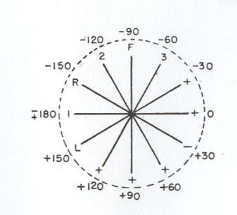

Right axis deviation Left axis deviation
- left posterior hemiblock - left anterior hemiblock
- right ventricular hypertrophy - LBBB
- acute cor pulmonale (eg PE) - left ventricular hypertrophy
- limb-lead reversal - elevated diaphragm (ascites)
- dextrocardia - inferior infarct (lg Q in aVF)

Intervals

PR < 200ms

1° AV block PR interval ≥ 200ms
2° AV block dropped beats (P wave without conduction)
Type I (Wenckebach) – progressive lengthening PR interval
Type II – intermittent loss of AV conduction
3° AV block complete loss of AV conduction with escape beats

QRS < 120ms

Bundle branch blocks
- RBBB
- QRS > 110ms
- rSR´ in V₁ (or, a tall R in V₁)
- wide terminal S wave in V₆ (and lateral leads)

- LBBB
- QRS > 120ms
- monophasic R wave in V₆
- absence of septal q waves in lateral leads

QT < ½ R-R interval that precedes it

↓QT hypercalcemia
↑QT hypocalcemia
hypokalemia (actually, ↑QU interval)

Chamber Enlargement

Left ventricular hypertrophy
- deepest S in V₁₋₂ + tallest R in V₅₋₆ > 35mm, or
- R in aVL > 12mm (especially with left axis deviation)

- associated criteria
- strain pattern in lateral leads
- left axis deviation
- then, QRS widening, poor R wave progression, ST elevation

Right ventricular hypertrophy
- tall R wave in V₁
- right axis deviation

Right atrial enlargement – “P-pulmonale”
- tall, peaked P waves (> 2.5mm in II, III, or aVF)
- prominent positive initial deflection in V₁

Left atrial enlargement – “P-mitrale”
- wide, notched P in I, II, or aVL (> 120ms)
- large, negative terminal deflection in V₁
Useful differentials to remember

QRS prolongation – (conduction – poisons – masqueraders)
- RBBB (beware other causes of tall R wave in V₁ – see below)
- LBBB (beware hypothermia and WPW type B)
- Severe LVH
- Na-channel blocker toxicity (eg TCA)
- Hyperkalemia
- Wolfe-Parkinson-White
- Hypothermia
(also: ventricular rhythms, like AIVR and ventricular paced)

Tall R wave in lead V₁ (tall T = T wave > S wave in that complex)
- RBBB - wide QRS
- RVH - right axis deviation
- Old posterior MI - old inferior MI
- WPW – type A - delta waves, short PR

ST-segment elevation
- STEMI
- LBBB
- Ventricular paced complex
- Severe LVH
- Pericarditis
- Benign early repolarization
- LV aneurysm
(also occasionally: acute PE, hyperK, SAH, HCM, and other case reports)

Impressive T-wave inversion
- Ischemia (NSTEMI)
- Vasospasm
- CNS event (esp SAH)
- Wellen’s syndrome
- Takotsubo cardiomyopathy
- Apical hypertrophic cardiomyopathy
- Post-ventricular pacing (“memory T waves”)

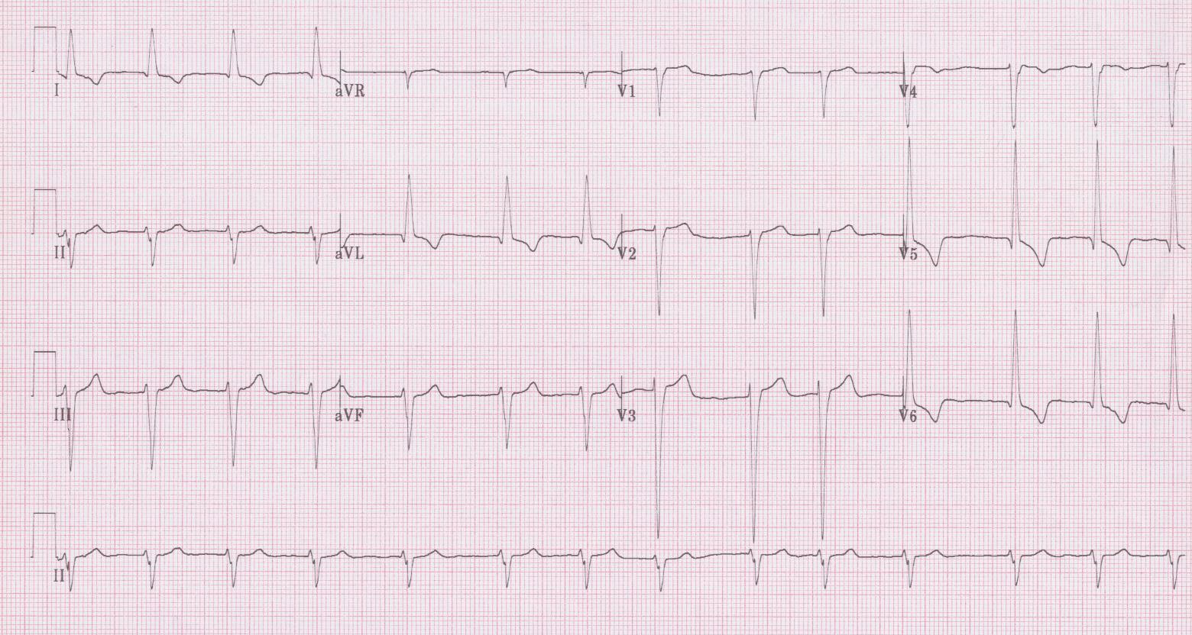
1.

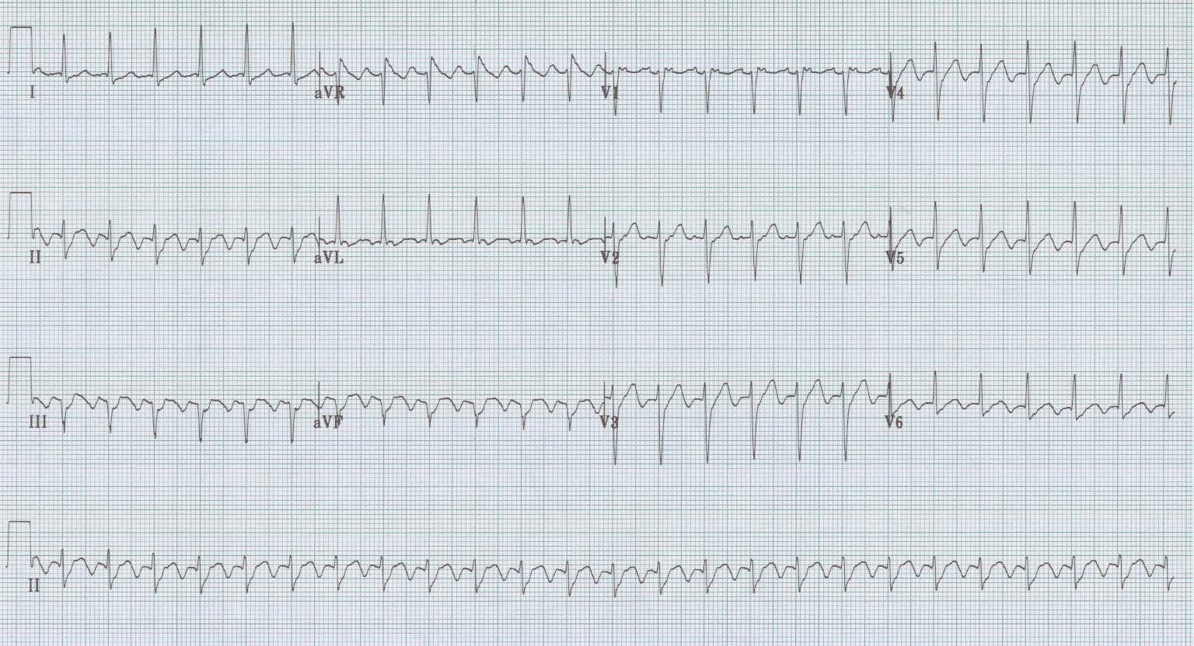
2.

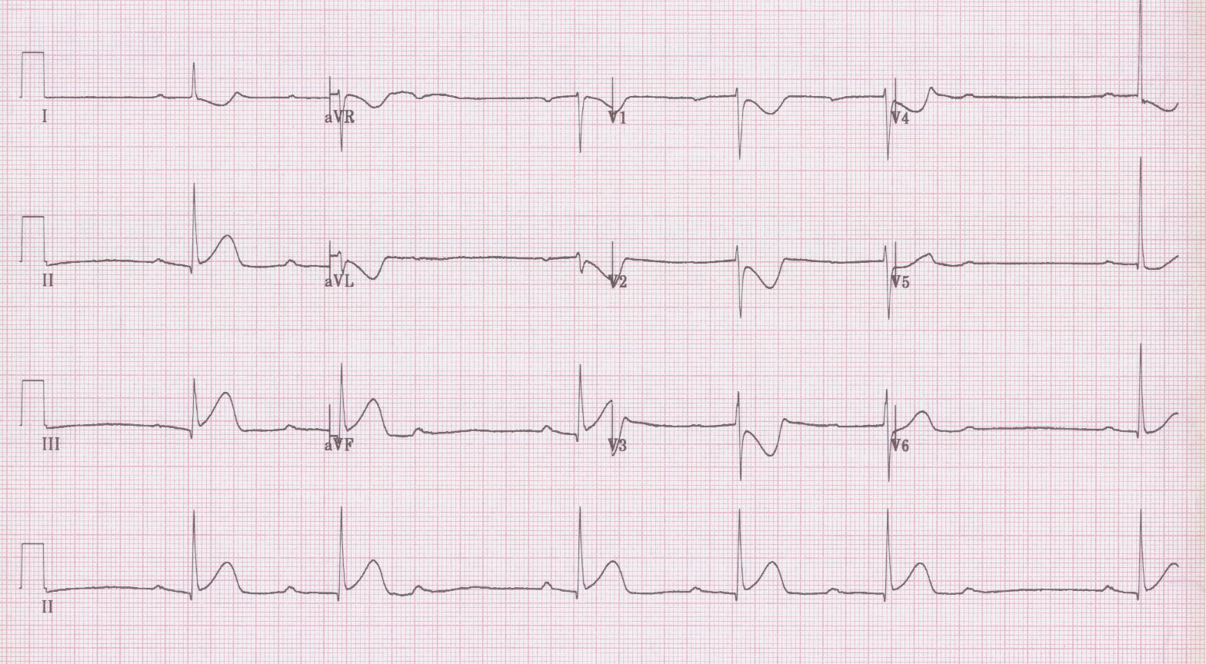
3.

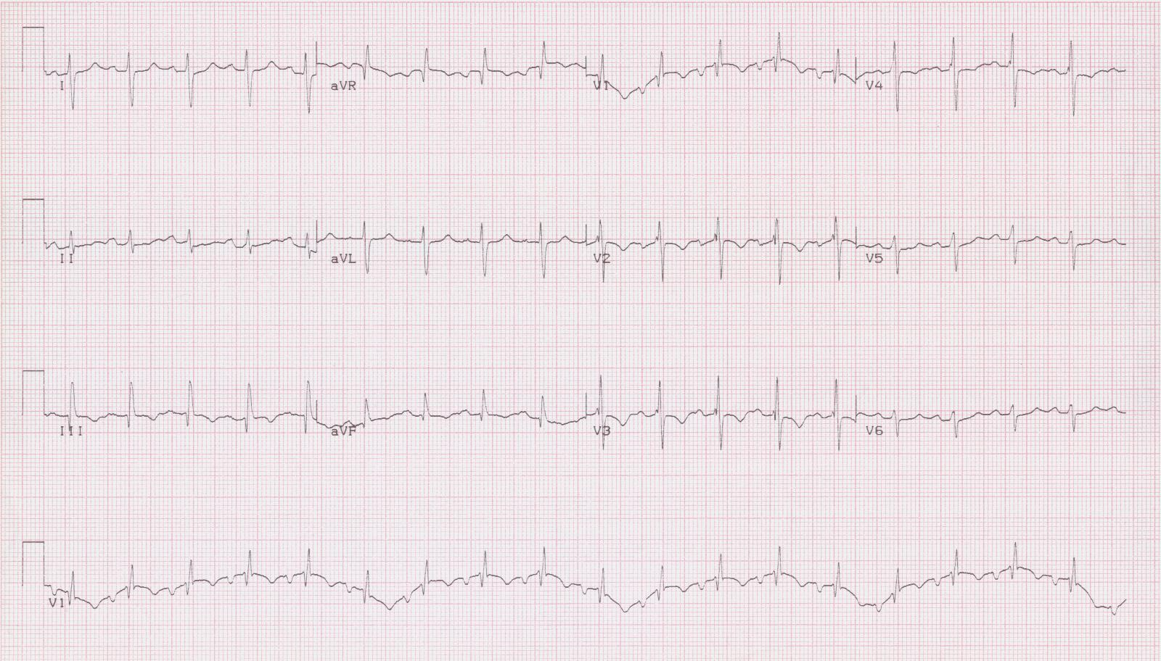
4.

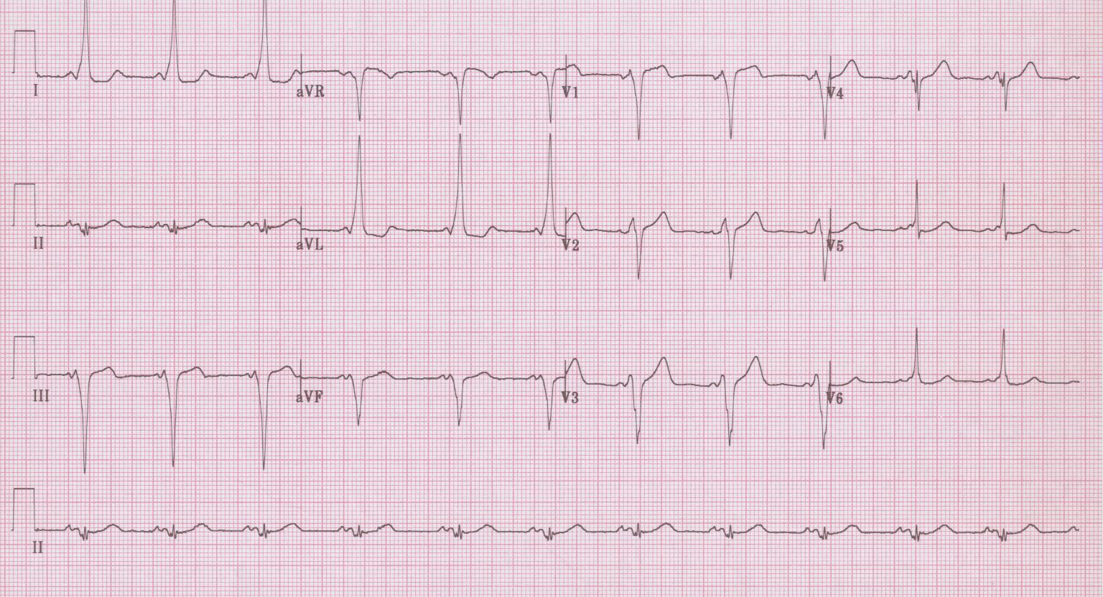
5.

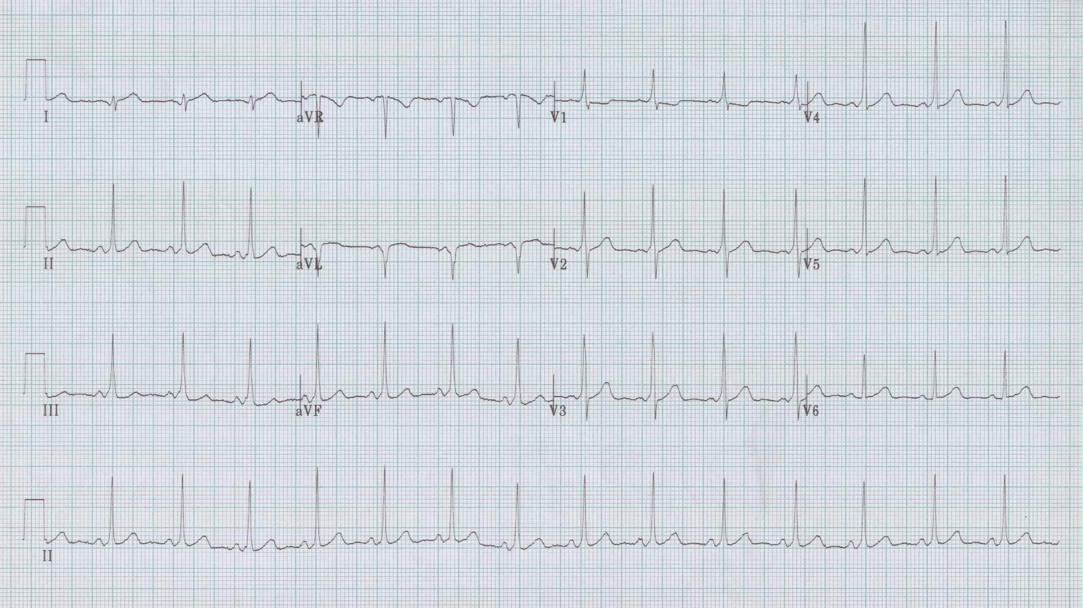
6.

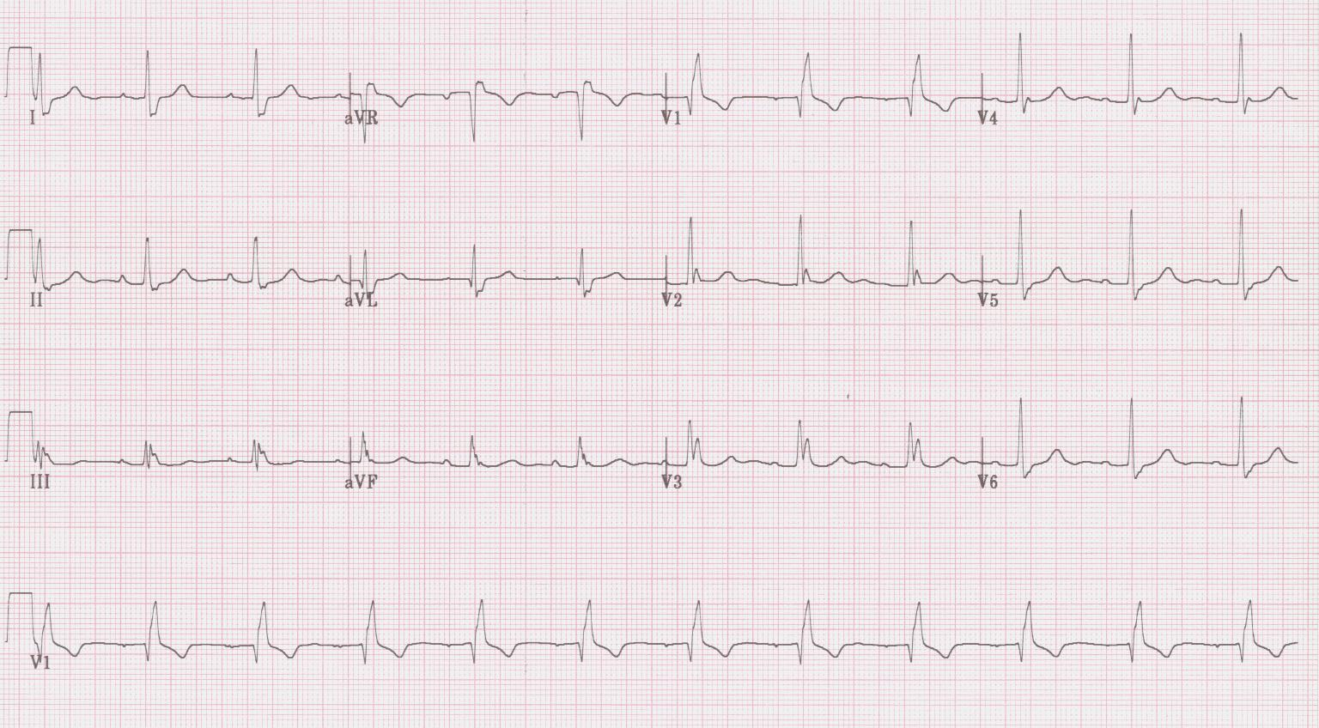
7.

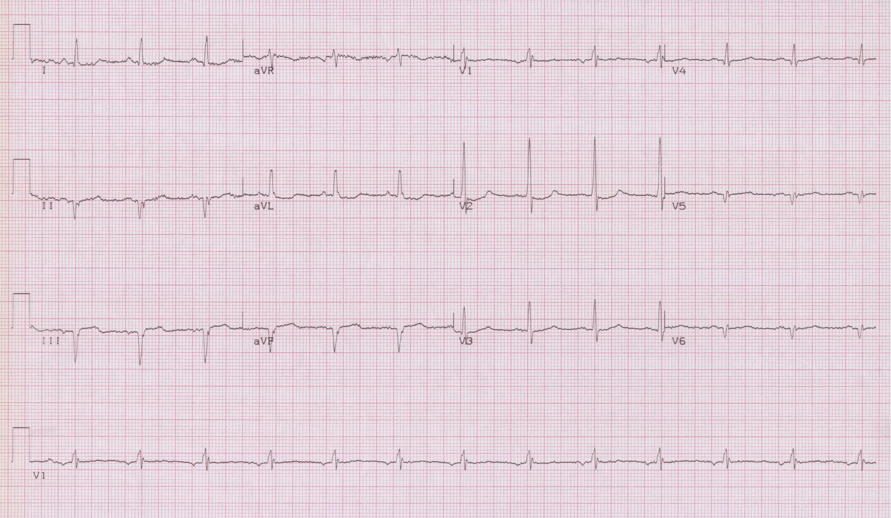
8.
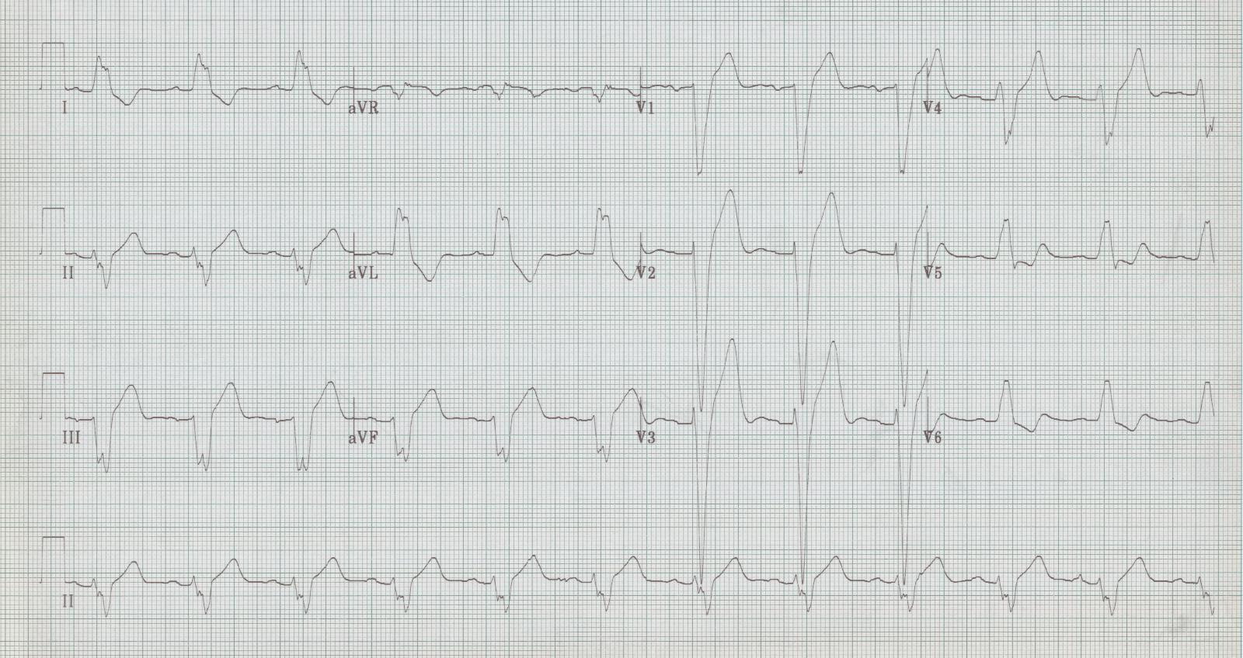
9.

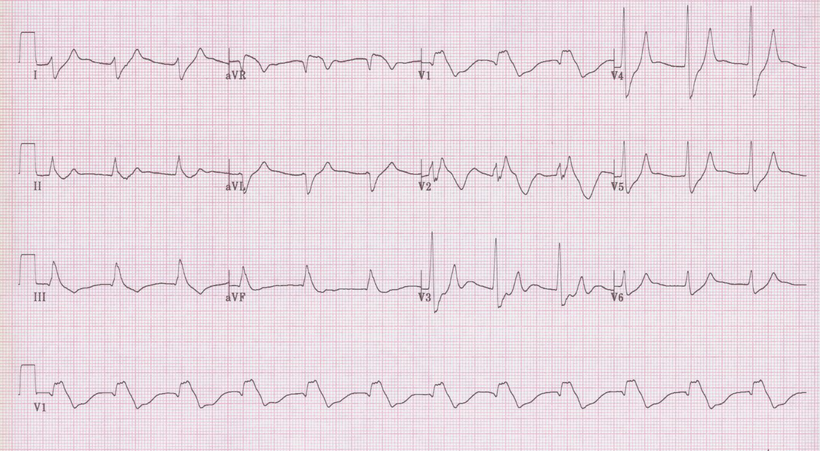
10.

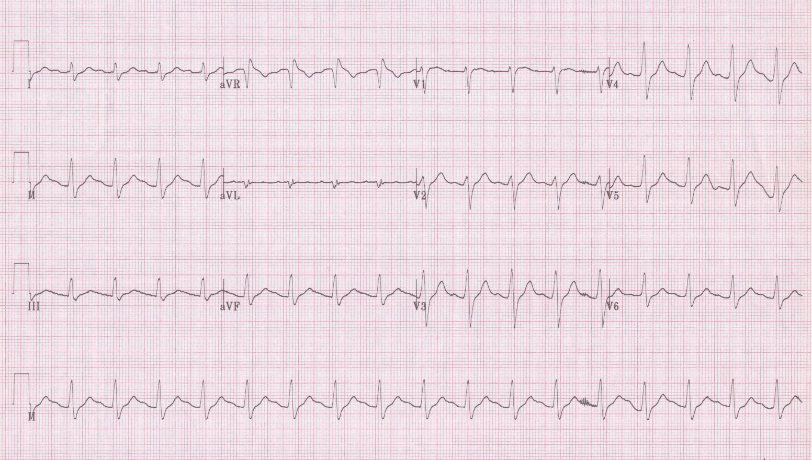
11.

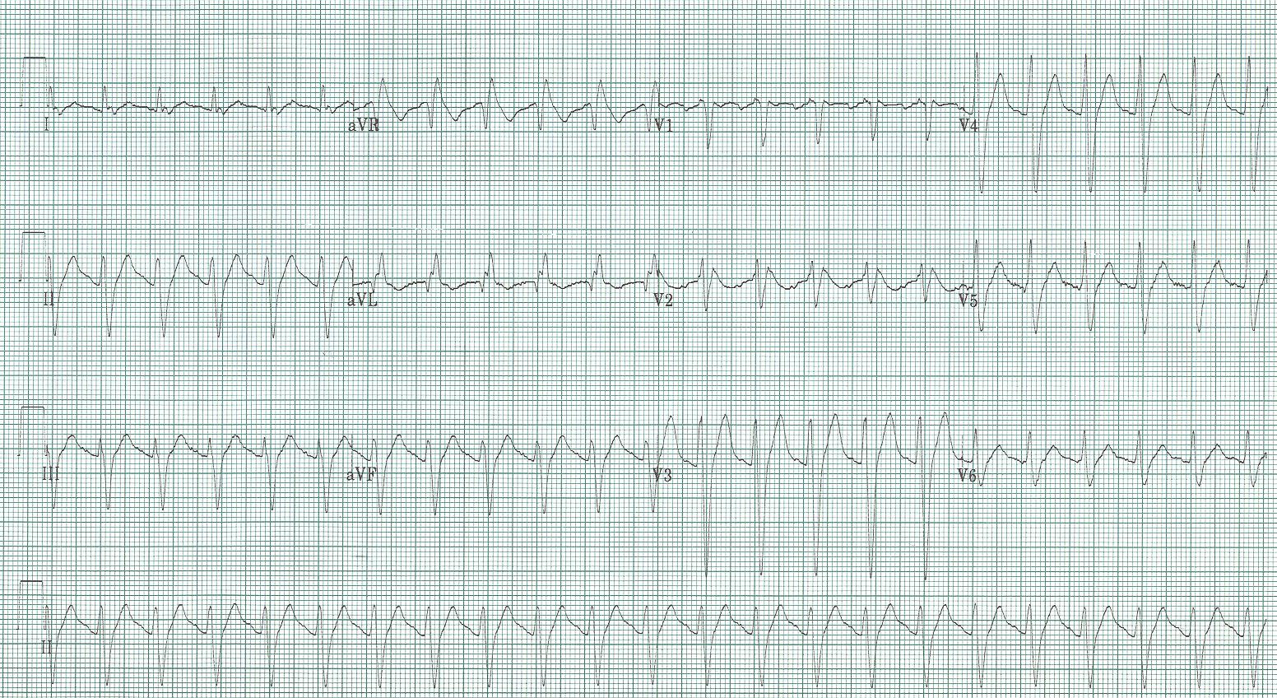
11a

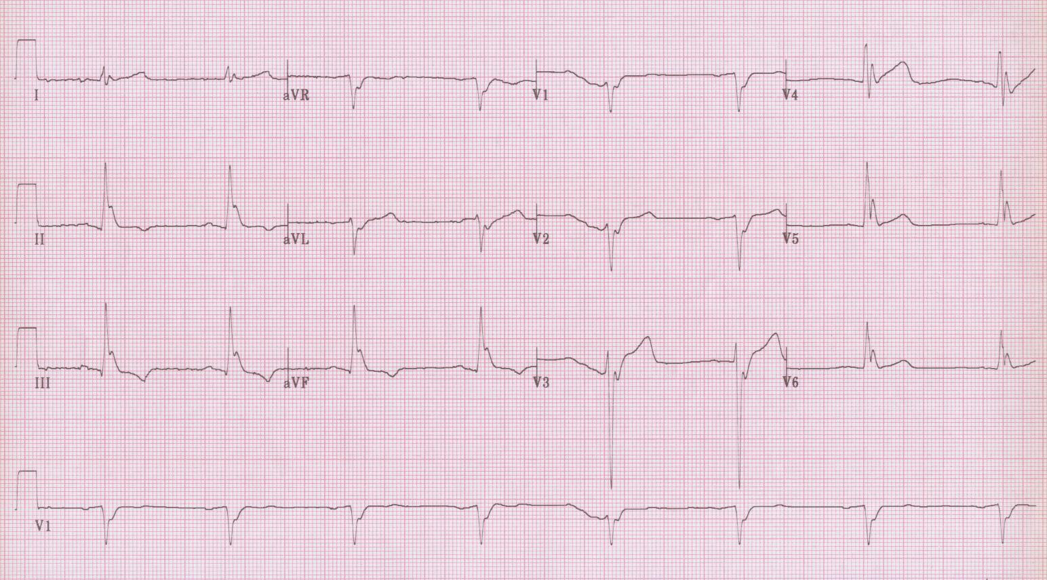
12.

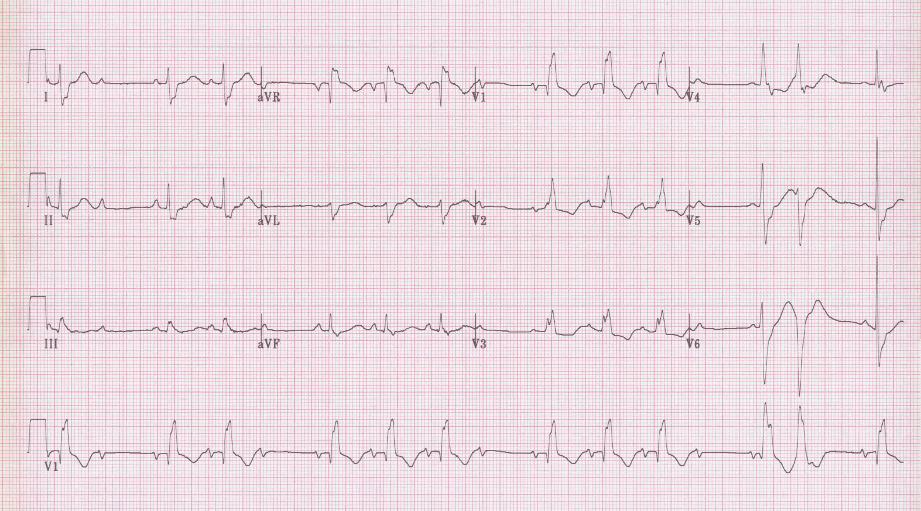
13. Unknown #1

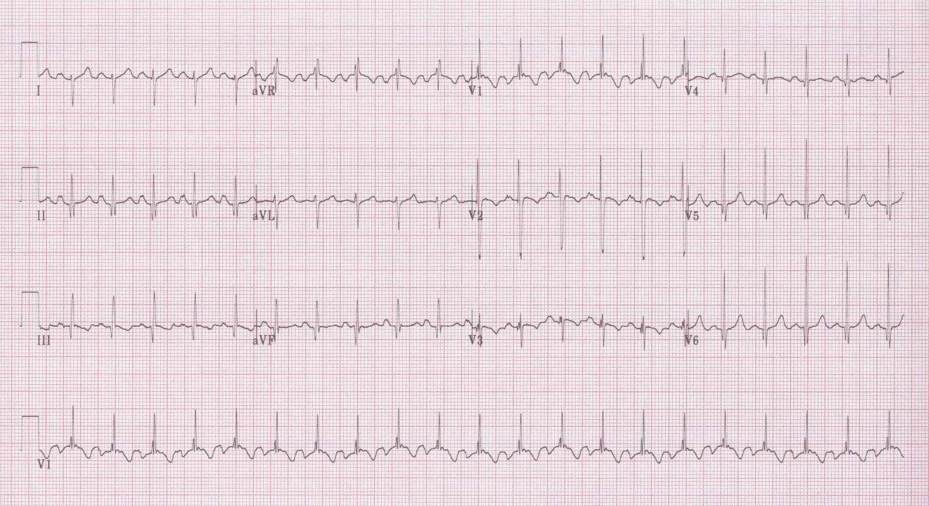
14. Unknown #2

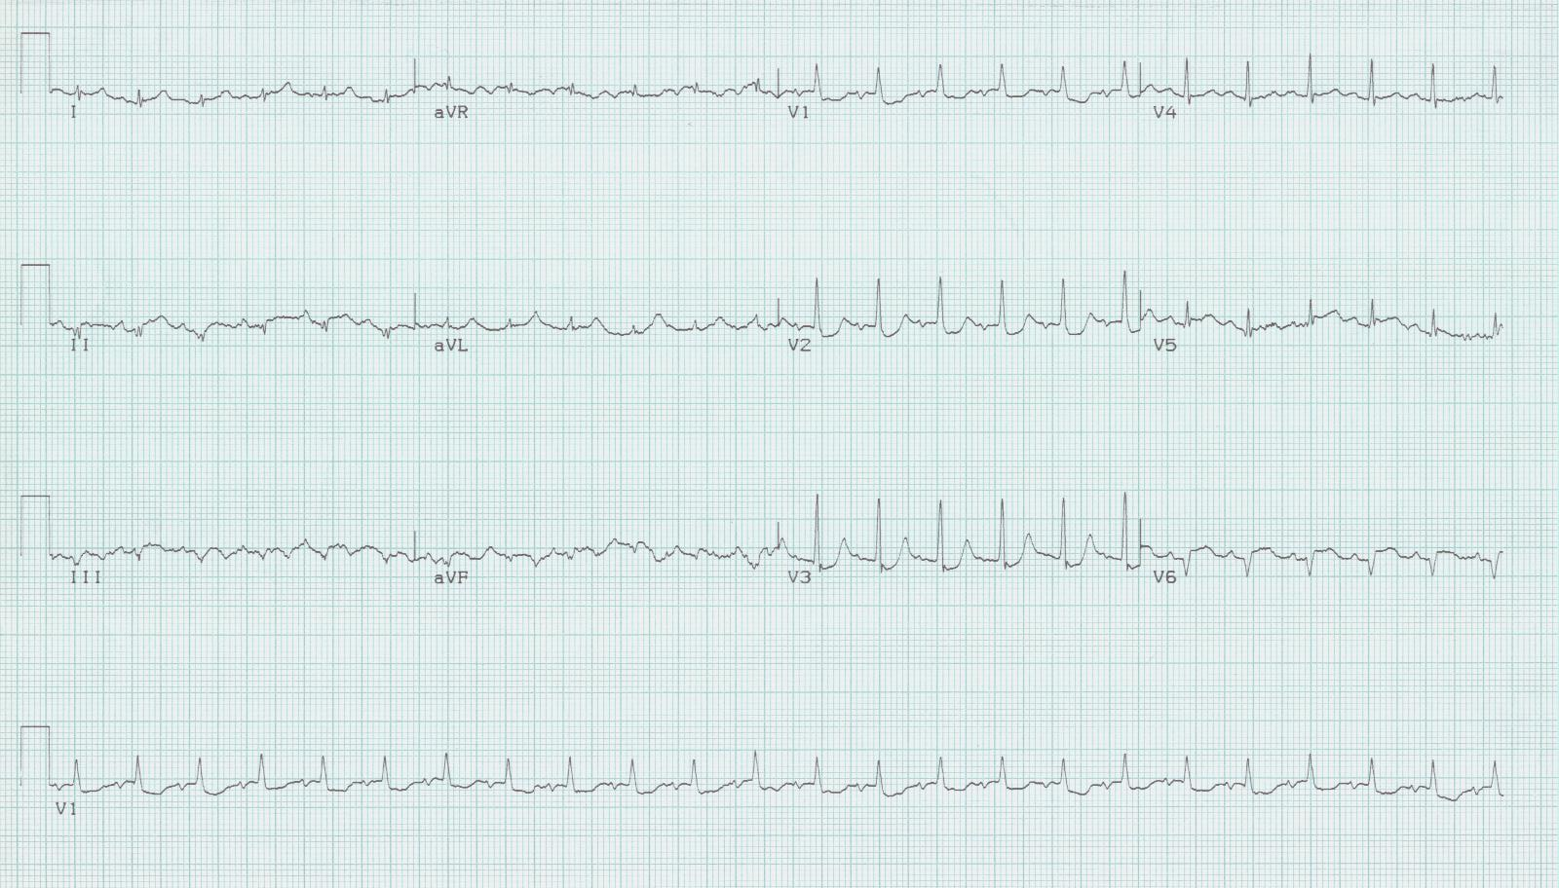
15. Unknown #3

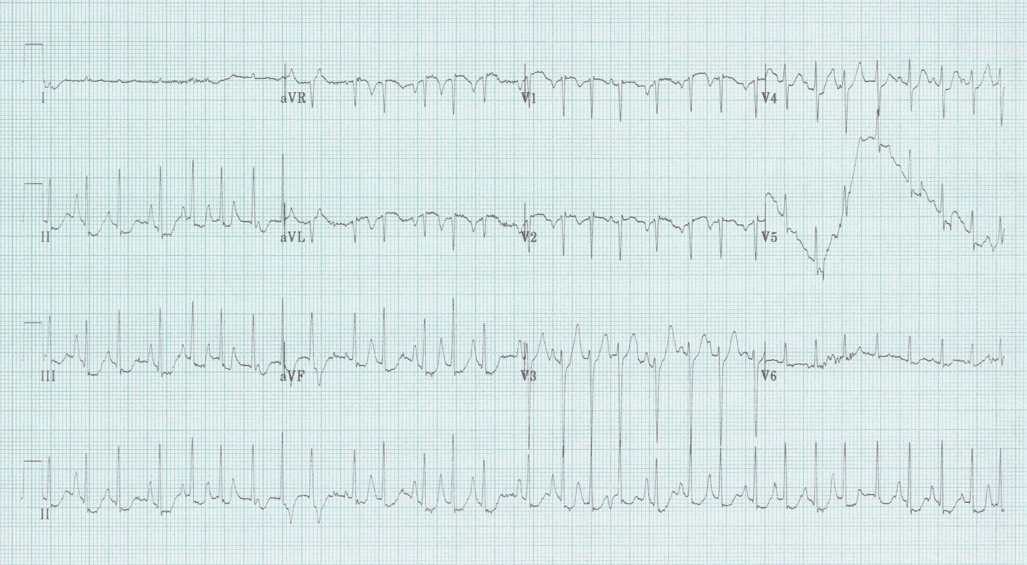
16. Unknown #4

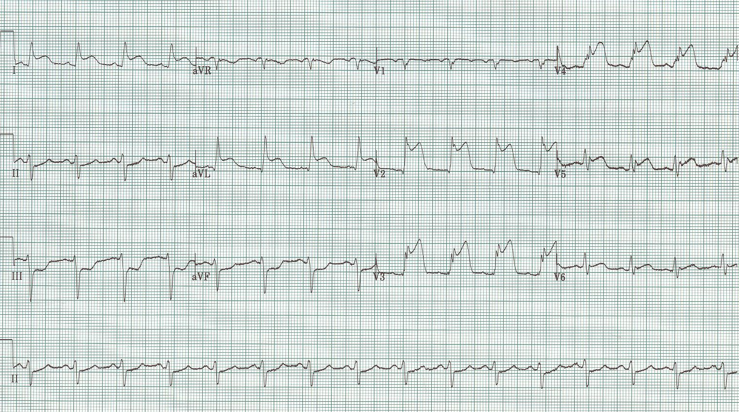
17.

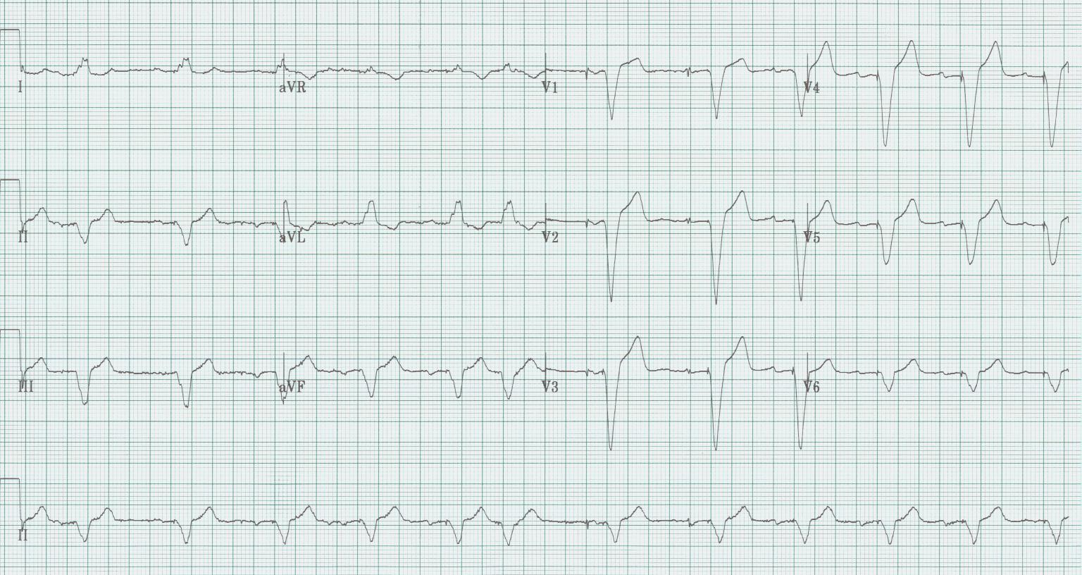
18.

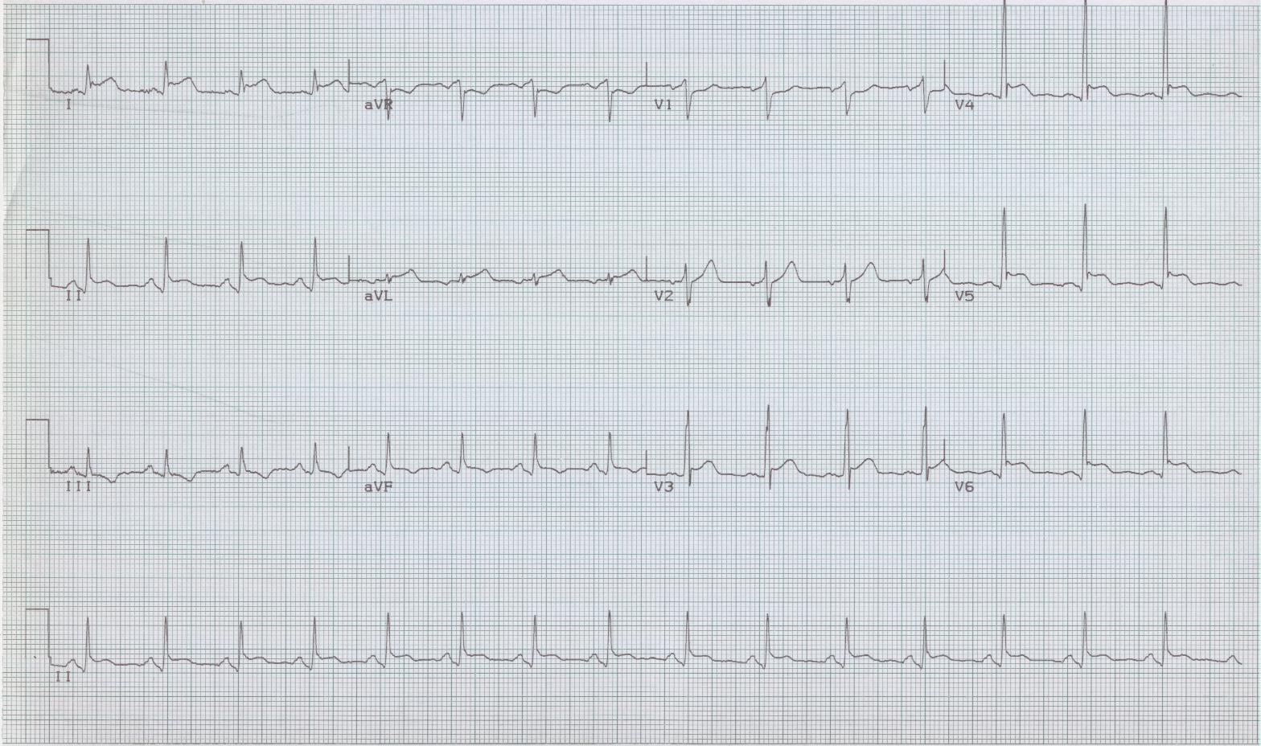19.
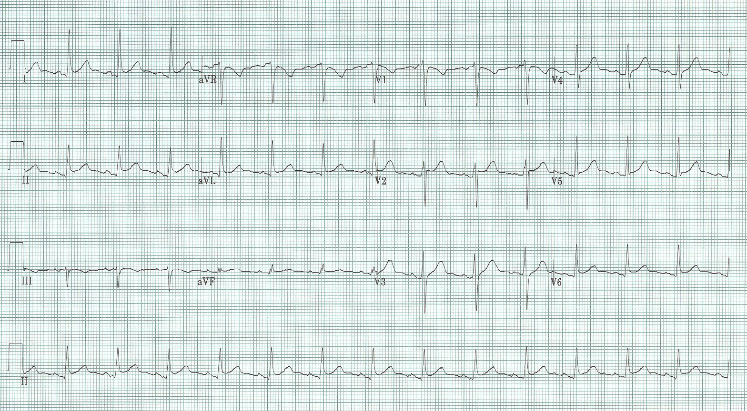
19a.

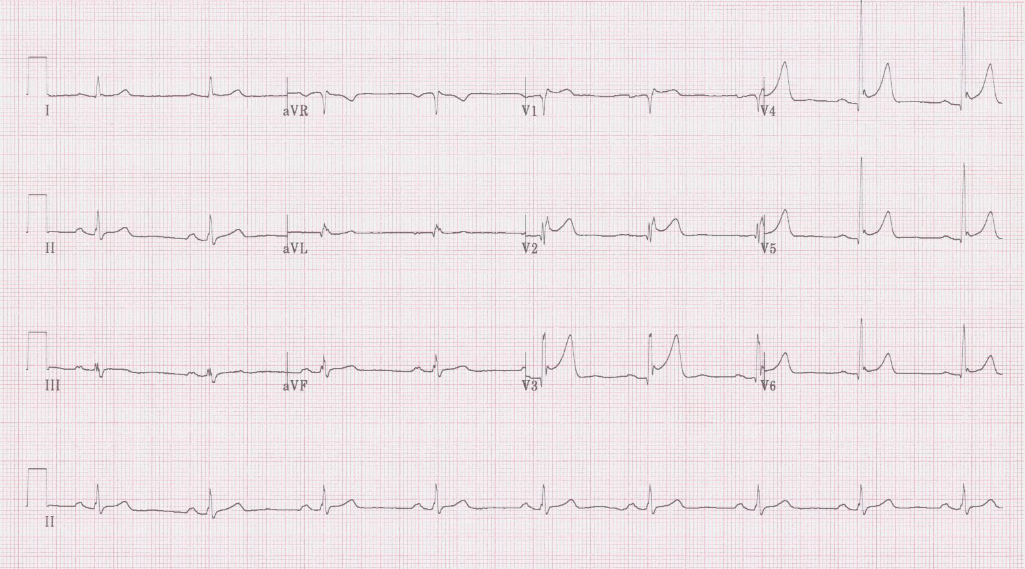
20.
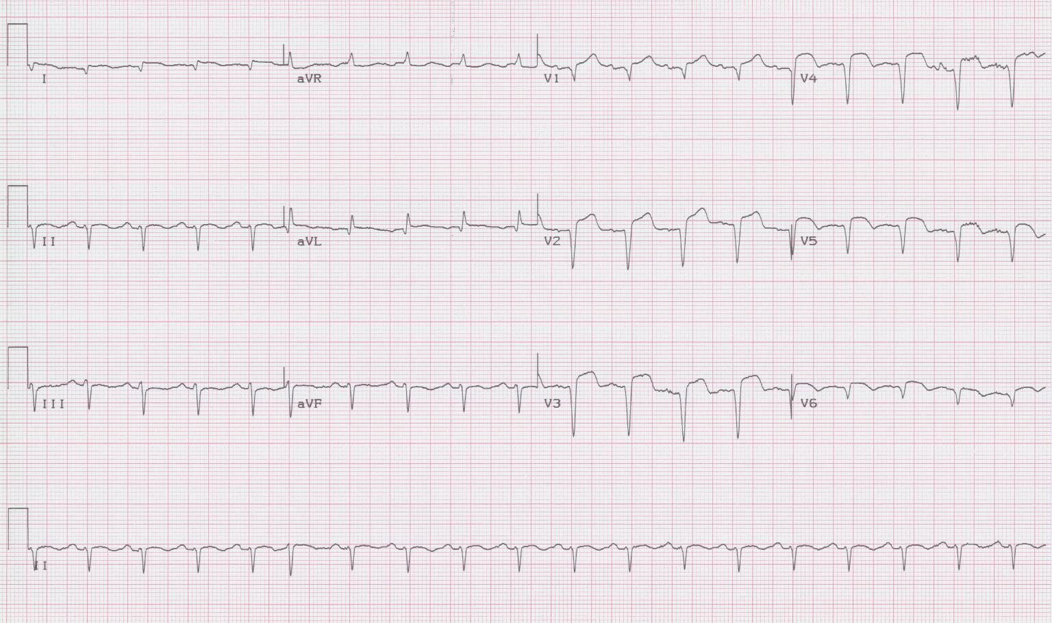21.
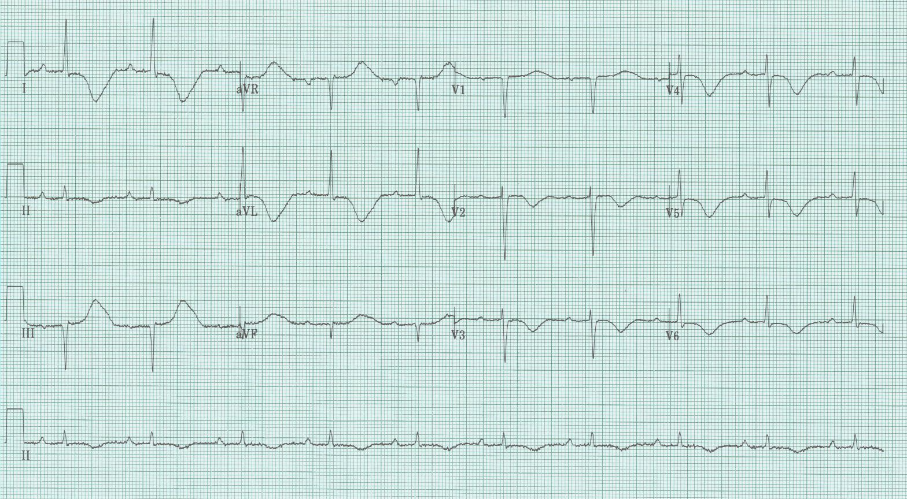
22.

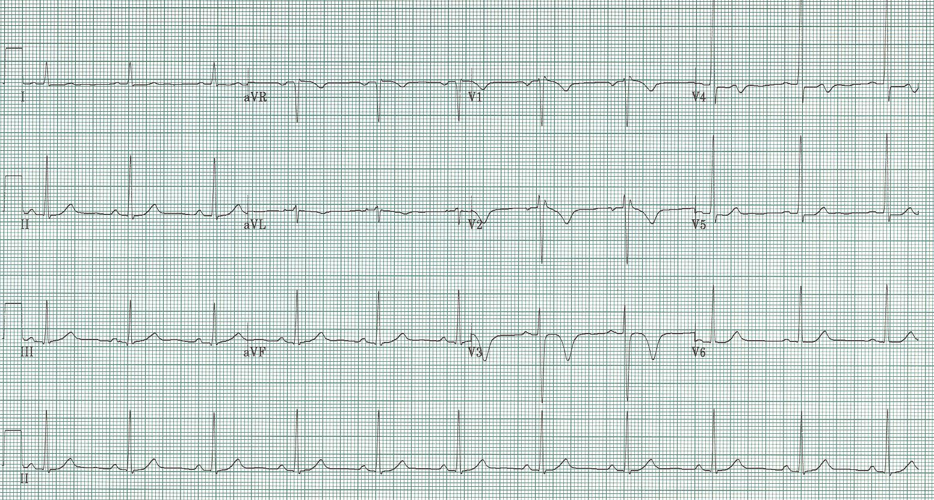
23.

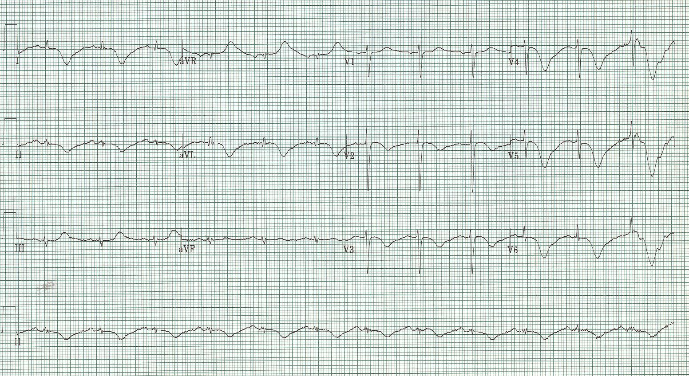
24.

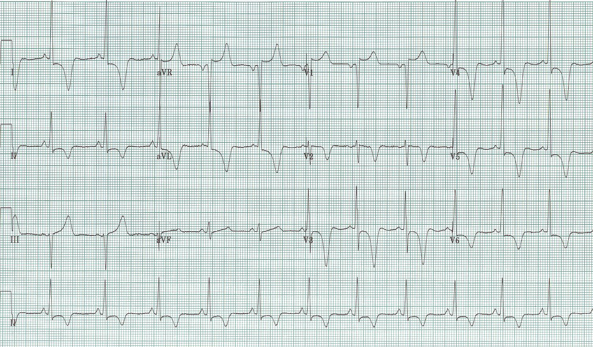
25.
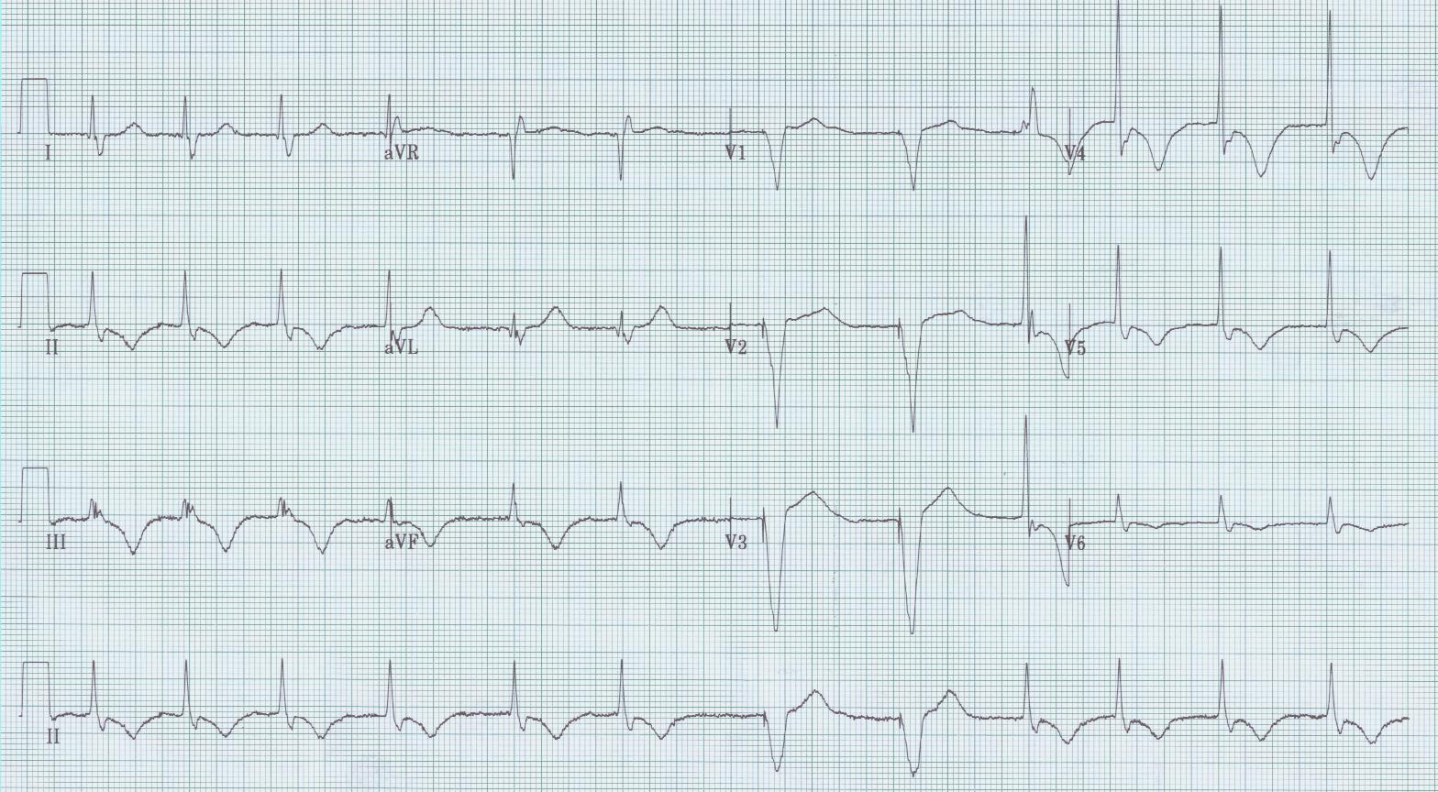
26.

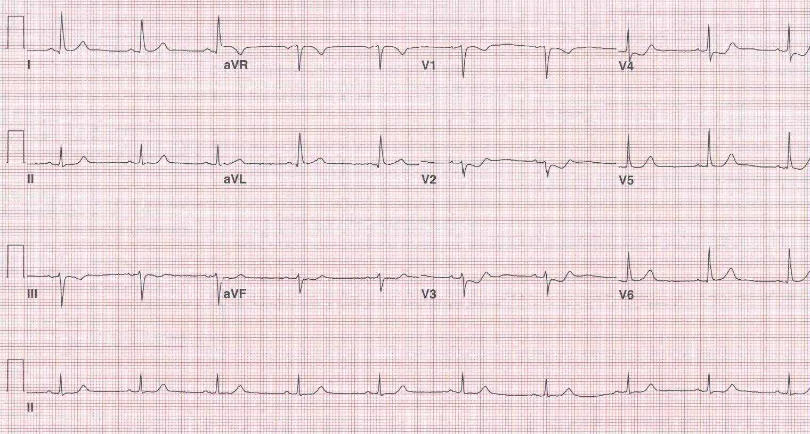
27.

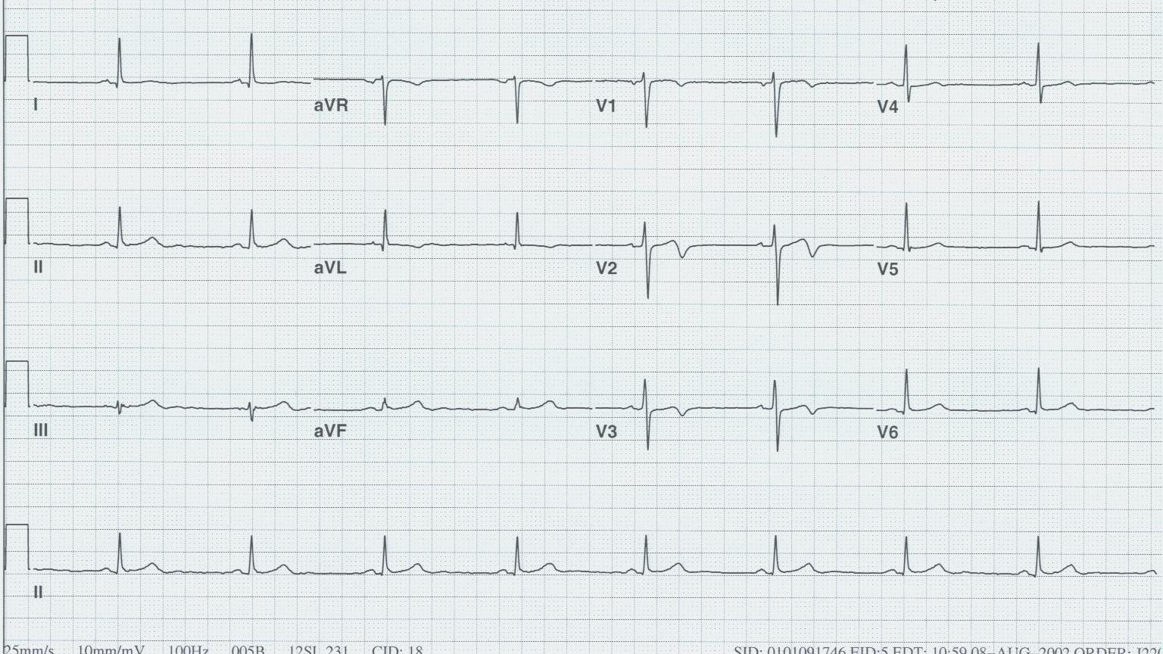
28.

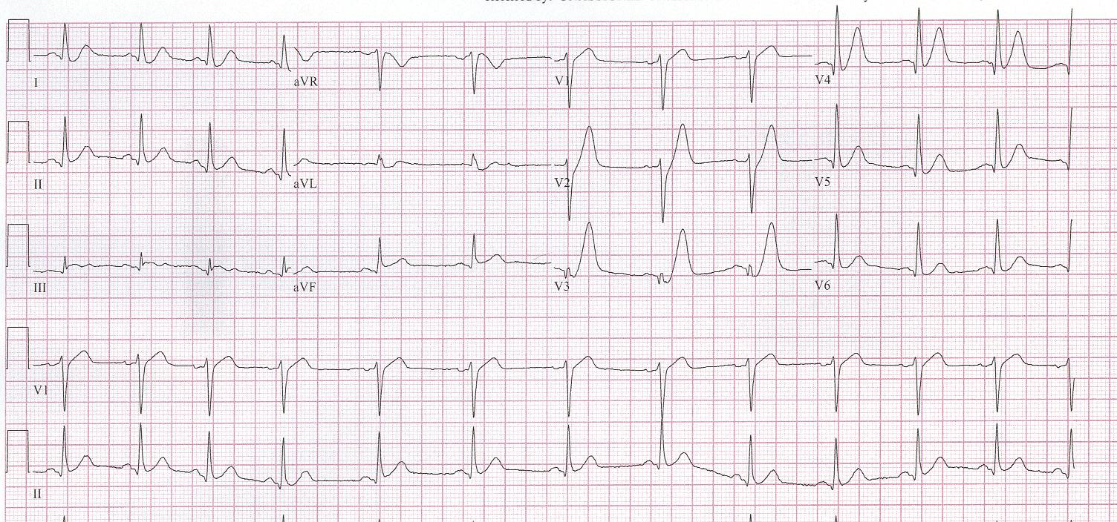
29.

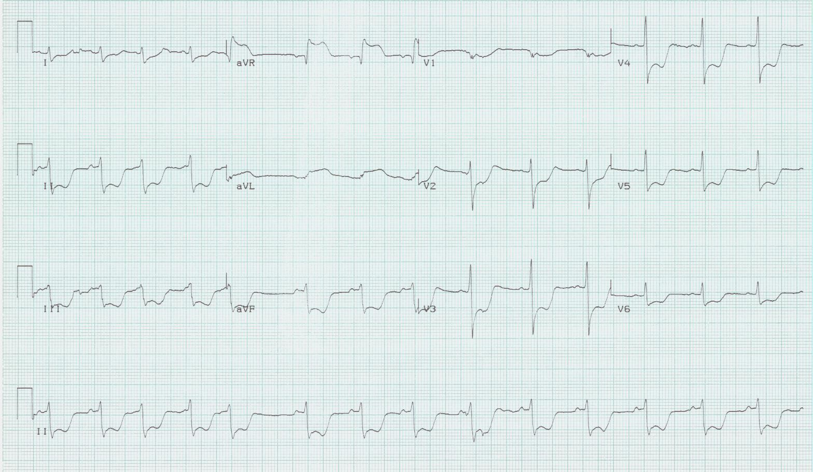
30.
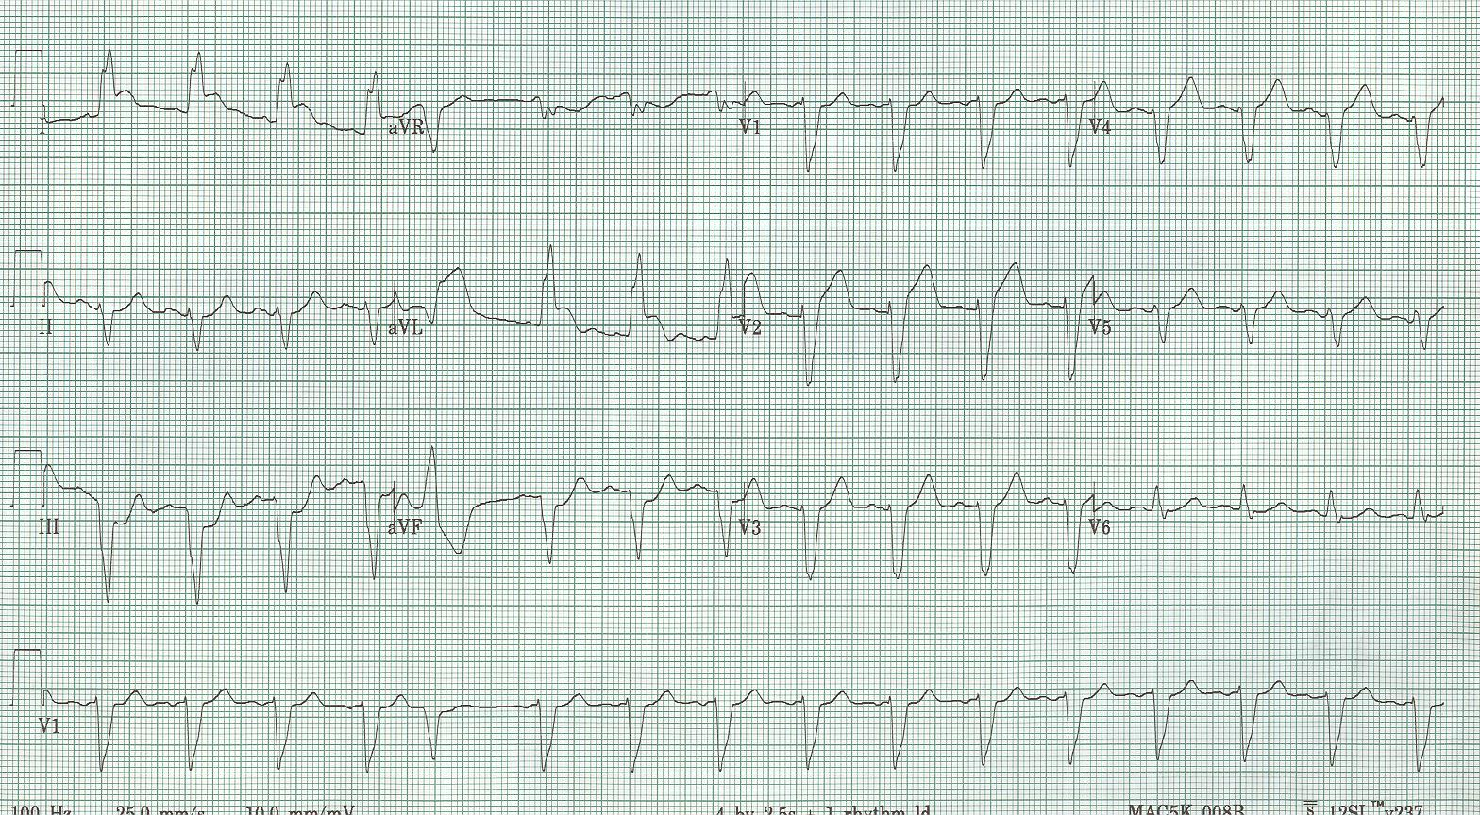
31.

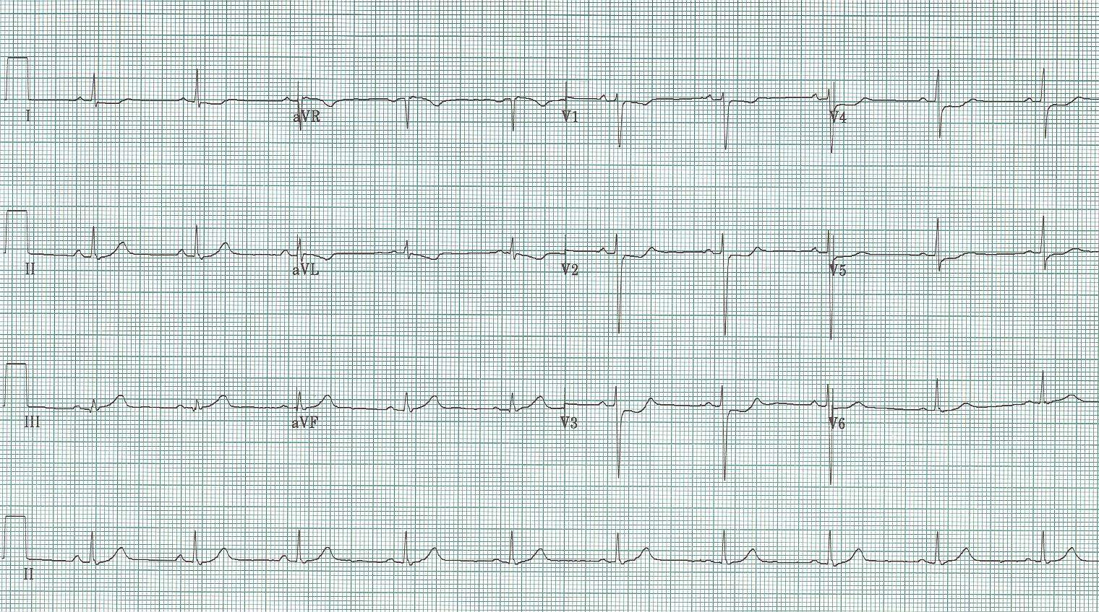
31. Unknown #2

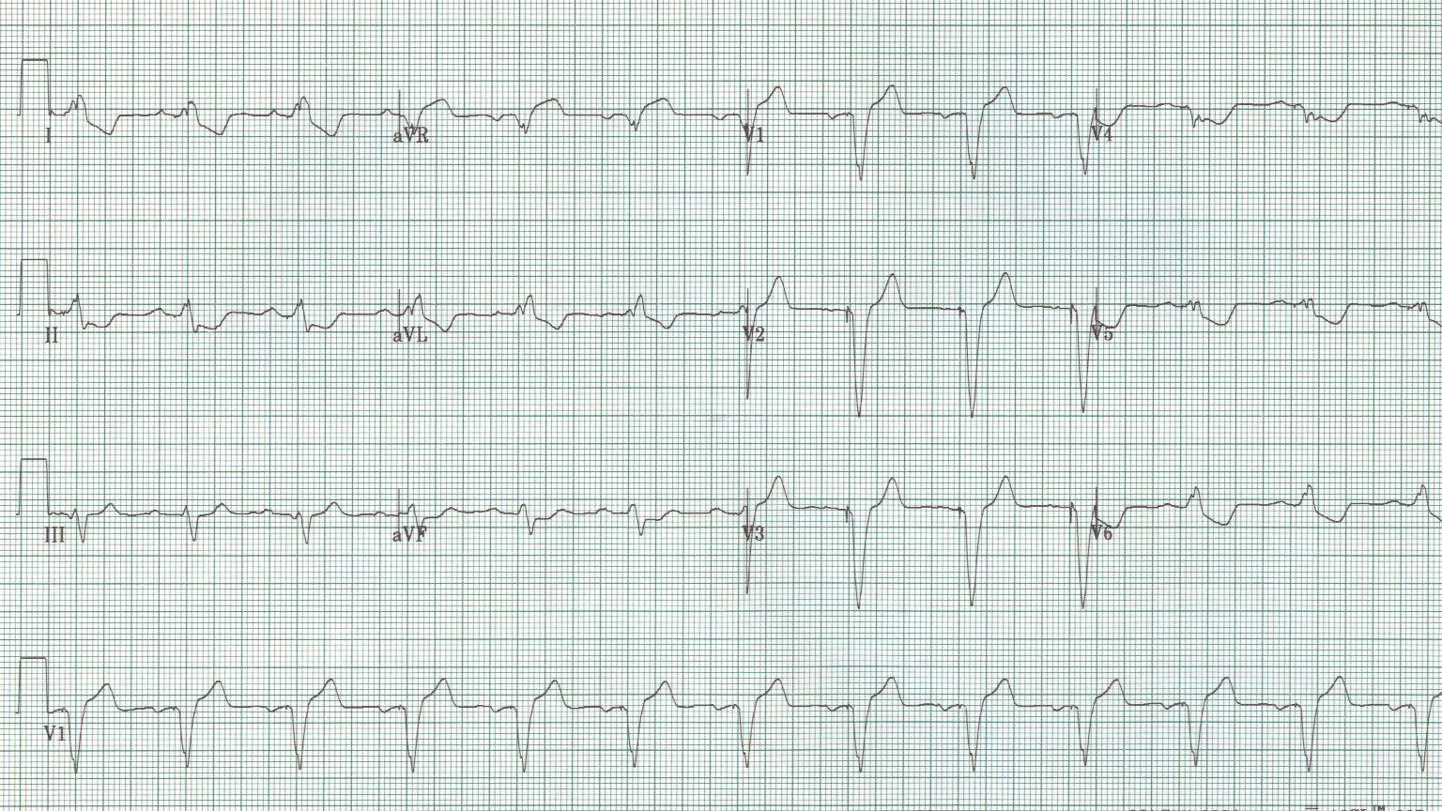
32. Unknown #3

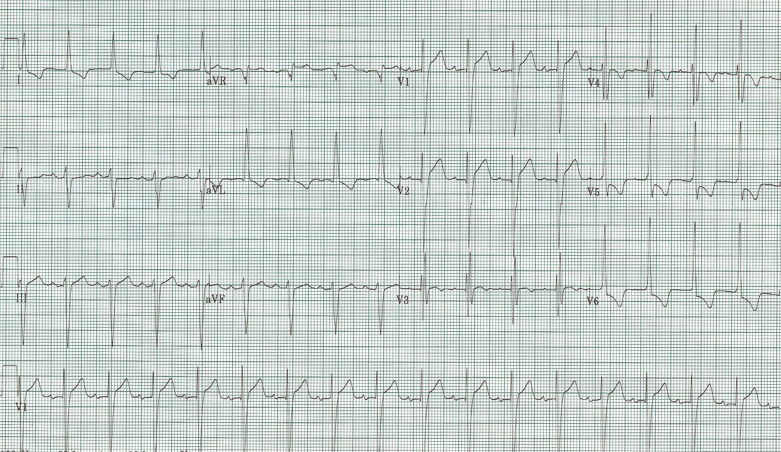
34. Unknown #3
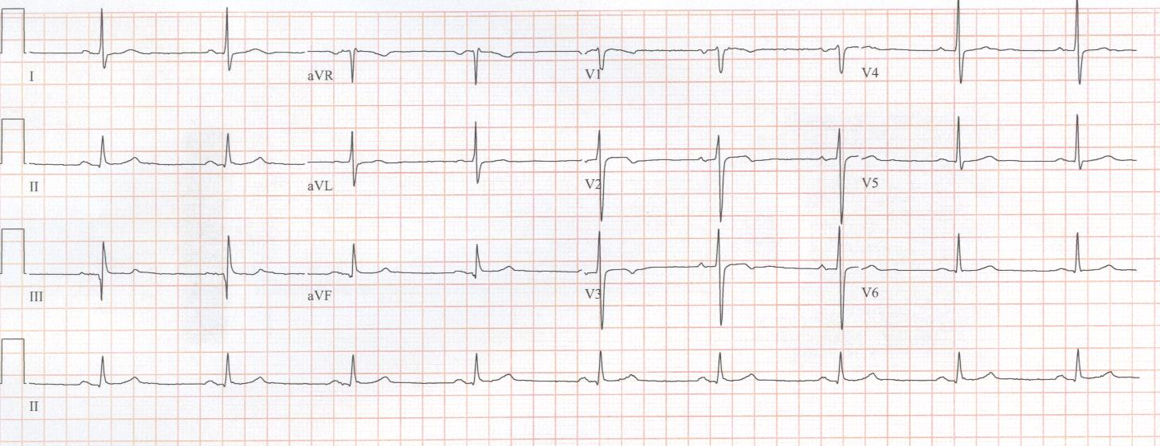
35. Unknown #4

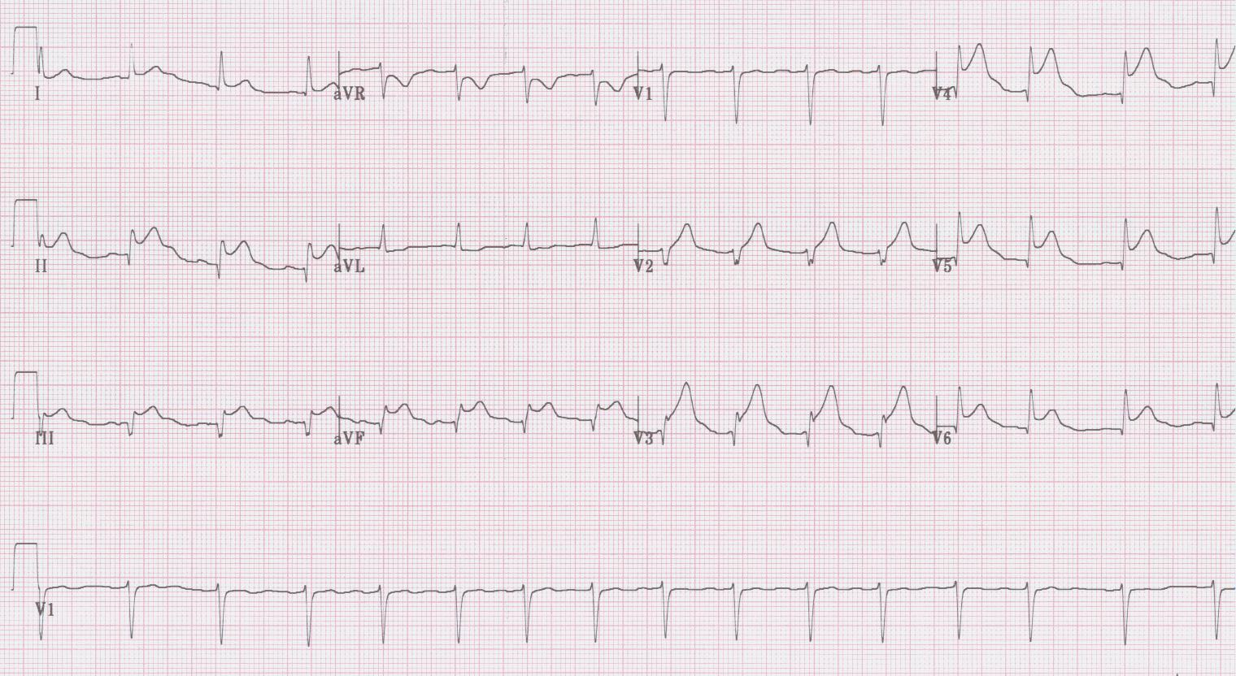
36. Unknown #5

EKG Interpretations

- Atrial fibrillation with controlled ventricular response of 84/minute, left axis deviation (-50°), QRS slightly prolonged at 100msec, voltage for LVH (with associated changes including left axis, prolongation of the QRS, and repolarization changes of strain pattern laterally, poor R wave progression and ST-elevation V₂₋₃). A good example of the changes of severe LVH.
- Atrial flutter with 2:1 block (clue – the rate is exactly 150/min), axis -30°, notice how the QRS in some leads (eg, II, III, aVF) appears prolonged by a portion of the flutter wave inscribed behind the QRS.
- 2° AV block, Type I (Wenckebach) with rate of 36/minute, with hyperacute T waves inferiorly (II, III, aVF) and ST-segment depression and T wave inversion V₁₋₃ representing acute inferior-posterior infarction.
- Sinus at 108/minute, right axis deviation (+120°) and tall R wave in V₁ suggest right ventricular hypertrophy in this patient with primary pulmonary HTN.
- Sinus at 66/min, axis -30°, PR interval is short (the width of the P wave), widening of the QRS by a delta wave most noticeable in I and aVL – Wolff-Parkinson-White, type B (not LBBB).
- Sinus at 84/minute, axis 0°, short PR interval and delta waves – WPW, type A because of the tall R wave in V₁.
- Sinus at 72/minute, normal axis, PR 200msec (1° AV block), QRS prolonged at 120msec with tall R wave in V₁ – RBBB (also note wide terminal S waves in lateral leads).
- Sinus at 78/minute, left axis at -60°, tall R waves in V₁₋₂ with associated Q waves in inferior leads – old inferior-lateral MI.
- Sinus at 72/minute, left axis, wide QRS at 160msec with tall monophasic R in lateral leads consistent with LBBB, note expected repolarization changes of ST depression and T inversion laterally, and ST-segment elevation and exuberant T waves in anterior leads (V₁₋₃).
- Regular rate at 72/minute, no P waves seen, very wide QRS and peaked T waves (V₄) – severe hyperkalemia.
- Sinus tachycardia at 105/minute, slight prolongation of both QRS and QT intervals, note prominent R in aVR – all consistent with TCA toxicity. 11a has a noticeably prolonged QRS and an R in aVR > 5mm – a severe TCA overdose in a teenager.
- Sinus bradycardia at 48/minute, significant QRS prolongation by an additional wave at the end of each QRS, an Osborne wave – this is hypothermia.
- 2° AV block, type II with overall rate of 72/minute, right axis deviation, wide QRS with tall R in V₁ – RBBB, the right axis with a RBBB adds the diagnosis of left posterior hemiblock (a bifascicular block). The 9th and 10th complexes are PVCs because P waves march through the rhythm, and thus these beats are dissociated from sinus activity and are necessarily ventricular in origin.
- Sinus tachycardia at 126/minute, right axis deviation and tall R in V₁ – RVH, negative terminal deflection of biphasic P wave in V₁ diagnostic of LA enlargement – this combination is typical of mitral stenosis.
- Sinus tachycardia at 144/minute, tall R wave in V₁ coupled with tiny but perceptible Q waves inferiorly diagnose a subacute inferior-posterior MI; the very small complexes in the limb leads suggest tamponade – this elderly woman presented in shock three days after severe chest and back pain following rupture of the myocardium resulting in tamponade.
- MAT (multifocal atrial tachycardia) at 180/minute, axis +90, although P waves vary because of MAT they are nearly all tall in the inferior leads suggestive of right atrial enlargement (“P-pulmonale”), and the essentially isoelectric complexes in lead I has been called the “lead I sign” suggestive of COPD. This patient had severe COPD and was actually theophylline toxic causing the rapid MAT.
- Sinus at 96/min, axis -30, intervals normal, striking ST-segment elevation in V₂₋₆, I, and aVL with reciprocal changes in the inferior leads consistent with an acute anterolateral STEMI.
- 100% ventricular paced rhythm at 72/minute, with appropriate “LBBB morphology” of QRS complexes including repolarization changes of ST-segment elevation in V₁₋₃.
- Sinus at 90/minute, normal axis and intervals, ST-segment elevation in I, II, V₃₋₆ with PR interval depression in II and PR elevation in aVR – all suggestive of acute pericarditis. 19a additionally has good Spodick’s sign of downsloping T-P segment in lead II rhythm strip.
- Sinus at 54/minute, normal axis and intervals, with ST elevation V₂₋₆, notching of J point in same leads, and early transition of R/S – early benign repolarization.
- Sinus at 114/minute, ST-segment V₁₋₆ with Q waves in same leads – ventricular aneurysm.
- Sinus at 60/minute, PR interval prolonged at 280msec (1° AV block), QT interval prolonged with striking T wave inversion – in this patient with subarachnoid hemorrhage, these changes are consistent with CNS effect.
- Sinus at 66/minute, normal axis and intervals, deep T wave inversion in V₂₋₄ – in this patient with prior chest pain, a classic presentation of Wellens’ syndrome.
- Sinus at 72/minute, striking T wave inversion and QT intervals – in this middle-aged man it is consistent with Takotsubo cardiomyopathy.
- Striking T wave inversion in a young man – Yamaguchi syndrome, or apical hypertrophic cardiomyopathy.
- Basic rhythm is atrial fibrillation with two ventricular paced beats, widespread T wave inversion – an example of T-wave inversions due to ventricular pacing or “memory T waves.”
- Sinus at 60/min, axis -20°, intervals normal, ST-segment depression in V₂₋₄ consistent with an isolated posterior wall MI.
- Sinus at 48/minute, normal axis and intervals, biphasic T waves in V₂₋₃ – in a patient with prior chest pain, consistent with a form of Wellens’ syndrome.
- Sinus at 78/minute, normal axis and intervals, persistent hyperacute T waves V₂₋₄ with J point depression and upsloping ST in the same leads – de Winters’ sign of proximal LAD occlusion.
- Sinus at 84/minute and PAC, impressive ST-segment depression in 9 of 12 leads, and ST-segment elevation in aVR and aVL – this pattern is predictive of critical left main disease.
- Sinus at 96/minute with PVC, wide QRS in a LBBB morphology with concordant ST-segment elevation in I and aVL – positive Sgarbossa criteria for acute MI.
- Sinus at 60/minute, normal axis and intervals – ST-seg depression in V₂₋₄, an isolated posterior MI due to total occlusion of the circumflex artery.
- Ventricular paced rhythm at 78/minute, with ST-segment in multiple leads and ST-segment elevation in aVR, changes not typical of the expected LBBB morphology, and in fact suggestive of critical left main disease.
- Sinus tachycardia at 108/minute, left axis at -60°, intervals normal, voltage criteria for LVH with repolarization changes including T wave inversion laterally and ST-segment elevation V₁₋₂.
- Sinus at 54/minute, normal axis and intervals, subtle biphasic T waves V₁₋₂ that were new from prior tracing – a Wellens’ syndrome and the patient went on to have a large anterior MI one week later.
- Obvious ST-segment elevation in multiple leads (inferior as well as V₁₋₆) – this is not pericarditis; it is an acute STEMI due to a wrap-around LAD with extension of the distal LAD around the apex to the inferior wall.

References

Armstrong EJ, Kulkarni AR, et al. Electrocardiographic criteria for ST-elevation myocardial infarction in patients with left ventricular hypertrophy. Am J Cardiol 110:977-983, 2012.

De Winter RJ, et al. A new ECG sign of proximal LAD occlusion. NEJM 359:2071-73, 2008.

Hanna EB, Glancy DL. ST-segment depression and T-wave inversion: classification, differential diagnosis, and caveats. Clev Clin J Med 78: 404-414, 2011.

Hayden GE, Brady WJ, Perron AD, et al. Electrocardiographic T-wave inversion: differential diagnosis in the chest pain patient. Am J Emerg Med 20:252, 2002.

Lawner BJ, Nable JV, Mattu A. Novel patterns of ischemia and STEMI equivalents. Cardiol Clin 20:591-599, 2012.

LeWinter MM. Percarditis – clinical review. NEJM 371:2410-16, 2014.

Pollak P, Brady W. Electrocardiographic patterns mimicking ST segment elevation myocardial infarction. Cardiol Clin 30:601-615, 2012.

Rhinehart J, Brad WJ, Perron AD, Mattu A. Electrocardiographic manifestations of Wellens’ syndrome. Am J Emerg Med 20:638-43, 2002.

Smith SW, Dodd KW, et al. Diagnosis of ST-elevation myocardial infarction in the presence of LBBB with the ST-elevation to S-wave ratio in a modified Sgarbossa rule. Ann Emerg Med 60:766-776, 2012.

Wang K, Asinger RW, Marriott HJL. ST-segment elevation in conditions other than acute myocardial infarction. NEJM 349:2128-35, 2003.

