Part 2 – Electrolytes, tachycardias, and miscellaneous

Electrolytes
- Hyperkalemia
- peaked tall T waves – widening of QRS complex – decrease P waves – sin wave
- Hypokalemia
- increasing U waves with decreasing T waves – apparent prolongation QT (QU)
- Hypercalcemia
- short QT interval, leftward shift of apex of T wave
- Hypocalcemia
- prolongation of QT interval

Tachycardias

 | Regular Rhythm | Irregular Rhythm
Narrow QRS | Sinus tachycardia  SVT  2:1 atrial flutter | Atrial fibrillation  Multifocal atrial tachycardia
Wide QRS | Ventricular tachycardia  SVT with…  - pre-existing BBB  - rate-related aberrancy  - bypass tract (WPW) | Atrial fib with…  - pre-existing BBB  - rate-related aberrancy  - bypass tract (WPW)

Miscellaneous, but interesting…

Atrial fibrillation with Ashman phenomenon
Pacemaker failure
Pulmonary embolus with anterior T inversion
Brugada syndrome
Heart transplant
COPD

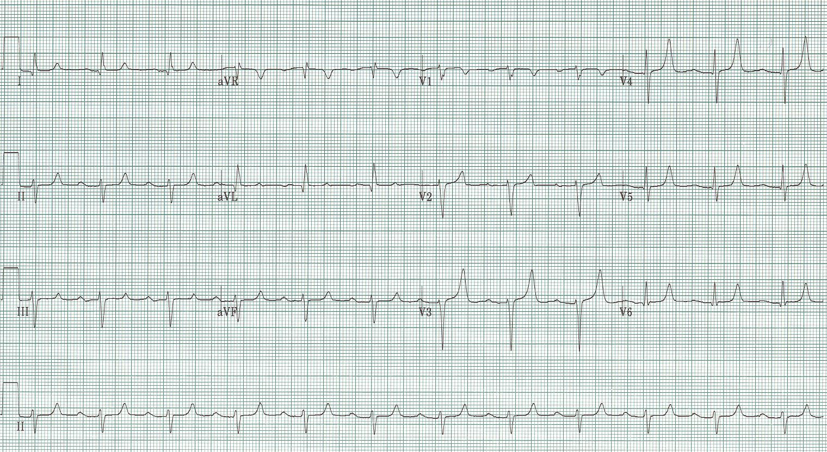
1.

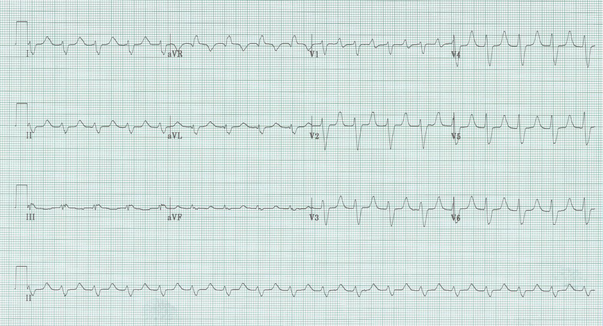
2.

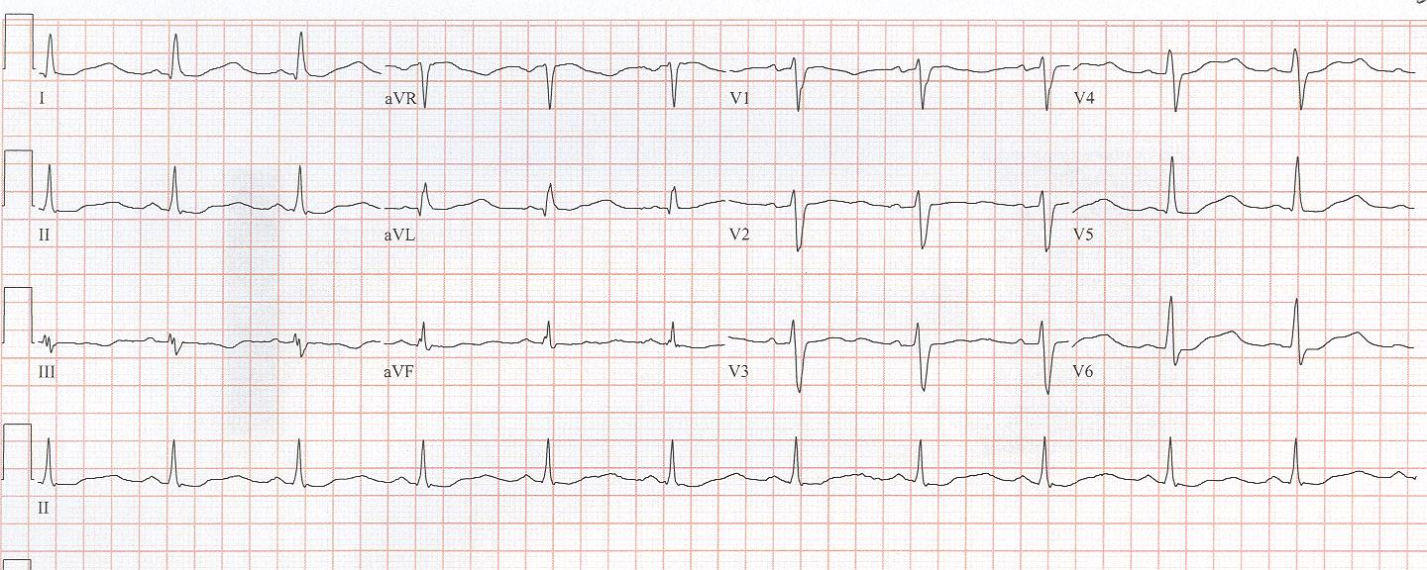
3.

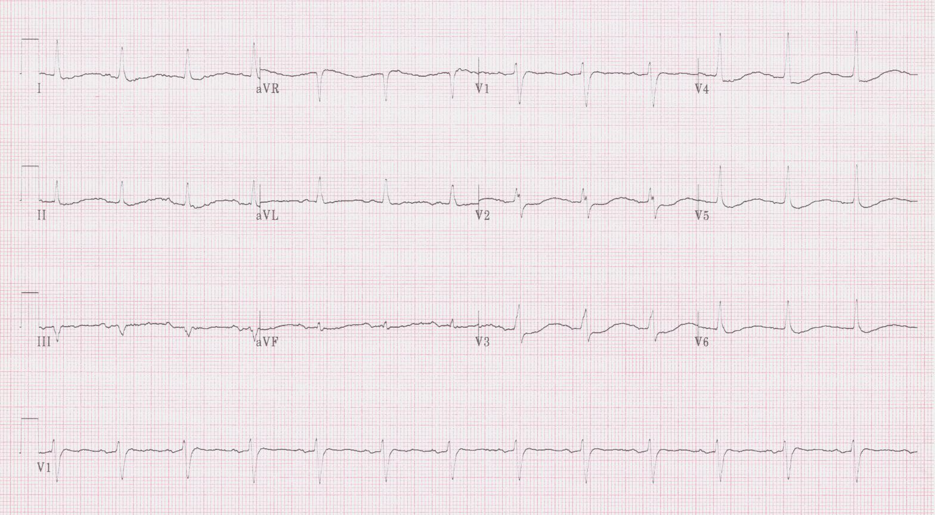
4.

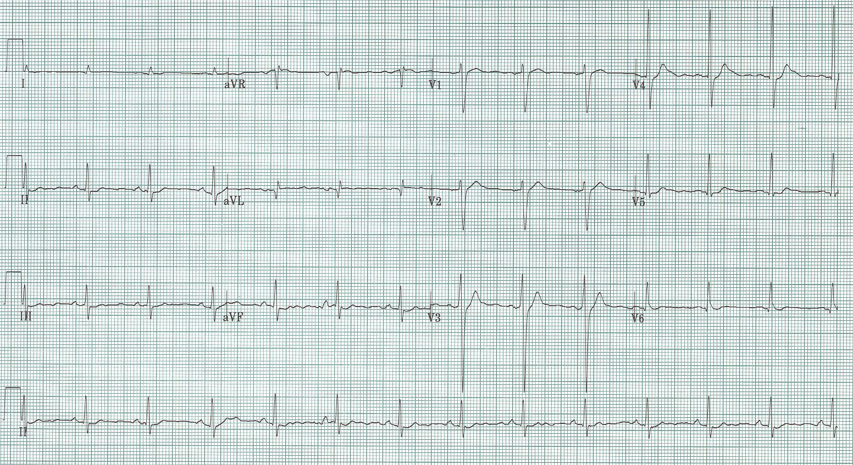
5.

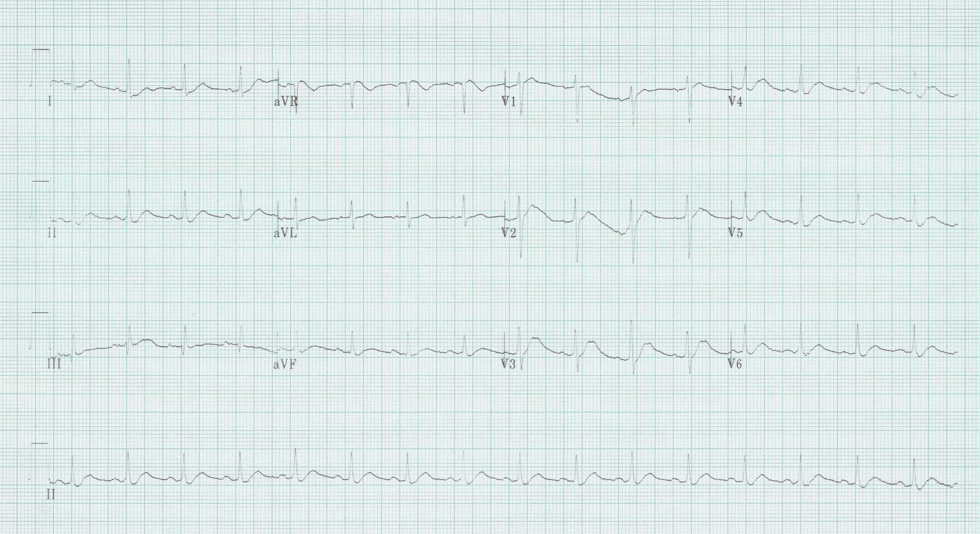
6.

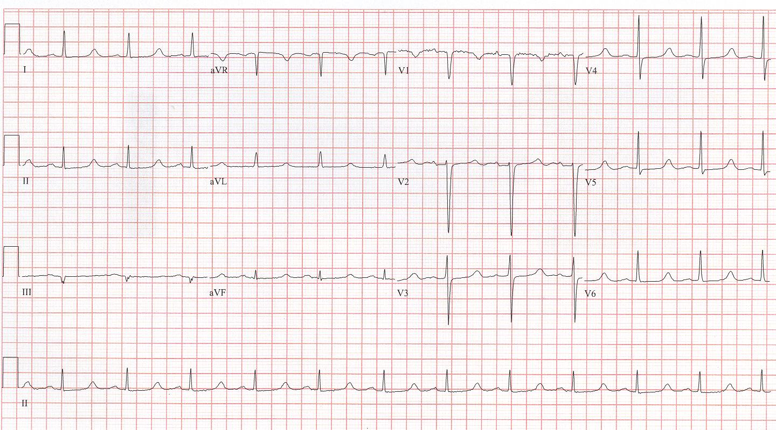
7.

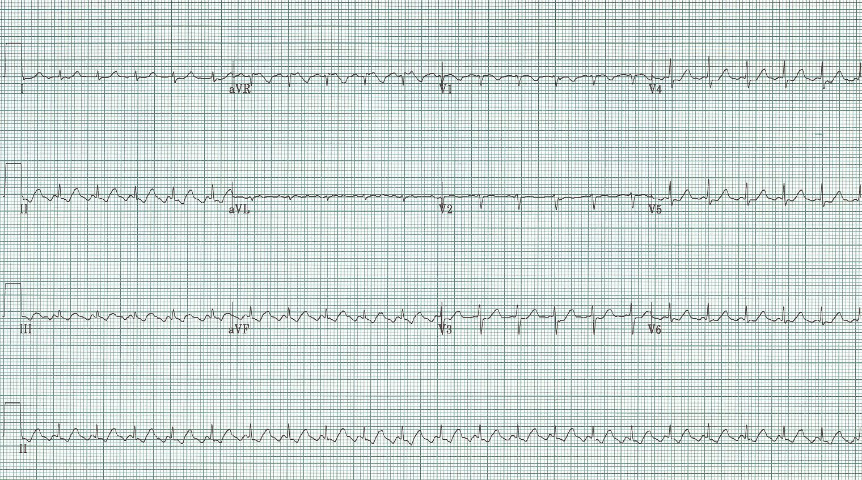
8.

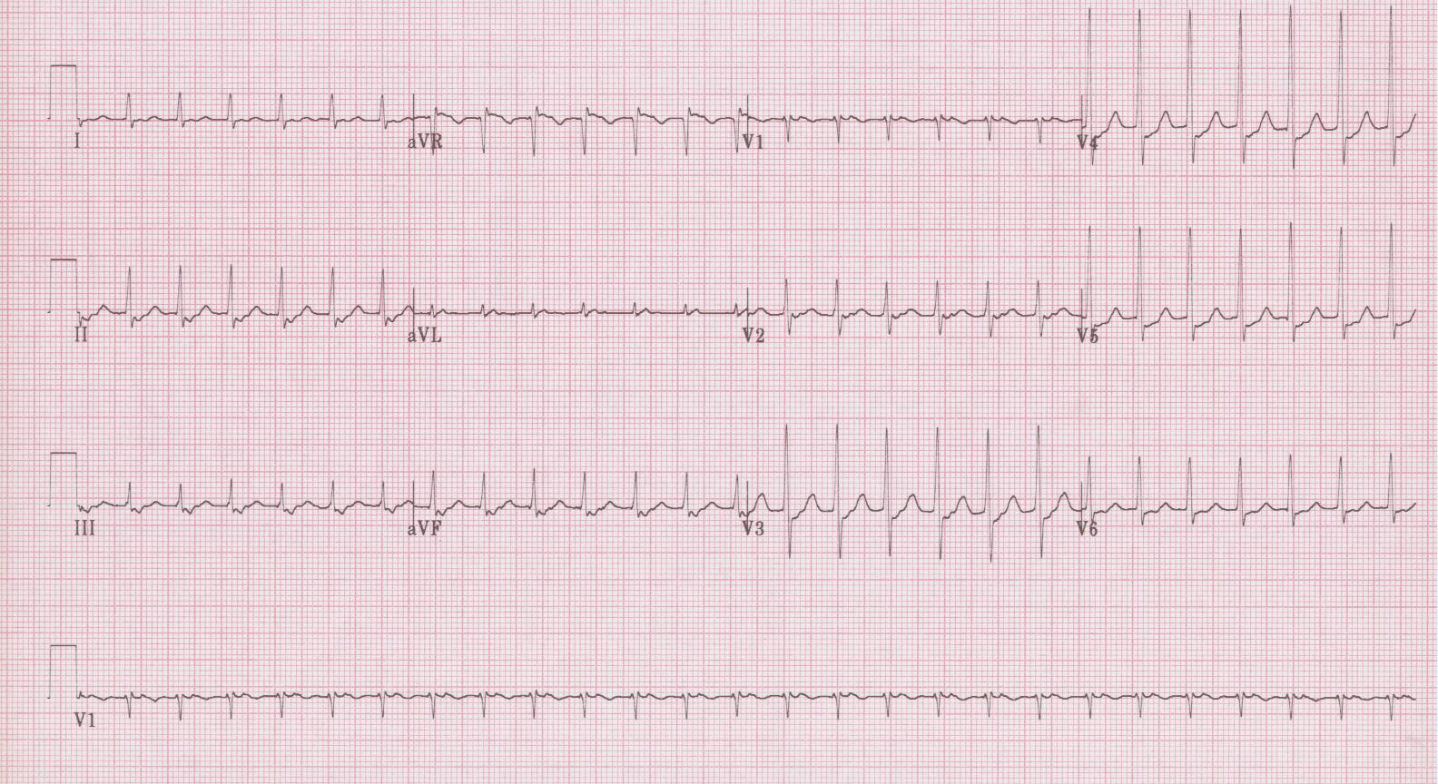
9.

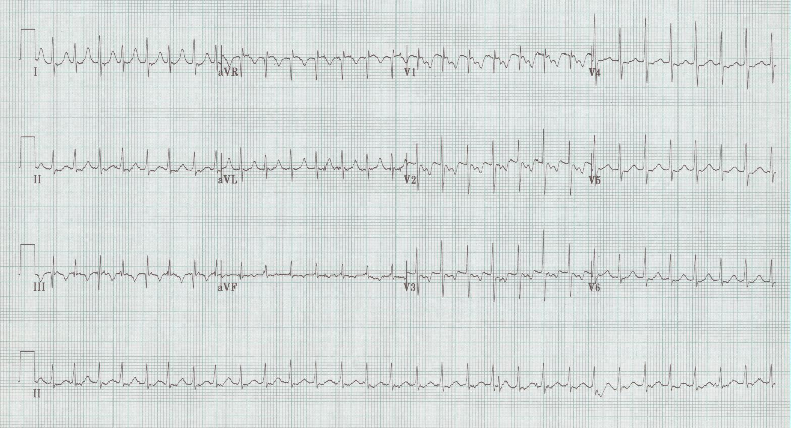
10.

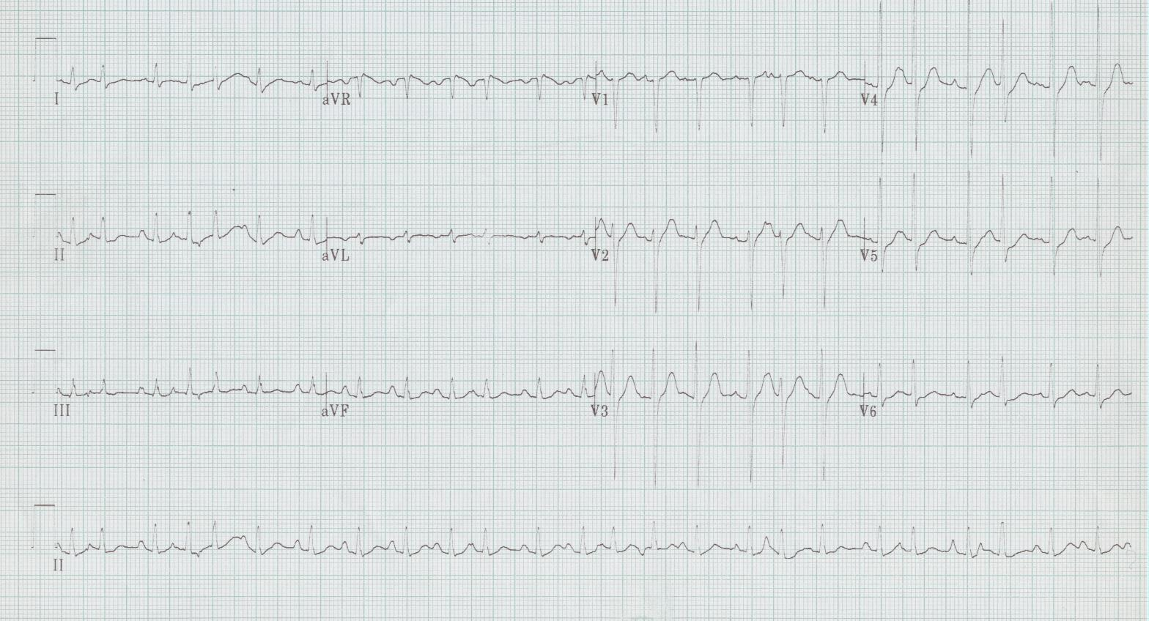
11.

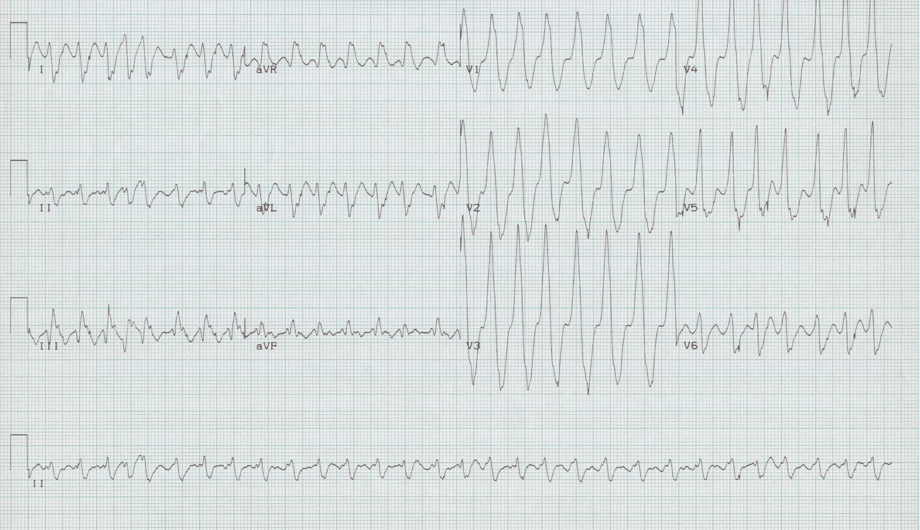
12.

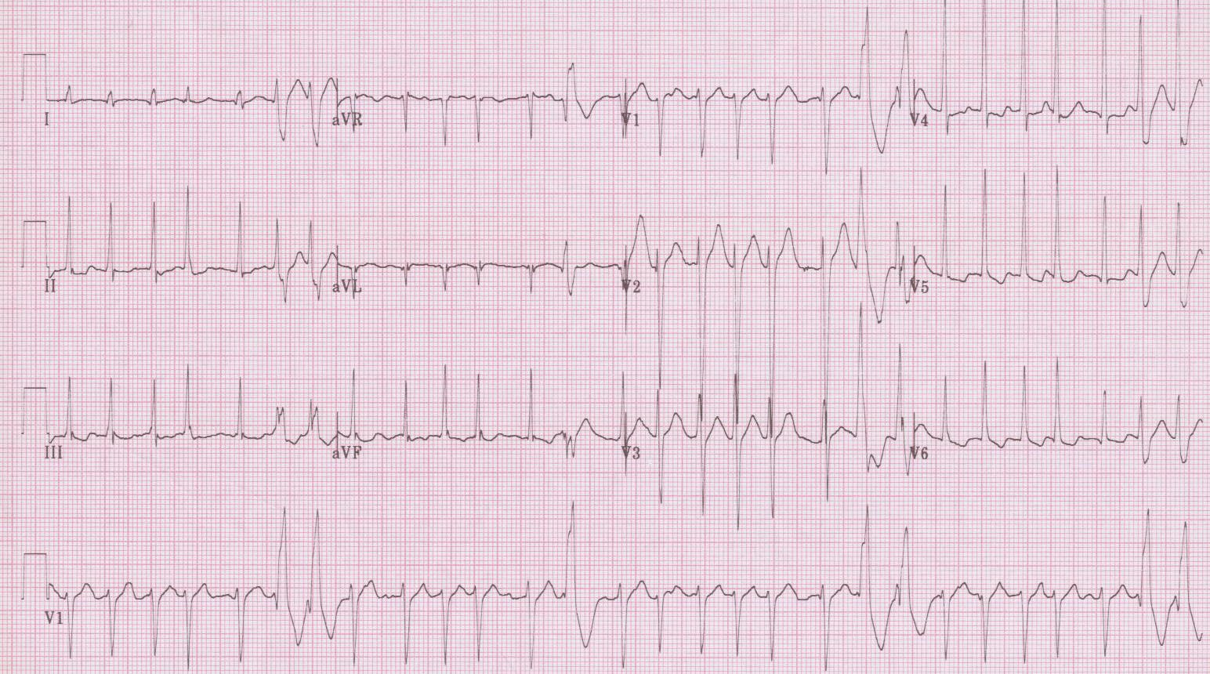
13.

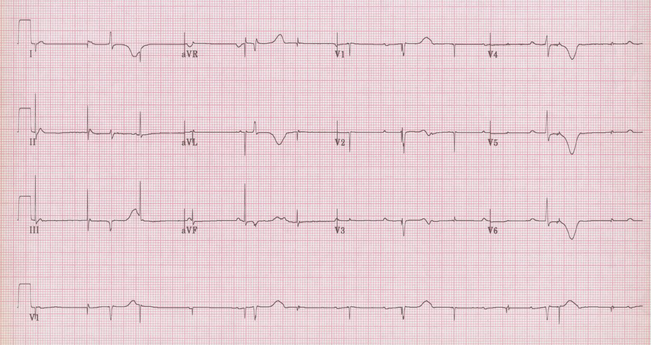
14.

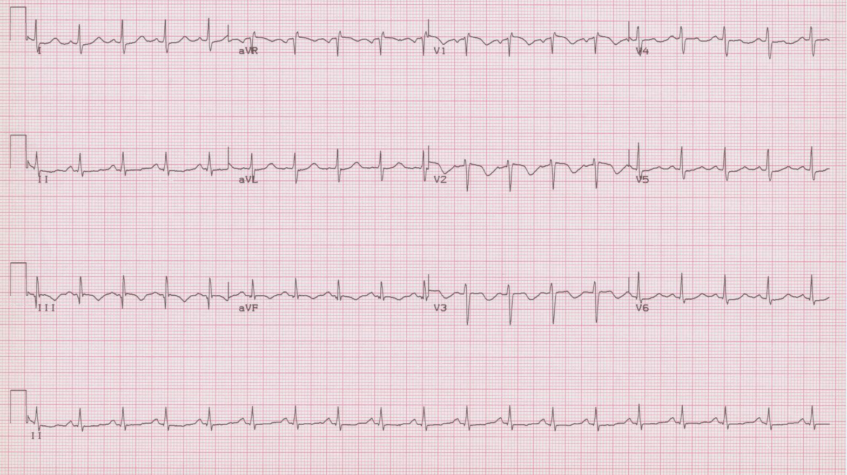
15.

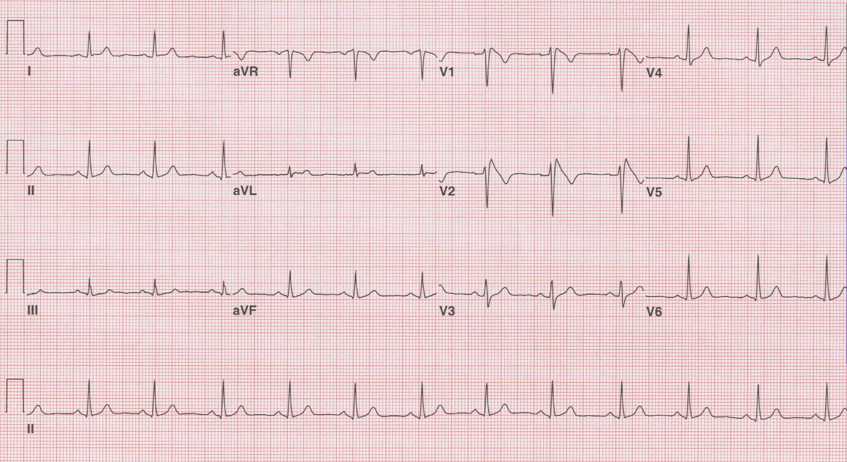
16.

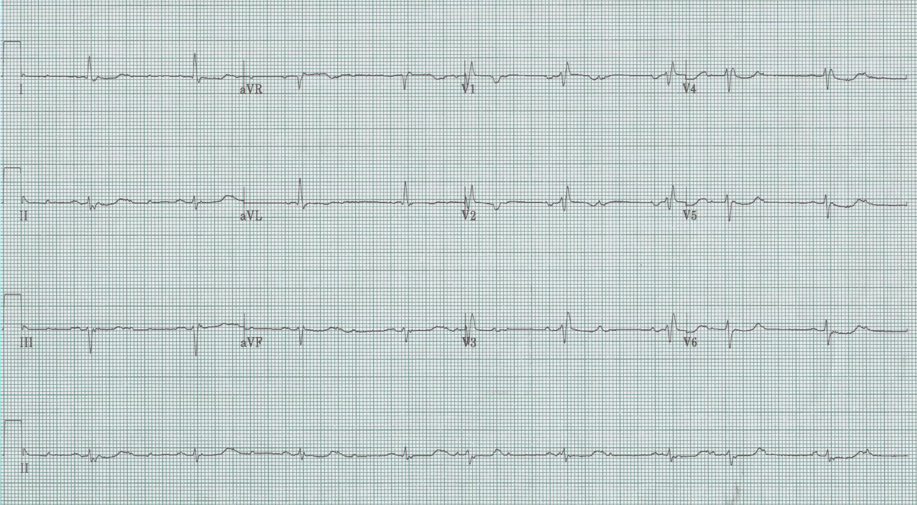
17.

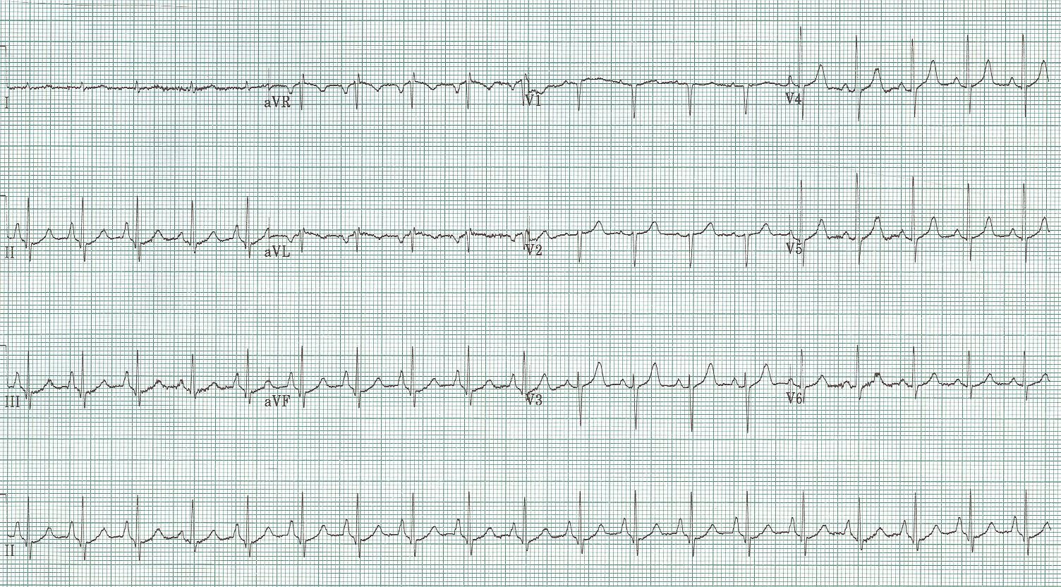
18.

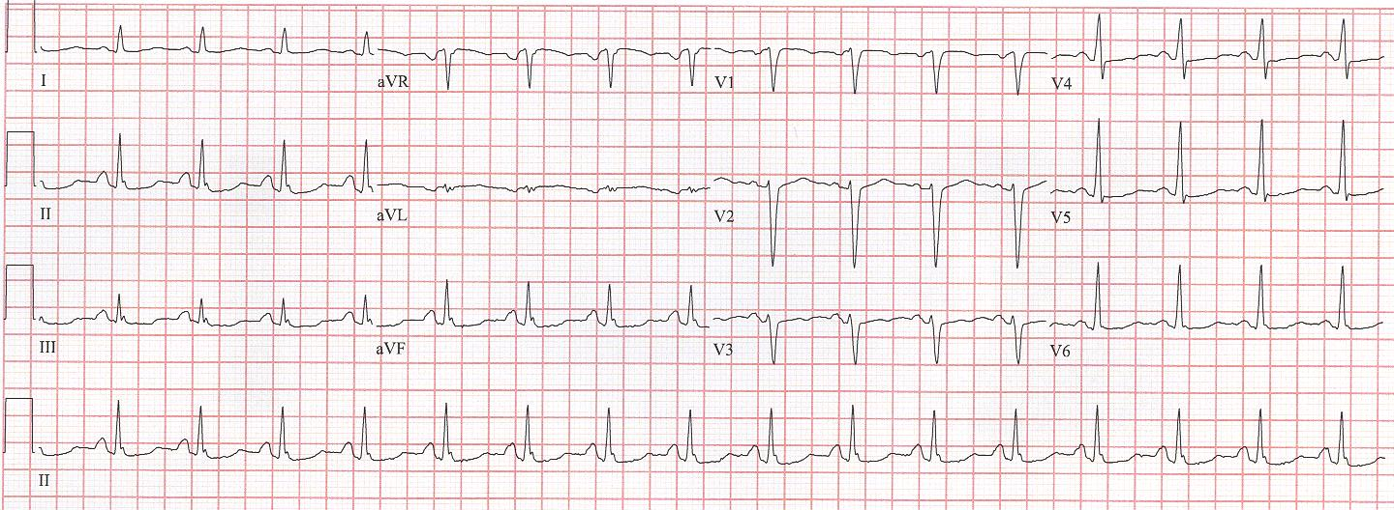
19. Unknown #1.

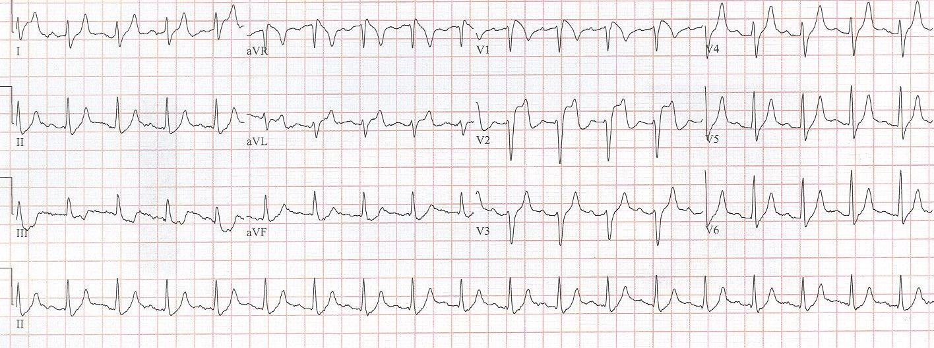
20. Unknown #2.

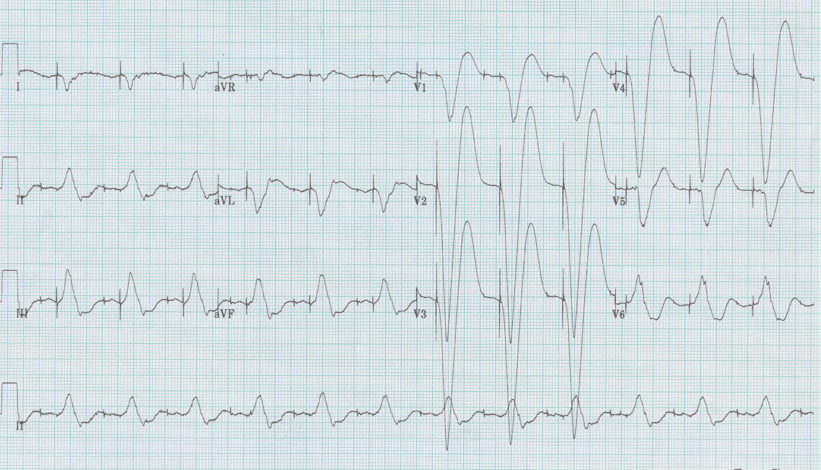
21. Unknown #3.

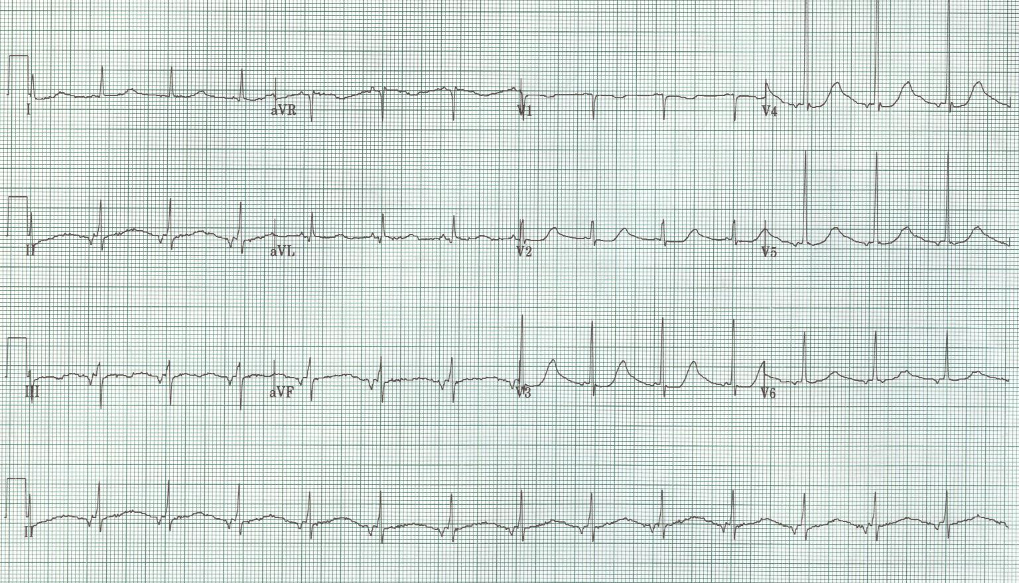
22. Unknown #4.

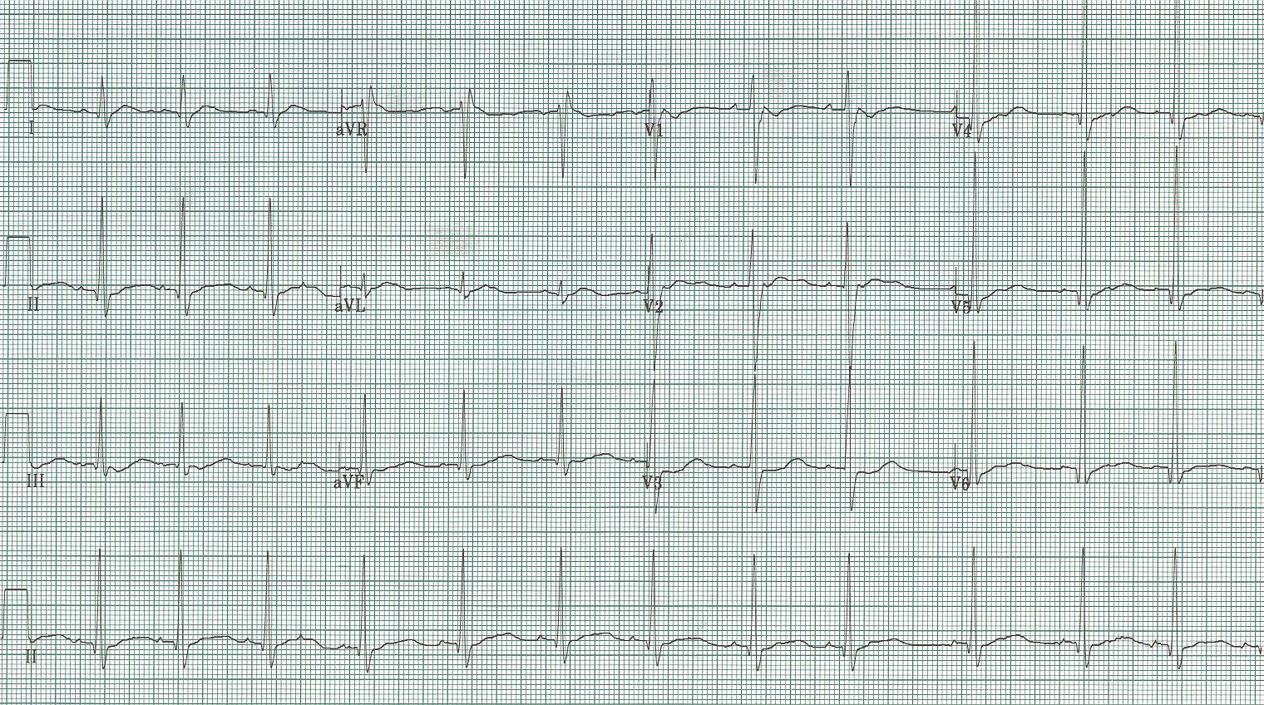
23. Unknown #5.

EKG Interpretations

- Sinus at 72/minute, left axis deviation (-60°), PR 220msec (1° AV block), tall and peaked T waves in V₃₋₄ consistent with hyperkalemia.
- Sinus at 108/minute, right axis (+100°), PR 240msec (1° AV block), QRS prolonged at 120msec, T waves are somewhat peaked and prominent compared to QRS – all suggestive of significant hyperkalemia.
- Sinus at 66/minute, prolonged QT in most leads although a distinction between diminished T waves and more prominent U waves can be appreciated inV₂₋₄, consistent with moderate hypokalemia.
- Sinus with very prolonged QT interval with down-sloping ST-segments consistent with severe hypokalemia. This elderly lady’s K⁺ was 1.7mEq/L; she was on hydrochlorothiazide for hypertension.
- Sinus at 84/minute, normal axis, QT interval appears very short even to the eye – this elder gentleman with metastatic gastric cancer presented with confusion and lethargy; hypercalcemia – his Ca⁺⁺ was 16mEq/L.
- Sinus with T waves with the apex shifted toward the left – another sign of significant hypercalcemia.
- Sinus at 72/minute, normal axis, normal PR and QRS, but a QT that is obviously prolonged – consistent with hypocalcemia.
- Regular narrow-complex tachycardia at 145/minute, close inspection of inferior leads (II, III, aVF) reveal flutter waves – 2:1 atrial flutter. When the rate is 140-150, always consider 2:1 flutter!
- Regular narrow-complex tachycardia at 155/minute, note the pseudo-S waves in inferior leads (II, III, aVF) typical of retrograde P waves that occur with AVNRT (AV node reentry tachycardia) – the sinus rhythm that resulted when this SVT was cardioverted no longer had pseudo-S waves.
- Regular narrow-complex tachycardia at 180/minute consistent with SVT – note the alternans of QRS complexes in some leads (esp III) and the long RP interval (best seen in V₁) – all consistent with AVRT (AV reentry tachycardia) implicating a bypass tract. Once cardioverted the resultant rhythm demonstrated Wolff-Parkinson-White.
- Irregularly irregular tachycardia at 150/minute, with P waves of varying morphology and PR interval – consistent with multifocal atrial tachycardia (MAT).
- Irregularly irregular wide-complex tachycardia at 180/minute, with some variation among the QRS morphology and some RR intervals approaching a rate of 300/minute – both suggesting atrial fibrillation with a bypass tract. Once cardioverted the resulting EKG demonstrated Wolff-Parkinson-White syndrome.
- Atrial fibrillation with a ventricular response of 172/minute with multiple wide complexes – either aberrantly conducted supraventricular beats or PVCs. Ashman’s phenomenon predicts that these beats are aberrantly conducted beats (long R-R, short R-R predicts aberrant conduction in a RBBB morphology).
- Underlying complete heart block with ventricular escape at 24/minute and P waves at 75/minute, and pacer spikes at 72/minute that neither sense nor capture – pacemaker failure due to battery depletion.
- Sinus at 115/minute, normal axis, T wave inversion in V₁₋₃ suggestive of acute right heart strain associated with acute pulmonary embolus.
- Sinus at 74/minute, normal axis, normal intervals, unique down-sloping ST-segment in V₁₋₂ – classic for Brugada syndrome, a Na-channelopathy causing ventricular arrhythmias and sudden death in a middle-aged population.
- Sinus at 60/minute with some ectopic beats…on closer inspection there is a second set of P waves, a few of which conduct – this is a heart transplant patient with two sinus nodes (one from the remnant of native atria, the other from the transplanted heart).
- Sinus at 120/minute, axis 90°, tall peaked P waves inferiorly (“P-pulmonale” of right atrial enlargement), and a “lead I sign” of COPD (all complexes essentially isoelectric) suggestive of COPD.
- 45-year-old woman presents with carpal spasm; she is 6 months s/p thyroidectomy and has not followed with providers as recommended. QT interval is prolonged and she has hypocalcemia due to hypoparathyroidism.
- 40-year-old heroin user presented with agitation and back pain, early EKG as shown with question ST-elevation V₁₋₂, interventional cath signed off the case when labs returned with K 7.8, BUN 27, creatinine 3.6, and CPK 28,960 – rhabdomyolysis causing ATN and hyperkalemia (induced Brugada due to hyperkalemia).
- Wide QRS complex and tall T waves (especially V₂₋₄) – a change compared to old tracings, suggesting hyperkalemia in this paced tracing.
- Middle-aged alcoholic with vomiting x 3 days experienced syncope. While being evaluated in ED experienced torsade de pointe. Labs returned with Mg 0.5, and K 2.5 – prolonged QT resolved with repletion of electrolytes.
- 14-year-old boy with recently diagnosed Graves disease with profound generalized weakness, K of 1.7mEq/L – diagnosed with thyrotoxic hypokalemic periodic paralysis. Note prolonged QT interval in V₃ but more clear T and U waves in lead V₂, consistent with prolonged QU due to hypokalemia.

References

Diercks DB, Shumaik GM, et al. Electrocardiographic manifestations: electrolyte abnormalities. J Emerg Med 27:153-160, 2004.

Fengler BT, Brady WJ, Plautz CU. Atrial fibrillation in the Wolff-Parkinson-White syndrome: ECG recognition and treatment in the ED. Am J Emerg Med 25:576-583, 2007.

Fox DJ, Tischenko A, et al. Supraventricular tachycardia: diagnosis and management. Mayo Clin Proc 83:1400-1411, 2008.

Junttila MJ…Brugada R. Induced Brugada-type electrocardiogram, a sign for imminent malignant arrhythmias. Circ 117:1890-1893, 2008.

Littmann L, Monroe MH, et al. The hyperkalemic Brugada sign. J Electrcard 40:53-59, 2007.

Mallet ML. Proarrhythmic effects of adenosine: a review of the literature. Emerg Med J 21:408-410, 2004.

If you would like more practice or review, I invite you to check out my free on-line access website with EKG files, EKG of the Week challenges, discussions of various EKG topics or controversies, and copies of handouts and PowerPoint presentations that I have done around the world (including AAEM 16 workshop).

www.TorreyEKG.com

New postings to the website are announced on Twitter…

@STorreyMD

