Induced Brugada Syndrome

A 41-year-old heroin user presented to the ED with agitation and back pain. An ECG early in his course was concerning for STEMI and the interventional cath team was alerted.

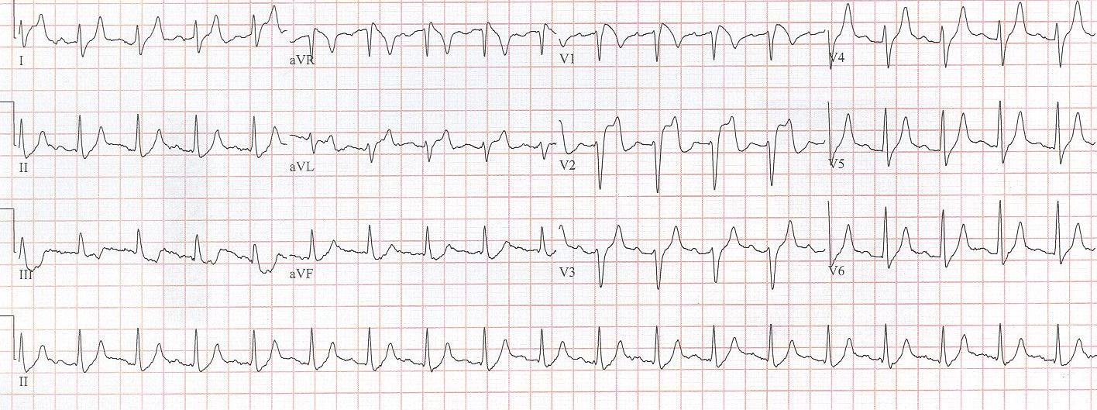

His labs returned with a non-hemolyzed potassium of 7.8! Other pertinent labs included BUN 27 and creatinine 3.6 (8/1.1 one month earlier) and CPK 28,960. Needless to say, once these labs returned, cardiology signed off on the case. He was hyperkalemic and had ATN from rhabdomyolysis.

The hyperkalemia was aggressively treated and the following ECG was obtained 90 minutes later.

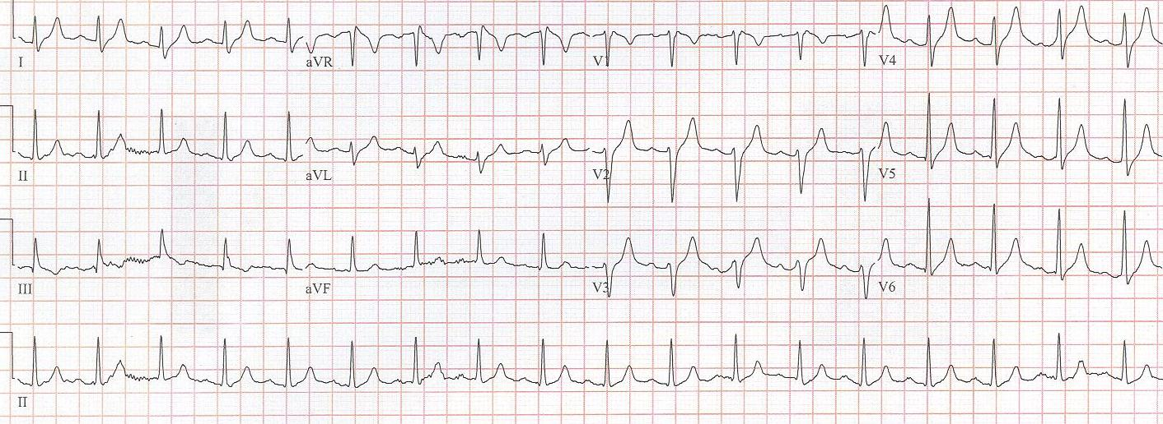

There have been multiple case-reports of hyperkalemia presenting with ECG changes typical of Brugada pattern. Perhaps Littmann, who reported 9 patients from his practice over 10 years, and also reviewed an additional 15 cases from the literature, published the best series. In most ECGs of hyperkalemic Brugada changes, the typical signs of Brugada (coved ST segments in V₁₋₂) are superimposed on changes of hyperkalemia, such as QRS widening, axis shifts, or flattening or absence of P waves. But in some cases, the Brugada changes were the only sign of hyperkalemia.

Junttila, who works with the Brugada brothers, reported a series of 47 patients who presented with Brugada-type ECG changes induced by one of several factors known to “unmask” Brugada syndrome. These factors included Na-channel blocking medications, propofol, cocaine, TCA, hyperkalemia, and fever. Of the 47 patients reported, 24 (51%) developed malignant arrhythmias during the acute event., including 18 with sudden cardiac death. The author concludes that the presence of a Brugada-type ECG pattern in patients during an acute event such as fever, treatment with several medications, drug use or electrolyte abnormality should be considered a risk factor for the development of life-threatening arrhythmias.

Some patients with inducible Brugada changes have been shown to have a genetic mutation of the Na-channel as in classic Brugada syndrome. Many factors, which are associated with unmasking Brugada, involve either reduction in inward sodium current (Na-channel blocking agents, TCA, cocaine) or augmenting outward sodium current (hyperkalemia). Mutated sodium channels have been shown to exhibit temperature-dependent gating changes and thus more evident ECG changes at increased temperatures.

It is difficult to make clinical recommendations regarding this phenomenon, but it is important, I believe, to be familiar with the occurrence of transient Brugada pattern during acute medical conditions that do find their way to the emergency department. When these changes are noted, think of hyperkalemia, treat the fever or stop the potential offending medication, and I would suggest monitoring the patient’s rhythm closely.

___________

Adler A…Antzelevitch C, et al.Fever-induced Brugada pattern: how common is it and what does it mean? Heart Rhythm 10:1375-1382, 2013.

Junttila MJ, Gonzalez M…Brugada, Brugada, Brugada. Induced Brugada-type electrocardiogram, a sign for imminent malignant arrhythmias. Circ 117:1890-1893, 2008.

Littmann L, Monroe MH, et al. The hyperkalemia Brugada sign. J Electrocardiol 40:53-59, 2007.

Mizusawa Y, Wilde A. Brugada Syndrome. Circ Arrhythm Electrophysiol 5:606-616, 2012.

Refaat MM, et al. Brugada Syndrome. Card Electrophysiol Clin 8:239-245, 2016.

