EKG signs of ischemia and infarction

Evolution of transmural MI

- hyperacute T waves
  - within minutes after onset of acute occlusion
  - transient
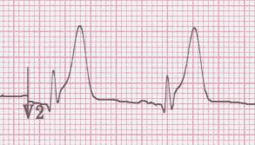

- giant R waves
  - “tombstones”
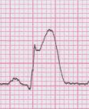

- ST segment elevation
  - begin to decrease within 6 hours after onset (faster after reperfusion)
  - most subside within few days – if persist after weeks consider aneurysm
  - may see reciprocal changes in opposite leads

- T wave inversion
  - begin to develop as ST segments return to baseline
  - remain for days to weeks
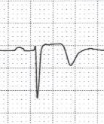

- abnormal Q waves
  - begin to develop in 6-12 hours, sooner with intervention
  - usually persist indefinitely

Differential of ST-segment elevation
- STEMI
- LBBB
- left ventricular hypertrophy
- ventricular paced rhythm
- benign early repolarization
- pericarditis
- left ventricular aneurysm

LBBB
EKG criteria
- QRS ≥ 0.12 mm
- monophasic R wave in aVL, V₆
- absence of Q waves in lateral leads (septal Q’s)
- repolarization changes – expected discordance
  - ST segment elevation in precordial leads (V₁ – V₃)
  - T wave inversion in lateral leads (I, aVL, V₅ –V₆)

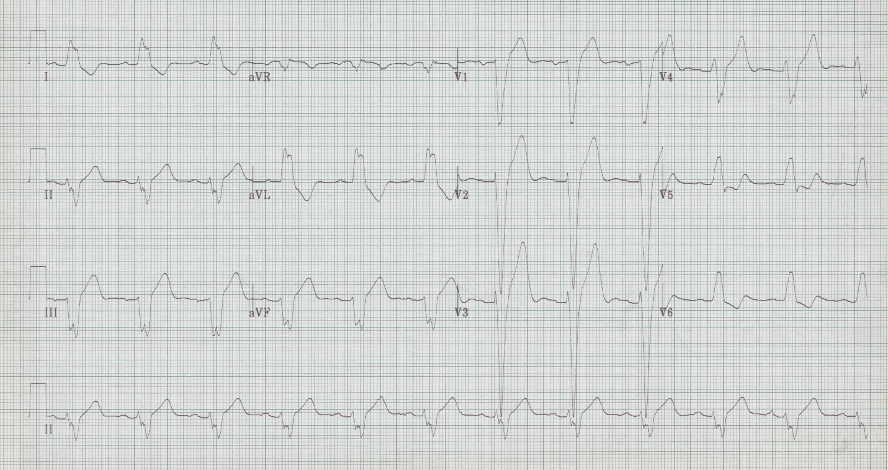
LBBB with expected ST and T wave changes

Ventricular paced rhythm (looks a lot like LBBB pattern)
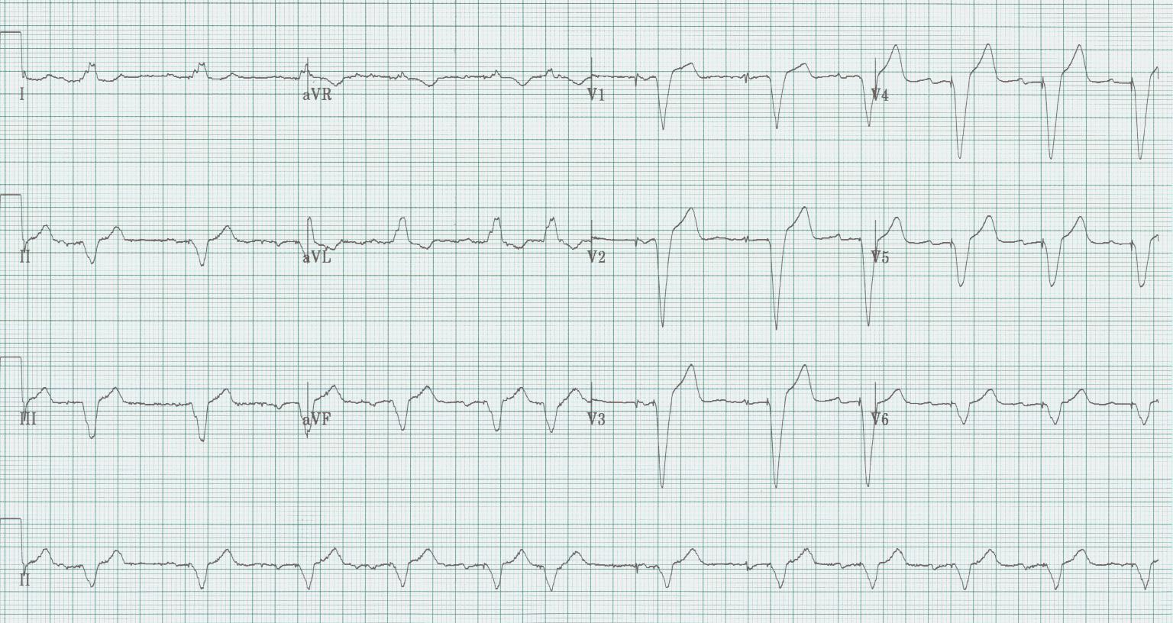

LVH (severe, with repolarization changes)
EKG criteria
- S in V₁ or V₂ + R in V₅ or V₆ > 35 mm (in a patient > 35 years) or
- R in aVL > 11 mm
- +/- associated findings
  - ST-segment and T wave changes V₅₋₆, I, aVL (“strain pattern”)
  - QRS widening
  - Left axis deviation
  - ST elevation in V₁₋₂ associated with poor R wave progression

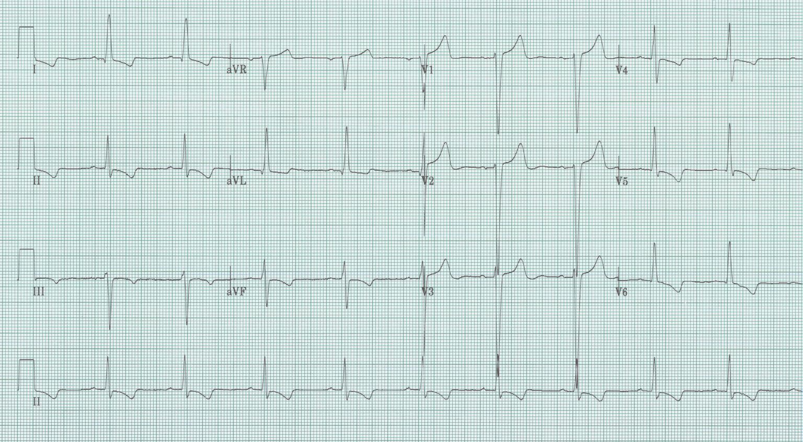

Benign early repolarization
EKG criteria
- ST elevation in precordial leads (most commonly V₃ then V₄ > V₂ > V₅
- upwardly concave ST segment (“smiley face”)
- J point elevation, frequently with notching
- ST elevation typically < 25% height of T wave in V₅₋₆ (vs. pericarditis or MI)
- tall R waves and early QRS transition (R/S ratio > 1 in V₂ or V₃
- tall peaked asymmetric T waves

- 31% of anterior MIs also manifest upwardly concave ST segments in V₃
- if T wave towers over R wave in V₂ or V₃ early repolarization unlikely

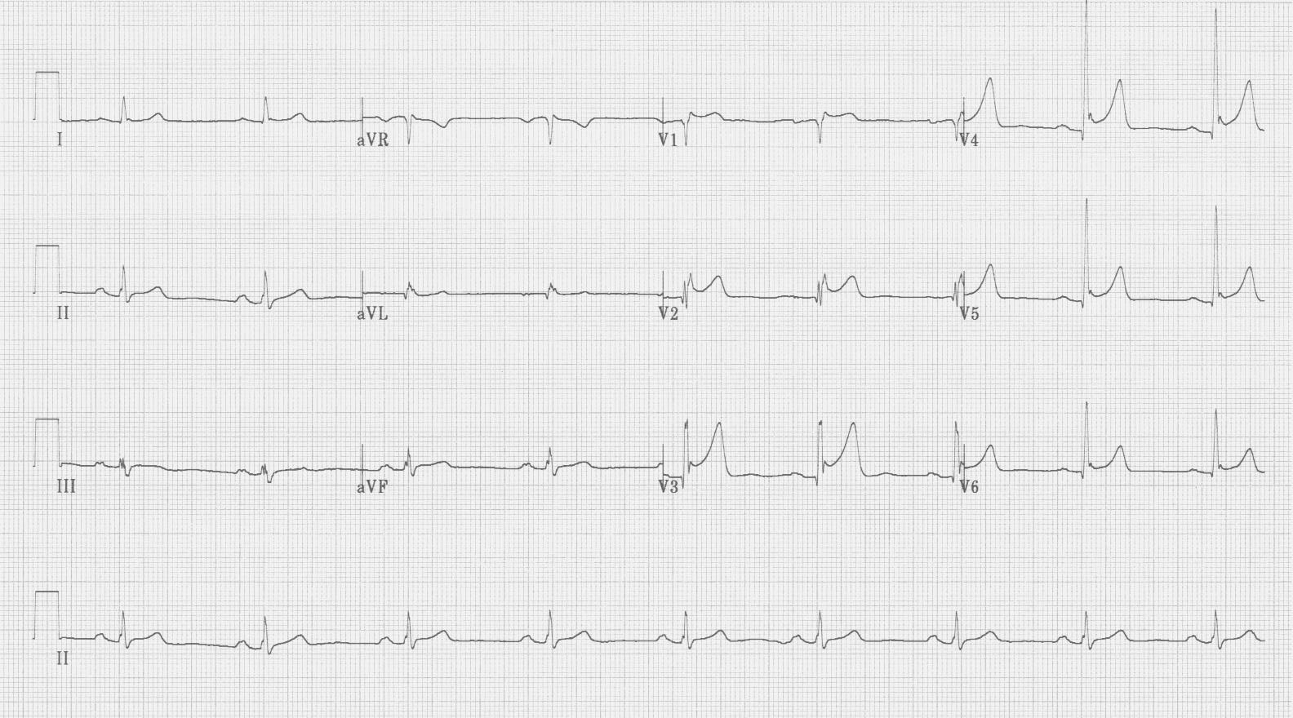
early repolarization

Ventricular aneurysm
EKG criteria
- ST elevation most common in leads V₂ and V₃
- usually ≤ 3 mm and almost always ≤ 4 mm
- T waves flattened or inverted, not tall or peaked
- Q waves are deep and well formed

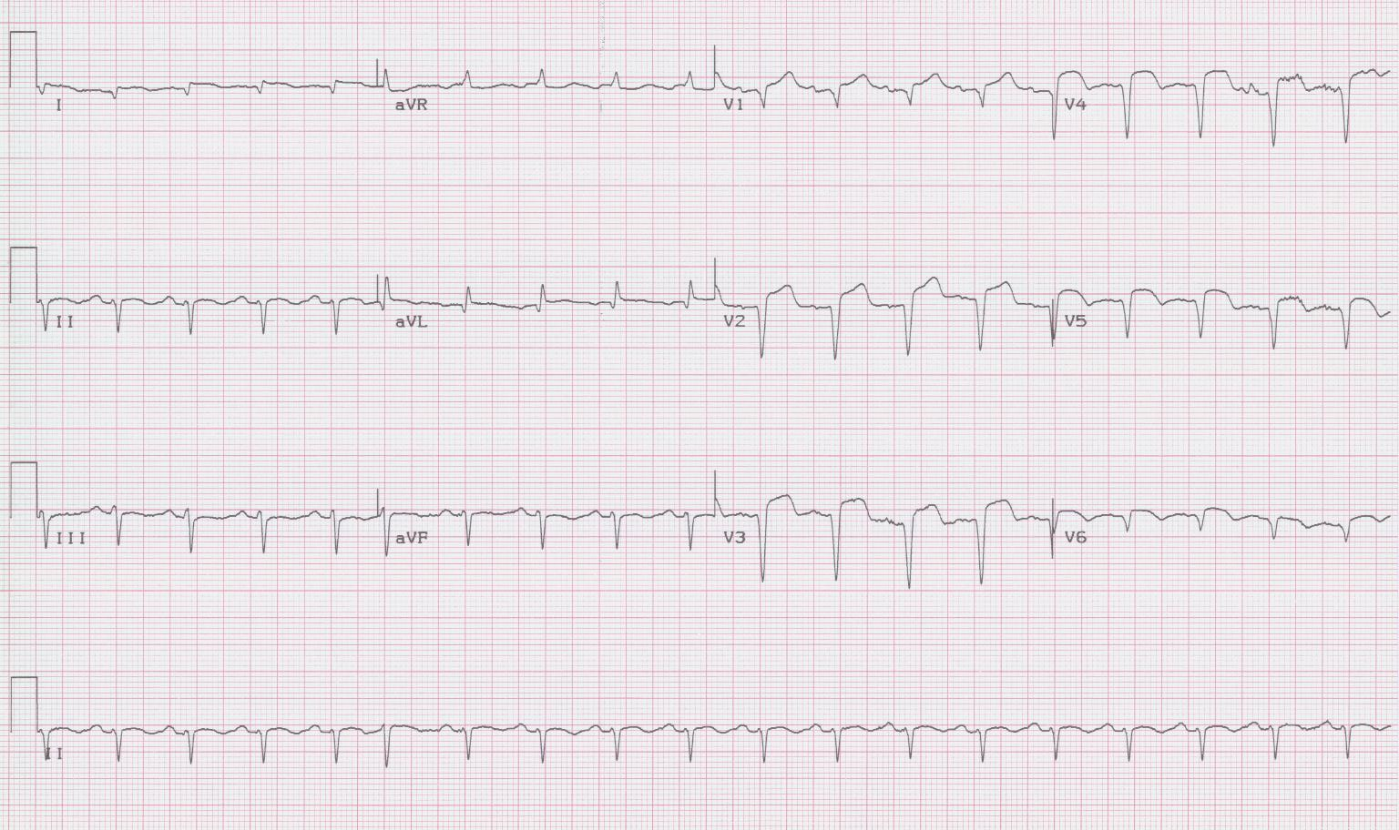
Left ventricular aneurysm

- “ventricular aneurysm” – a dyskinetic ventricular segment
- 80% anteriolateral, usually after LAD occlusion, associated with ↓ EF
- an uncommon cause of ST elevation (only 3-4% of EKGs with ST elevation)
- most frequently misinterpreted EKG in ED chest pain patient with high rate inappropriate thrombolytic (28% in non-AMI)

Pericarditis
EKG criteria
- diffuse ST elevation, typically greatest in II and V₅ (also I and V₆)
  - then in V₄ > V₃ > V₂ > V₁ (aVL least)
  - NO repolarization changes
- upwardly concave ST segment
- PR depression > 0.8 mm (relative to TP segment) is specific, not sensitive
  - most common in II, aVF, and V₄₋₆
  - PR elevation > 0.5 mm in aVR strongly suggests pericarditis

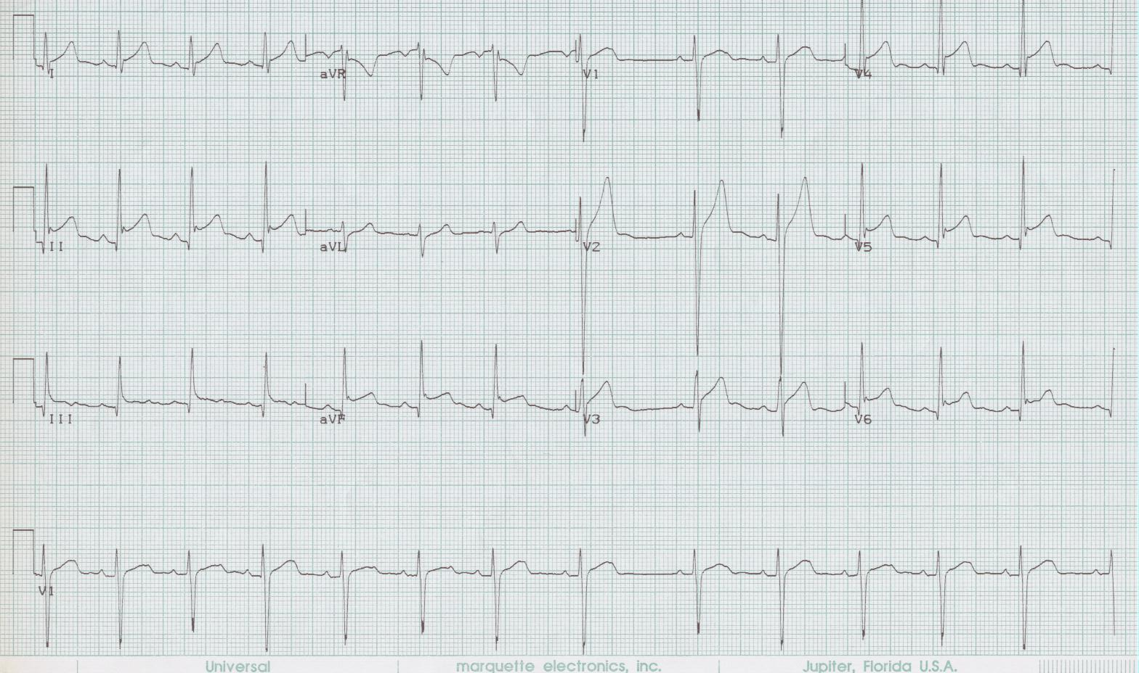
Pericarditis

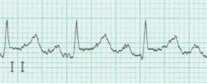
PR depression

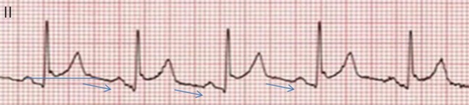
Spodick’s sign

Differential of impressively deep T wave inversion
- Ischemia (non-STEMI)
- Vasospasm
- CNS effect
- Wellens’ warning
- Takotsubo stress cardiomyopathy
- Post-ventricular pacing (“memory T waves”)

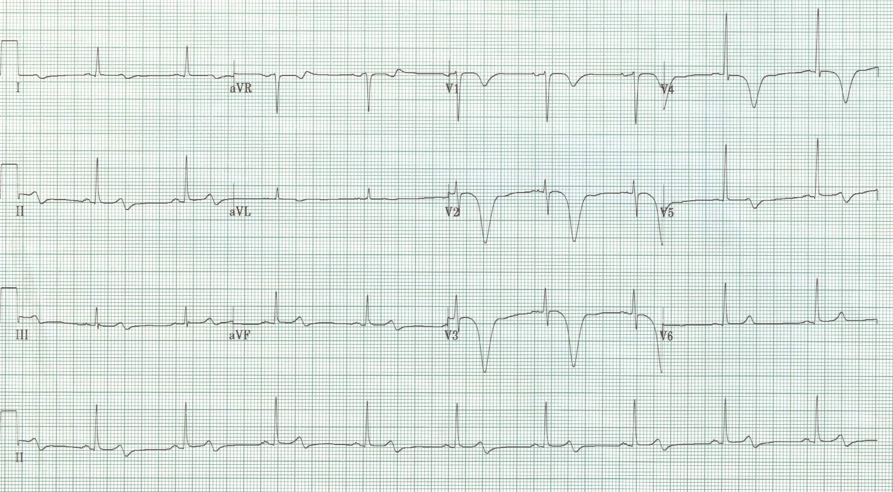
Chest pain after sumatriptan

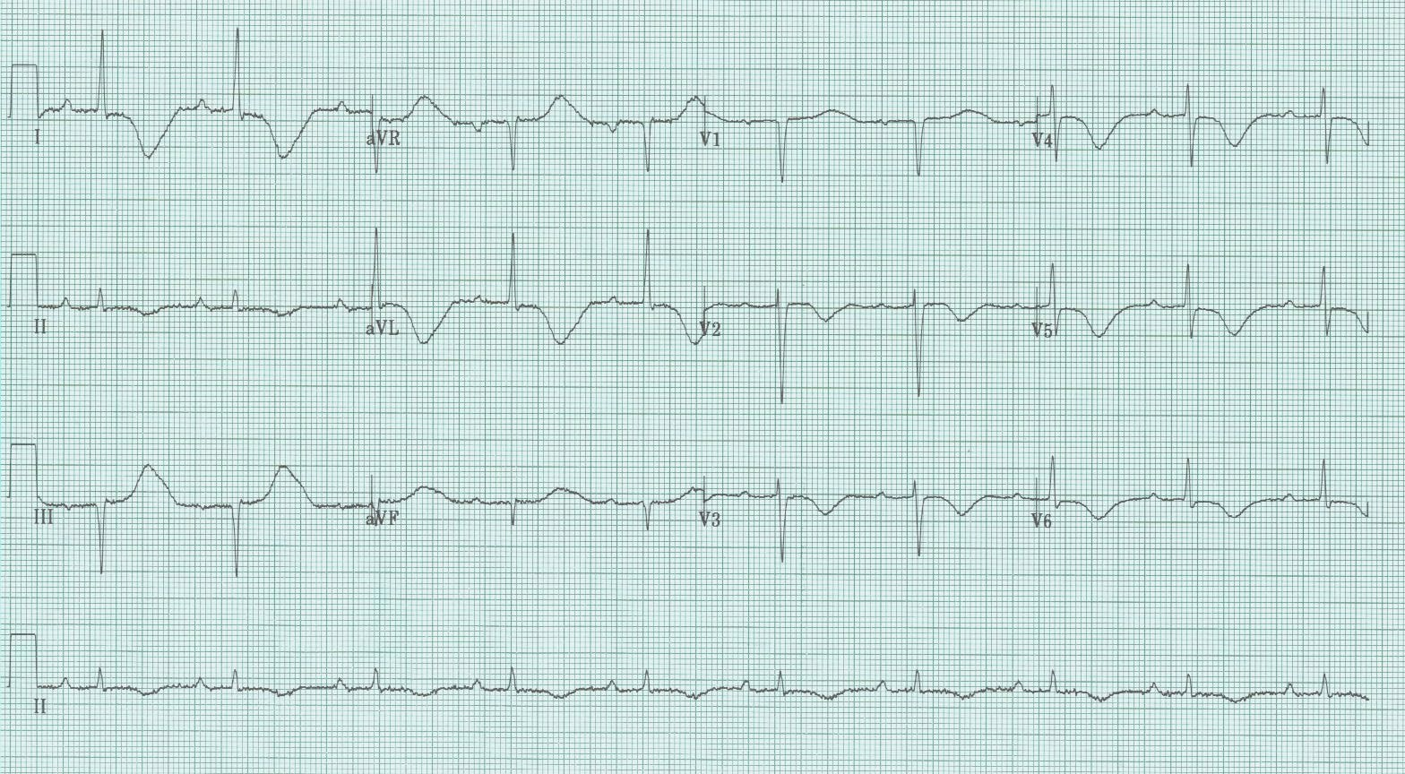
Worst headache of life

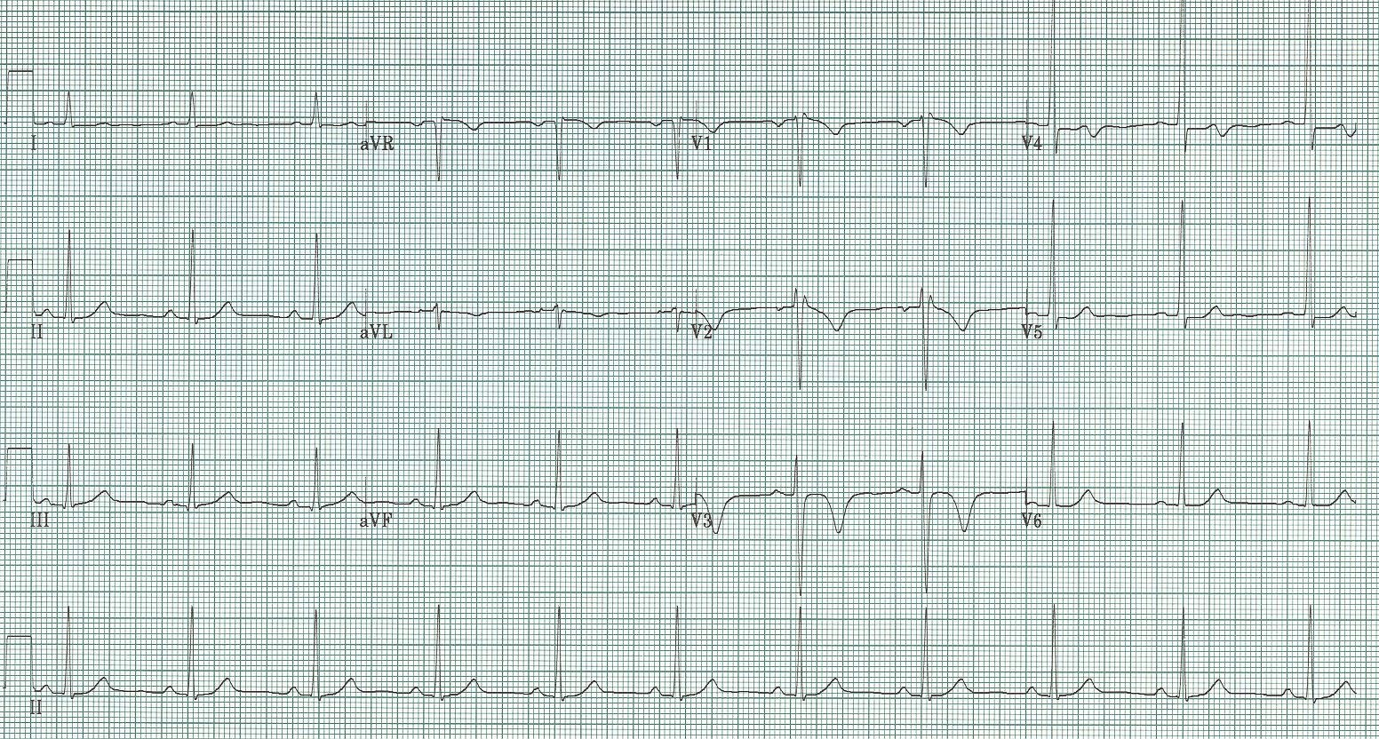
4 hours after chest pain episode

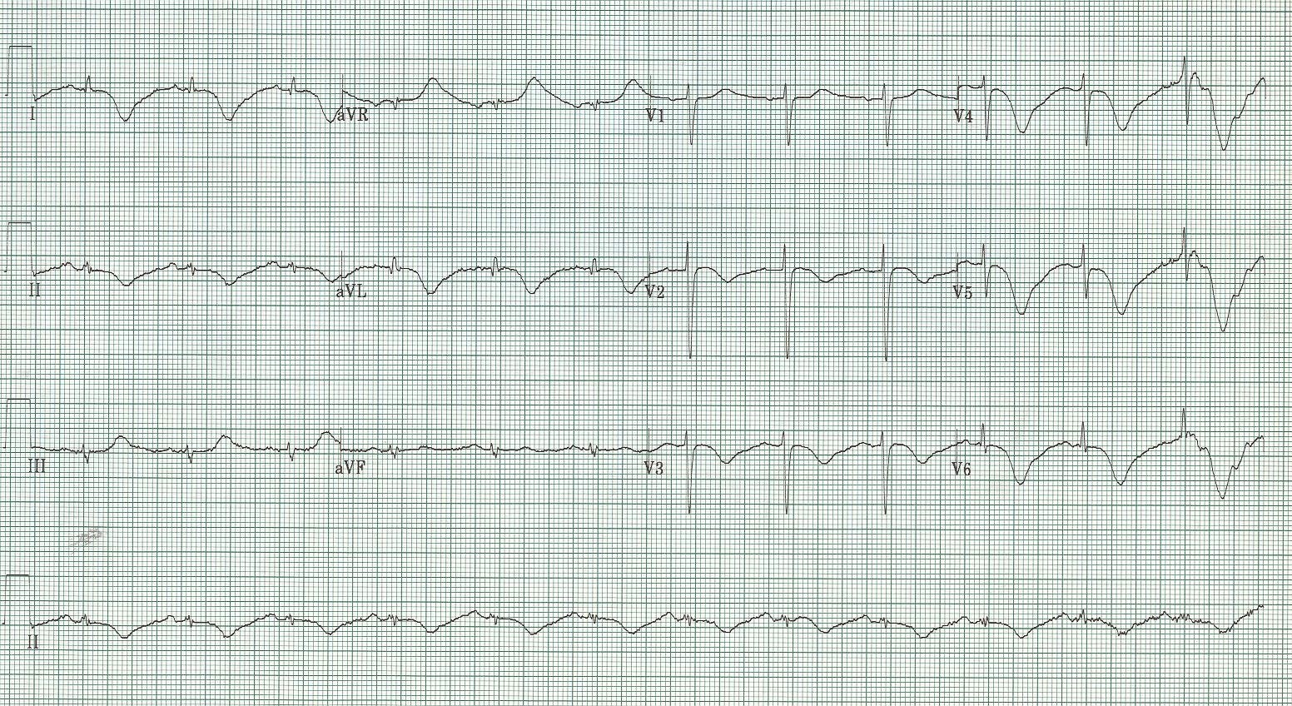
Chest pain after argument

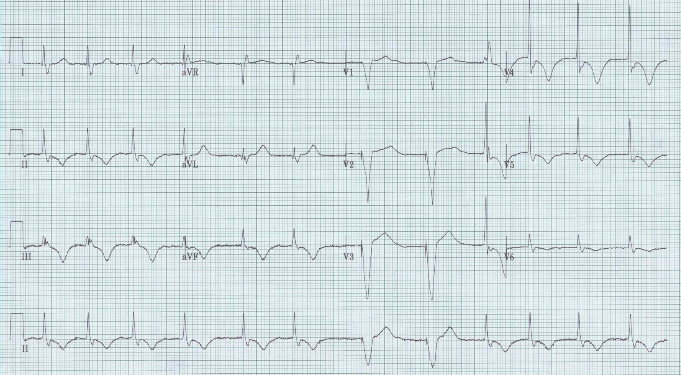
Post-ventricular pacing (“memory T waves”)

Subtle clues to infarction
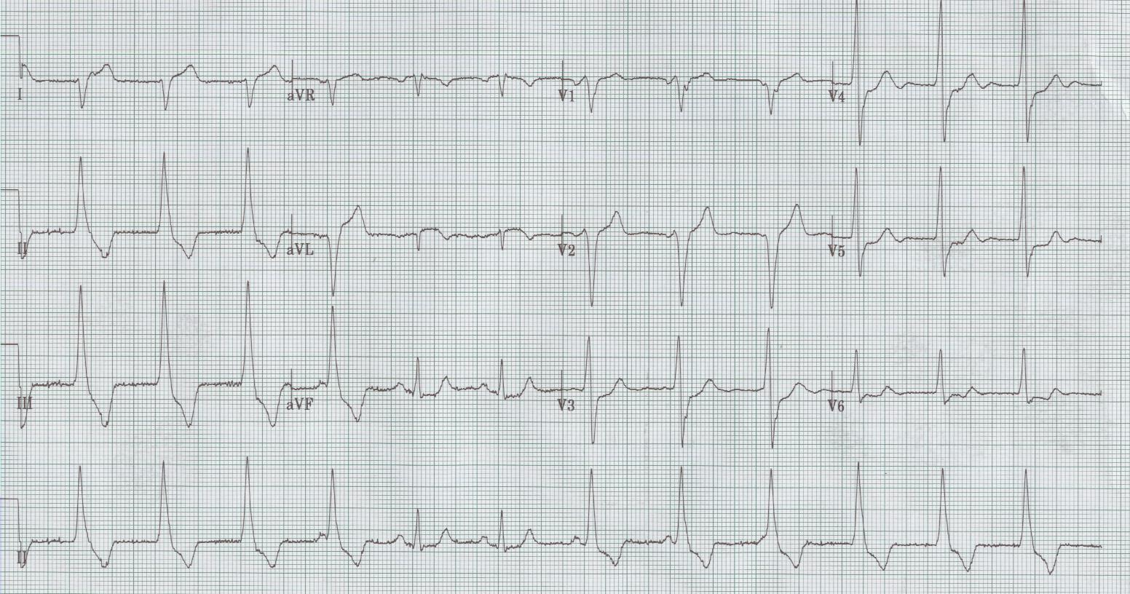
Accelerated Idioventricular Rhythm (AIVR)

References

Brady WJ. Acute posterior wall myocardial infarction: electrocardiographic manifestations. Am J Emerg Med 16:409-413, 1998.

Brady WJ, Perron AD, Chan T. Electrocardiographic ST segment elevation: correct identification of AMI and non-AMI syndromes by emergency physicians. Acad Emerg Med 8:349-360, 2001.

Engel J, Brady WJ, Mattu A, Perron AD. Electrocardiographic ST segment elevation: left ventricular aneurysm. Am J Emerg Med 20:238-242, 2002.

Hayden GE, Brady WJ, Perron AD, et al. Electrocardiographic T-wave inversion: differential diagnosis in the chest pain patient. Am J Emerg Med 20:252-262, 2002.

Rhinehardt J, Brady WJ, Perron AD, Mattu A. Electrocardiographic manifestations of Wellens’ Syndrome. Am J Emerg Med 20:638-643, 2002.

Sgarbossa EB, Pinski SL, Barbagelata A, et al. Electrocardiographic diagnosis of evolving acute myocardial infarction in the presence of left bundle-branch block. NEJM 334:481-487, 1996.

Spodick DH. Acute pericarditis: current concepts and practice. JAMA 289:1150-1153, 2003.

Wang K, Asinger RW, Marriott HJL. ST-segment elevation in conditions other than acute myocardial infarction. NEJM 349:2128-2135, 2003.

Zimetbaum PJ, Josephson ME. Use of the electrocardiogram in acute myocardial infarction. NEJM 348:933-940, 2003.

