Pacemakers and AICD
- how they work and why they sometimes don’t

Pacemaker nomenclature
I - chamber paced (Ventricle – Atria – Dual)
II - chamber sensed (V – A – D)
III - response to sensing (Trigger, Inhibit, Dual)

For example, common pacemakers include:
VVI – paces ventricle, sensing ventricular beat causes inhibition of pacing
DDD – senses and paces both chambers (2 leads), physiologic

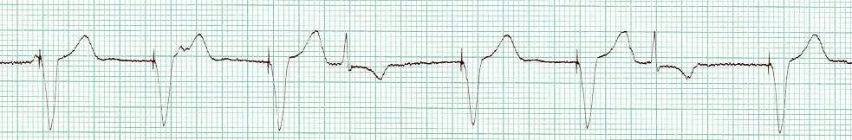
VVI pacemaker

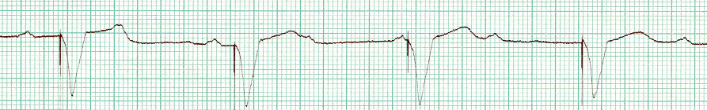
VVI pacemaker

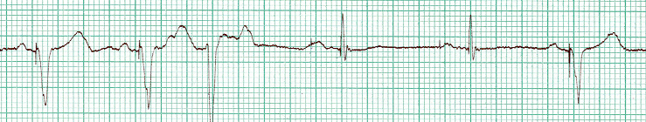
DDI pacemaker

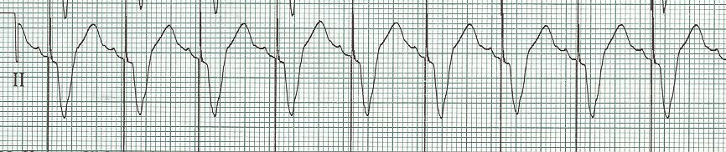
Unipolar lead – electricity between tip of lead and generator large voltage spike

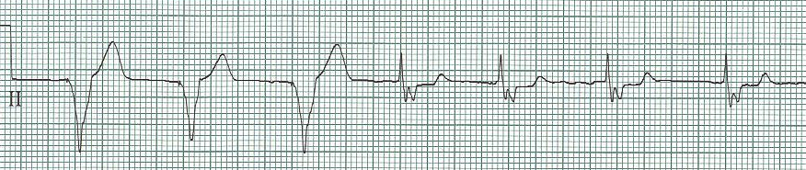
Bipolar lead – electricity between two electrodes on tip of lead small voltage spike

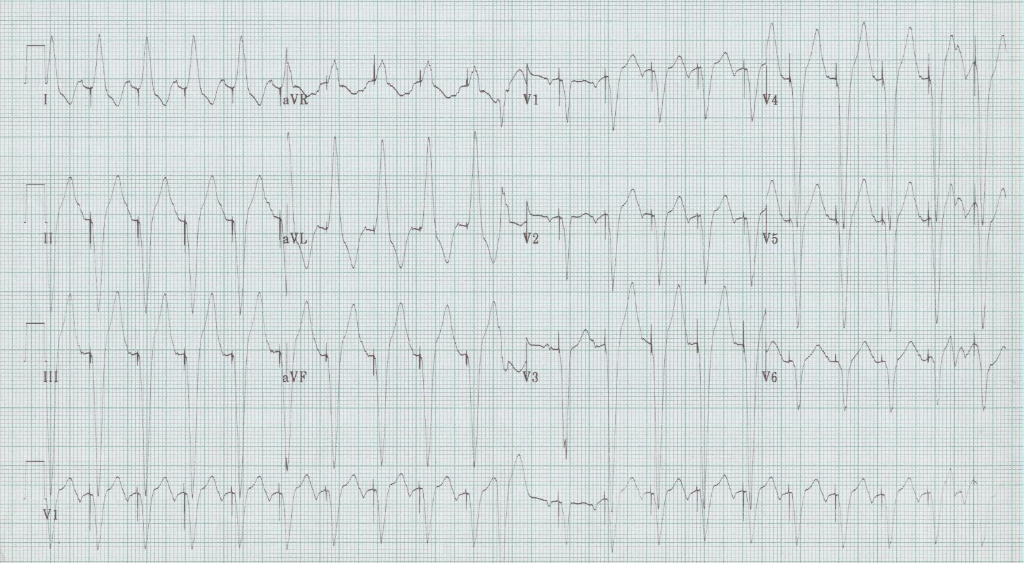
First quiz – why is this pacemaker firing at 130/minute?
Pacemaker malfunction

Failure to pace or discharge impulse
- component failure – rare
- total battery depletion – VVI 10-15 years, DDD 7-10 years
- lead fracture or disconnection
- oversensing – muscular activity or external electrical interference

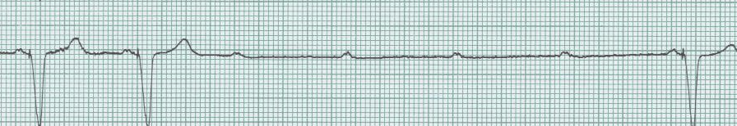

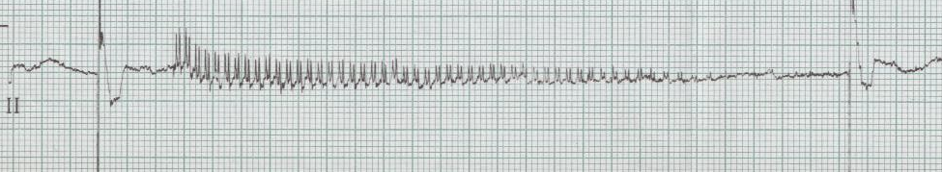

Failure to capture myocardium
- lead dislodgement – most common cause
- lead insulation break
- elevated myocardial threshold
- battery depletion

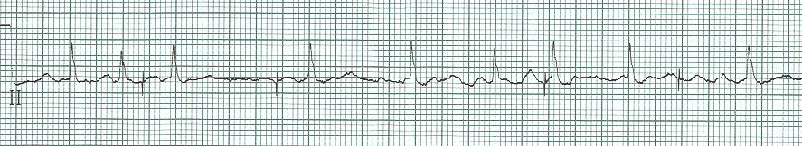

Failure to sense spontaneous depolarizations
- lead dislodgement
- poor lead placement
- change in cardiac signal or QRS morphology

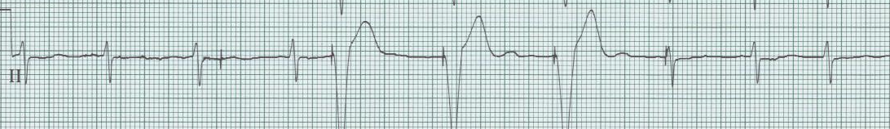
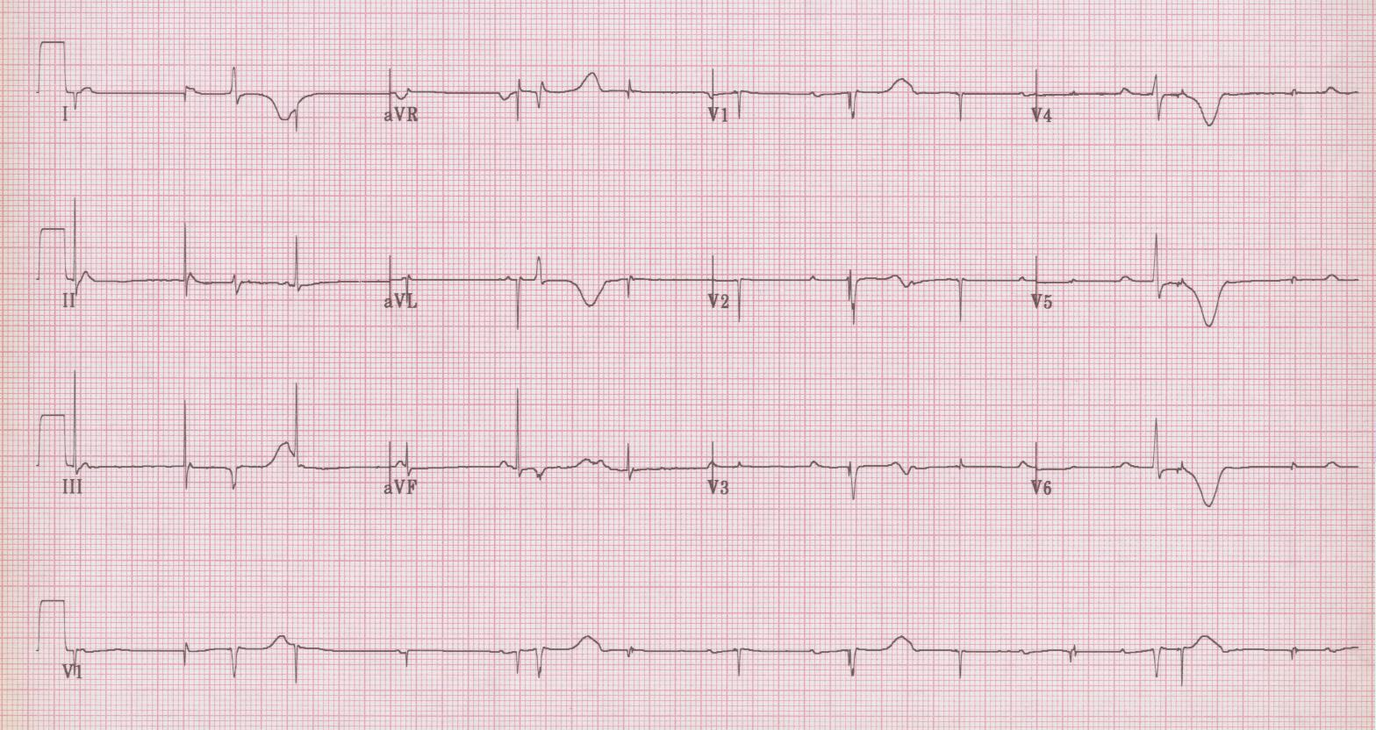
2nd Quiz – Elderly woman with syncope in church

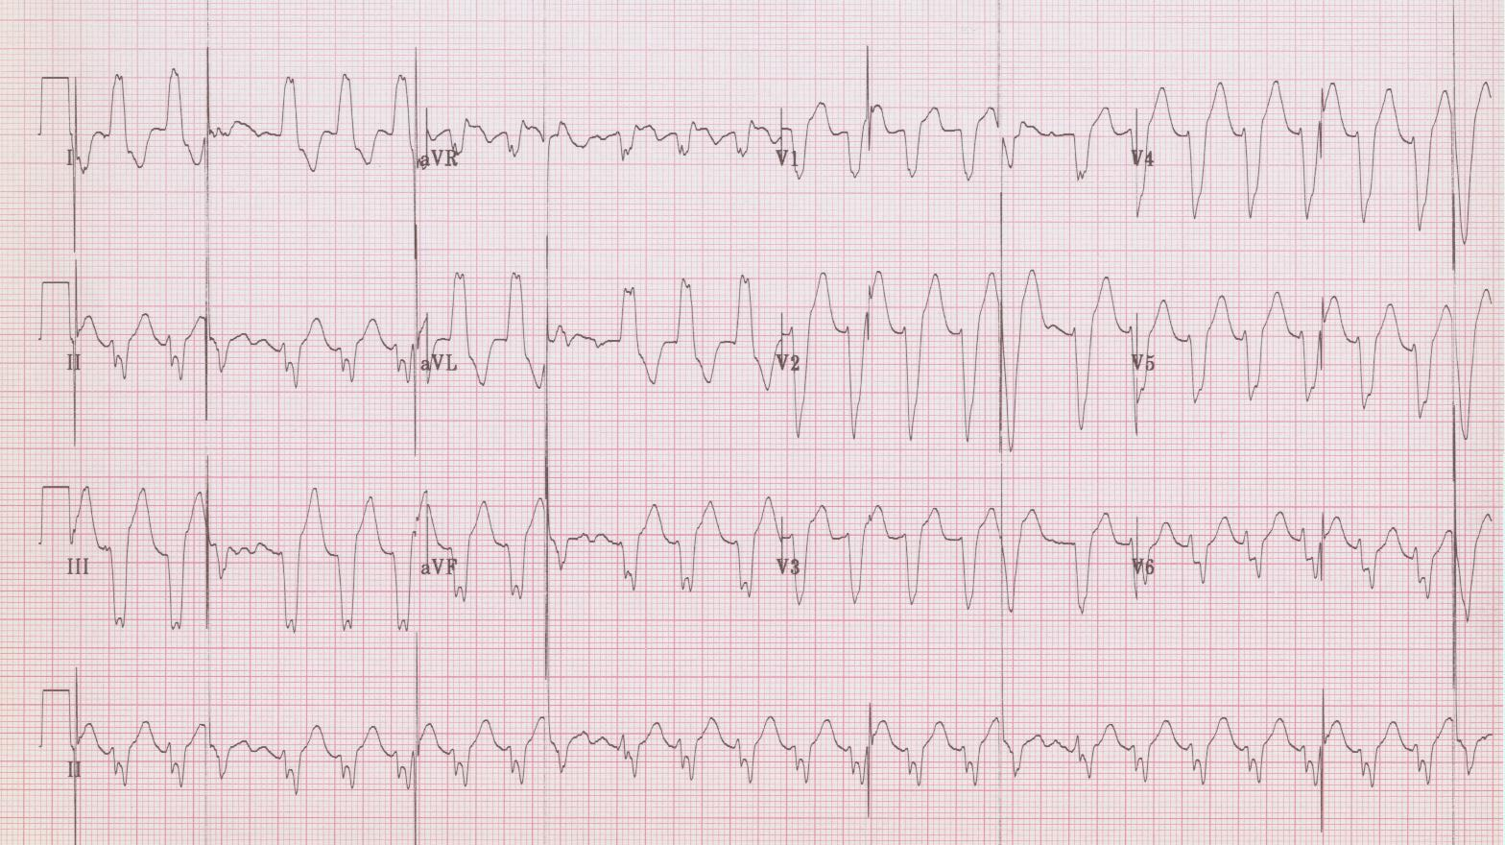
Quiz #3 – Elderly man with palpitations

Specifics of pacemaker malfunction

Lead dislodgement
- usually within first months after implantation
- increased risk – large RV, poor placement
- “Twiddler’s syndrome” – unintentional manipulation of generator
- into SVC or right atrium phrenic nerve stimulation pacing of diaphragm
hiccups – change in pacer spike and QRS complex

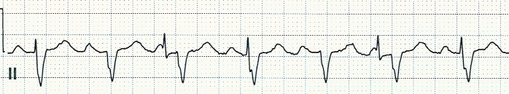

Lead fracture
- usually months after implantation
- caused by stress at connection site, chest trauma

Lead perforation
- usually soon after implantation (80% within 4 days)
- may cause acute tamponade
- failure to capture and sense, or change in complex (LBBB RBBB)

Failure to capture 2° elevated myocardial threshold
- threshold gradually increases 2° fibrosis
- hyperkalemia, acidosis, hypoxemia
- ischemia or infarction
- antiarrhythmic drug toxicity

Hysteresis
- programmable function that allows rate to be slightly lower than set
- may allow patients to retain their own rhythm without battery depletion
- EKG – inappropriately long interval after intrinsic beat

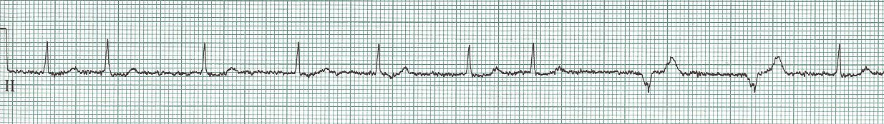

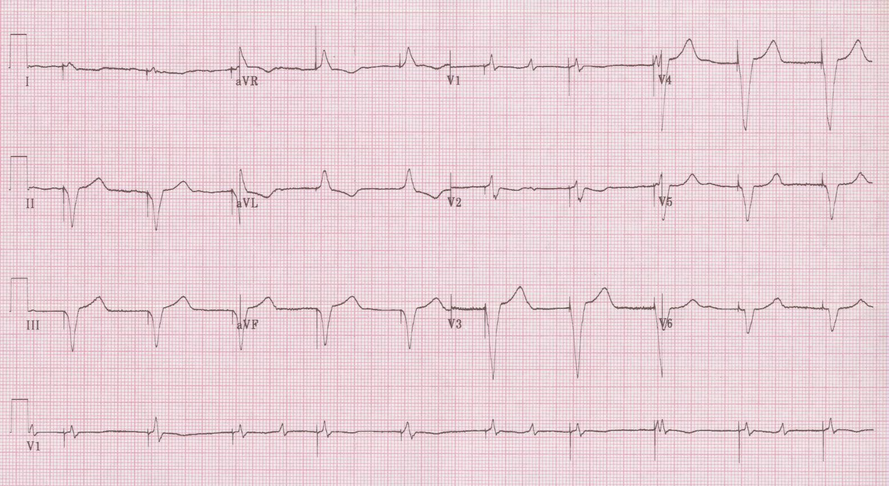
1

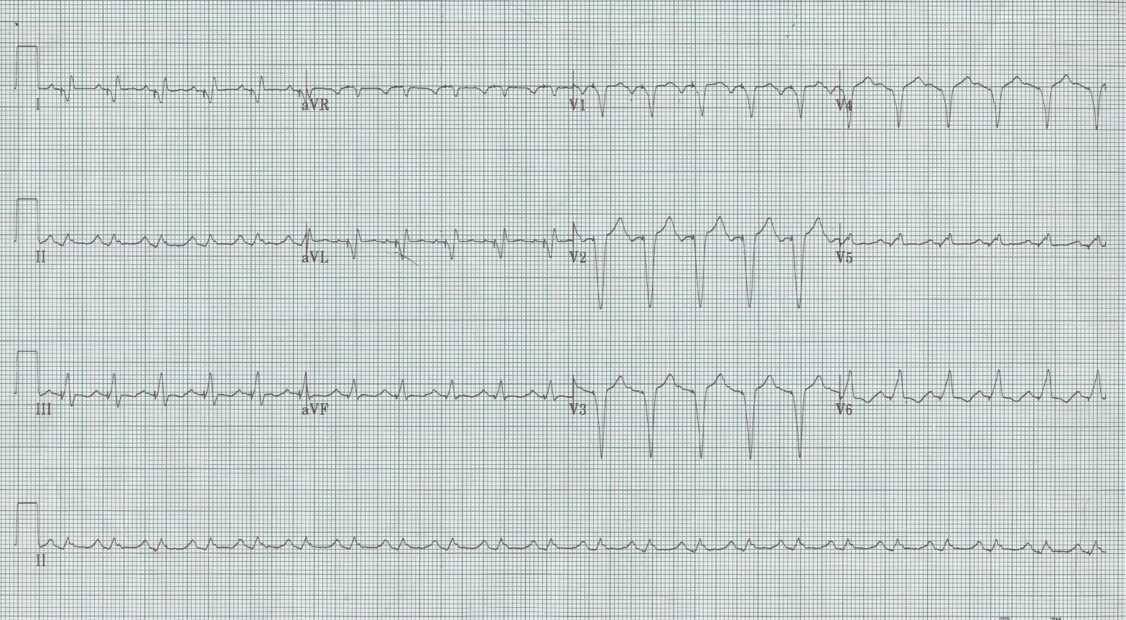
2

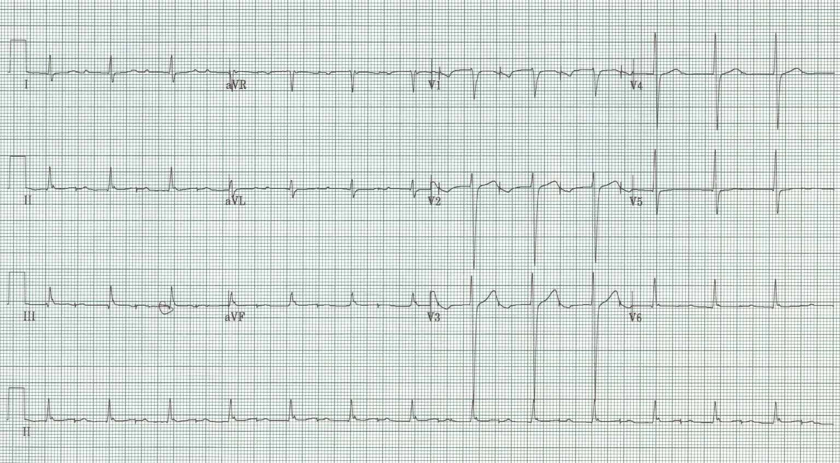
3

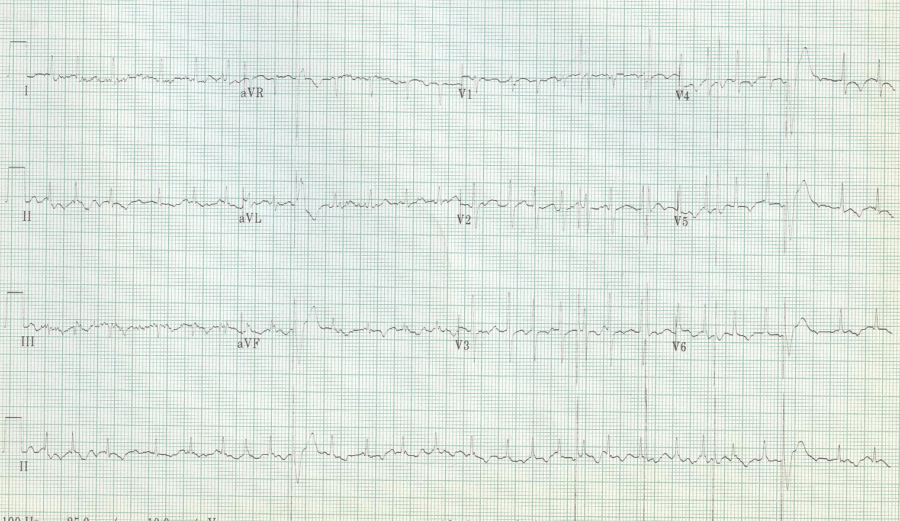
4

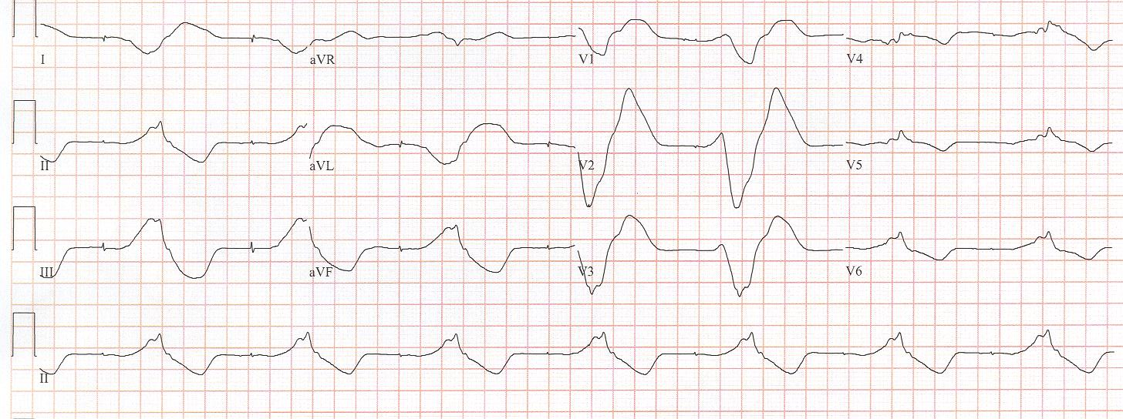
5

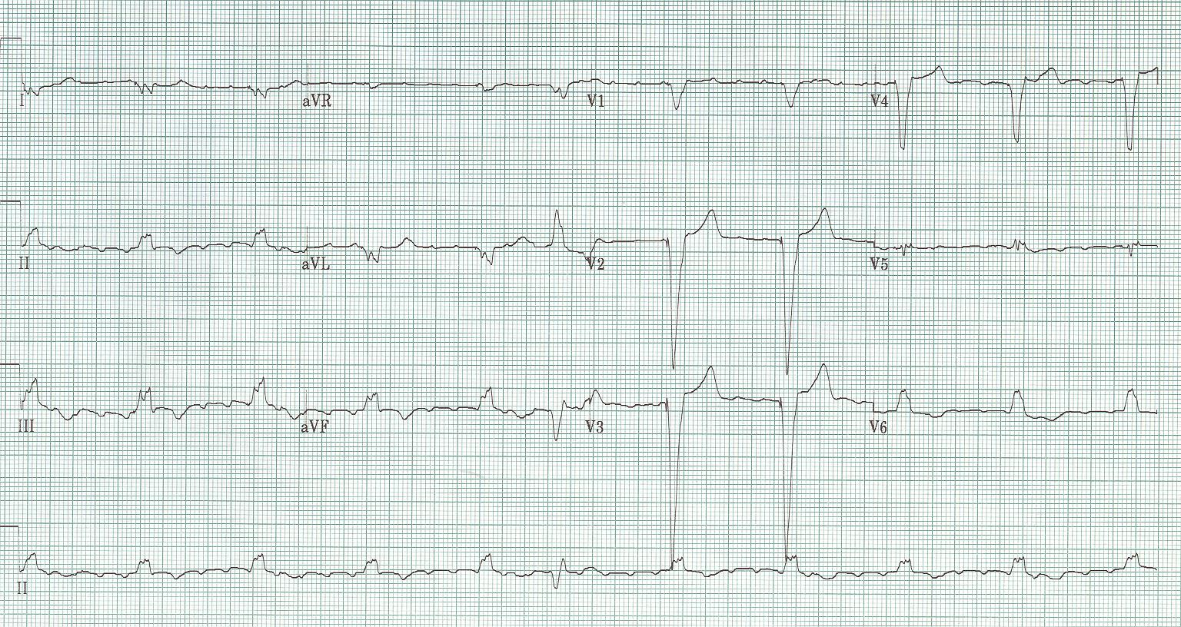
6

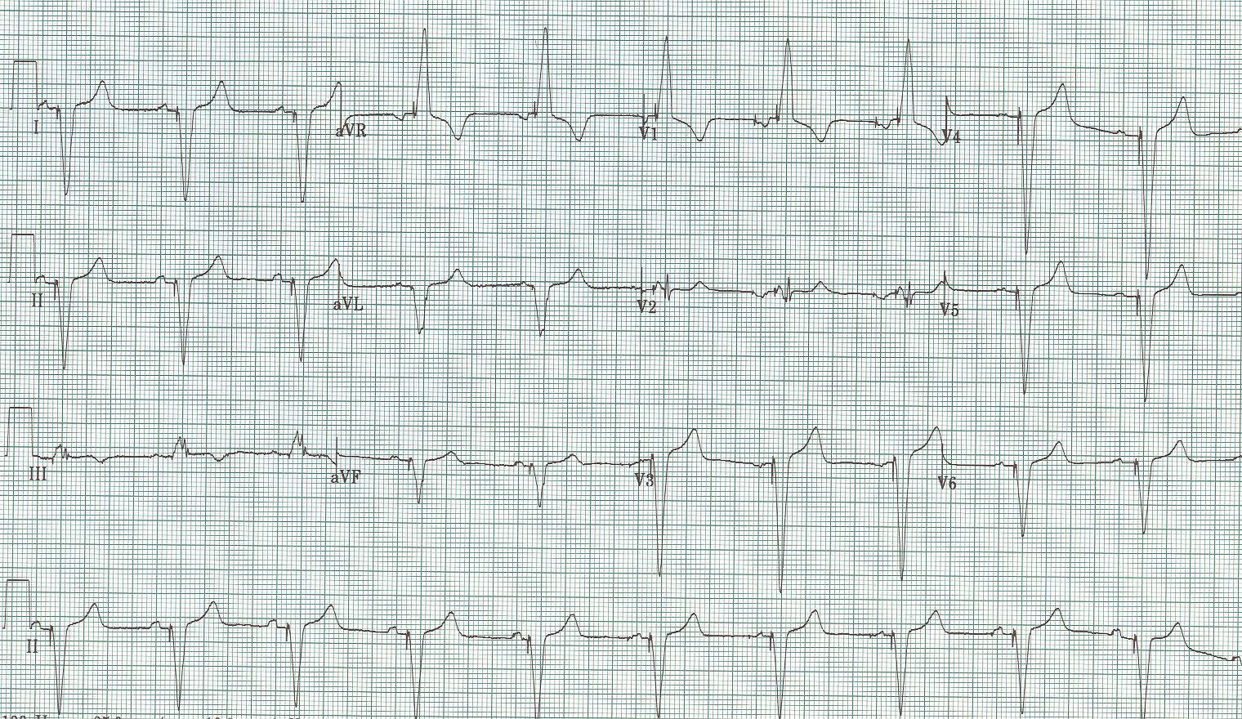
7

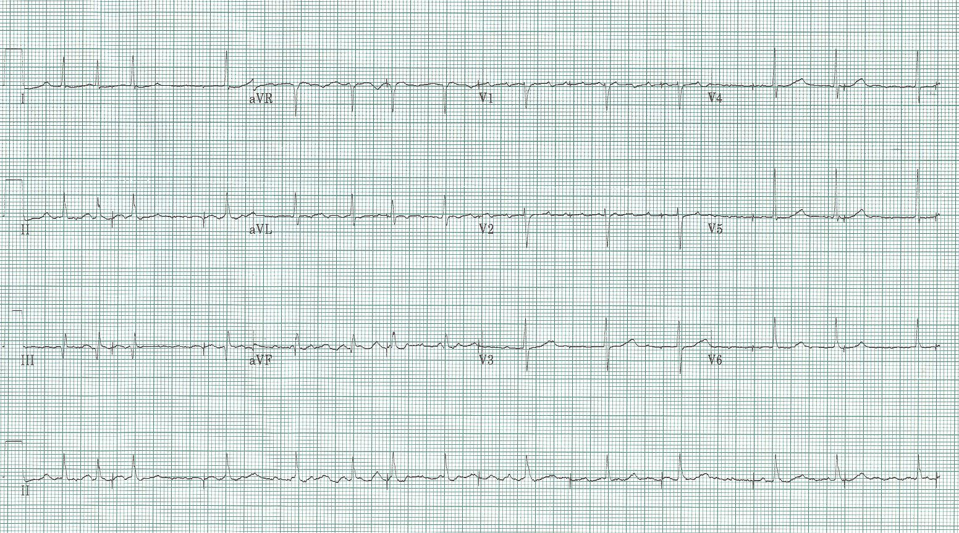
8

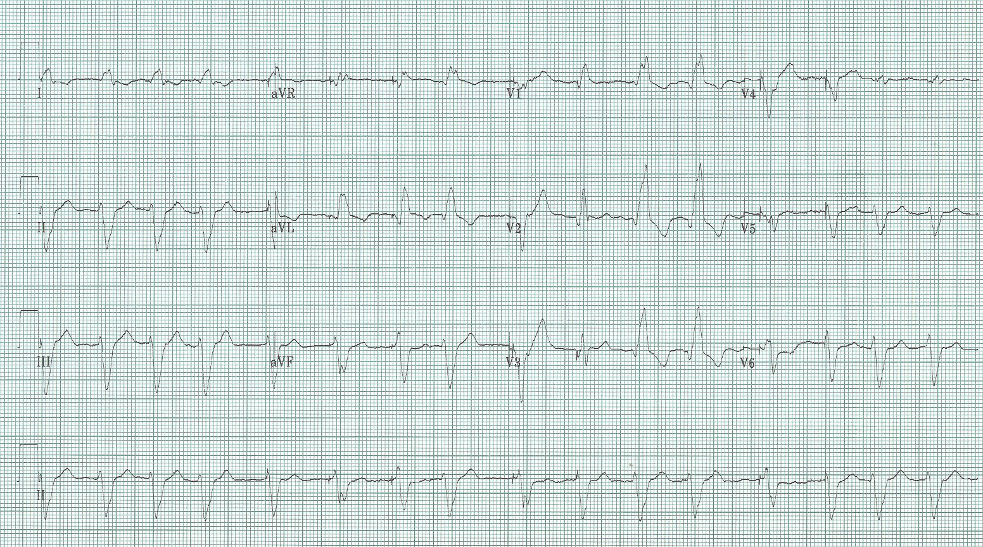
9

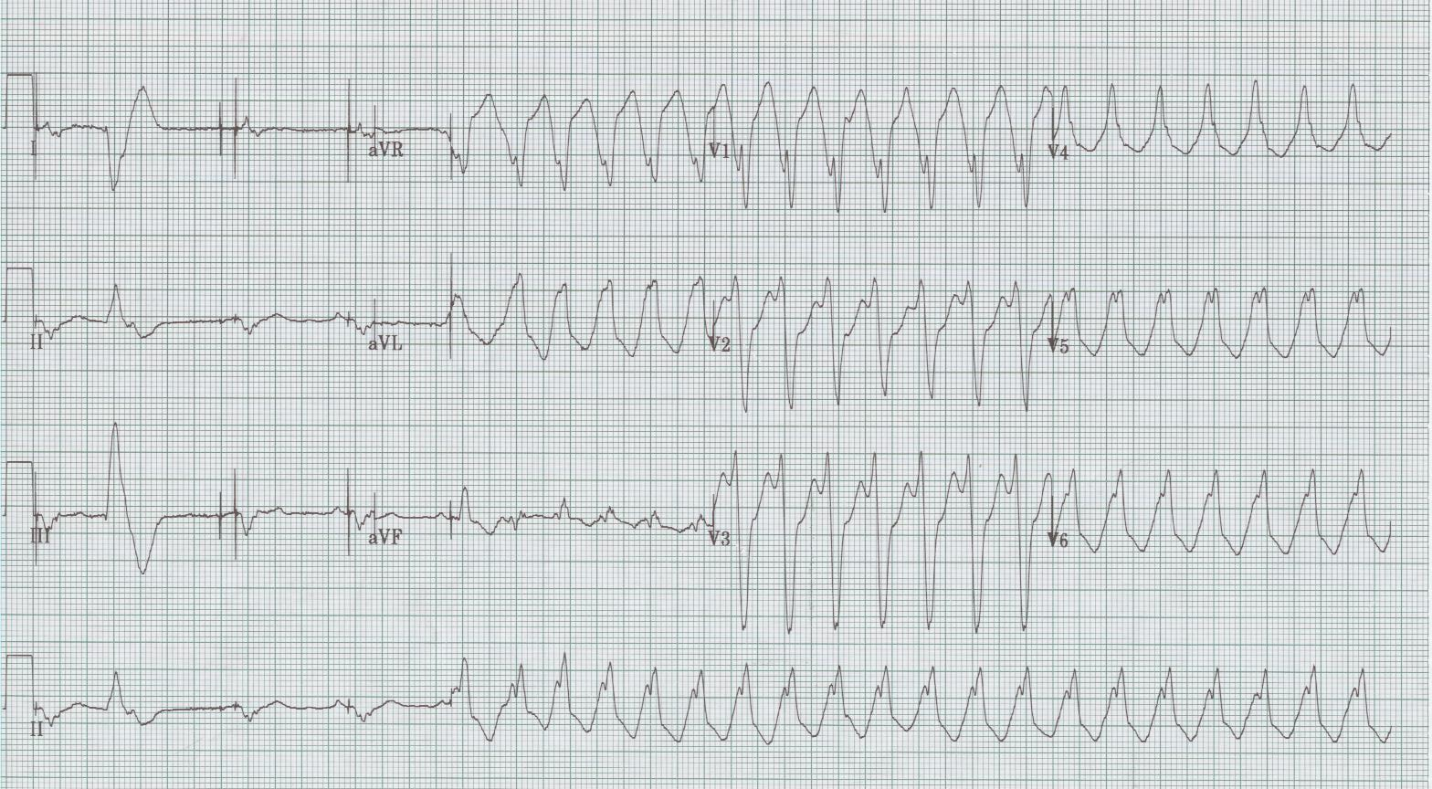
10

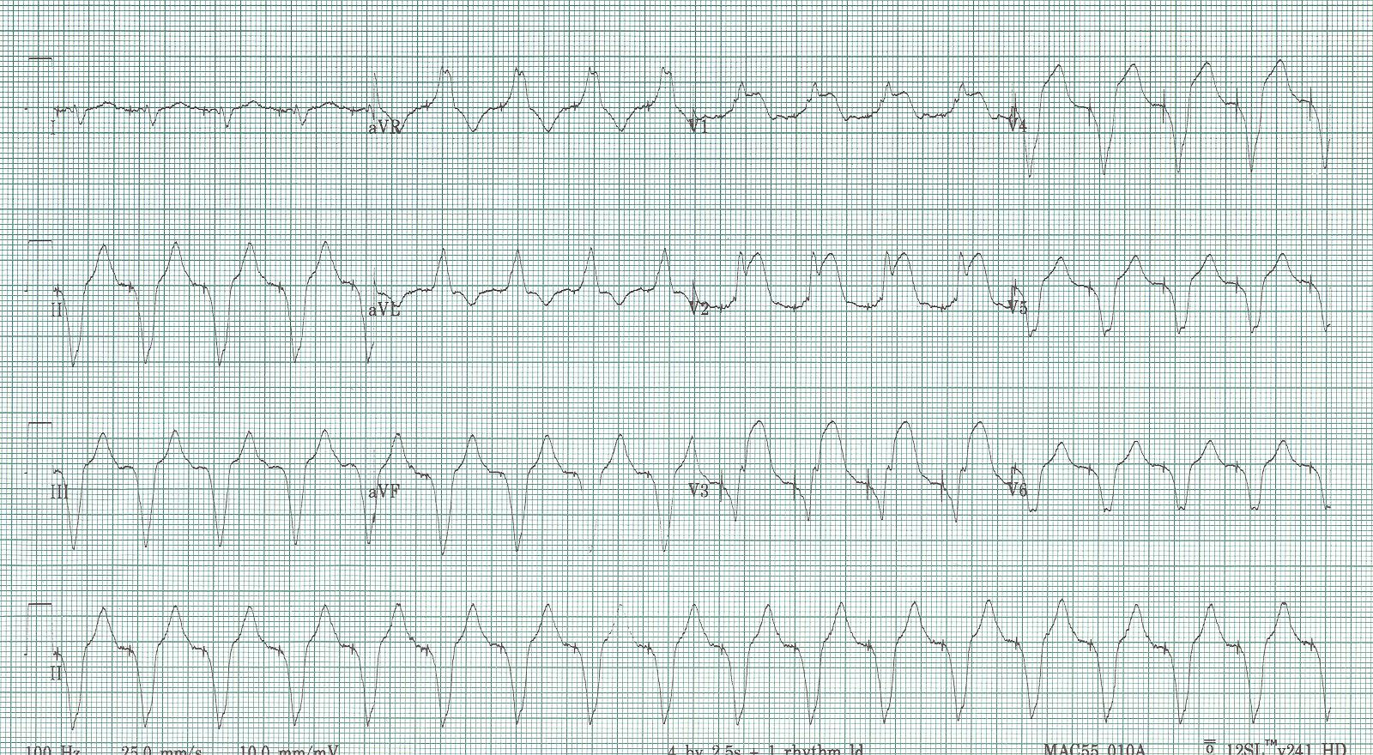
11

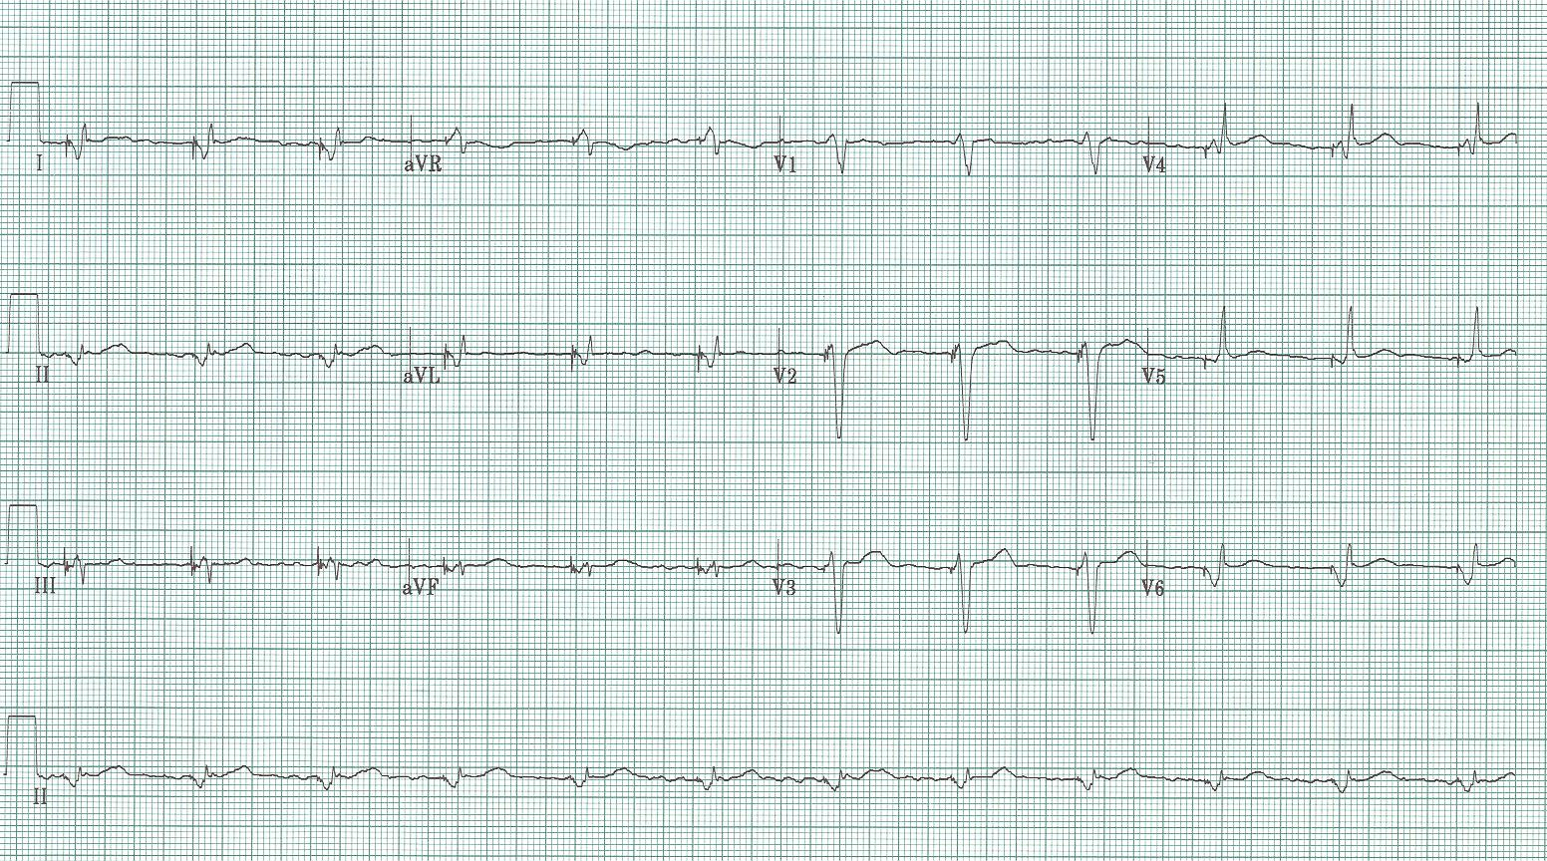
12

ICD – Implantable cardioverter-defibrillator

Pacemaker with defibrillation coils

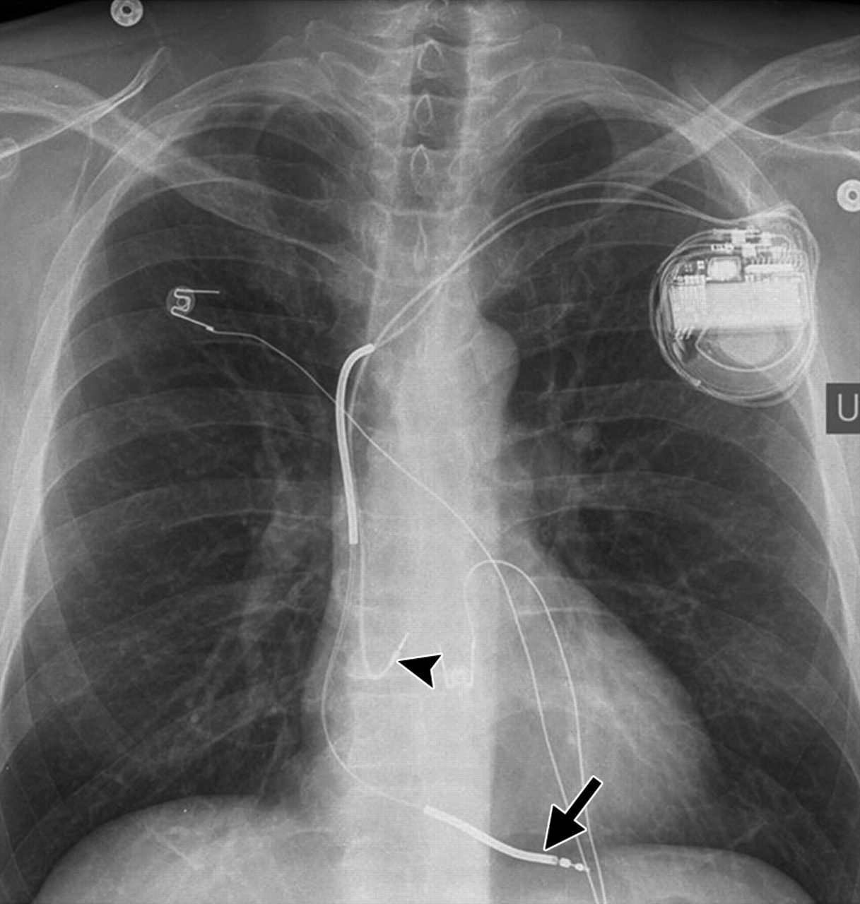

Complications
- inappropriate detection and delivery of shock – most common
- wound/pocket problems (hematoma, infection)
- lead dislodgement or migration

Inappropriate shocks (in up to 40% patients)
- interrogate the device - reprgramming
- usually SVT (including sinus tach, atrial fib), also electrical noise, lead fracture
- better results with modern programming strategies

Phantom shocks – (often have received prior real shock causing anxiety)

Appropriate shocks
- rate of appropriate shocks 2-3X rate of sudden death
- maybe shocked some rhythms that would not have been sustained
- add medication if frequent appropriate shocks

Electromagnetic interference – surveillance systems, MRI

Antitachycardia pacing – first attempt, should terminate 90% v tach

EMS concerns – CPR, external defibrillation

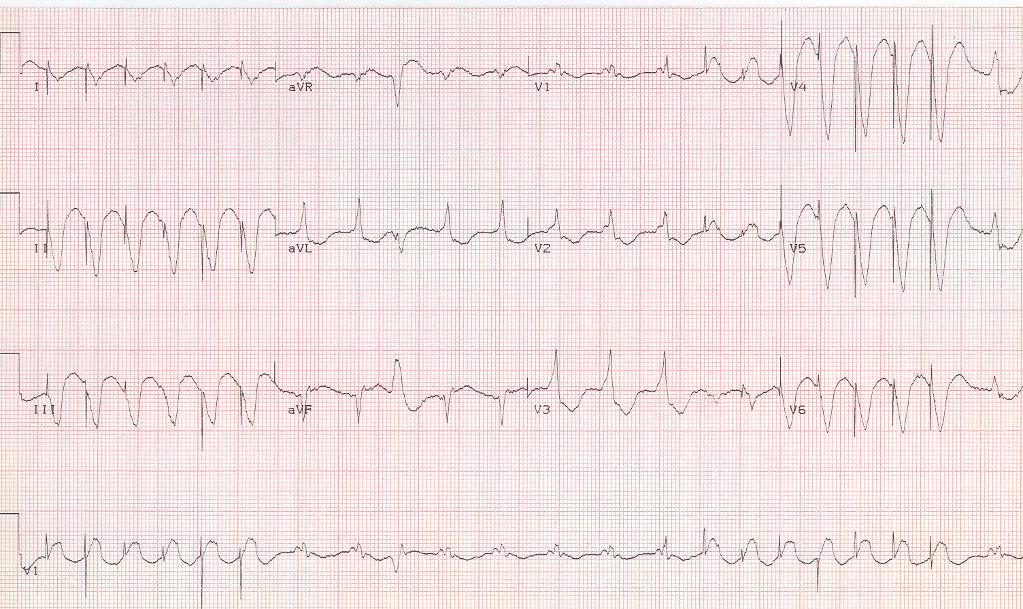
13

