STEMI Equivalents…an opportunity to save myocardium

Critical left main disease
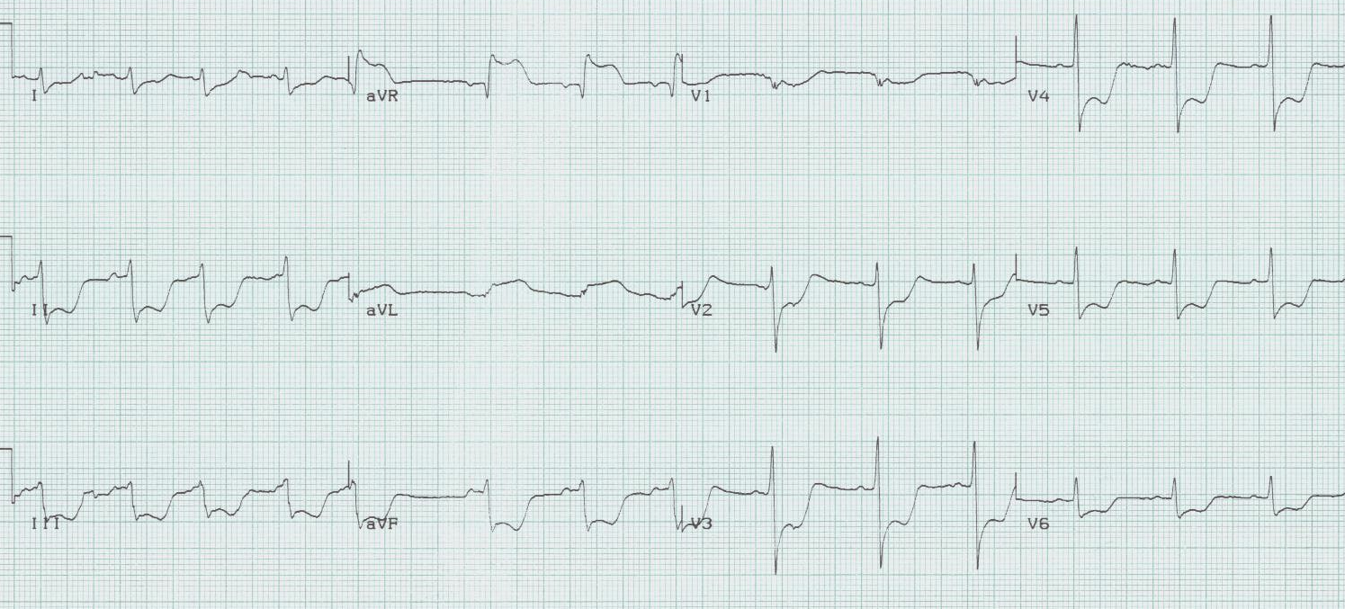

ST-segment depression in ≥ 8 leads AND ST-segment elevation in aVR is associated with critical stenosis of the left main coronary artery. These patients need urgent catheterization and possible CABG.

Isolated posterior MI
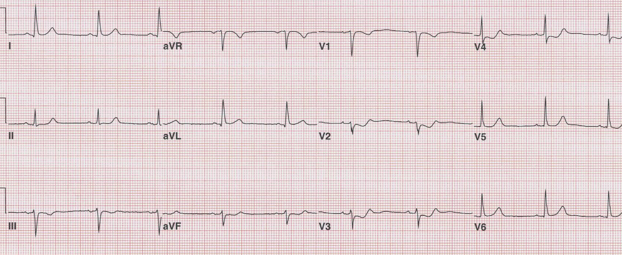

Most posterior wall infarcts occur as an extension of an inferior MI. Rarely, just the posterior wall may infarct, usually due to occlusion of the circumflex artery. The signs of isolated posterior MI include ST-segment depression in V₁₋₃ and then development of R waves in V₁₋₂ (the equivalent of Q waves).

Wellens’ syndrome
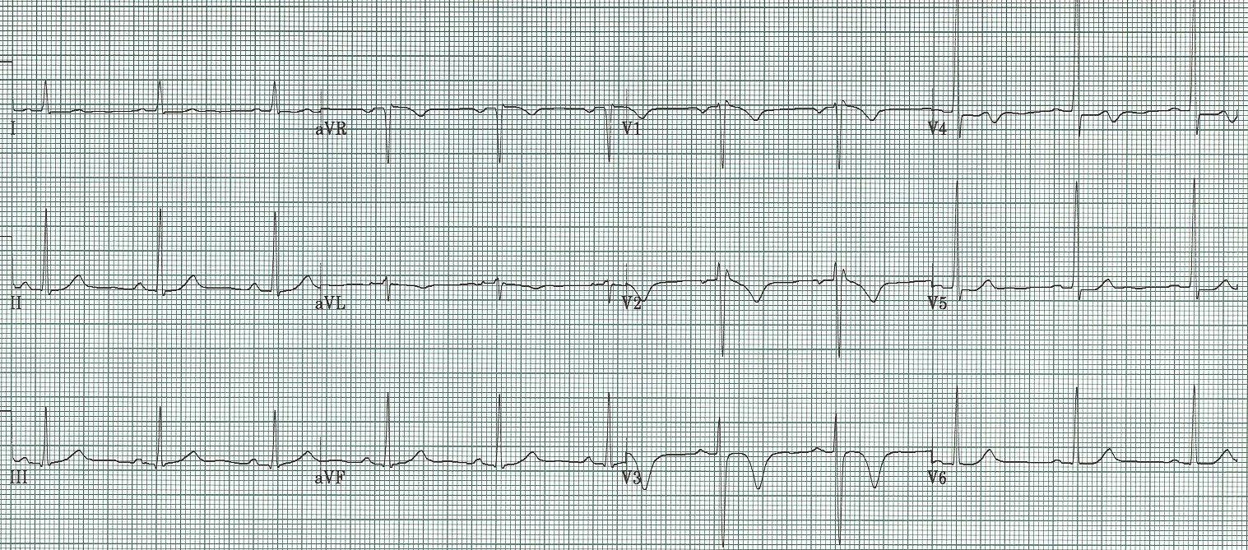

Critical stenosis of the proximal LAD artery is associated with either biphasic or inverted T waves in V₂₋₃ occurring in the pain free interval following a significant episode of chest pain. In their original paper, Wellens described this finding in 18% of patients admitted for unstable angina and found 75% of these patients went on to have an anterior MI within weeks. These patients need aggressive medical management and urgent cardiac catheterization.

deWinter’s ST/T wave complex
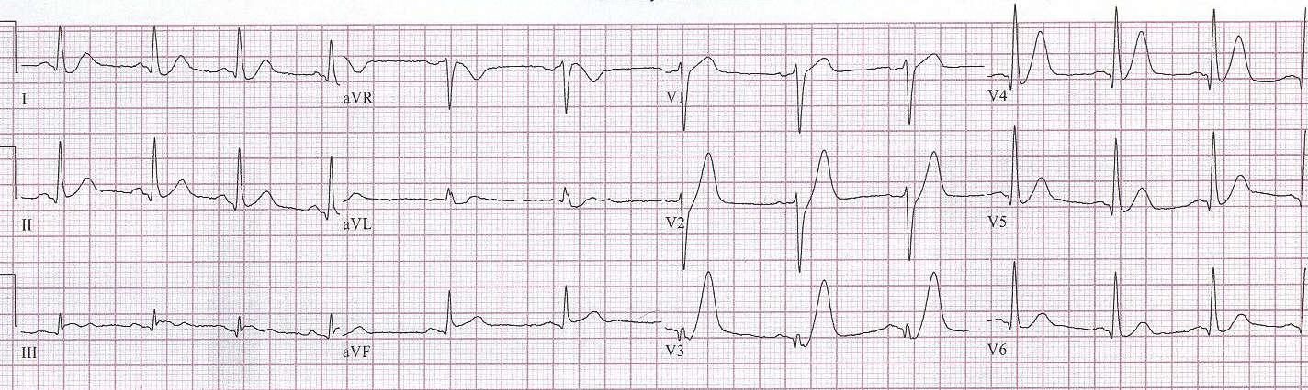

Persistent precordial hyperacute T waves associated with upsloping ST-segment depression represent occlusion of the proximal LAD. This pattern was noted in 2% of anterior MIs. This pattern should be referred for immediate intervention.

References

Lawner BJ, Nable JV, Mattu A. Novel patterns of ischemia and STEMI equivalents. Cardiol Clin 30:591-599, 2012.

Rostoff P, et al. Electrocardiographic prediction of acute left main coronary artery occlusion. Am J Emerg Med 25:852-855, 2007.

Brady WJ, Erling B, Pollack M, et al. Electrocardiographic manifestations: acute posterior wall MI. J Emerg Med 20:391-401, 2001.

De Zwaan C, Bär FW, Wellens HJJ, et al. Characteristic electrocardiographic pattern indicating a critical stenosis high in the left anterior descending coronary artery in patients admitted because of impending myocardial infarction. Am Heart J 103:730–6, 1982.

Rhinehardt J, Brady WJ, Perrod AD, et al. Electrocardiographic manifestations of Wellens’ syndrome. Am J Emerg Med 20:638-43, 2002.

deWinter RJ, Verounden NJ, Wellens HJ, et al. A new ECG sign of proximal LAD occlusion. NEJM 359:2071-2073, 2008.

Verouden NJ, deWinter RJ, et al. Persistent precordial ”hyperacute” T-waves signify proximal LAD occlusion. Am Heart J 95:1701-1706, 2009.

Additionally…

www.TorreyEKG.com

@STorreyMD

