Tachycardias – Recognition and Management

Objectives:
1. Review diagnostic criteria for the 6 most common tachycardias.
2. Compare and contrast the tachycardias (the diagnostic grid).
3. Answer several interesting questions:
a. What’s the scariest atrial fib you will ever see?
b. Let’s just use Adenosine - it’s safe, isn’t it?
c. How do you know if it’s v. tach?
4. Review a few sneaky rhythm strips…

Sinus tachycardia
- normal P wave before every QRS (upright in lead II)
- common causes:
  - fever
  - acute pulmonary embolism
  - compensation for shock (dehydration, hemorrhage, sepsis, etc.)
  - drugs – anticholinergic, sympathomimetic (cocaine)
  - thyrotoxicosis

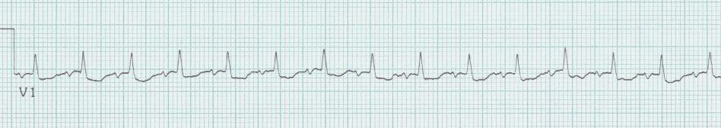

Atrial fibrillation
- no discernible P waves, atrial activity is fibrillatory (f) waves of varying amplitude, duration and morphology → random oscillations of baseline
- fibrillatory activity is most clearly seen in inferior leads and V₁ (vs. artifact)
- ventricular rhythm is irregularly irregular (other irreg irregular rhythm is MAT)
- if untreated, ventricular response is usually 100 – 180/minute

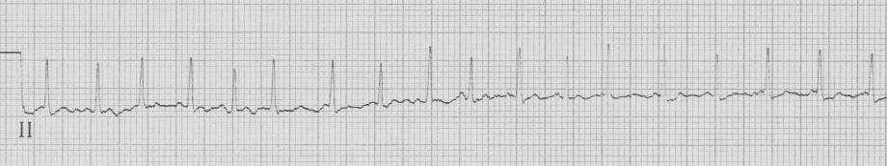
atrial fibrillation with rapid ventricular response

Atrial flutter
- atrial deflections are regular undulations (F waves) → saw-tooth pattern
- atrial rate usually 250 – 350/minute (contrast with PAT)
- rate and regularity of QRS complexes are variable and depend on AV conduction
- untreated atrial flutter is most often 2:1 AV conduction

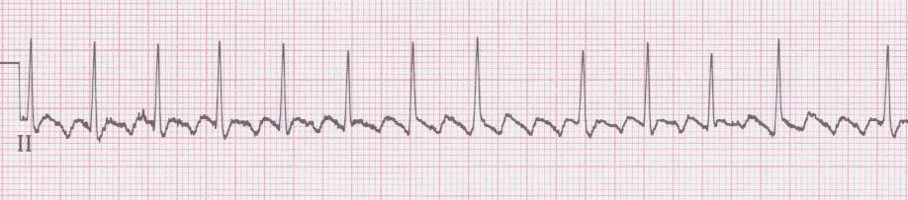
atrial flutter with variable block

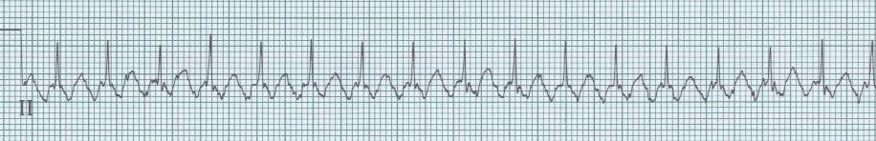
with a rate of 150/minute → always consider 2:1 flutter

Multifocal atrial tachycardia (MAT)
- P waves of varying morphology from at least 3 different foci
- absence of dominant atrial pacemaker (vs. sinus with frequent multifocal PACs)
- variable PP, RR, and PR intervals (the other irregularly irregular rhythm)
- seen in elderly, seriously ill, COPD, theophylline toxicity

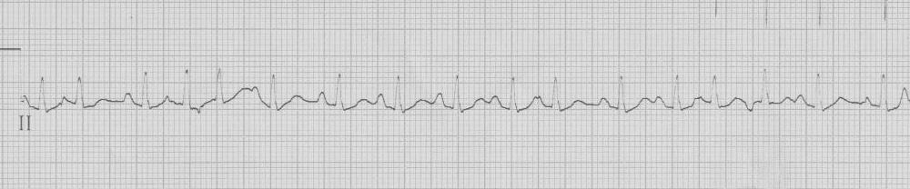

Supraventricular tachycardia (SVT)
- regular, narrow tachycardia 2° re-entry within AV node or using bypass tract
- onset and termination is abrupt, often following a PAC
- heart rate is between 140 – 220/minute
- AV nodal re-entrant SVT (50% of narrow SVT) – may have “pseudo-S waves”
- AV re-entry SVT (involving bypass tract)
  - orthodromic (antegrade via AV node/retrograde via bypass) → narrow QRS
  - antidromic (antegrade via bypass tract) → wide complex

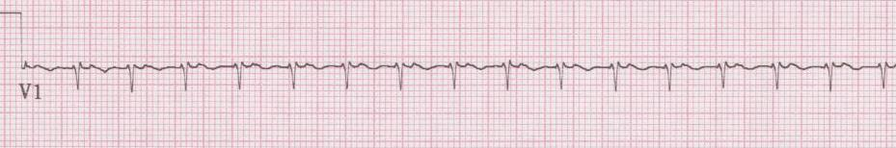

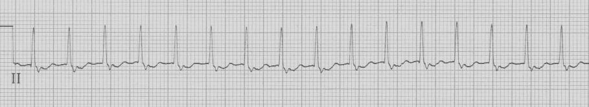

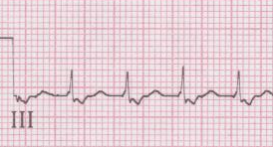
- SVT with “pseudo-S” waves → AV nodal reentry tachycardia

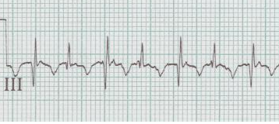
- SVT with QRS alternans and prolonged RP interval → AV reentry tachycardia

Arrhythmias via reentry mechanism
- “fast” pathway
- rapid conduction time
- long refractory period

- “slow” pathway
- slow conduction time
- short refractory period

PAC
→ finds “fast” path refractory
→ conducts down “slow” path
→ now “fast” path ready
→ completes circuit

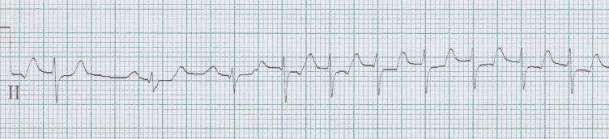
- how SVT begins

Ventricular tachycardia
- abnormal and wide QRS with secondary ST and T-wave changes
- regular rhythm, rate usually between 140 – 200/minute
- accounts for 70% of all wide-complex tachycardia
- differential includes SVT with aberrancy, pre-existing bundle, via bypass tract

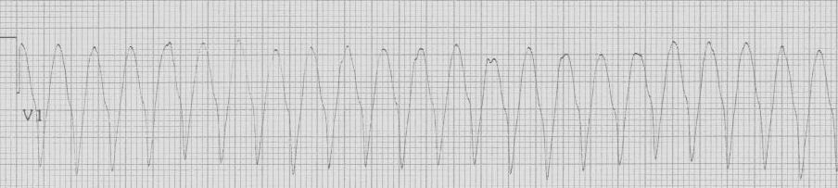

Tachycardia diagnostic grid:

 | Regular | Irregular
Narrow | Sinus tachycardia  Supraventricular tachycardia (SVT)  2:1 atrial flutter | Atrial fibrillation  Multifocal atrial tachycardia (MAT)
Wide | Ventricular tachycardia  SVT with aberrancy, bundle, bypass tract | Atrial fib with aberrancy, bundle, bypass

Some interesting questions…

1. What is the scariest atrial fibrillation you will ever see?

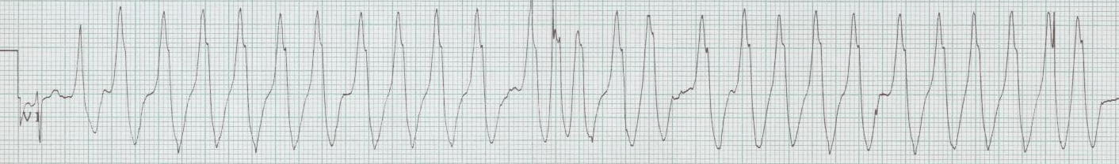
- rapid atrial fibrillation with wide complex in Wolff-Parkinson-White

- CAUTION in antegrade-conducting bypass tract with atrial fibrillation
→ may provoke conduction down bypass tract → ventricular fibrillation
- in fact, AVOID Adenosine, Beta-blockers, Ca⁺⁺-channel blockers, Digoxin

Amiodarone for Atrial fib with WPW?
- 2005 ACLS suggested appropriateness of amiodarone for atrial fib with WPW
- 2010 ACLS returns to preference for procainamide over amiodarone

2. Let’s just use adenosine…it’s safe isn’t it?

Adenosine (Adenocard®)
- an A₁ receptor agonist with rapid onset and brief duration of action
- frequent side effects: facial flushing, chest pressure, dyspnea
- 90% of AV nodal reentry is terminated by 12mg dose

- can also be used as diagnostic tool…
- sinus tachycardia → AV block with lots of P waves
- atrial flutter → AV block with flutter waves apparent
- SVT → cardiovert to sinus
- Ventricular tach → NOTHING happens

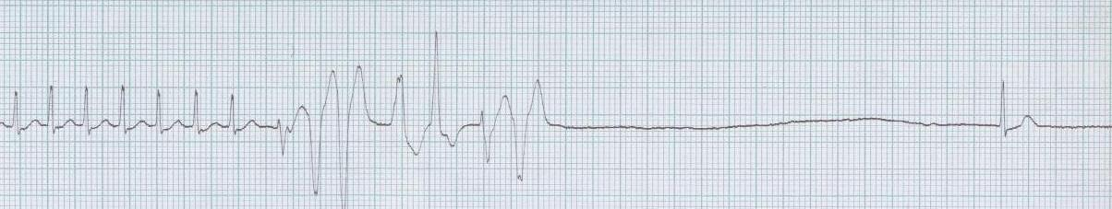

- Proarrhythmia effects (Mallet ML. Proarrhthmic effects adenosine Emerg Med J 21:408, 2004.)
  - may precipitate atrial fib, convert flutter to 1:1 conduction, torsade

The bottom line…
→ use adenosine, but respect the possibility of proarrhythmias.
- Resuscitative equipment must always be available

3. How do you know if it’s v. tach?

- Electrocardiographic criteria favoring V. tach
  - AV dissociation – essentially specific for v. tach, but rare (< 20% of VT)
  - QRS concordance – all QRS in chest leads (V₁₋₆) predominantly negative or positive
  - very wide QRS (LBBB pattern with QRS > 160msec or RBBB > 140msec)
    - exceptions: hyperkalemia, TCA toxicity, massive cardiomegaly
  - axis between -90° and ±180° (extreme right axis, or “no man’s land”)

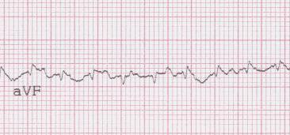
- P waves → AV dissociation

- Algorithms…
  - Brugada’s four step algorithm → 98% sens / 96% spec
Brugada P. Circ 83:1649, 1991
  - Vereckei Euro Heart J 2007
- Clinical schemes…
  - association with structural heart disease or previous MI (PPV > 95% )
Akhtar M. Ann Intern Med 109:905, 1988.

Some sneaky rhythm strips…

1. 68-year-old woman with history of COPD, recently discharged from hospital. She complains of palpitations and nausea.
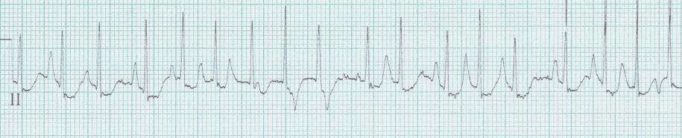

2. 38-year-old woman complains of palpitations, weight loss, and heat intolerance.
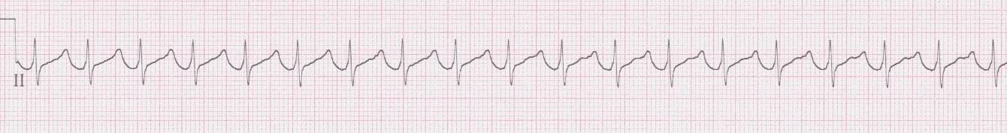

3. 70-year-old woman complains of weakness. PMH: Parkinson Disease
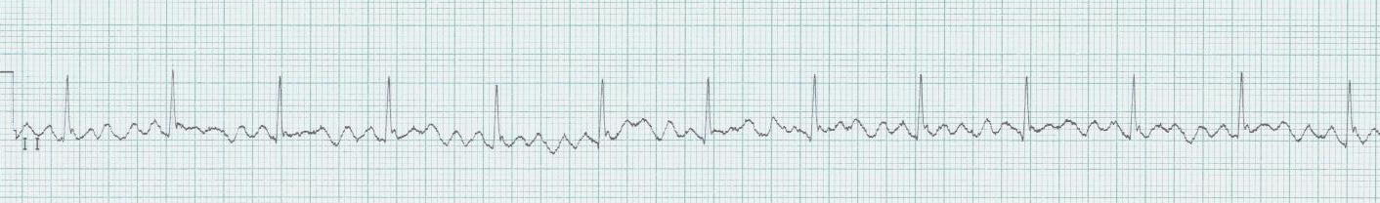

4. 72-year-old man with palpitations, weakness, and chest discomfort.
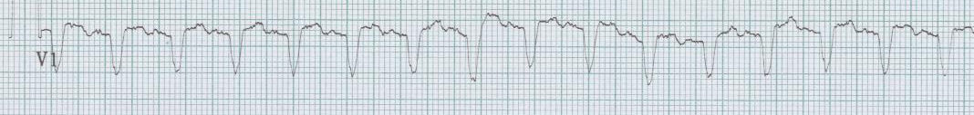

5. 65-year-old man with palpitations and shortness of breath.
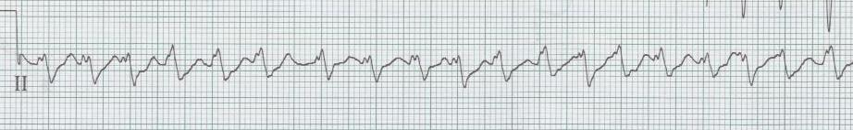

6. 56-year-old man with metastatic lung cancer from oncology clinic with SOB and ? a fib.
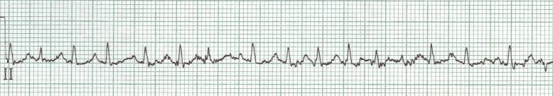

7. 75-year-old man from nursing home with altered mental status.
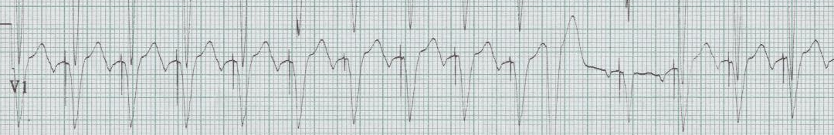

8. 65-year-old woman with dyspnea and chest pain.
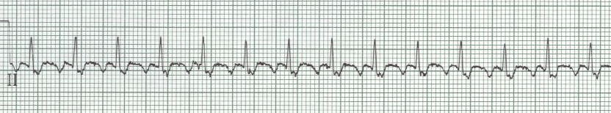

9. 70-year-old man with palpitations and SOB.
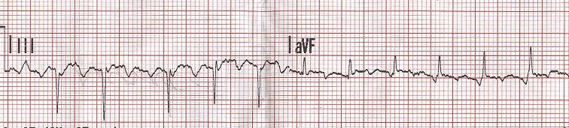

10. 65-year-old woman after syncope in church.
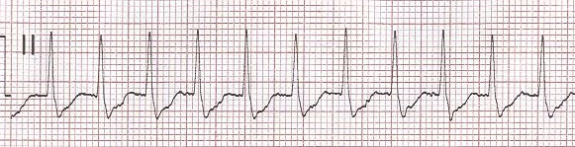
Answers to the sneaky rhythm strips…

1. What appear to be large T waves of varying size and shape are actually large P waves of varying morphology! This rhythm is MAT. This poor woman was given an incorrectly written prescription and was taking twice the amount of theophylline usually prescribed. Her theophylline level was twice normal.

2. This regular, narrow complex tachycardia at approximately 140/minute is sinus tachycardia, although it would be easy to incorrectly call it SVT. Notice the emergence of P waves at the end of the T waves at the end of the strip as the rate apparently slows a little bit.

3. Regular narrow complex rhythm at 80/minute with what looks like coarse oscillations of the baseline (? fibrillatory waves). The clue to this rhythm is recognizing that the fibrillatory waves appear to occur most prominently in lead II and III (limb leads) while they were not so noticeable in V₁. Going to the bedside revealed at lady with gross extremity tremors from her Parkinson Disease.

4. A regular wide-complex tachycardia at 150/minute. The possibilities include ventricular tachycardia, SVT with aberrancy, pre-existing bundle, or WPW (given the rate of 150/minute, SVT would also include 2:1 flutter). Notice the apparent atrial activity occurring in the middle of the R-R interval. This stable patient was given Adenosine with following result:
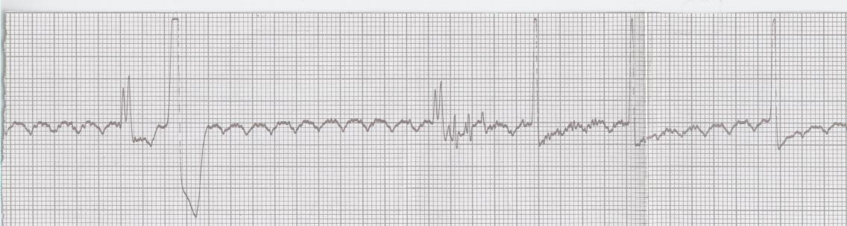
The rhythm was in fact 2:1 flutter with a pre-existing bundle branch block. The rate was successfully treated with diltiazem.

5. A wide complex tachycardia that is ever so slightly irregularly irregular, at a rate of 180/minute. With no prior EKGs and no cardiac history, the patient was given Amiodarone (avoiding A-B-C-D medications!), and the atrial fib slows:
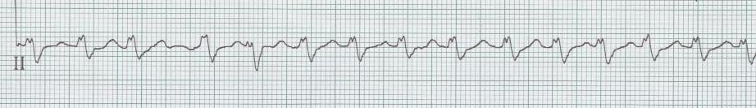
and finally, converts to sinus spontaneously…
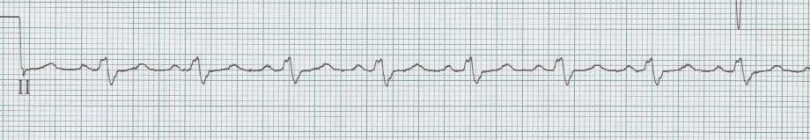
6. An irregularly irregular tachycardia could certainly be atrial fibrillation, but if you look close there does seem to be P waves before most QRS complexes. These P waves are of different morphology – this is the other irregularly irregular tachycardia – MAT! This patient is hypoxic, dehydrated, has lung disease and lung cancer – a prescription for this rhythm. With oxygen and fluids his rhythm improved but remain MAT.
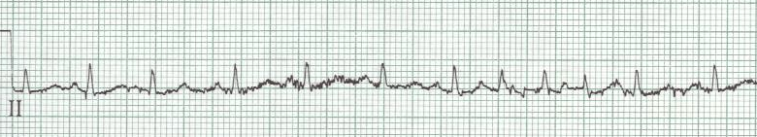

7. Ventricular paced rhythm at 130/minute – is the pacemaker not functioning correctly? Look at the pause following a PVC – there is now an obvious P that the ventricular pacer spike follows. This is a dual chamber pacer (more physiologic), and the ventricular pacing is following the sinus tachycardia caused by this patients fever and dehydration.

8. Regular narrow-complex tachycardia at 150/minute – 2:1 atrial flutter…notice the flutter waves best seen in the inferior leads.

9. Narrow complex tachycardia that is mostly regular around 150/minute – adenosine was administered as the provider thought this was SVT….oops!
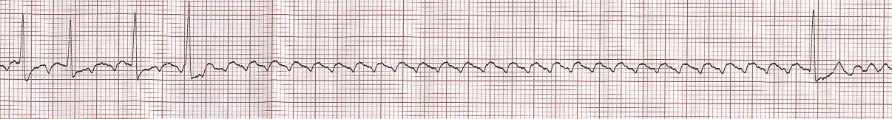

10. Narrow-complex regular tachycardia at 168/minute – notice the pseudo-S waves in the lead II rhythm strip – suggesting this is SVT (AVNRT). This rhythm broke spontaneously; compare the QRS complexes in lead II…
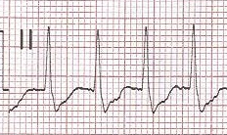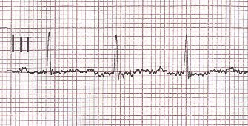
lead II in SVT with pseudo-S waves lead II from 12-lead post conversion to sinus

