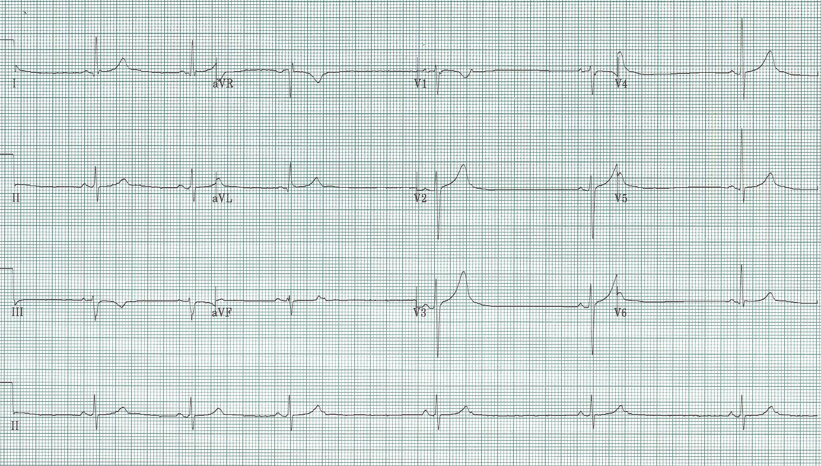
1. 70-year-old woman with episodes of lightheadedness

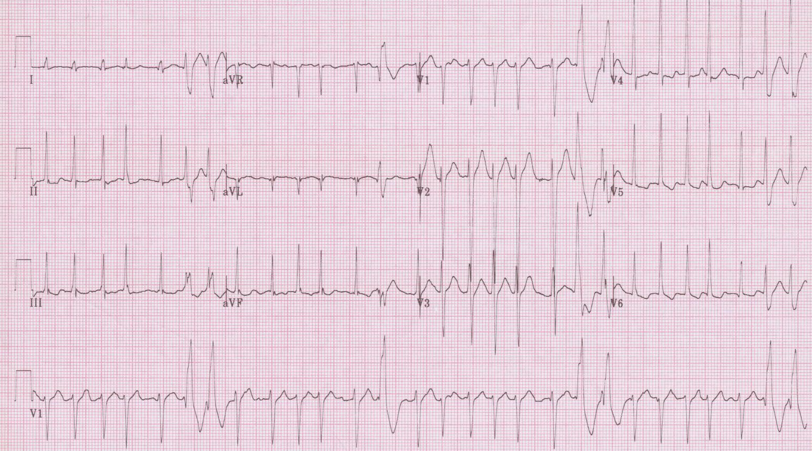
2. 35-year-old man complains of palpitations after a night of “partying”. Nursing is concerned about the frequent “PVCs”.

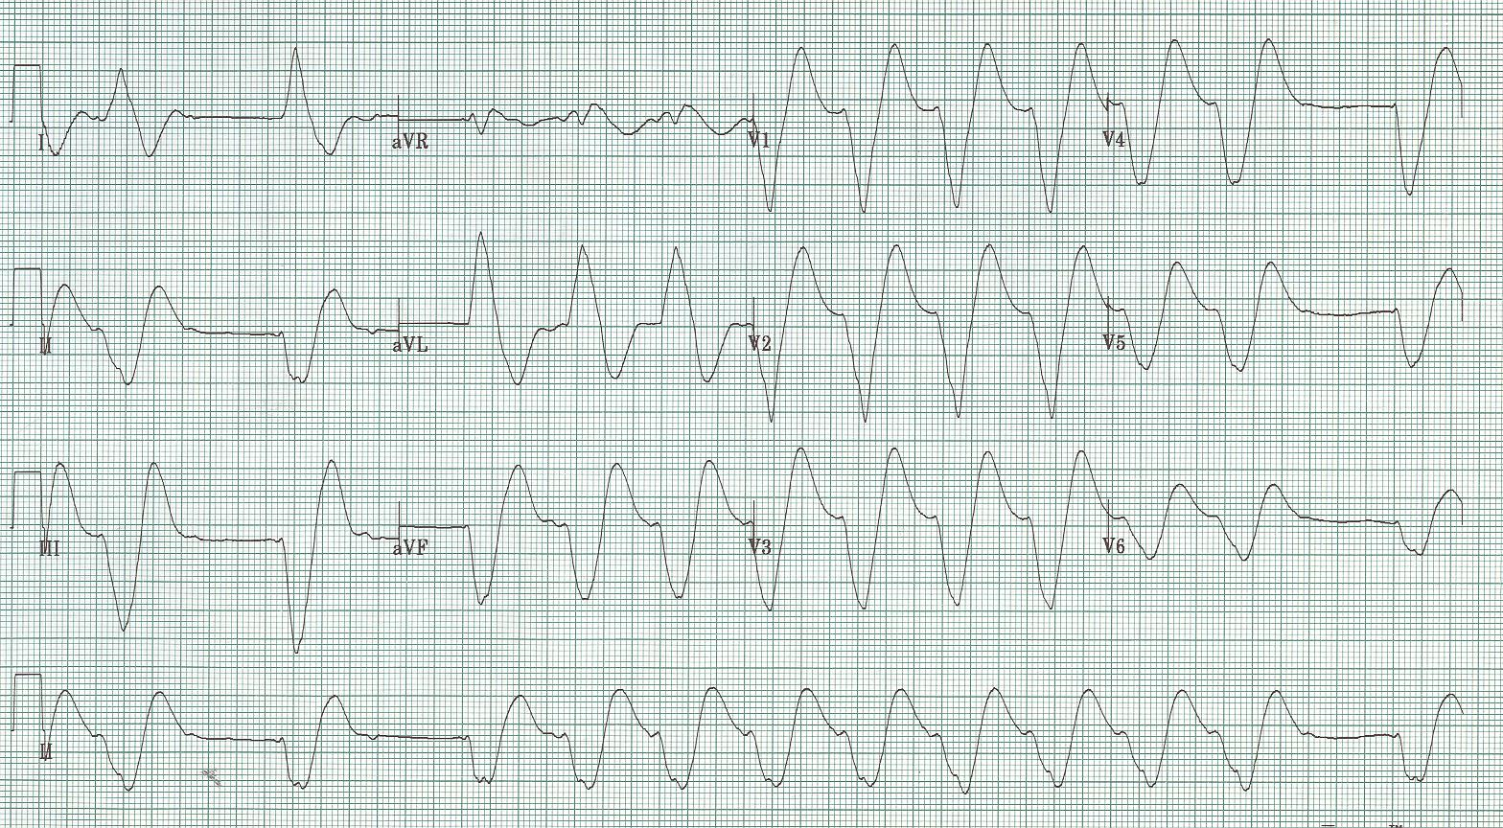
3. 40-year-old man with complaints of generalized weakness over several weeks.

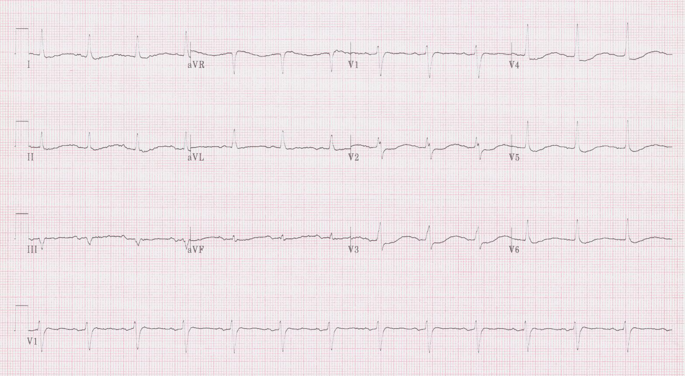
4. 75-year-old woman complains of significant generalized weakness. She was started on hydrochlorothiazide (HCTZ) for HTN 1 month prior.

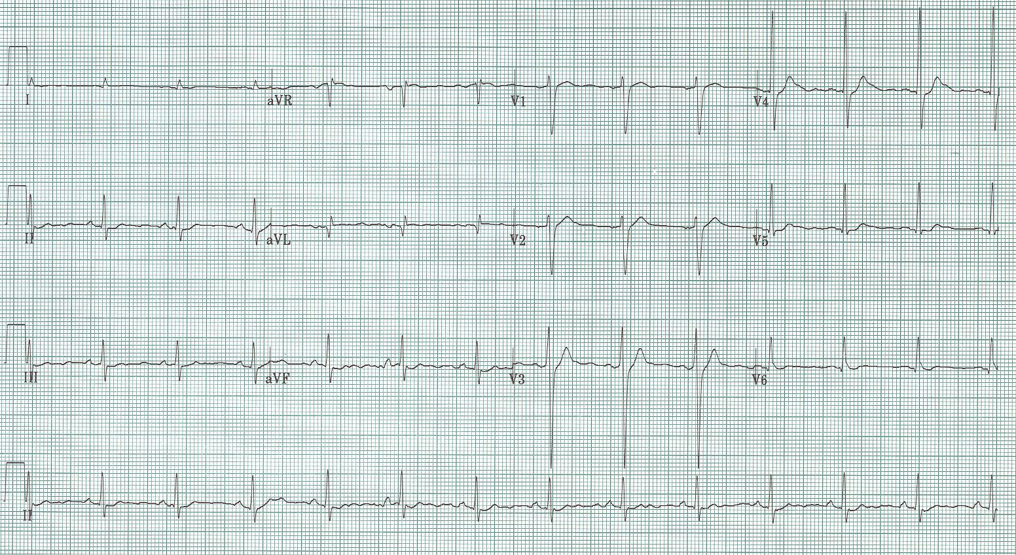
5. 60-year-old man with lethargy and altered mental status. PMH: squamous cell lung cancer
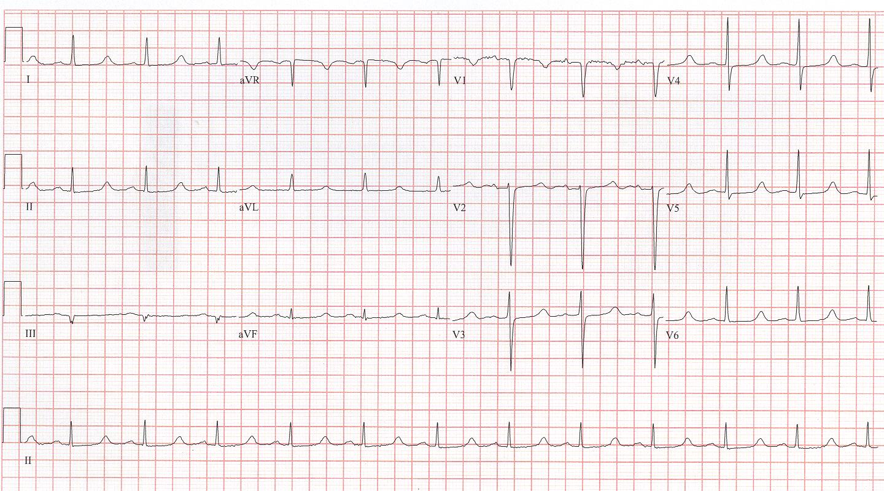
6. 46-year-old woman with carpal spasm. PMH: thyroidectomy

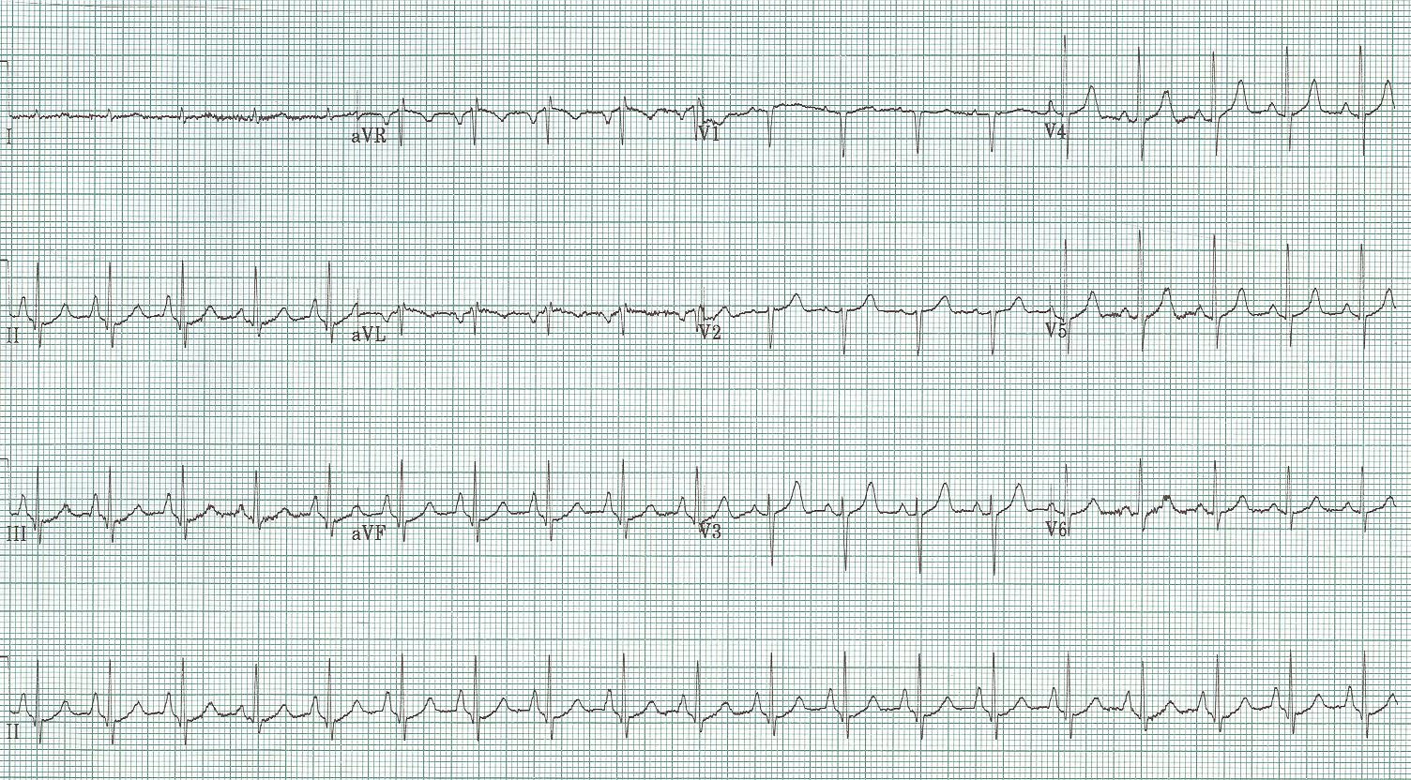
7. 60-year-old woman with increasing shortness of breath and sputum production over prior week.
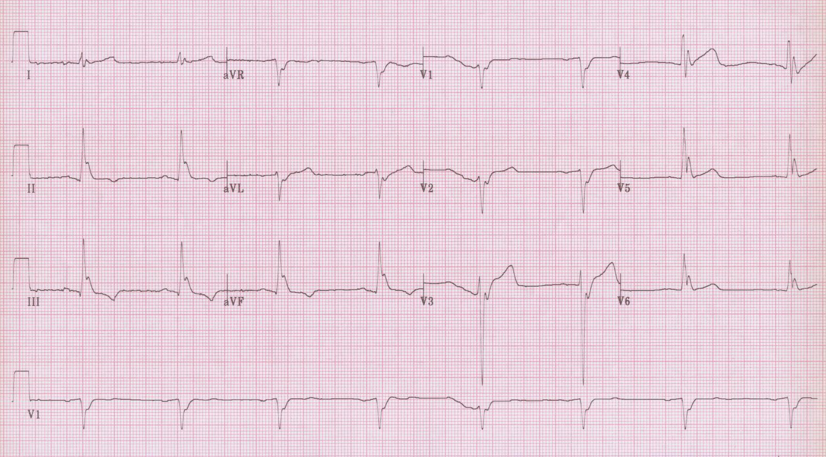
8. 30-year-old man found unresponsive outside, assumed to be a drug overdose…

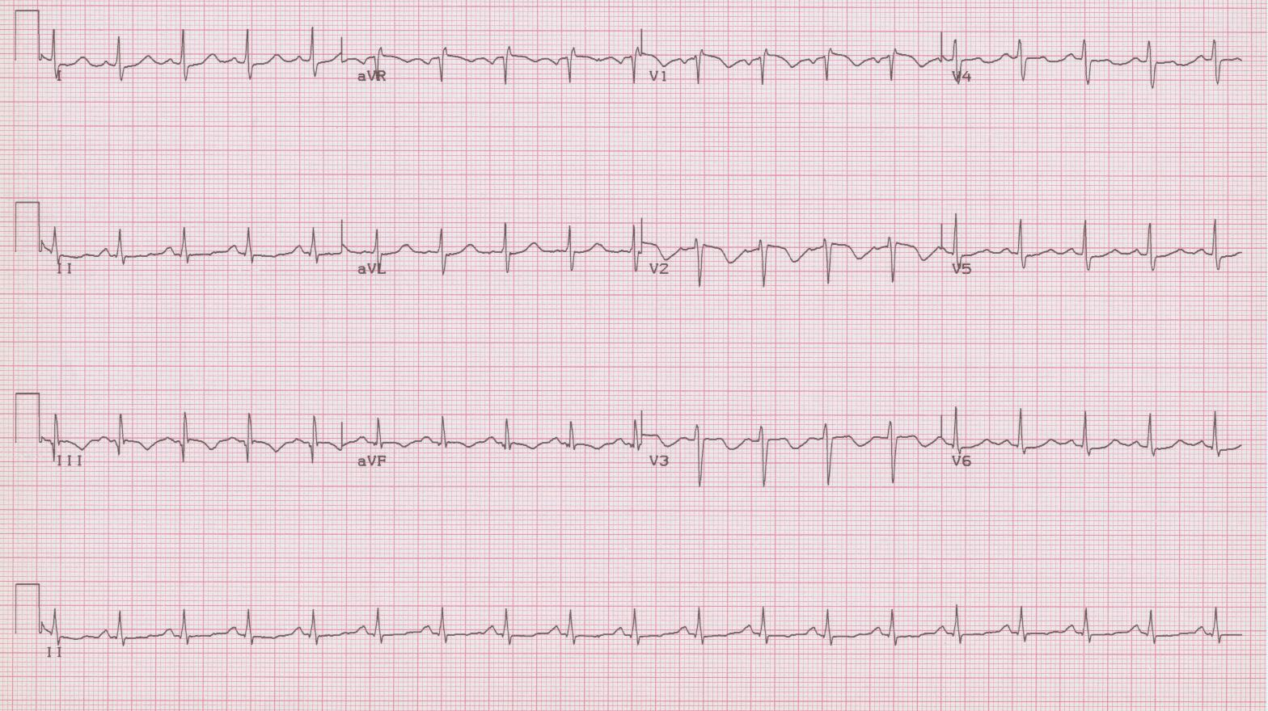
9. 40-year-old woman with right flank pain and near syncope, VS: 96/60, 120, 24, afebrile, O₂sat 93%; recently had arthroscopic knee surgery.

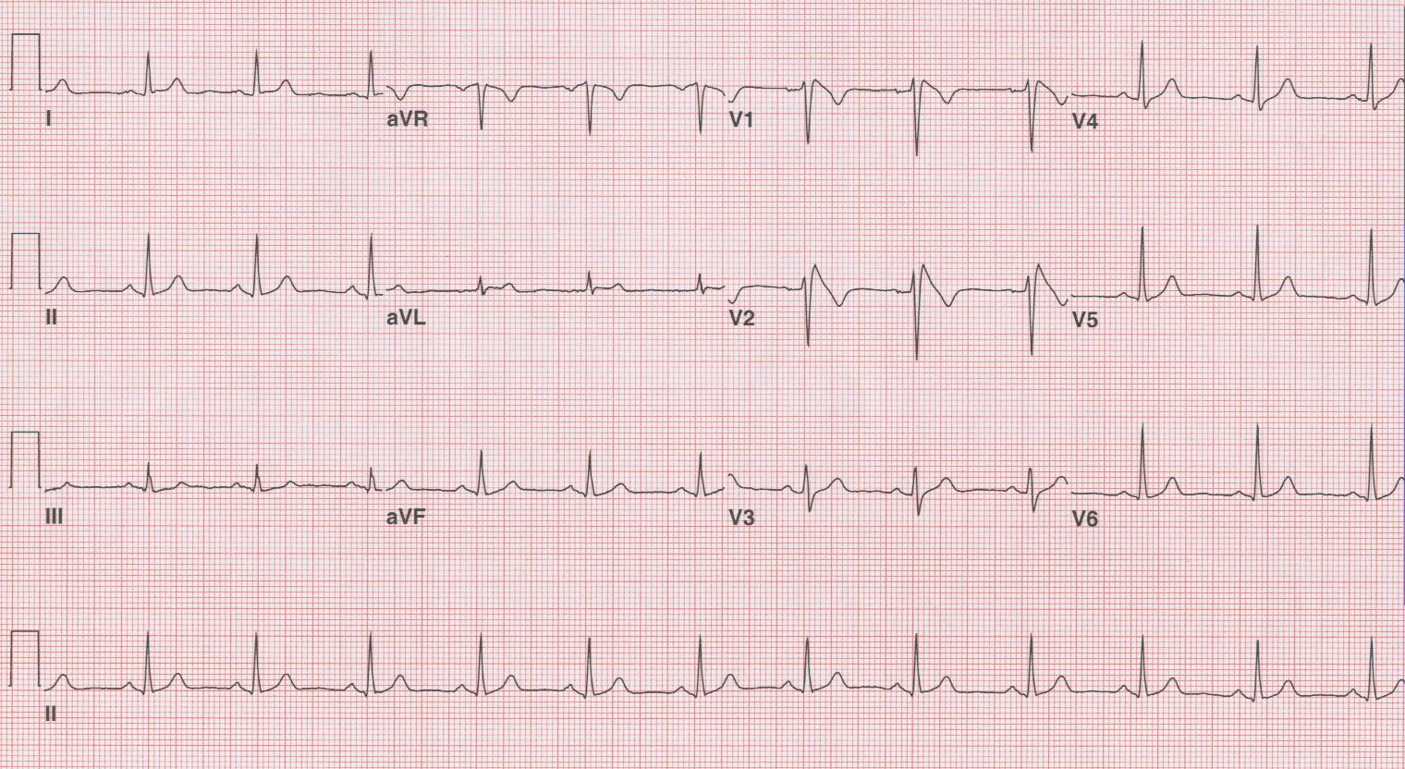
10. 42-year-old man presents after syncope episode; now no complaints, normal VS and exam. He has a family hx of unexplained sudden death in father and uncle in the 40’s.
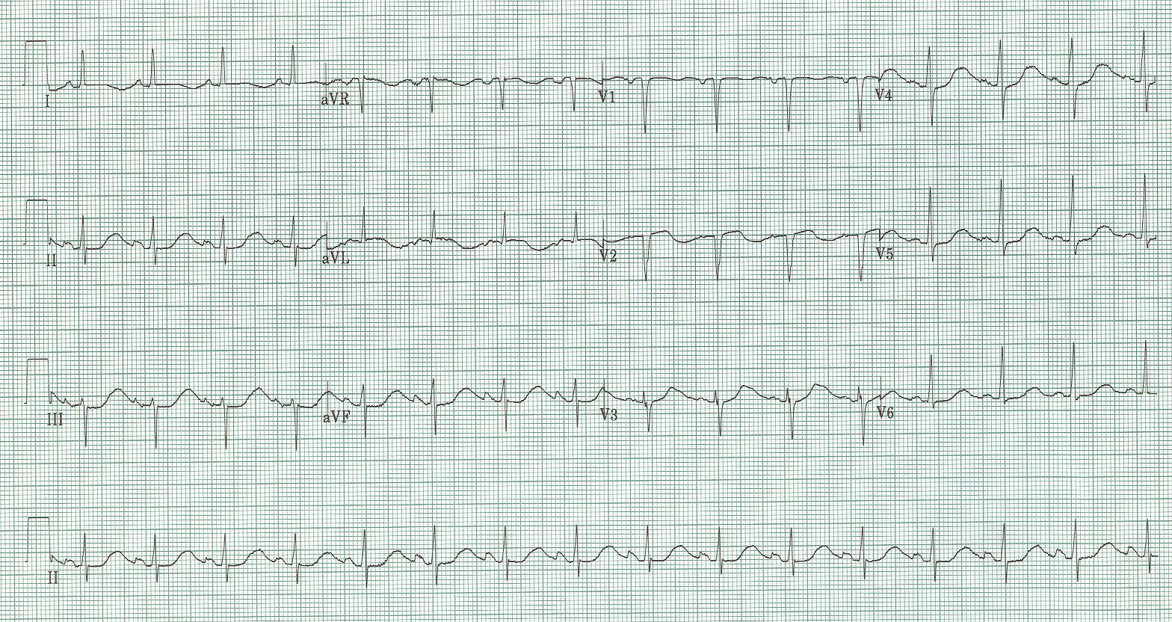
12. 46-year-old woman, an alcoholic well known to the ED, presents after syncopal episode. She also reports vomiting and diarrhea for three days.

Discussion of Advanced EKGs

The most common cause, of a pause during sinus rhythm, is a blocked PAC
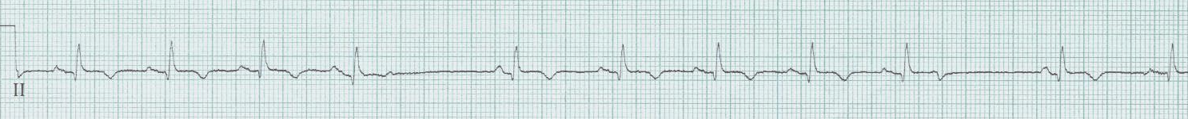
The T-wave at the beginning of the pause is deformed by a very early premature atrial depolarization, too early to conduct successfully to the ventricles. Be careful not to assume sinus node dysfunction. Blocked PACs in a bigeminy pattern can also be mistaken for sinus bradycardia or 2:1 AV block.

Ashman’s phenomenon – it will make you look smart
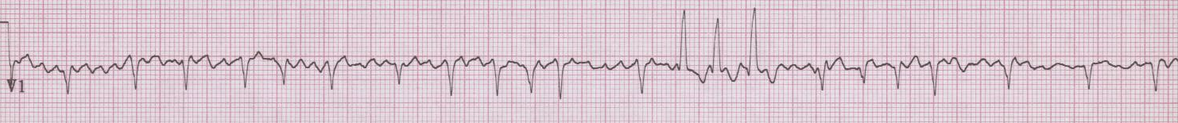
Repolarization after a QRS complex (the QT interval) is proportional to the rate of the rhythm (specifically the preceding R-R interval). Thus, in an irregular rhythm (typically atrial fibrillation, occasionally MAT), when a long R-R interval is followed by a short interval, the subsequent QRS may be aberrantly conducted. Aberrancy is predictably of RBBB morphology as this bundle is most influence by repolarization delays. LONG – SHORT – WEIRD

Hyperkalemia – it will save someone’s life
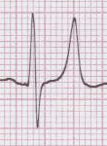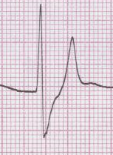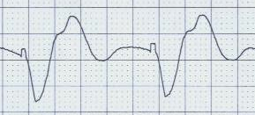
Hyperkalemia causes changes in the EKG in a predictable sequence, just not at predictable potassium levels. It is possible to see little, if any, changes at a fairly high potassium level, especially in dialysis patients.
- peaked T-waves
- early prolongation of the QRS complex
- diminution of the P wave (may disappear)
- further prolongation of the QRS
- appearance of the “sine wave”

Hypokalemia - a cause of prolonged QT interval?
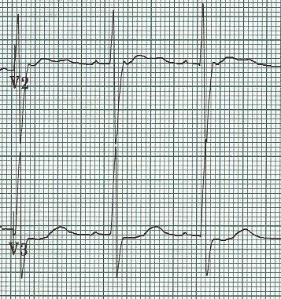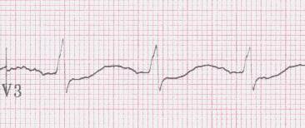
Hypokalemia causes appearance of U-waves, best seen in mid-anterior leads, V2-4, as well as decrease in amplitude of T-waves. These changes eventually produce the appearance of a prolonged QT interval (actually a Q-U interval). There may also be associated ST-segment depression, the “roller coaster” profile.

Hypercalemia – think of this in appropriate clinical settings
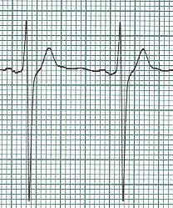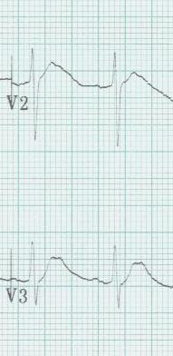
Hypercalcemia causes shortening of the QT interval. There is no specific number for a short QT, but always be suspicious of QTc < 400msec. Occasionally, while the QT interval may not be particularly short, there is noticeable shifting of the apex of the T wave toward the QRS complex.

Multiple electrolyte depletion – watch the QT interval!
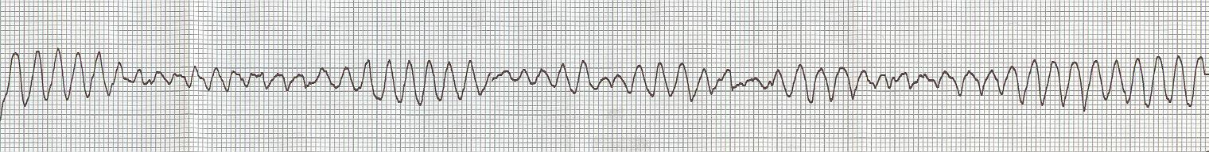
The combination of hypomagnesemia, hypokalemia, and occasionally hypocalemia causes significant prolongation of the QT interval and may precipitate torsade de pointes. This can occur in alcoholics with concommitent acute GI illness or in patients on with multiple risk factors (age, CHF, diuretics, QT prolonging meds – particularly antibiotics, cardiac meds, antipsychotics).

COPD – diagnosed even before the CXR
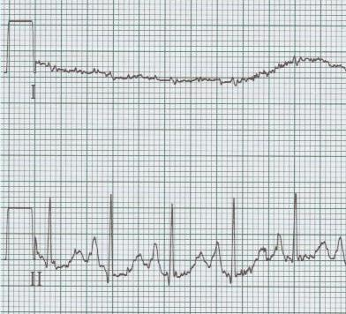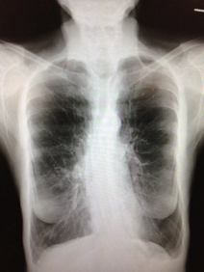
COPD can be diagnosed from the EKG – the classic EKG of COPD may include peaked P waves in lead II (“P-pulmonale”) indicating R atrial enlargement and “lead I sign” with the P-QRS-T waves in lead I all nearly isoelectric.

Hypothermia
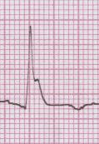
Osborne waves (J waves) of hypothermia appear on the EKG at approximately 90° (32° C), and increase as the temperature decreases. Osborne waves will be upright when the QRS complex is upright, and inverted with negative QRS complexes. Notice, there will be no artifact from shivering, which stops by 90° (32° C).

Pulmonary Embolus – a difficult diagnosis
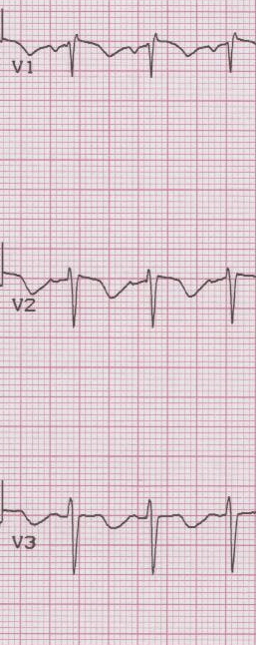
PE is an impossibly difficult diagnosis to make from an EKG. The EKG may suggest the diagnosis, however, even when classic clinical signs are misleading. With significant PEs there will be R heart strain that cause T-wave inversion in the right anterior leads (V1-3). This change is associated with larger embolus burden and can occur as early as ED presentation or within the first 24 hours.

Brugada Sydrome – “screams in the night”
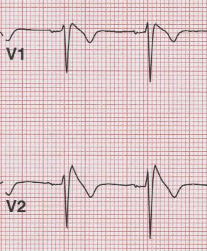
Brugada syndrome, a Na-channelopathy, is an inherited cause of sudden death from abrupt ventricular arrhythmias.

www.TorreyEKG.com @STorreyMD

