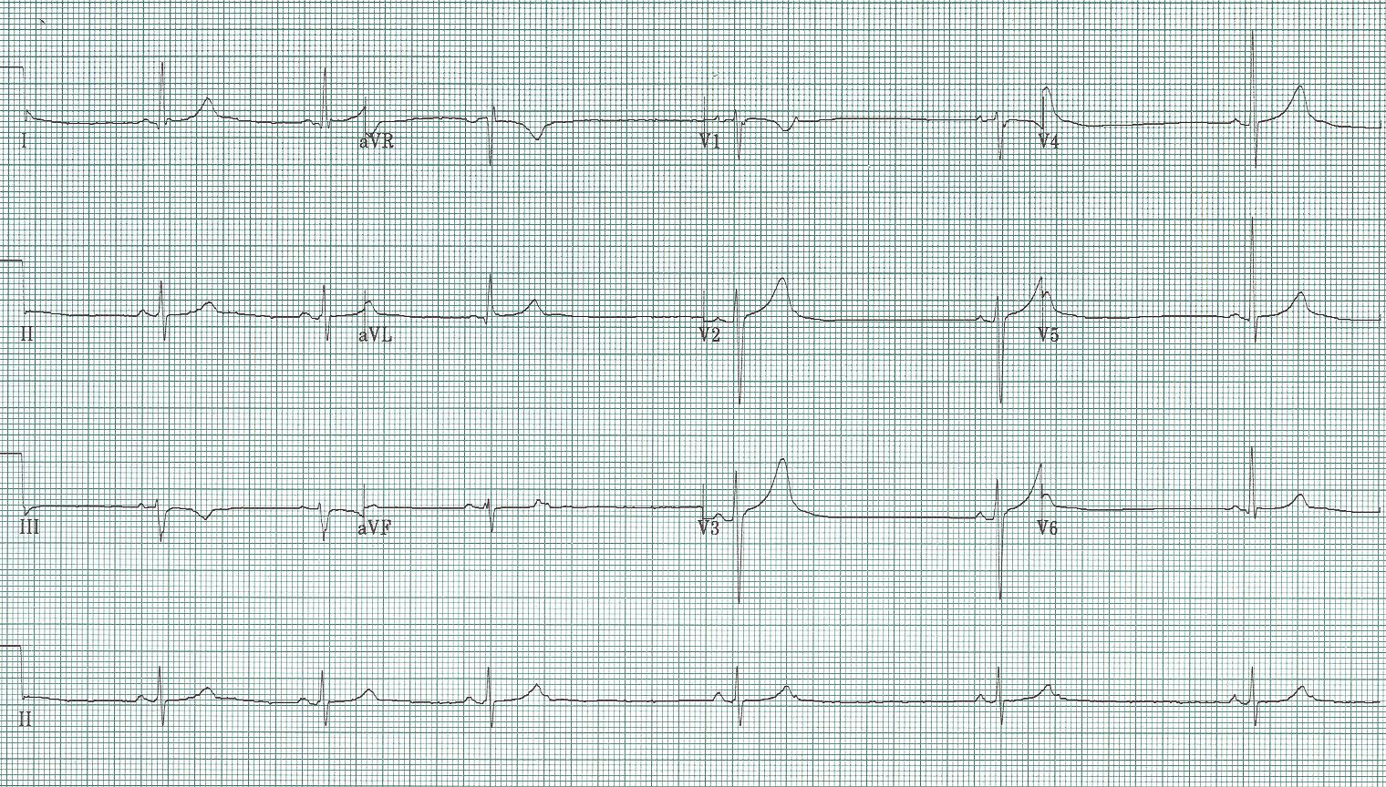
1. 70-year-old woman with episodes of lightheadedness

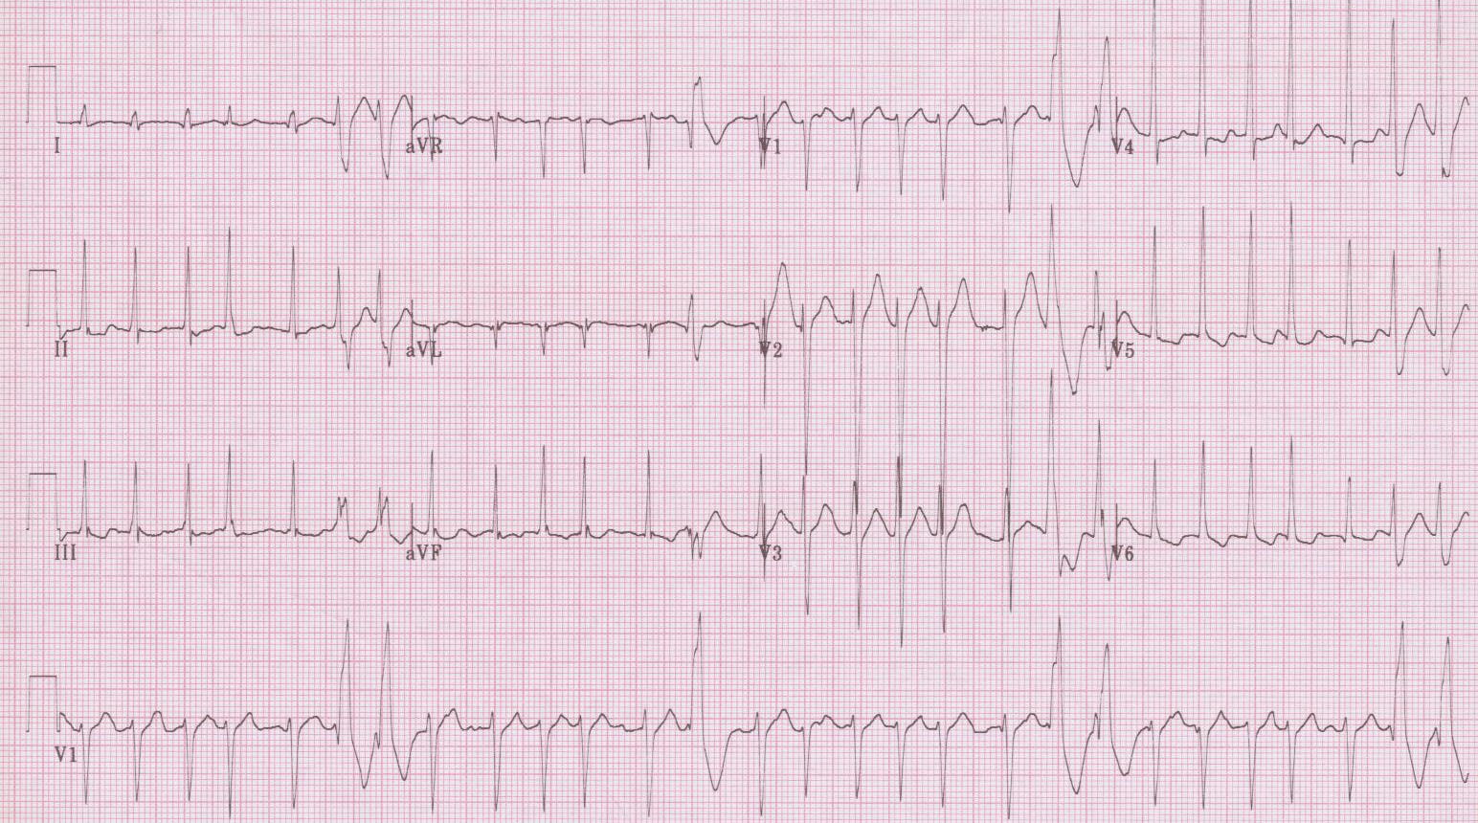
2. 35-year-old man complains of palpitations after a night of “partying”. Nurses are concerned about the frequent “PVCs”.

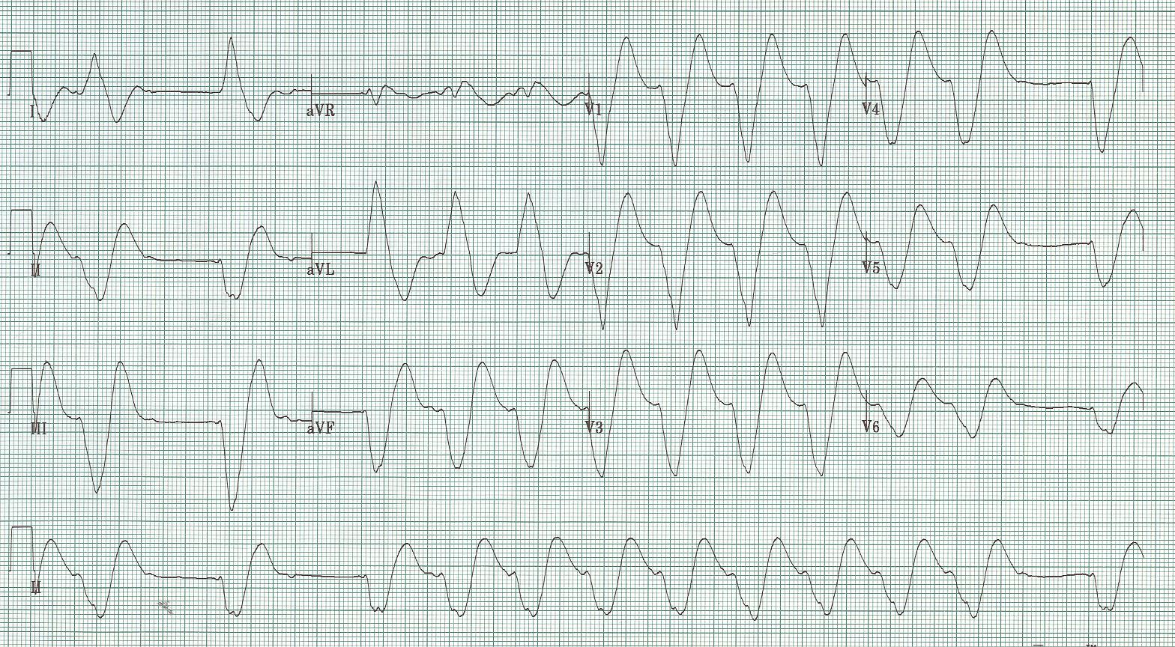
3. 40-year-old man with complaints of generalized weakness over several weeks.

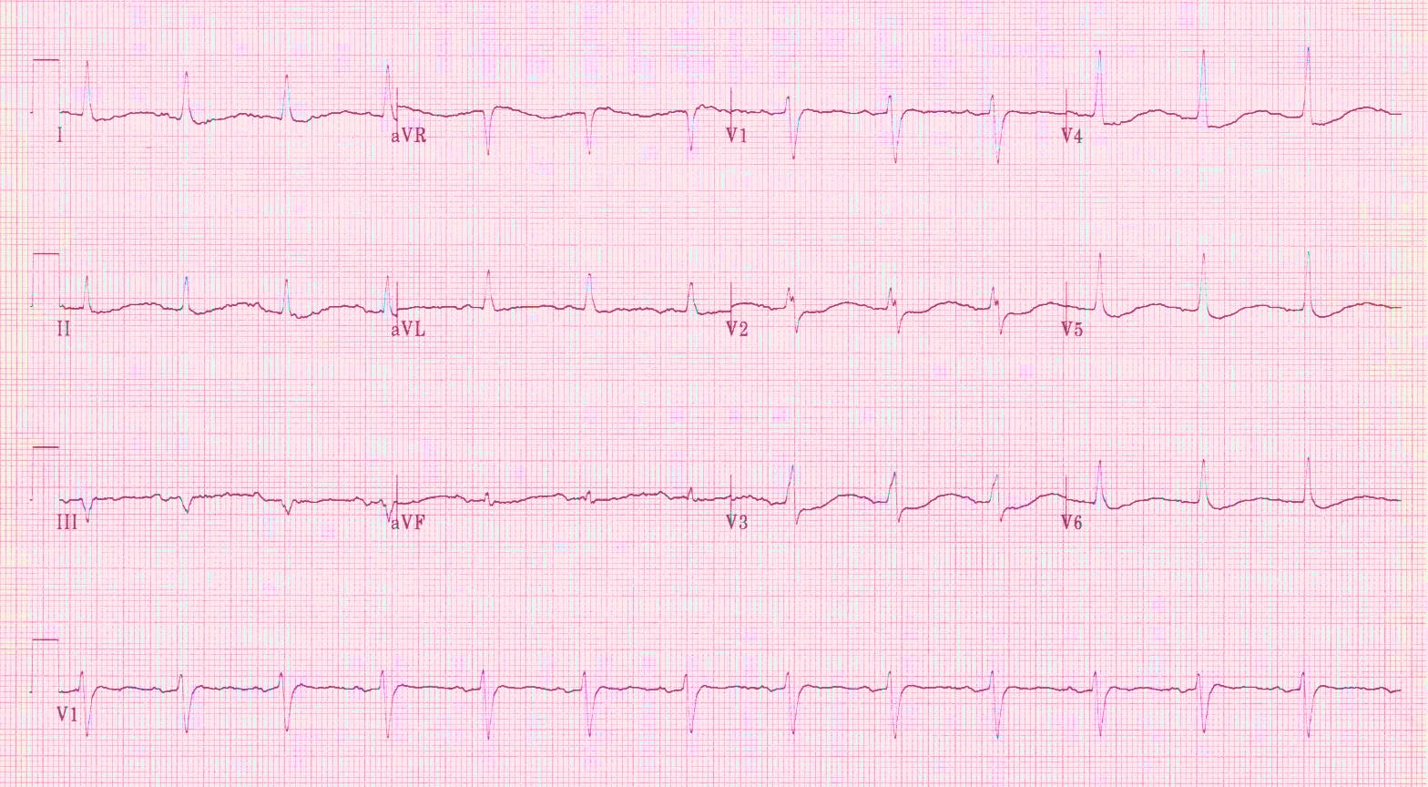
4. 75-year-old woman complains of significant generalized weakness. She was started on hydrochlorothiazide (HCTZ) for HTN 1 month prior.

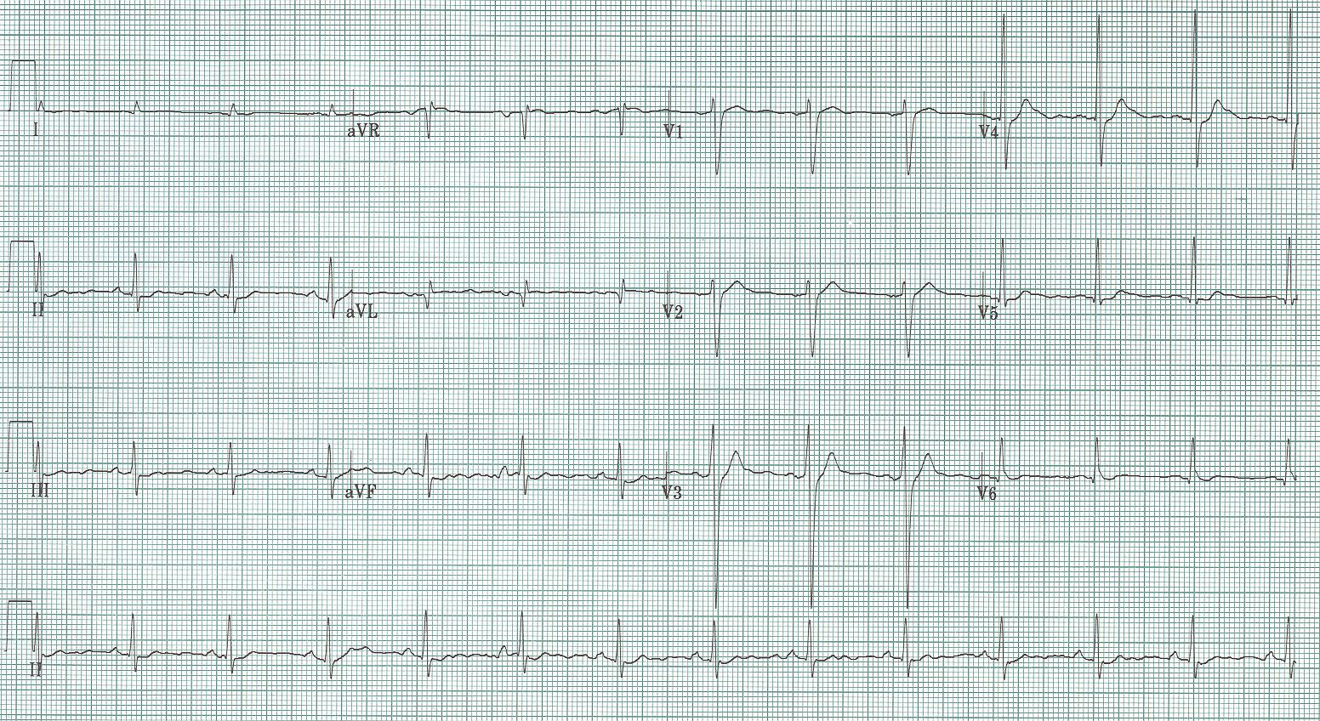
5. 60-year-old man with lethargy and altered mental status. PMH: squamous cell lung cancer
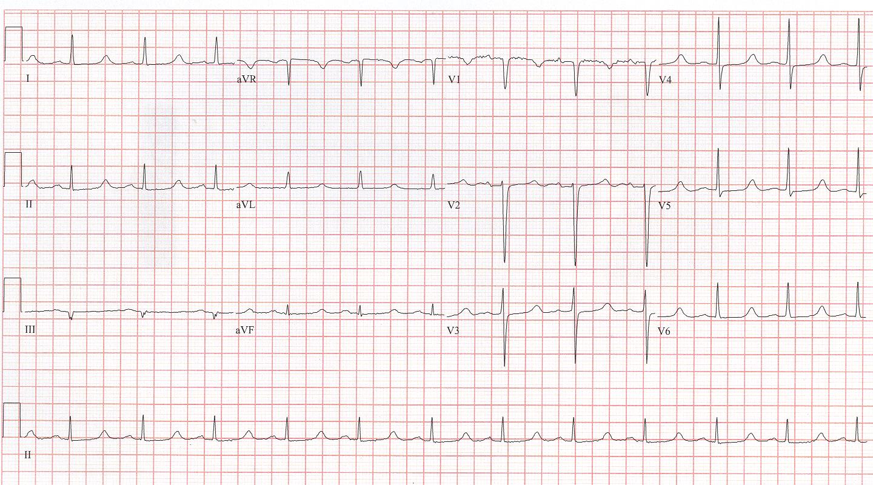
6. 46-year-old woman with carpal spasm. PMH: thyroidectomy
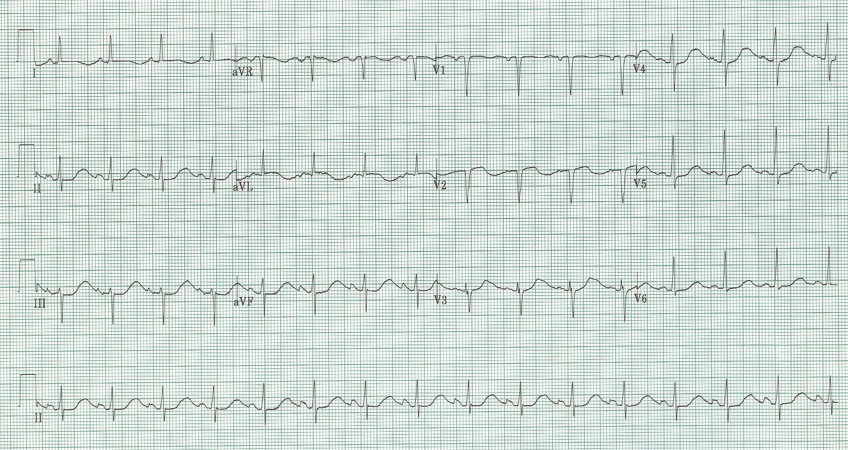7. 46-year-old woman, an alcoholic well known to the ED, presents after syncopal episode. She also reports she has had vomiting and diarrhea for three days.

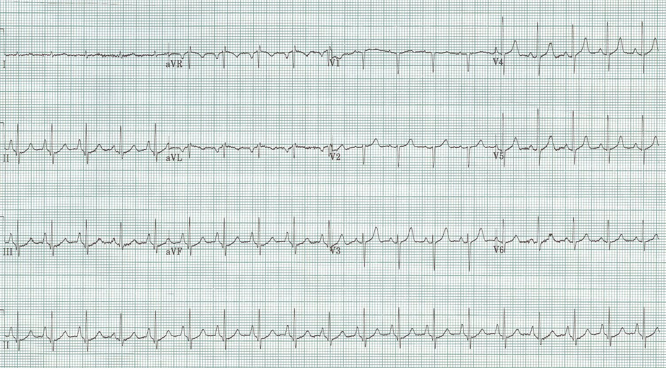
8. 60-year-old woman with increasing shortness of breath and sputum production over prior week.
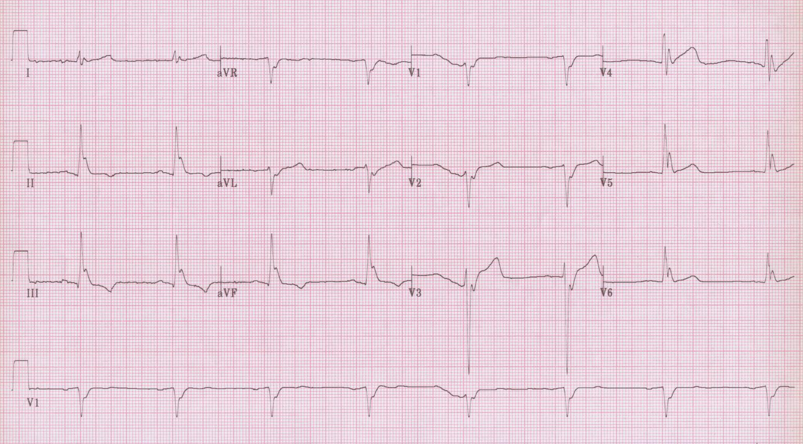
9. 30-year-old man found unresponsive outside, assumed to be a drug overdose…

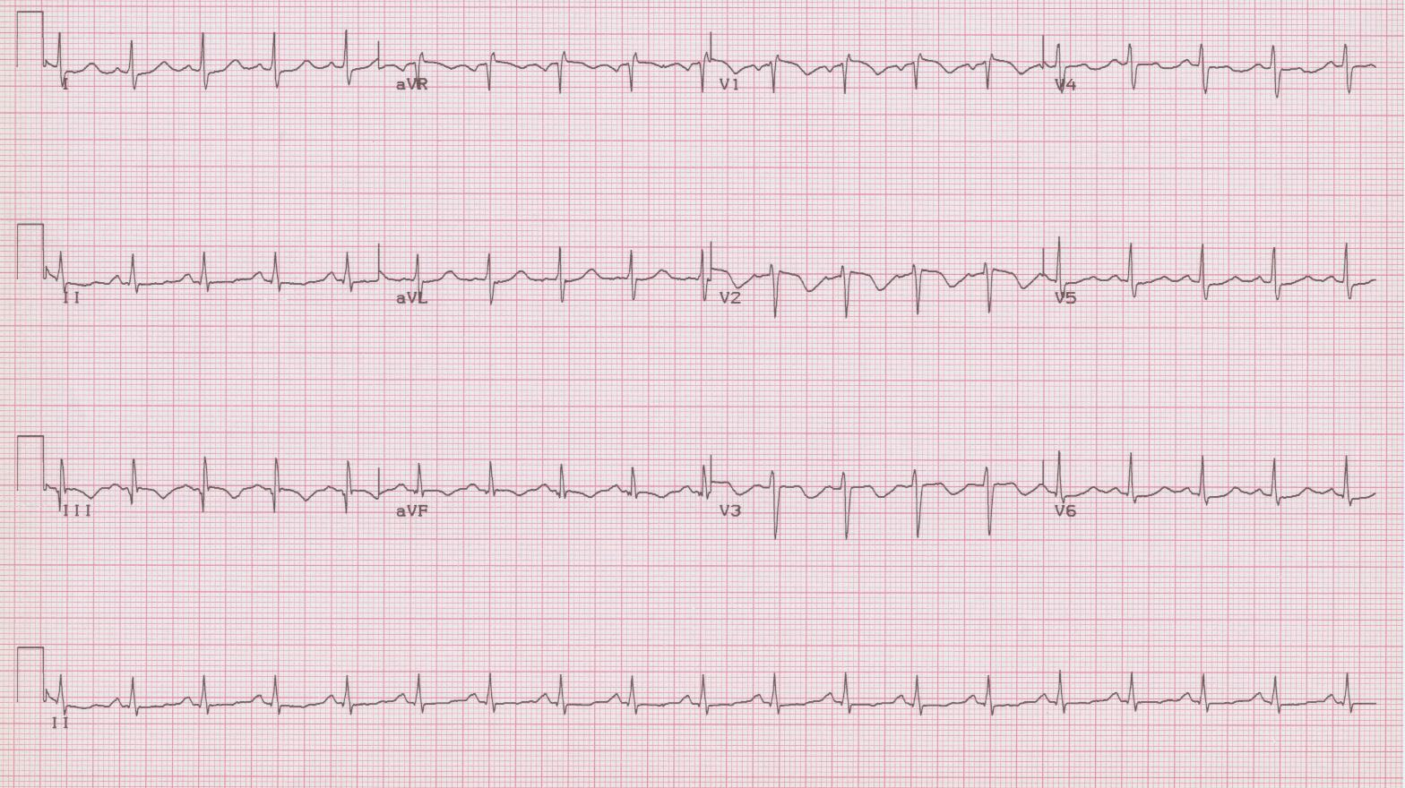
10. 40-year-old woman with right flank pain and near syncope, VS: 96/60, 120, 24, afebrile, O₂sat 93%; recently had arthroscopic knee surgery.
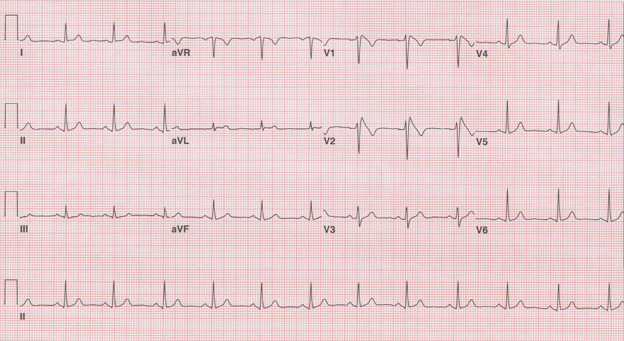
11. 42-year-old man presents after syncope episode; now no complaints, normal VS and exam. He has a family hx of unexplained sudden death in father and uncle in the 40’s.

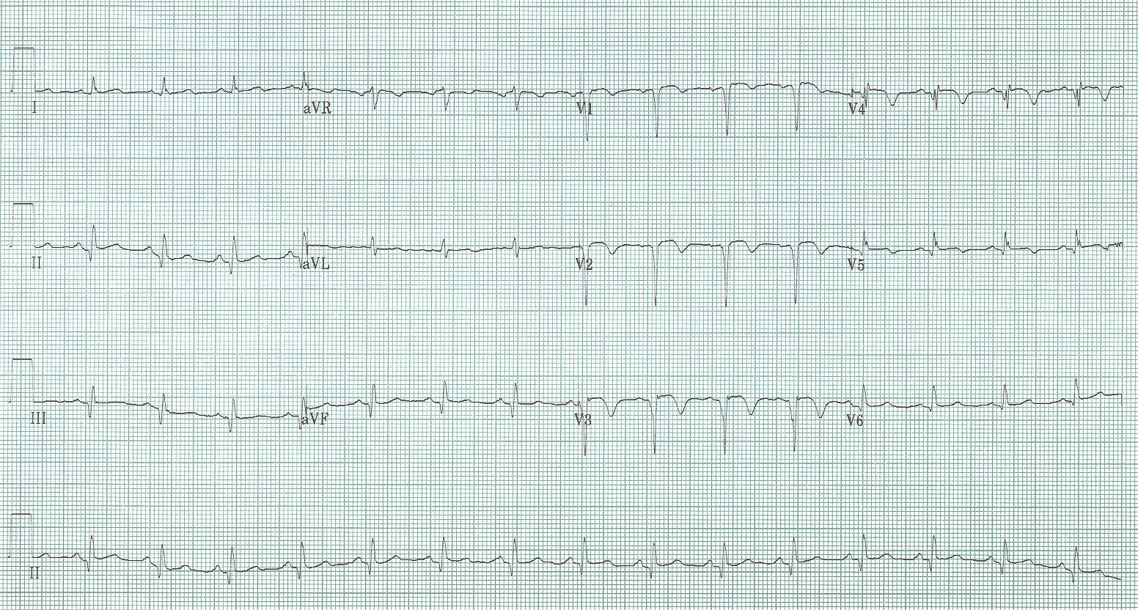
12. 55-year-old man presents with right hemiparesis and expressive aphasia.

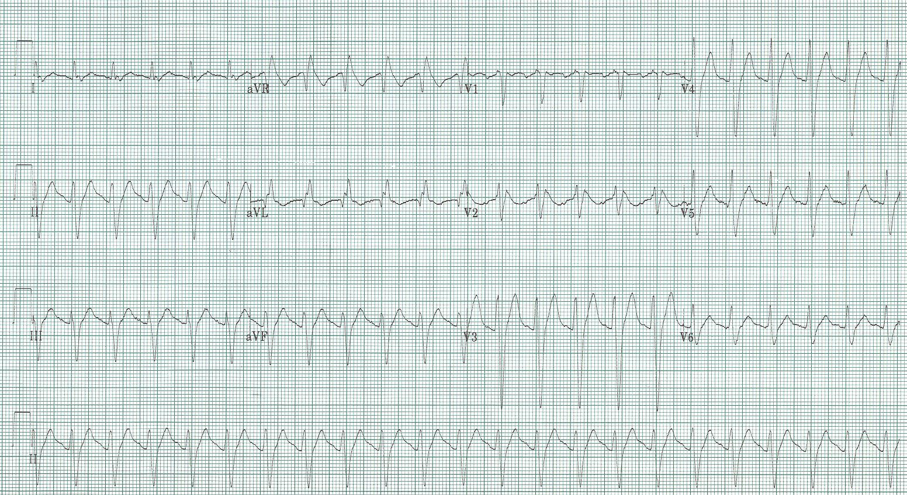
13. 17-year-old male found unresponsive, a suspected toxic ingestion as suicide attempt.

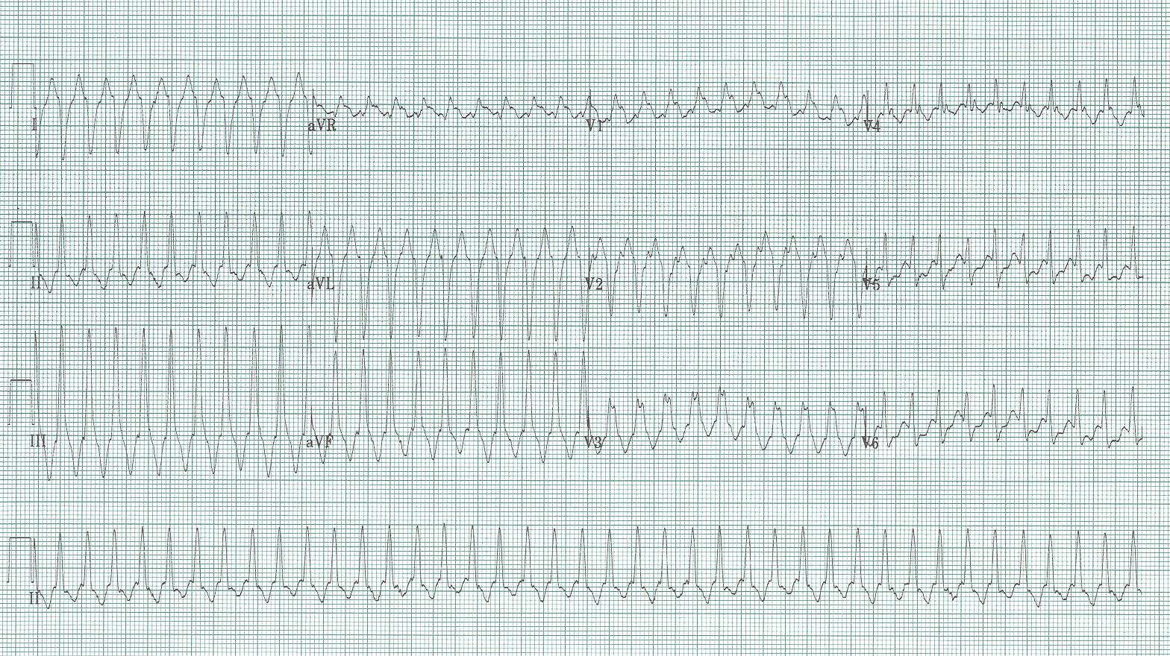
14. 35-year-old man with chest discomfort and heart racing. PMH: IVDA
Exam – BP 120/70, HR 240, O₂sat 96% room air; healed thoracotomy scar

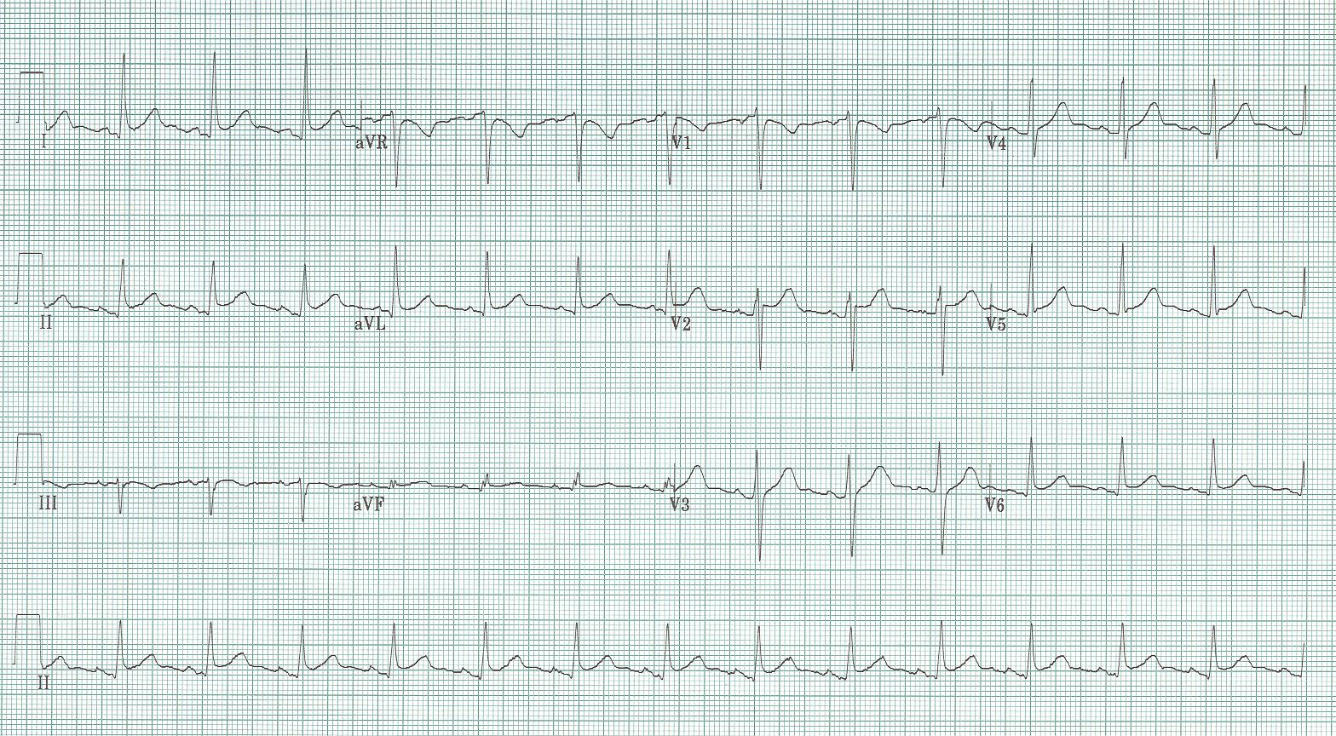
15. 55-year-old man with waxing and waning chest discomfort for 12 hours.
No cardiac risk factors or past medical history.
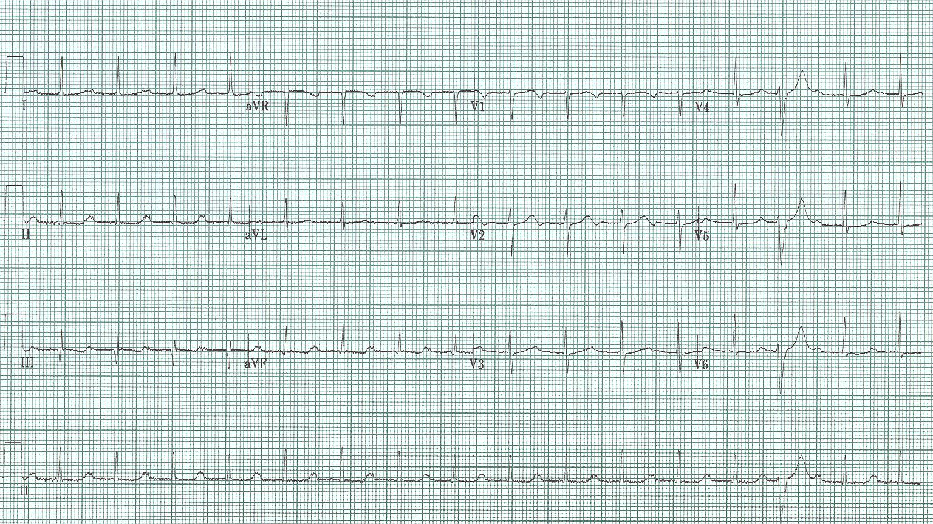
16. 60-year-old man being evaluated for syncope.

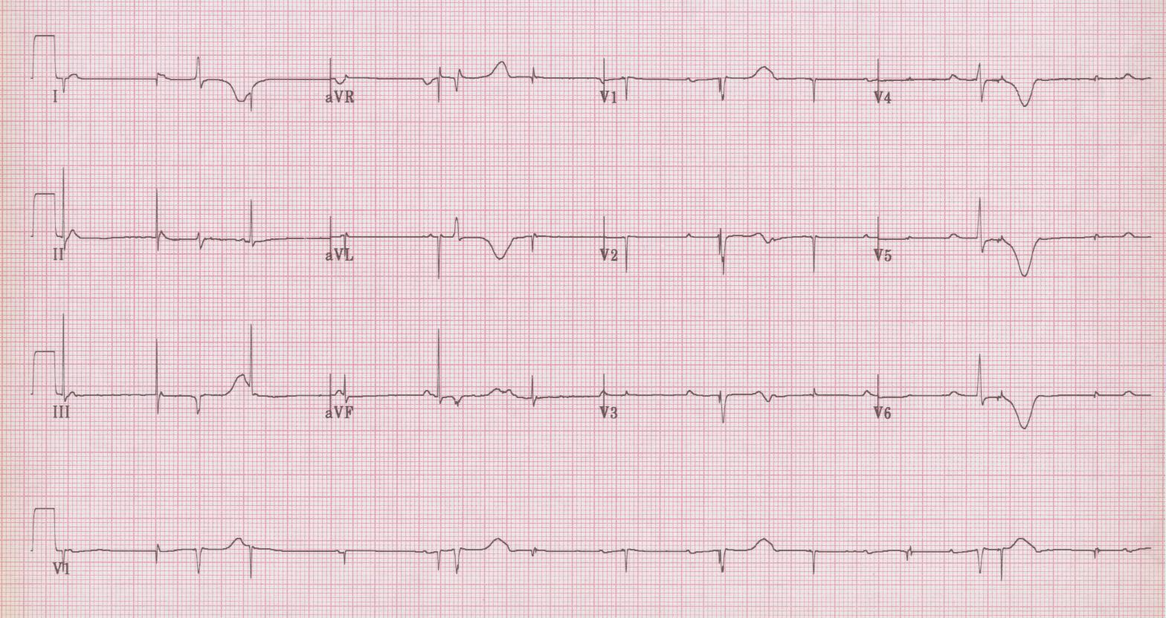
17. 78-year-old woman presents via EMS following syncope in church.
Triage VS – BP 120/70, HR 70, R 20, O₂sat 97%

