Advanced EKGs

The most common cause, of a pause during sinus rhythm, is a blocked PAC
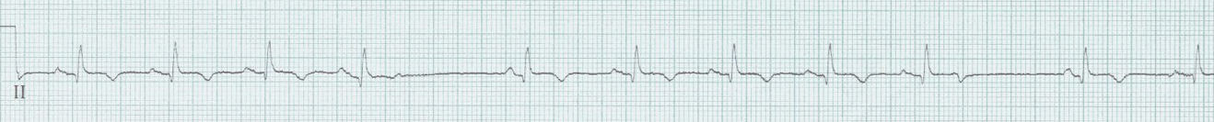
The T-wave at the beginning of the pause is deformed by a very early premature atrial depolarization, too early to conduct successfully to the ventricles. Be careful not to assume sinus node dysfunction. Blocked PACs in a bigeminy pattern can also be mistaken for sinus bradycardia or 2:1 AV block.

Ashman’s phenomenon – it will make you look smart
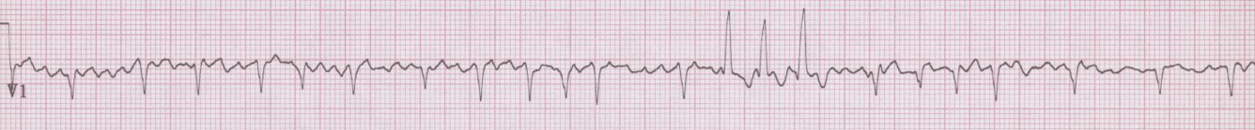
Repolarization after a QRS complex (the QT interval) is proportional to the rate of the rhythm (specifically the preceding R-R interval). Thus, in an irregular rhythm (typically atrial fibrillation, occasionally MAT), when a long R-R interval is followed by a short interval, the subsequent QRS may be aberrantly conducted. Aberrancy is predictably of RBBB morphology as this bundle is most influence by repolarization delays. LONG – SHORT – WEIRD

Hyperkalemia – you will save someone’s life
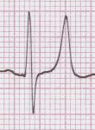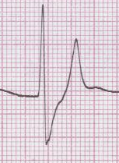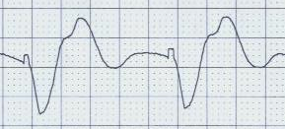
Hyperkalemia causes changes in the EKG in a predictable sequence, just not at predictable potassium levels. It is possible to see little, if any, changes at a fairly high potassium level, especially in dialysis patients.
- peaked T-waves
- early prolongation of the QRS complex
- diminution of the P wave (may disappear)
- further prolongation of the QRS
- appearance of the “sine wave”
Beware bizarre bradycardias and curious WCT (eg rate < 130)
– THINK HYPERKALEMIA
Hypokalemia - a cause of prolonged QT interval?
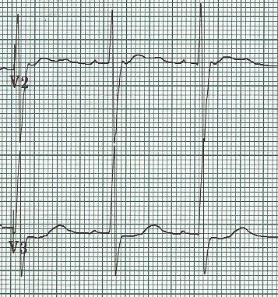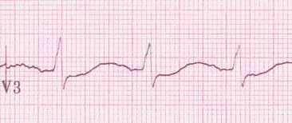
Hypokalemia causes appearance of U-waves, best seen in mid-anterior leads, V2-4, as well as decrease in amplitude of T-waves. These changes eventually produce the appearance of a prolonged QT interval (actually a Q-U interval). There may also be associated ST-segment depression, the “roller coaster” profile.

Hypercalemia – think of this in appropriate clinical settings
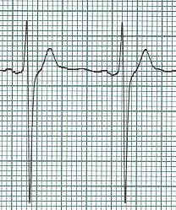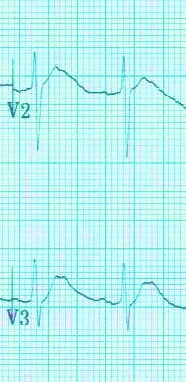
Hypercalcemia causes shortening of the QT interval. There is no specific number for a short QT, but always be suspicious of QTc < 400msec. Occasionally, while the QT interval may not be particularly short, there is noticeable shifting of the apex of the T wave toward the QRS complex.

Now, not enough of the cation…
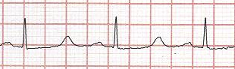
Very long QT interval associated with hypocalcemia in a patient with hypoparathyroid disease after thyroidectomy and non-compliance with calcium replacement
Multiple electrolyte depletion – watch the QT interval!
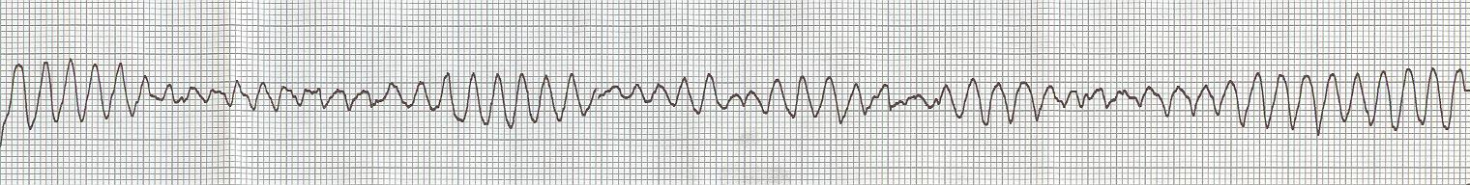
The combination of hypomagnesemia, hypokalemia, and occasionally hypocalemia causes significant prolongation of the QT interval and may precipitate torsade de pointes. This can occur in alcoholics with concommitent acute GI illness or in patients on with multiple risk factors (age, CHF, diuretics, QT prolonging meds – particularly antibiotics, cardiac meds, antipsychotics).

COPD – diagnosed even before the CXR
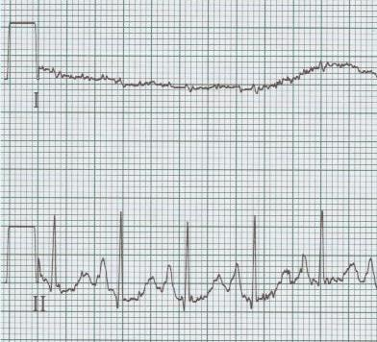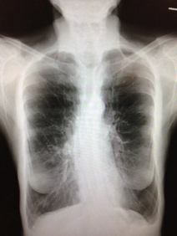
COPD can be diagnosed from the EKG – the classic EKG of COPD may include peaked P waves in lead II (“P-pulmonale”) indicating R atrial enlargement and “lead I sign” with the P-QRS-T waves in lead I all nearly isoelectric.

Hypothermia
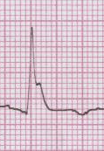
Osborne waves (J waves) of hypothermia appear on the EKG at approximately 90° (32° C), and increase as the temperature decreases. Osborne waves will be upright when the QRS complex is upright, and inverted with negative QRS complexes. Notice, there will be no artifact from shivering, which stops by 90° (32° C).

Pulmonary Embolus – a difficult diagnosis
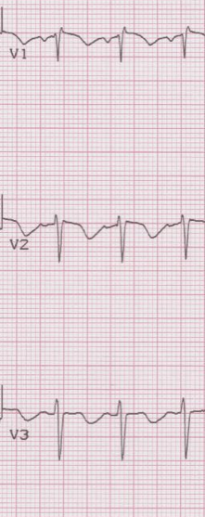
PE is an impossibly difficult diagnosis to make from an EKG. The EKG may suggest the diagnosis, however, even when classic clinical signs are misleading. With significant PEs there will be R heart strain that cause T-wave inversion in the right anterior leads (V1-3). This change is associated with larger embolus burden and can occur as early as ED presentation or within the first 24 hours.

Brugada Sydrome – “screams in the night”
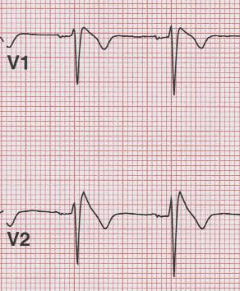
Brugada syndrome, a Na-channelopathy, is an inherited cause of sudden death from
abrupt ventricular arrhythmias.

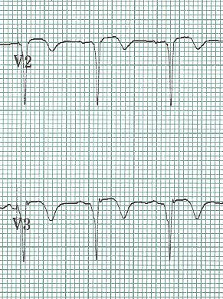
Another source of embolic stroke

Atrial fibrillation is a well-known cause of embolic stroke due to clot formation in the atria. Less focus is paid to another cause of embolic stroke – a ventricular clot, typically formed in the weeks that follow a large anterior MI.

The large Q waves in V1 – V4 of this EKG with associated T-wave inversion is consistent with a subacute MI, perhaps weeks old. TEE demonstrated a ventricular clot requiring long-term anticoagulation.

TCA toxicity
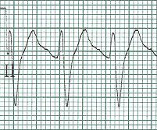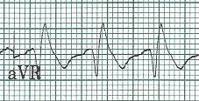
TCA toxicity has several important effects on the EKG. Increased QT interval, prolonged QRS complex, and the appearance of a prominent R wave in lead aVR are consistent with significant TCA toxicity and the possibility of neurologic or cardiac complications. These findings require recognition and emergent treatment with NaBicarb bolus and infusion.

Interesting WCT (wide-complex tachycardia)
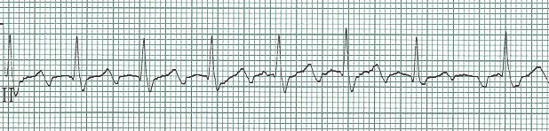
A regular tachycardia approaching 250-300/min should make you think of 1:1 conduction of atrial fibrillation, just as constant rates around 150/minute should suggest 2:1 atrial flutter. After treatment with diltiazem, the underlying flutter waves become apparent. Luckily, as with all WCT, it is never necessary to differentiate VT from supraventricular rhythms (wide due to pre-existing BBB, aberrancy, or conduction via a bypass tract); it is important only to follow ACLS protocol for WCT and treat accordingly.

Subtle findings of pericardial inflammation
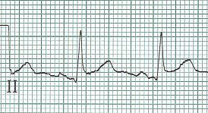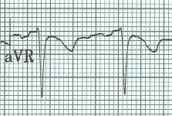
Apparent ST-elevation is PR elevation in aVR
due to PR depression

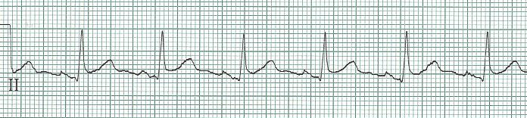
Spodick’s sign – downsloping T-P segment in II

PVCs are very helpful…sometimes
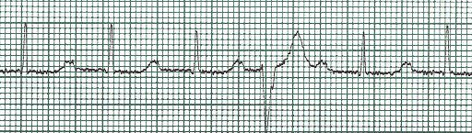
While a quick glance at this EKG might suggest a junctional rhythm, the occurrence of a single PVC with it’s fully compensatory pause reveals a P wave with substantial PR interval of 400msec. In fact many T waves are actually P waves when seen through the lens of this helpful PVC!

“DFO” – done fell out (EMS slang for syncope)
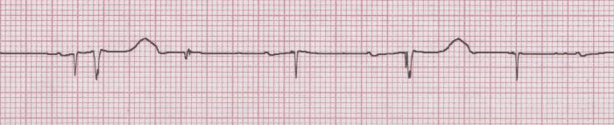
Pacemaker failure (neither sensing nor capturing) with underlying 3° AV block and QRS complexes (ie heart rate) – 24/min; P waves – 72/min (and dissociated from QRS); and pacer spikes – 70/min.

www.TorreyEKG.com @STorreyMD

